**Question 1 :**

// write a typescript program to which contain function named Maximum. that function accept array of numbers and return largest number from array as

// Input : 23,89,6,29,56,45,77,32

// Otput : 89

function Maximum(num1 : number[]) : number

{

    var i : number = 0;

    var max :number = 0;

    for(i = 0; i < num1.length; i++)

    {

        if(num1[i] > max)

        {

            max = num1[i];

        }

    }

    return max;

}

var maxNum : number = 0;

var array : number [] = [23,89,6,29,56,45,77,32];

maxNum = Maximum(array);

console.log("Maximum number is :"+maxNum);

**Output:**

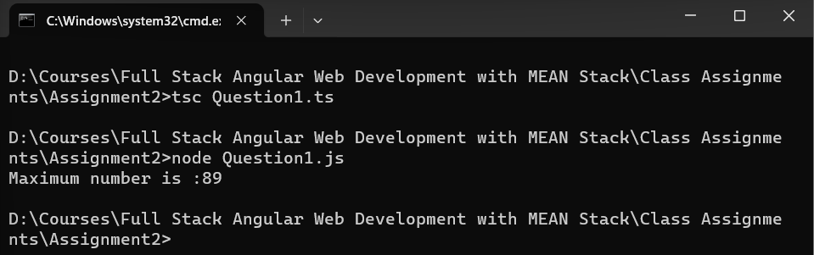

**Question 2:**

// write a typescript program to which contain function named Summation. that function accept array of numbers and return summation of each number from array

// Input : 23,6,7,4,5,7

// Output : Addition is 52

function Summation(num1 : number []) : number

{

    var i : number = 0;

    var sum : number = 0;

    for(i = 0; i < num1.length; i++)

    {

        sum = sum + num1[i];

    }

    return sum;

}

var Additon: number = 0;

var array : number [] = [23,6,7,4,5,7];

Additon = Summation(array);

console.log("Addition of all numbers is :"+Additon);

**Output :**

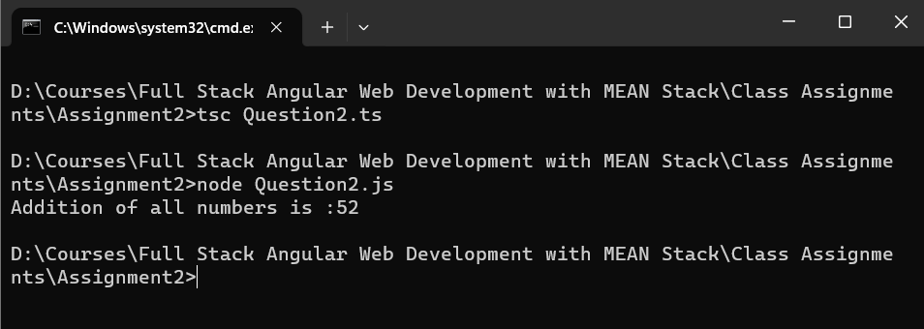

**Question 3 :**

// write a typescript program to which contain function named Maximum. that function accept array of numbers and return largest number from array as

// Input : 23,89,6,29,56,45,77,32

// Otput : 89

function Maximum(num1 : number[]) : number

{

    var i : number = 0;

    var j : number = 0;

    var firstMax :number = 0;

    var secondMax :number = 0;

    for(i = 0; i < num1.length; i++)

    {

        if(num1[i] > firstMax)

        {

            firstMax = num1[i];

        }

        else if(num1[i] > secondMax)

        {

            secondMax = num1[i];

        }

    }

    return secondMax;

}

var secondMaxNum : number = 0;

var array : number [] = [23,89,6,29,56,45,77,32];

secondMaxNum = Maximum(array);

console.log("Maximum number is :"+secondMaxNum);

**Output:**

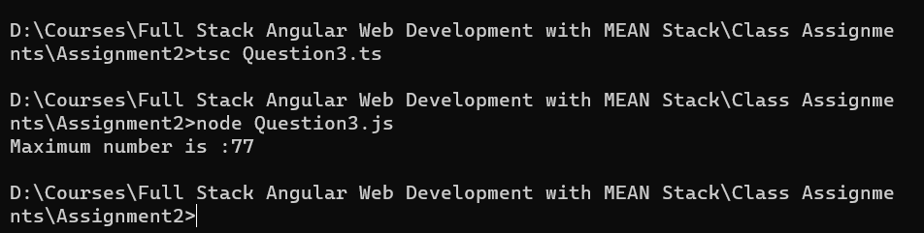

**Ouestion 4:**

var ChkArmstrong = (No1: number): boolean => {

    var str: string = "";

    var length: number = 0;

    str = String(No1);

    length = str.length;

    const sum = str

        .split('')

        .map(digit => Number(digit))

        .reduce((accumulator, current) => accumulator + Math.pow(current, length), 0);

    return sum === No1;

};

var Num1: number = 153;

var Result: boolean = false;

Result = ChkArmstrong(Num1);

if (Result == true)

{

    console.log(Num1 + " is an Armstrong number ");

}

else

{

    console.log(Num1 + " is not an Armstrong number ");

}

**Output:**

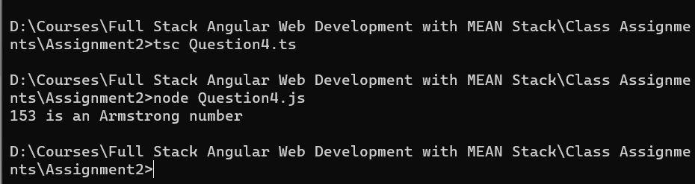

**Question 5:**

// write a typescript program to which contain function named ChkString. that function accept one string and check whether that string contains "Marvellous" word or not.

// Input : "Pune Kothrud Marvellous Infosystems"

// Otput : String contains Marvellous in it.

function ChkString(inputString : string) : string

{

    if (inputString.indexOf("Marvellous"))

    {

        return "String contains Marvellous in it.";

    }

    else

    {

        return "String does not contain Marvellous.";

    }

}

var Input : string = "Pune Kothrud Marvellous Infosystems";

var  Result : string = ChkString(Input);

console.log(Result);

**Output:**

