**Question 1:**

// Create one typeScript application which contains one class named as Arithmetic. Arithmetic class contains three characteristics (Class data members) as Number1,Number2. Create one parameterised constructor which accept two values and assign it to Number1 and Number2.

//In arithmetic class we have to write four methods as Addition, Substraction, Multiplication, Division.

//Adddition will add Number1, Number2 and return result

//Substraction will substract Number1, Number2 and return result

//Multiplication will multiply Number1, Number2 and return result

//Division will divide Number1, Number2 and return result

//after Designing class create two objects of that class by providing some hardcoded value. Call all the methods by using both the objects.

class Arithmetic {

    public Number1 : number ;

    public Number2 : number ;

    constructor(A : number, B : number)

    {

        this.Number1 = A;

        this.Number2 = B;

    }

    Addition() : number

    {

        var Ans : number = 0;

        Ans = this.Number1 + this.Number2;

        return Ans;

    }

    Substraction() : number

    {

        var Ans : number = 0;

        Ans = this.Number1 + this.Number2;

        return Ans;

    }

    Multiplication() : number

    {

        var Ans : number = 0;

        Ans = this.Number1 * this.Number2;

        return Ans;

    }

    Division() : number

    {

        var Ans : number = 0;

        Ans = this.Number1 / this.Number2;

        return Ans;

    }

}

var obj1 = new Arithmetic(20,10);

var obj2 = new Arithmetic(40,20);

var Result : number = 0;

Result = obj1.Addition();

console.log("Addition of "+obj1.Number1+" and "+obj1.Number2+" is "+Result);

Result = obj1.Substraction();

console.log("Substraction of "+obj1.Number1+" and "+obj1.Number2+" is "+Result);

Result = obj1.Multiplication();

console.log("Multiplication of "+obj1.Number1+" and "+obj1.Number2+" is "+Result);

Result = obj1.Division();

console.log("Division of "+obj1.Number1+" and "+obj1.Number2+" is "+Result);

Result = obj2.Addition();

console.log("Addition of "+obj2.Number1+" and "+obj2.Number2+" is "+Result);

Result = obj2.Substraction();

console.log("Substraction of "+obj2.Number1+" and "+obj2.Number2+" is "+Result);

Result = obj2.Multiplication();

console.log("Multiplication of "+obj2.Number1+" and "+obj2.Number2+" is "+Result);

Result = obj2.Division();

console.log("Division of "+obj2.Number1+" and "+obj2.Number2+" is "+Result);

**Output :**

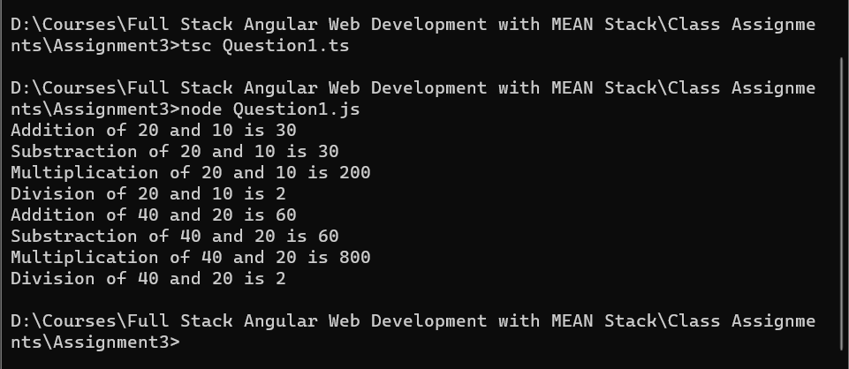

**Question 2:**

//Create one typescript application which contains one class named as Circle .

//Circle class contain two charateristics(Class data member) as Radius and PI.

// Create one parameterised  constructor which willl accept one value and assign it to radius. value of PI member is set to 3.14.

//In circle class we have to one method (Behaviours) as Area whiich will return area of circle.

//after Designing class create two objects of that class by providing some hardcoded value. Call all the methods by using both the objects.

class Circle {

    public Radius : number;

    public PI : number = 3.14;

    constructor (A : number)

    {

        this.Radius = A;

    }

    Area () : number

    {

        var Result : number = 0;

        Result = (this.Radius ** 2) * this.PI;

        return Result;

    }

}

var obj1 = new Circle(15);

var obj2 = new Circle(19);

var area : number = 0;

area = obj1.Area();

console.log("Area of circle with Radius "+obj1.Radius+" is "+area );

area = obj2.Area();

console.log("Area of circle with Radius "+obj2.Radius+" is "+area );

**Output :**

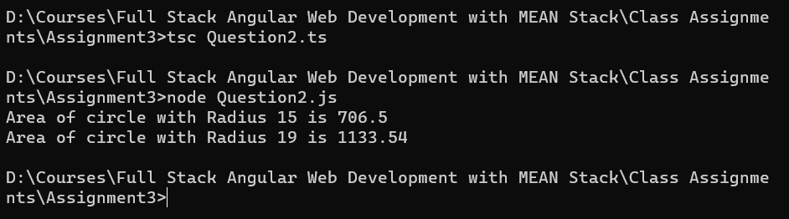

**Question 1:**

//Create one typescript application which contains one class named as CircleX. Which will iherits above Circle class

//In circleX class we have to one method (Behaviours) as Circumference whiich will return Circumference of circle.

//after Designing class create two objects of that class by providing some hardcoded value. Call all the methods by using both the objects.

class Circle {

    public Radius : number;

    public PI : number = 3.14;

    constructor (A : number)

    {

        this.Radius = A;

    }

    Area () : number

    {

        var Result : number = 0;

        Result = (this.Radius ** 2) * this.PI;

        return Result;

    }

}

class CircleX extends Circle {

    Circumference () : number

    {

        var Result : number = 0;

        Result = 2 * this.PI * this.Radius;

        return Result;

    }

}

var obj1 = new CircleX(15);

var obj2 = new CircleX(19);

var area : number = 0;

var circumference : number = 0;

area = obj1.Area();

circumference = obj1.Circumference();

console.log("Area of circle with Radius "+obj1.Radius+" is "+area );

console.log("Circumference of circle with Radius "+obj1.Radius+" is "+circumference );

area = obj2.Area();

circumference = obj2.Circumference();

console.log("Area of circle with Radius "+obj2.Radius+" is "+area );

console.log("Circumference of circle with Radius "+obj2.Radius+" is "+circumference );

**Output :**

