**Question 1:**

As we want to create our first application use below commands

1. ng new MarvellousFirst
2. cd MarvellousFirst
3. ng serve
4. http://localhost:4200

**Output :**

**D:\Courses\Full Stack Angular Web Development with MEAN Stack\Class Assignments\Assignment4>ng new MarvellousFirst**

**? Which stylesheet format would you like to use? CSS**

**? Do you want to enable Server-Side Rendering (SSR) and Static Site**

**Generation (SSG/Prerendering)? Yes**

**CREATE MarvellousFirst/angular.json (2784 bytes)**

**CREATE MarvellousFirst/package.json (1292 bytes)**

**CREATE MarvellousFirst/README.md (1069 bytes)**

**CREATE MarvellousFirst/tsconfig.json (877 bytes)**

**CREATE MarvellousFirst/.editorconfig (274 bytes)**

**CREATE MarvellousFirst/.gitignore (548 bytes)**

**CREATE MarvellousFirst/tsconfig.app.json (324 bytes)**

**CREATE MarvellousFirst/tsconfig.spec.json (273 bytes)**

**CREATE MarvellousFirst/server.ts (1703 bytes)**

**CREATE MarvellousFirst/.vscode/extensions.json (130 bytes)**

**CREATE MarvellousFirst/.vscode/launch.json (470 bytes)**

**CREATE MarvellousFirst/.vscode/tasks.json (938 bytes)**

**CREATE MarvellousFirst/src/main.ts (250 bytes)**

**CREATE MarvellousFirst/src/favicon.ico (15086 bytes)**

**CREATE MarvellousFirst/src/index.html (301 bytes)**

**CREATE MarvellousFirst/src/styles.css (80 bytes)**

**CREATE MarvellousFirst/src/main.server.ts (264 bytes)**

**CREATE MarvellousFirst/src/app/app.component.html (20884 bytes)**

**CREATE MarvellousFirst/src/app/app.component.spec.ts (943 bytes)**

**CREATE MarvellousFirst/src/app/app.component.ts (373 bytes)**

**CREATE MarvellousFirst/src/app/app.component.css (0 bytes)**

**CREATE MarvellousFirst/src/app/app.config.ts (321 bytes)**

**CREATE MarvellousFirst/src/app/app.routes.ts (77 bytes)**

**CREATE MarvellousFirst/src/app/app.config.server.ts (350 bytes)**

**CREATE MarvellousFirst/src/assets/.gitkeep (0 bytes)**

**√ Packages installed successfully.**

**Successfully initialized git.**

**√ Packages installed successfully.**

**D:\Courses\Full Stack Angular Web Development with MEAN Stack\Class Assignments\Assignment4>cd MarvellousFirst**

**D:\Courses\Full Stack Angular Web Development with MEAN Stack\Class Assignments\Assignment4\MarvellousFirst>ng serve --o**

**? Would you like to share pseudonymous usage data about this project with**

**the Angular Team**

**at Google under Google's Privacy Policy at**

**https://policies.google.com/privacy. For more**

**details and how to change this setting, see https://angular.io/analytics.**

**Yes**

**Thank you for sharing pseudonymous usage data. Should you change your mind, the following**

**command will disable this feature entirely:**

**ng analytics disable**

**Global setting: enabled**

**Local setting: enabled**

**Effective status: enabled**

**Initial Chunk Files | Names | Raw Size**

**polyfills.js | polyfills | 82.71 kB |**

**main.js | main | 23.32 kB |**

**styles.css | styles | 95 bytes |**

**| Initial Total | 106.13 kB**

**Application bundle generation complete. [8.419 seconds]**

**Watch mode enabled. Watching for file changes...**

**➜ Local:** [**http://localhost:4200/**](http://localhost:4200/)

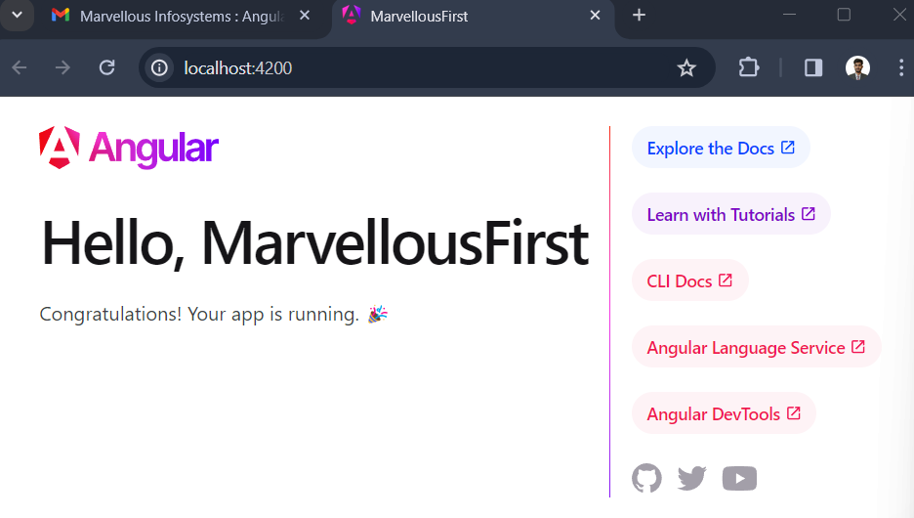

**Question 2:**

Create Angular application which will display “Welcome to Marvellous Infosystem’s First Application!”

On Page. [MarvellousFirstApp]

**Output/Solution :**

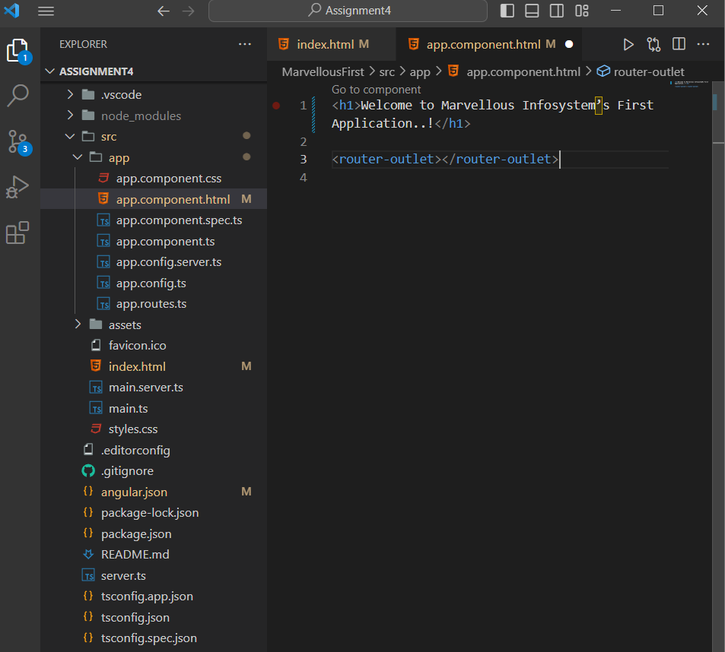

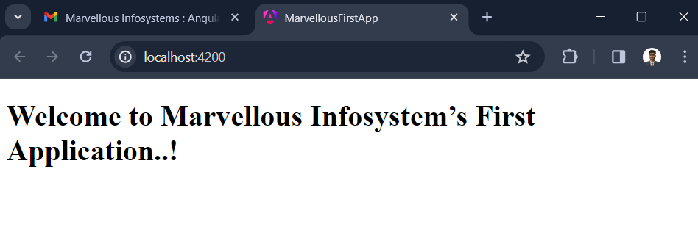

**Question 3:**

Create Angular Application Which will display one text field and static text “Marvellous Infosystems” on page [MarvellousLabel].

To do remove whole code of from app.component.html and write statements to add label..

**Output/Solution :**

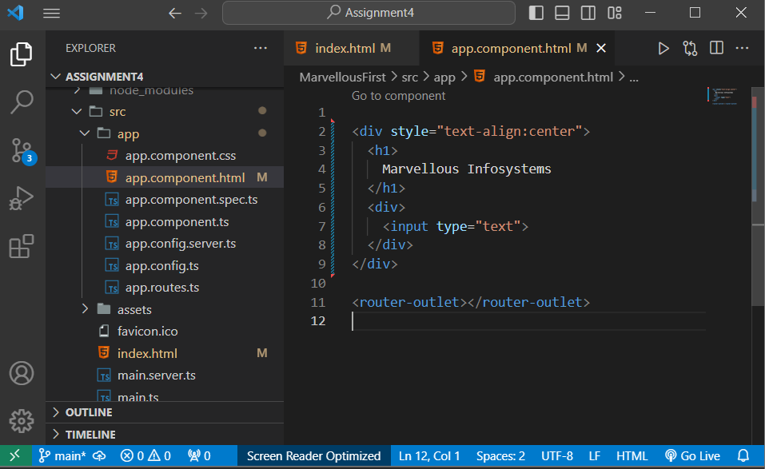

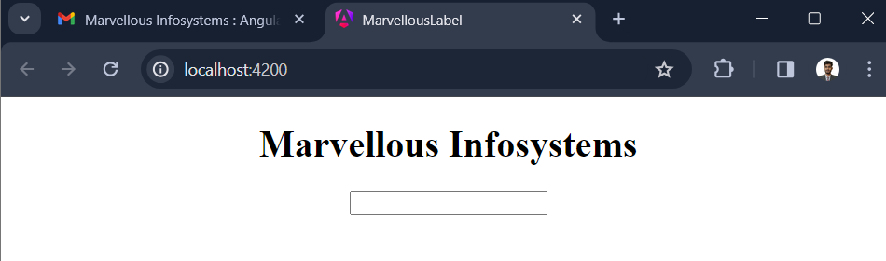

**Question 4:**

Create Angular application which creates one Custom component named as Demo. Render That Demo Component

To do this use below command

**Ng generate component Demo**

Add selector of Demo component into app component.

**Output/Solution:**

