**Question 1:**

Create Angular application which will create component named as FirstComp. That component will display “ Hello from First component” on page. Render that component from index.html file

**Output:**

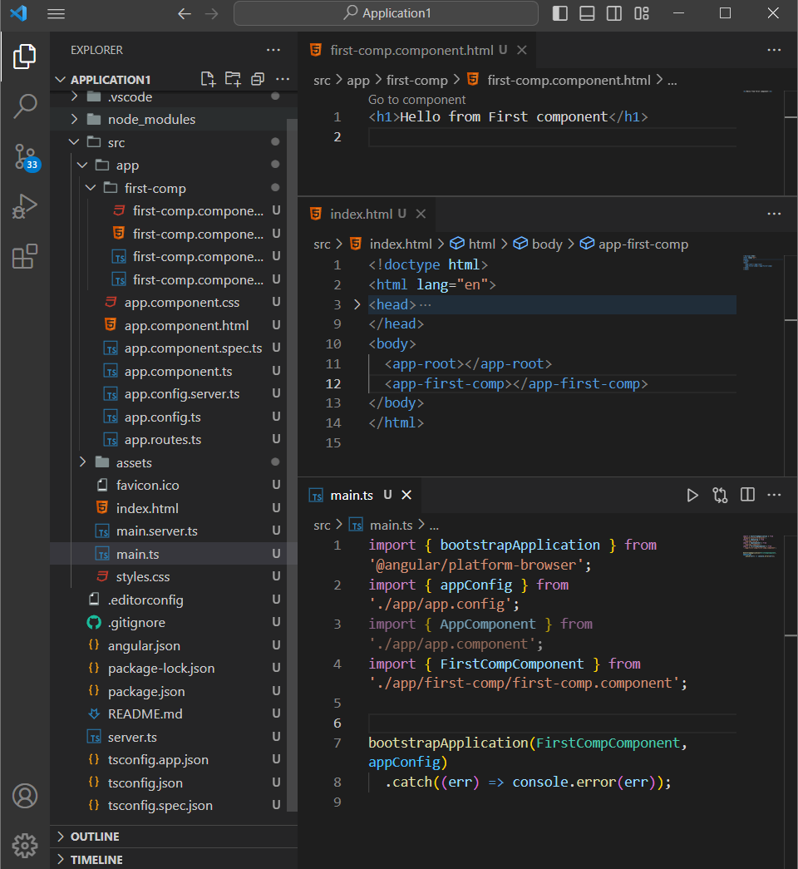

[**Git Hub link**](https://github.com/Tejas-Bhandare/Angular-Projects/tree/3d594f05192bfc1e04e1a1afd666e3e97fae7928/Assignment5/Application1)

**Question 2:**

Create one application which will create two components named as FirstComp, SecondComp. FirstComp will display “ Hello from First component” on page & SecondComp will display “ Hello from second component” on page. Render both component from root component i.e. App component.

**Output :**

[**Git hub link**](https://github.com/Tejas-Bhandare/Angular-Projects/tree/afd2cb83501b2852faafd6638f8c6e29d9048fbc/Assignment5/Application2)

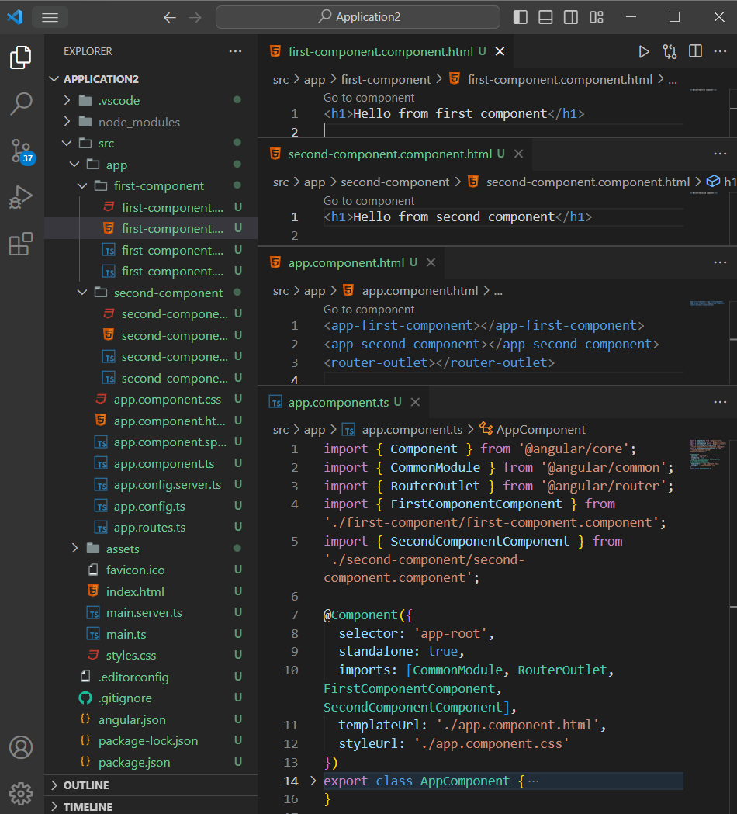

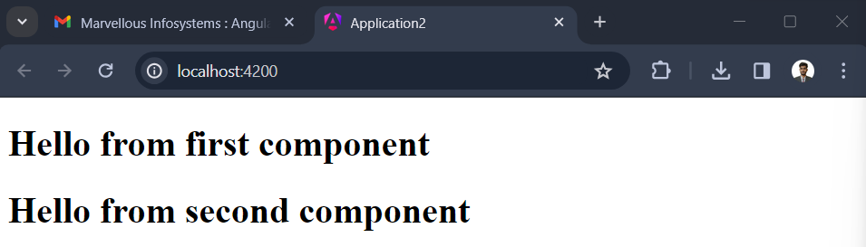

**Question 3:**

Create one application which will create two components named as FirstComp, SecondComp. FirstComp will display “ Hello from First component” on page & SecondComp will display “ Hello from second component” on page. Render FirstComp from App component & SecondComp from FirstComp.

**Output:**

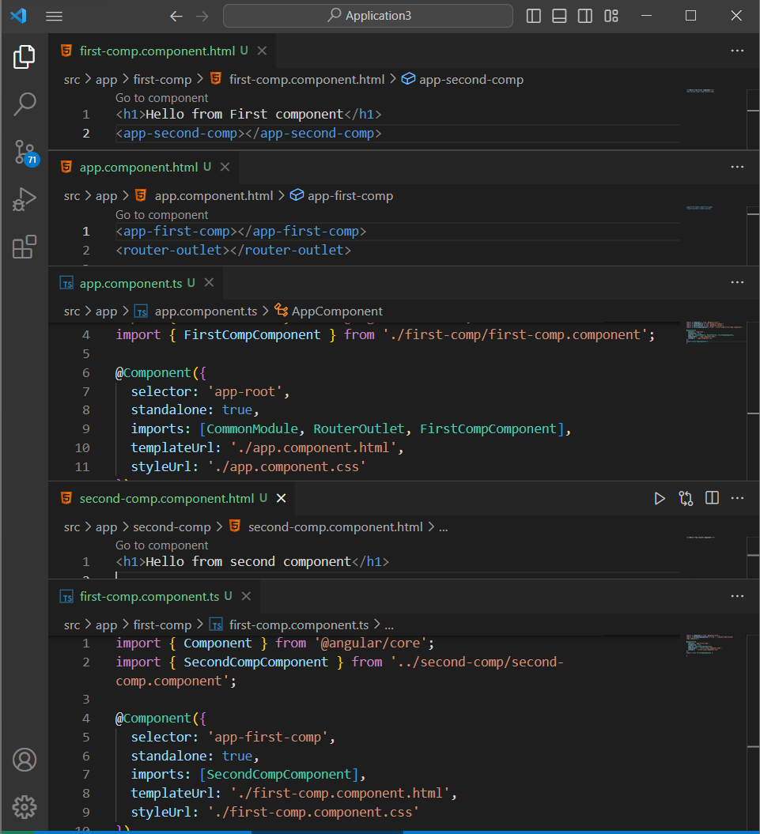

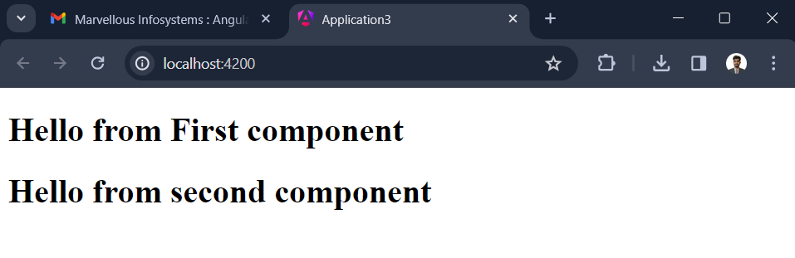

[**Git Hub link**](https://github.com/Tejas-Bhandare/Angular-Projects/tree/afd2cb83501b2852faafd6638f8c6e29d9048fbc/Assignment5/Application3)