**Question 1:**

Create Application which will display one text field and one Static Text “Marvellous Infosystems” on page. Follow all the steps to create new project and update app.component.html file .In this file add code to display one static text and one text field.

**Output :**

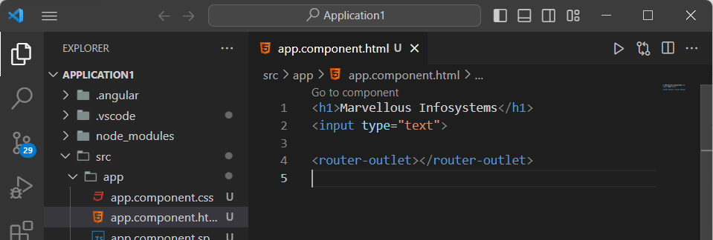 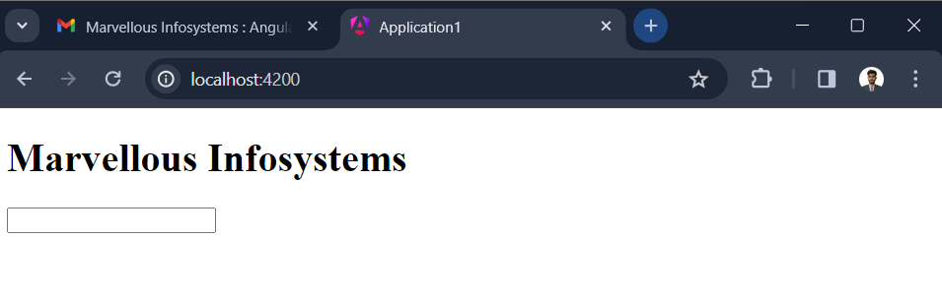

**Question 2:**

Create Application which will display one text field and one Static Text “Marvellous Infosystems” on page. Color of text should be blue. Follow all the steps to create new project and update app.component.html file .In this file add code to display one static text and one text field.

As we want to specify color add the specification in the app.component.css file and see the changes.

**Output:**

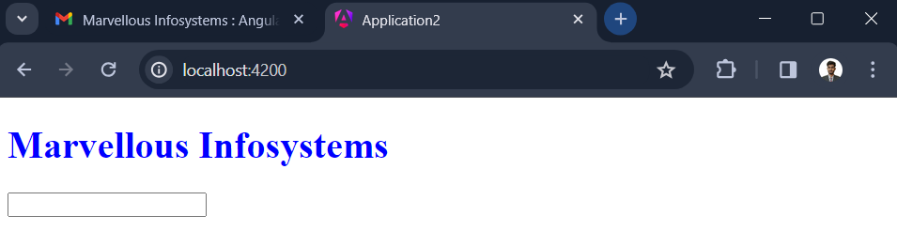

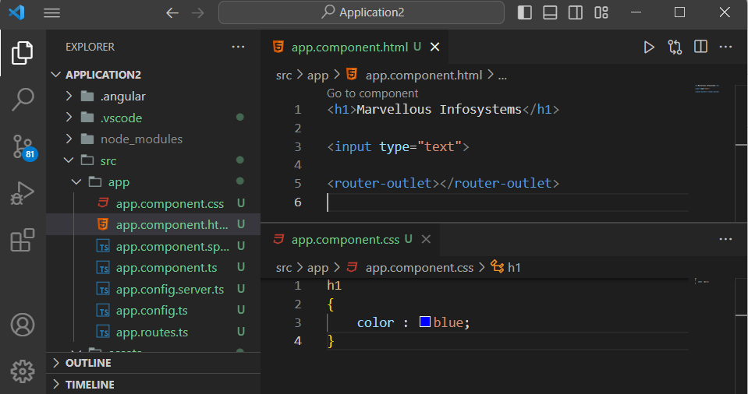

**Question 3:**

Create same application as previous question but instead of using app.component.html and app.component.css file separately add its contents in inline format inside app.component.ts file.

**Output:**

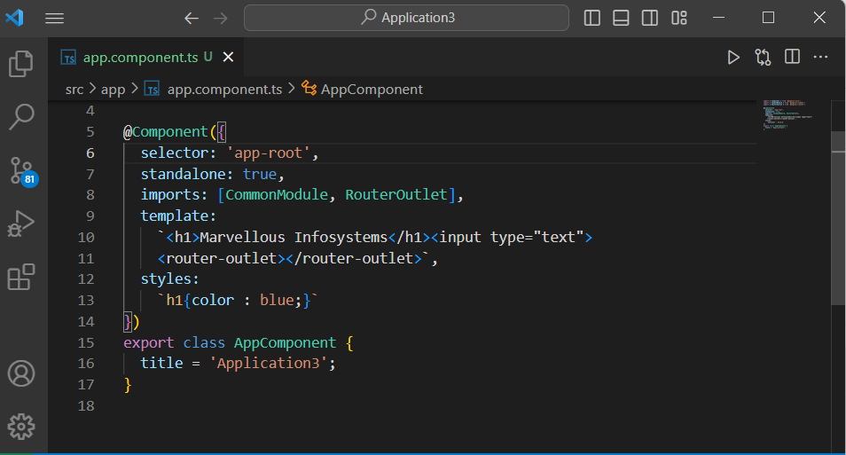

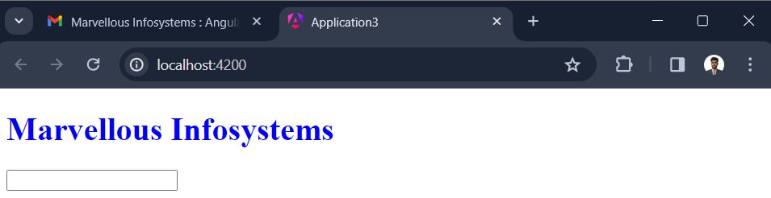

**Question 4:**

Create angular application which will demonstrate the concept of string interpolation. For this purpose create new component named as newComp and render that from app component. Inside that new component add one class property as name .

Display that Name in small case.

Display that Name in Capital case.

Display Name of string.

Dissplay new string sfter concatenation with “Infosystems”.

To Demonstrate the string interpolation create one characteristics in class as “Name” which should be assigned to some string as

Name = “Marvellous”

Now use this charateristics in html file using the concept of string interpolation as {{Name}}

**Output:**

