**Question 1:**

Create Application which contain two components as First and Second, Display Specific yext from both the components. Text of first component should be displayed in red and for second component use blue color.

Follow the same steps as the above application. As we want to specify the colors we have to write the colors specification in appropriate .css file of each component.

**Output :**

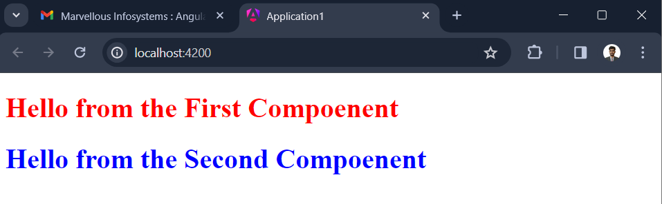

**Question 2:**

Create Angular Application which contain one user defined function inside class named as fun. We have to call that function using string interpolation . That function should return string to string as “Marvellous Infosystems”

Write one public function inside class named as fun() call that function inside {{call}}

**Output :**

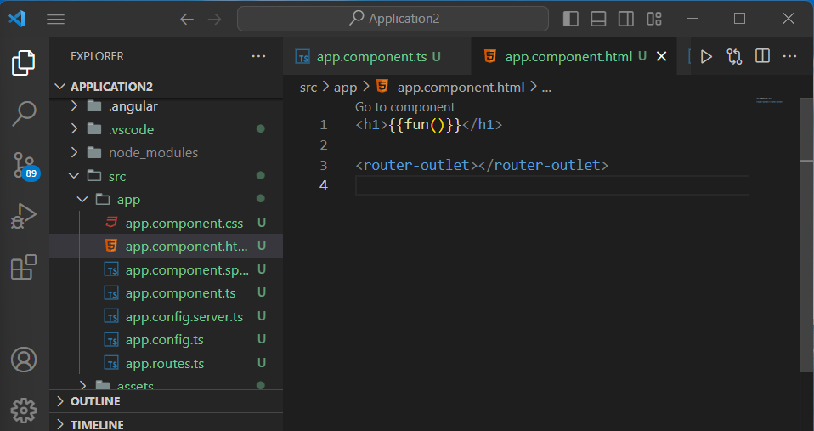

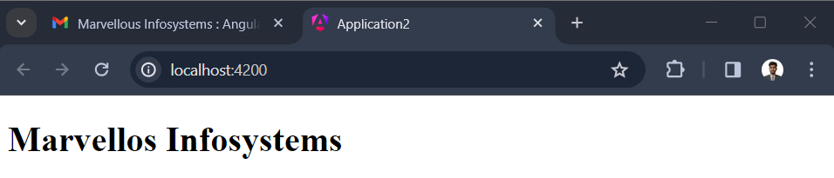

**Question 3:**

Create one angular application which contain one button. When user press that button we have to display some text as “Educating for better tomorrow” otherwise display “Marvellous Innfosystems”.

As we want to handle event of button click we have to use this tag as ( click )= “fun”. In this case inside the fun() function we will change the text.

**Output:**

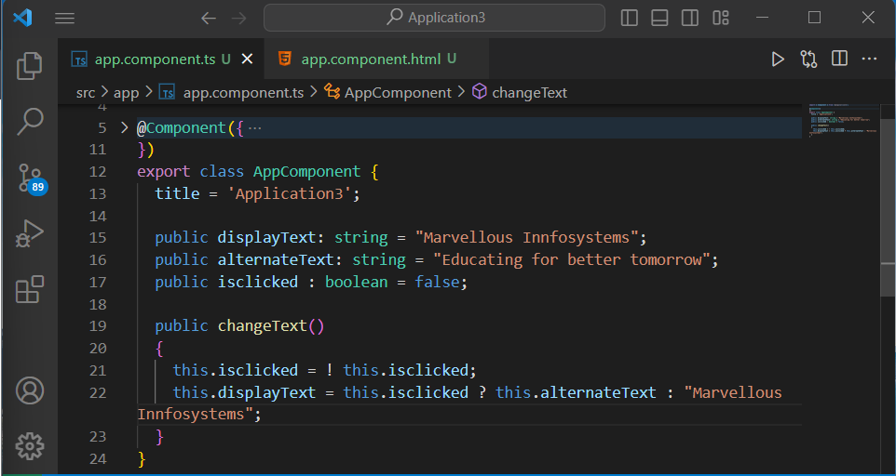

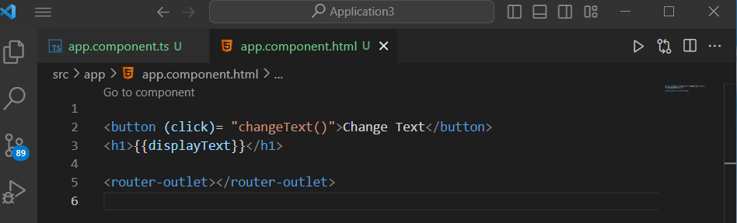

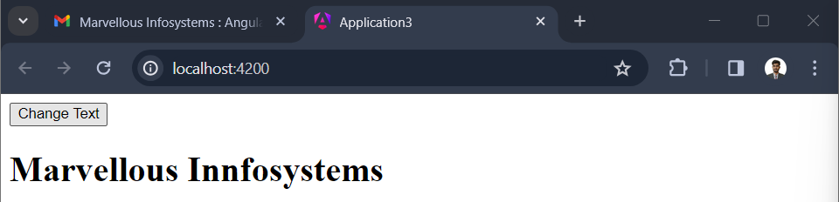

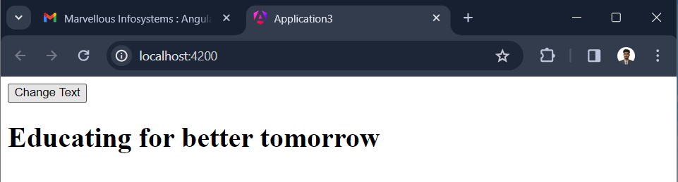

**Question 4 :**

Create angular application which contains two buttons an UPPER and LOWER. When user press UPPER button display Text as “ MARVELLOUS INFOSYSTEMS” and if press LOWER button display text as “marvellous infosystems”. String Should be characteristics of class.

**Output :**



