**Question 1:**

Create application which contains two components as app and child. Child component contains textbox and one button. User enters text in that textbox and when user press the button data from that textbox should be sent to parent component i.e. app. After getting data from child component app component will display the data using string interpolation.

**Output:**

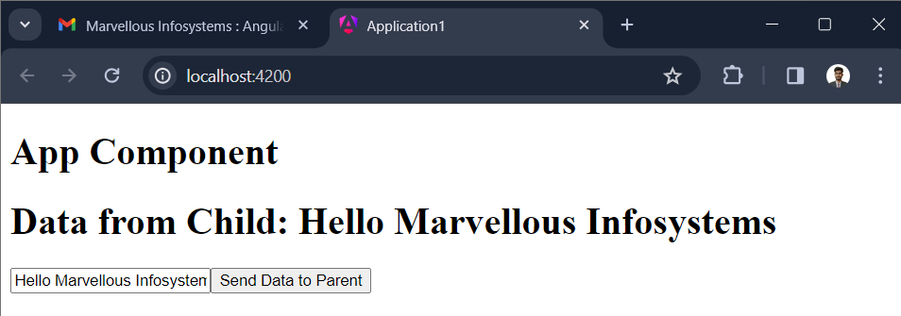

**Question 2:**

Create angular application which contains two component as app and Child. App component send “Hello from Parent” to Child component and Child component send “Hello from Child” to parent component. In this application parent and child component communicate with each other by sending data.

**Output:**

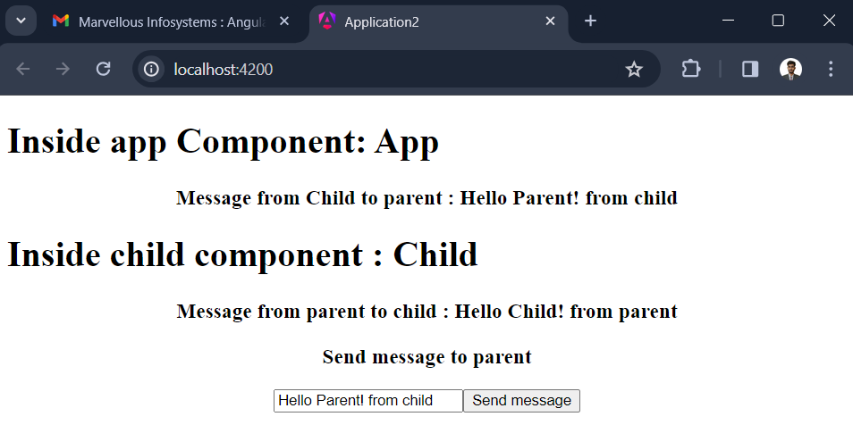

**Question 3:**

Create angular application which contains only one component as app. App component contains one text box . When user enters data in that text box we have to display length of string simultaneously.(Use [(ngModel)] )

**Output:**

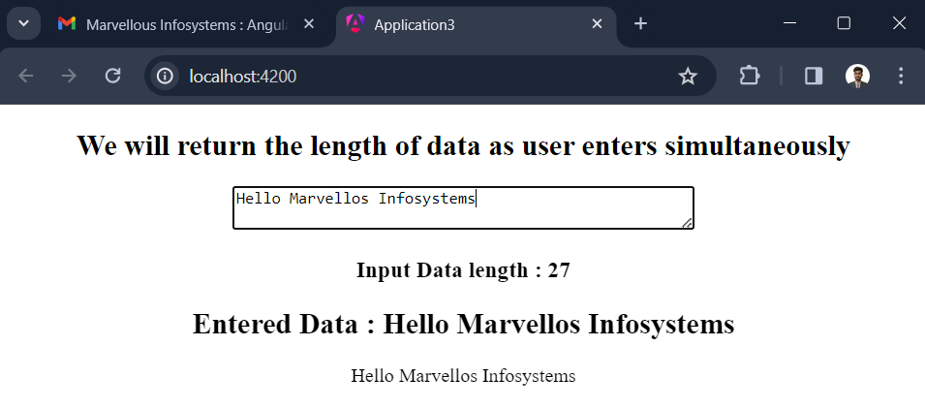

**Question 4:**

Recreate previous application without using ngModel directive . (Use event listener)

**Output:**

