**Question 1:**

Create angular application which creates one custom pipe named as MyRev. This custom pipe accept string as value and display the string reverse format.

**Output :**

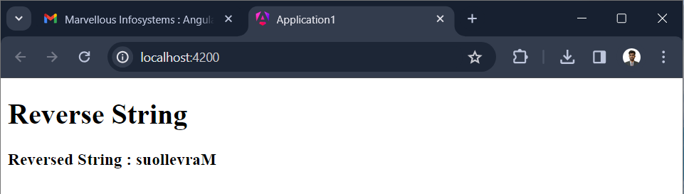

**Question 2:**

Create angular application which creates two custom pipe named as MyAdd and MyMult. MyAdd pipe add two numbers and MyMult is used to multiply two numbers

**Output :**

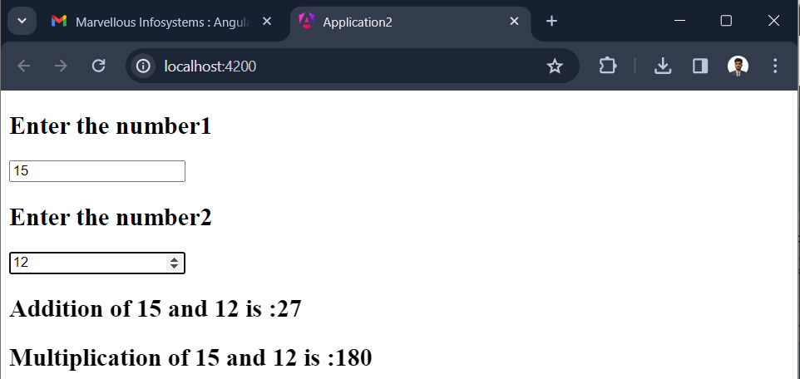

**Question 3:**

Create angular application which creates one custom pipe named as MarvellousChk. This custom pipe accept one integer as value and parameter can be Prime, Perfect, Even, Odd.

Depends on the parameter we have to check status of the number and return the result accordingly

**Output :**

