Name: Tejas C K
SRN: PES2UG23CS647
Section: J
Email ID: tejasck05@gmail.com / pes2ug23cs647@pesu.pes.edu
Mobile Number: 9448081972
Github Link: https://github.com/Tejas-CK/Gen-AI-Hands-on---PES2UG23CS647.git

Assignment 1: Screenshots
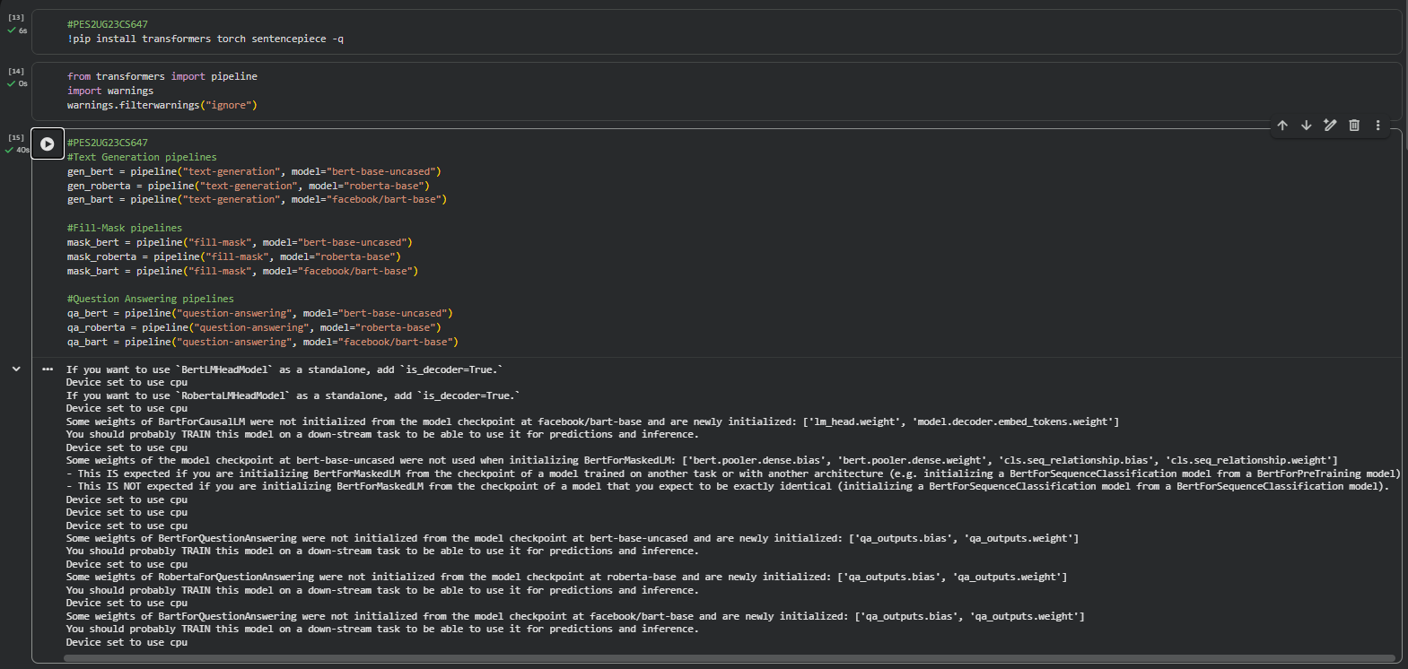

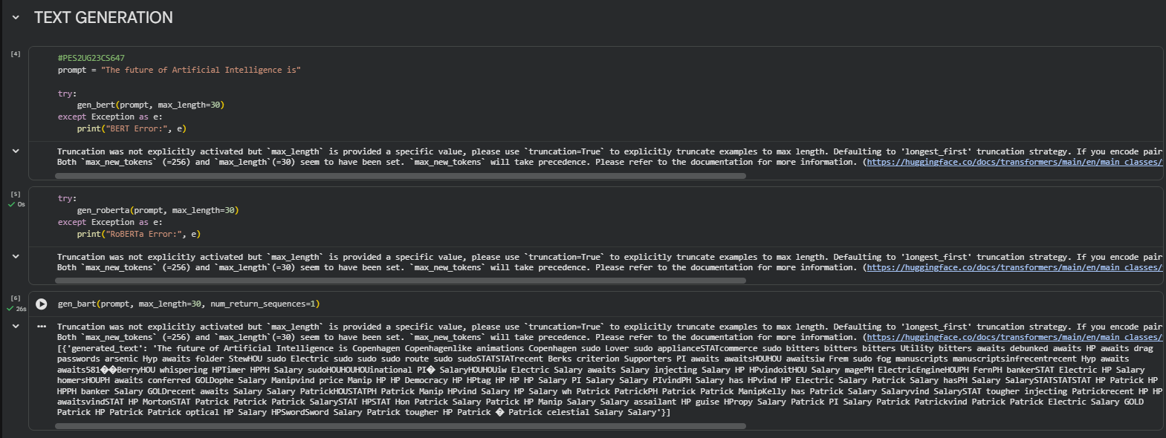

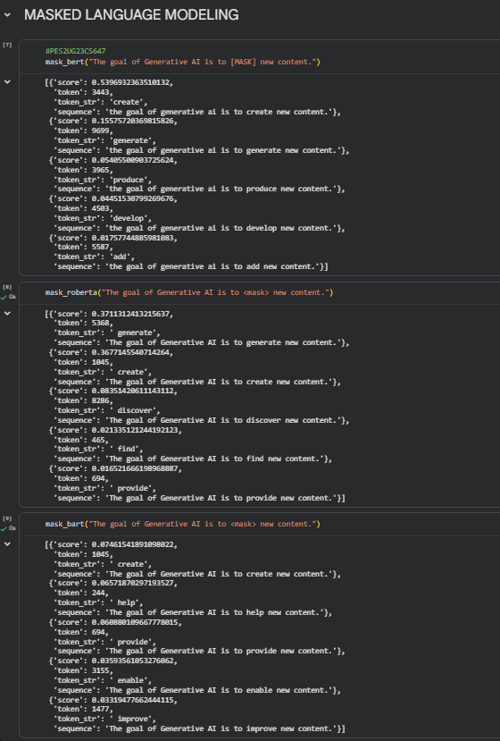

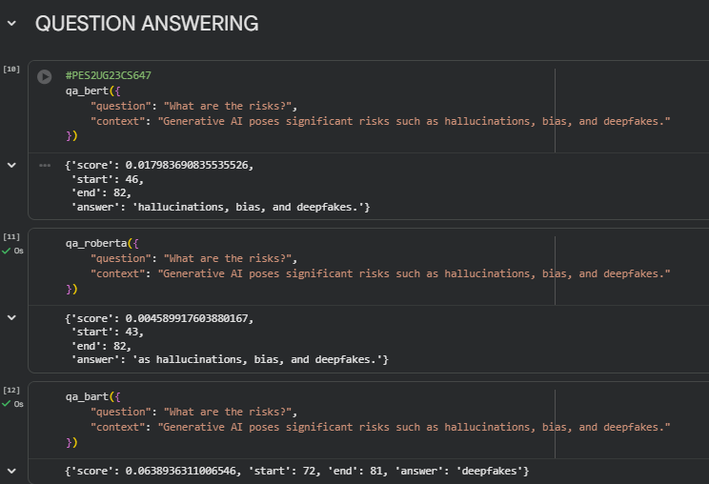

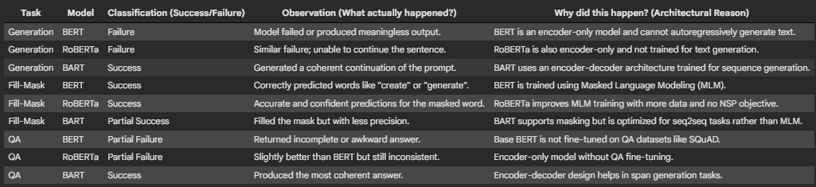

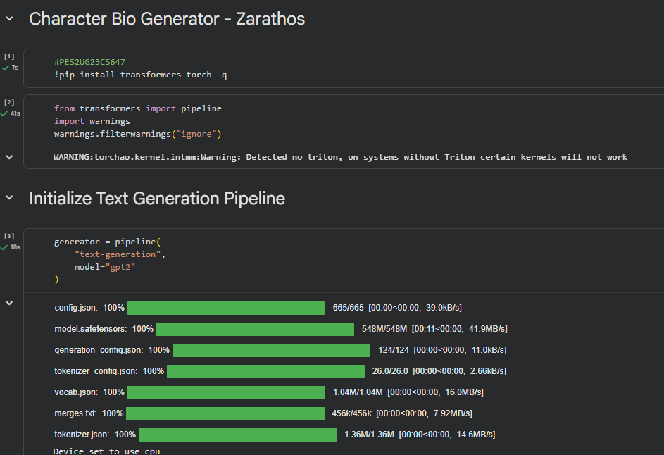
Assignment 2: Screenshots

