Date and Time functions

1. Write a query to display the first day of the month (in datetime format) three

months before the current month.

Sample current date : 2014-09-03

Expected result : 2014-06-01

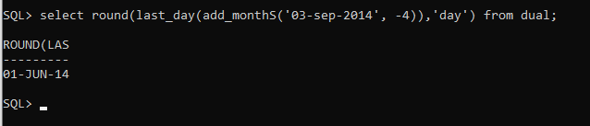

2. Write a query to display the last day of the month (in datetime format) three

months before the current month.

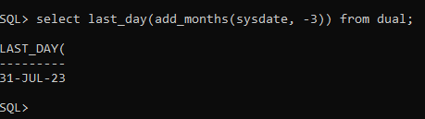

3. Write a query to get the distinct Mondays from hiredate in emp tables.

4. Write a query to get the first day of the current year.

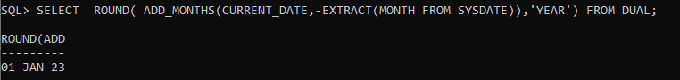

5. Write a query to get the last day of the current year.

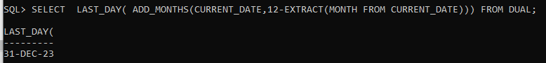

6. Write a query to calculate your age in year.

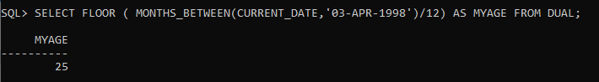

7. Write a query to get the current date in the following format.

Sample date : 04-sep-2014

Output : September 4, 2014

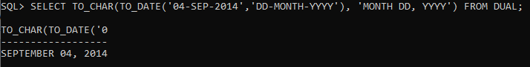

8. Write a query to get the current date in Thursday September 2014 format.

Thursday September 2014

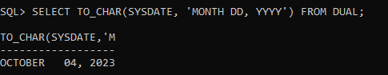

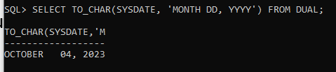

9. Write a query to extract the year from the current date.

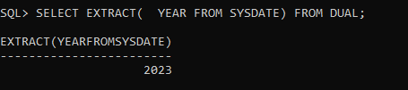

10. Write a query to get the first name and hire date from employees table

where hire date between 1-Jun-87' and '30-jul-87’

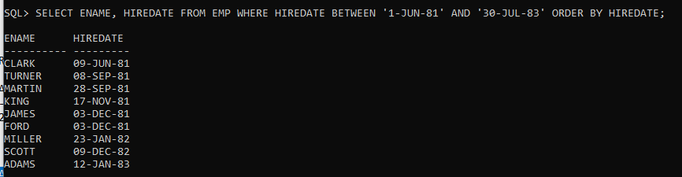

11. Write a query to display the current date in the following format.

Sample output: Thursday 4th September 2014 00:00:00

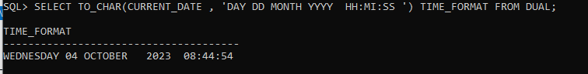

12. Write a query to display the current date in the following format.

Sample output: 05/09/2014

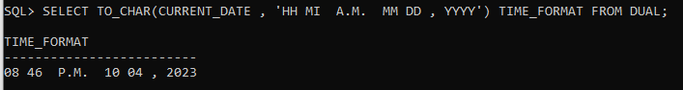

13. Write a query to display the current date in the following format.

Sample output: 12:00 AM Sep 5, 2014



14. Write a query to get the employees who joined in the month of June.

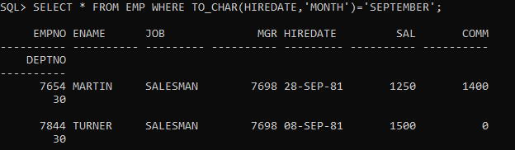

15. Write a query to get the years in which more than 10 employees joined.

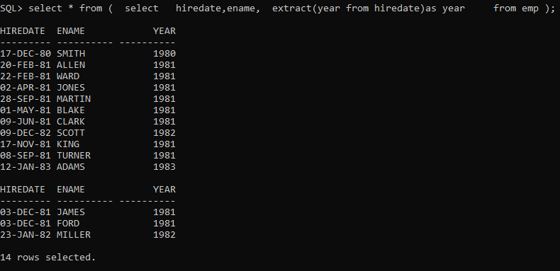

16. Write a query to get first name of employees who joined in 1987.



17. Write a query to get employees whose experience is more than 5 years.

18. Write a query to get employee ID, name, and date, salary of the

employees, display salary with $ symbol and thousand separator.

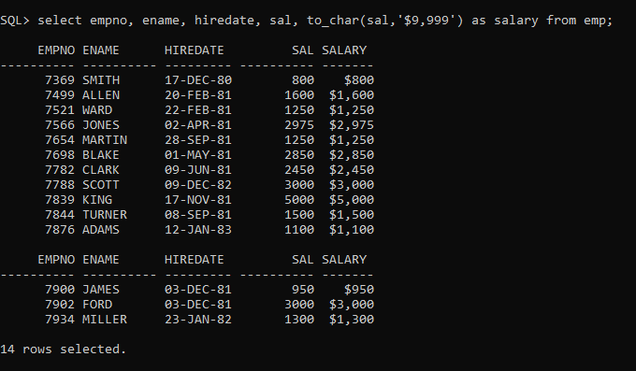

19. Write a query to get name, hire date and experience of the employees.

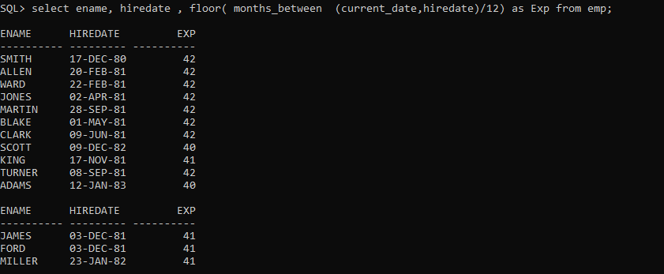

20. Write a query to get the department no, year, and number of employees

joined.

