**Experiment No: 5**

**OUTPUT:**

1. **BUS Topology:**

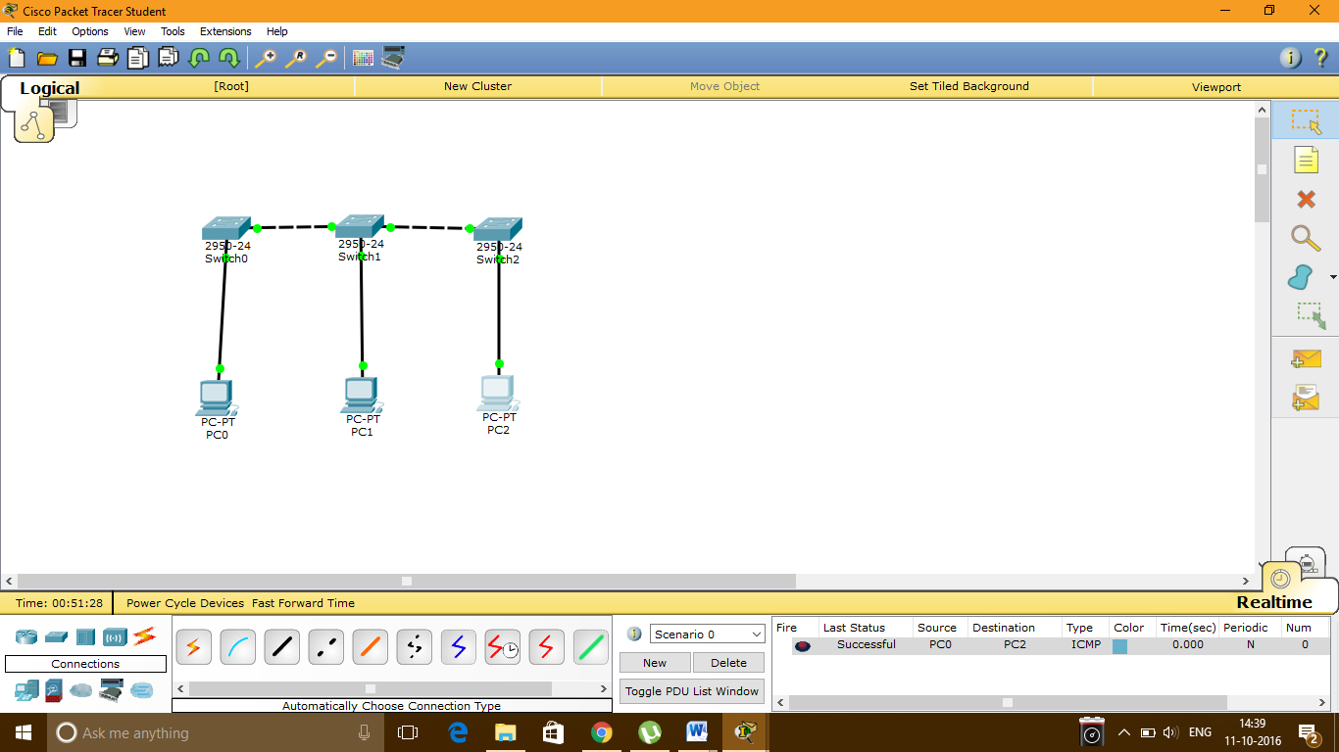

**IP Configuration of PC0:**

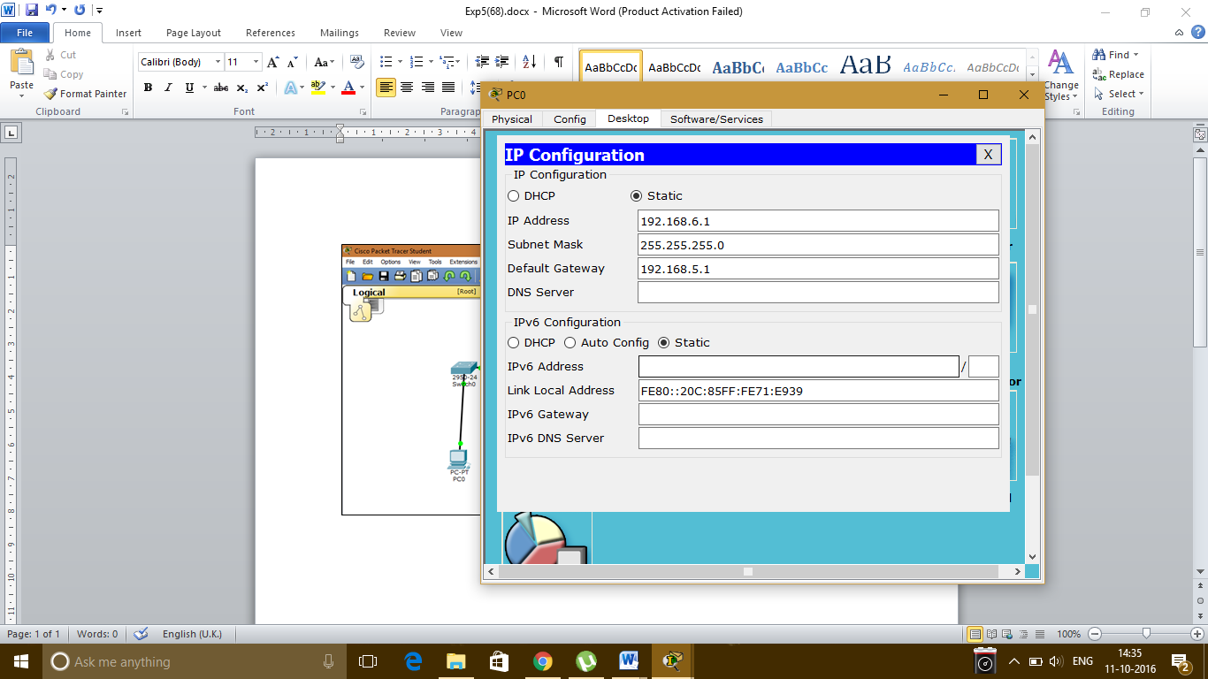

**IP Configuration of PC1:**

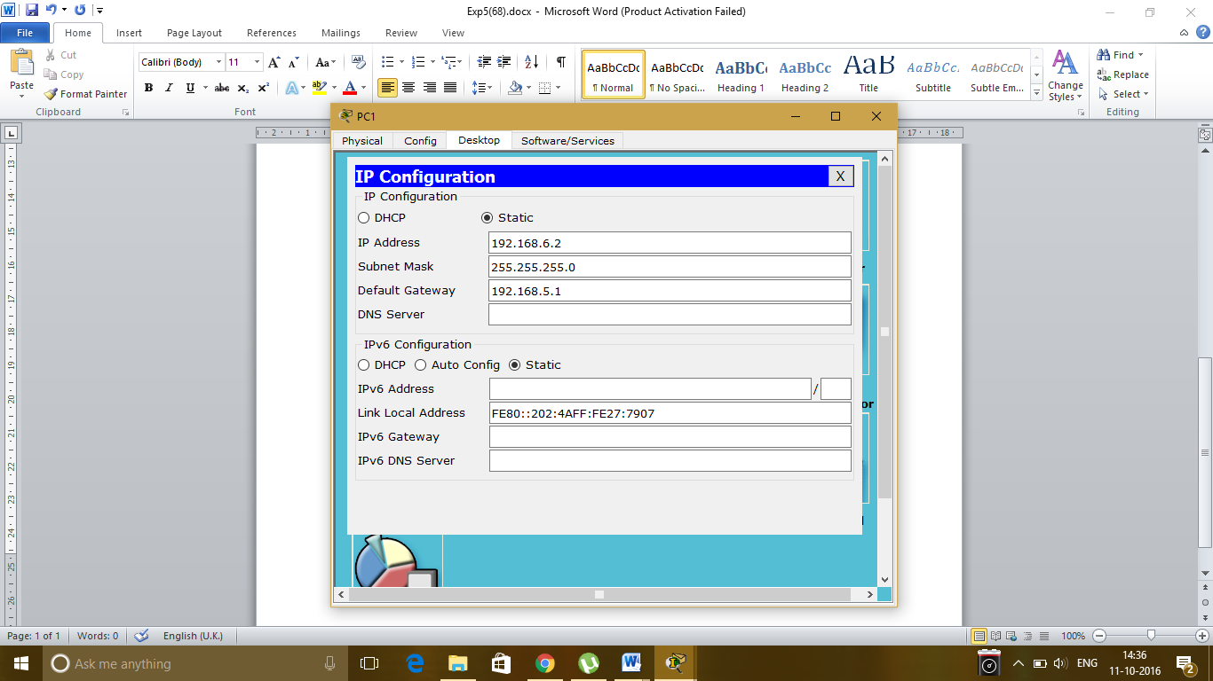

**IP Configuration of PC2:**

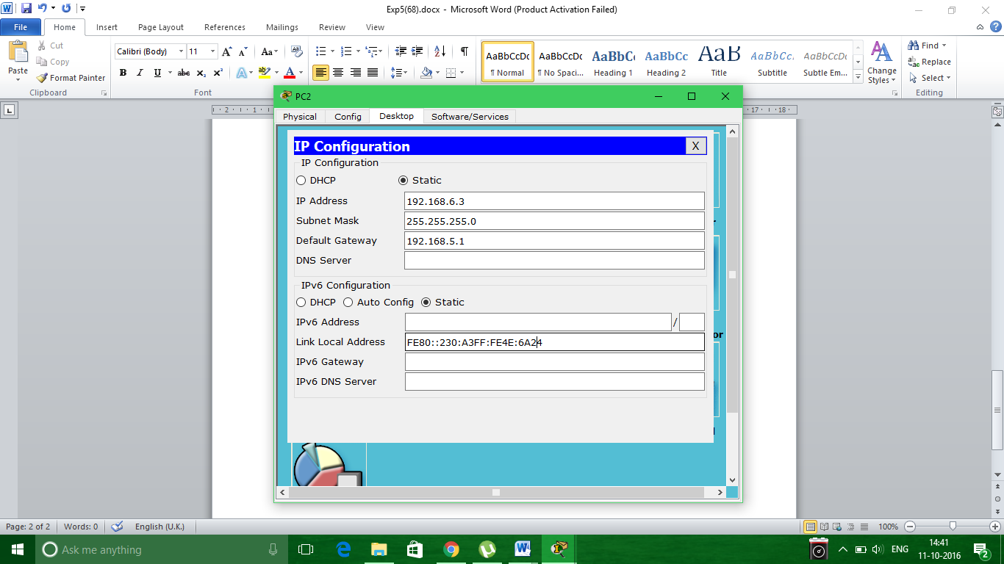

1. **RING Topology:**

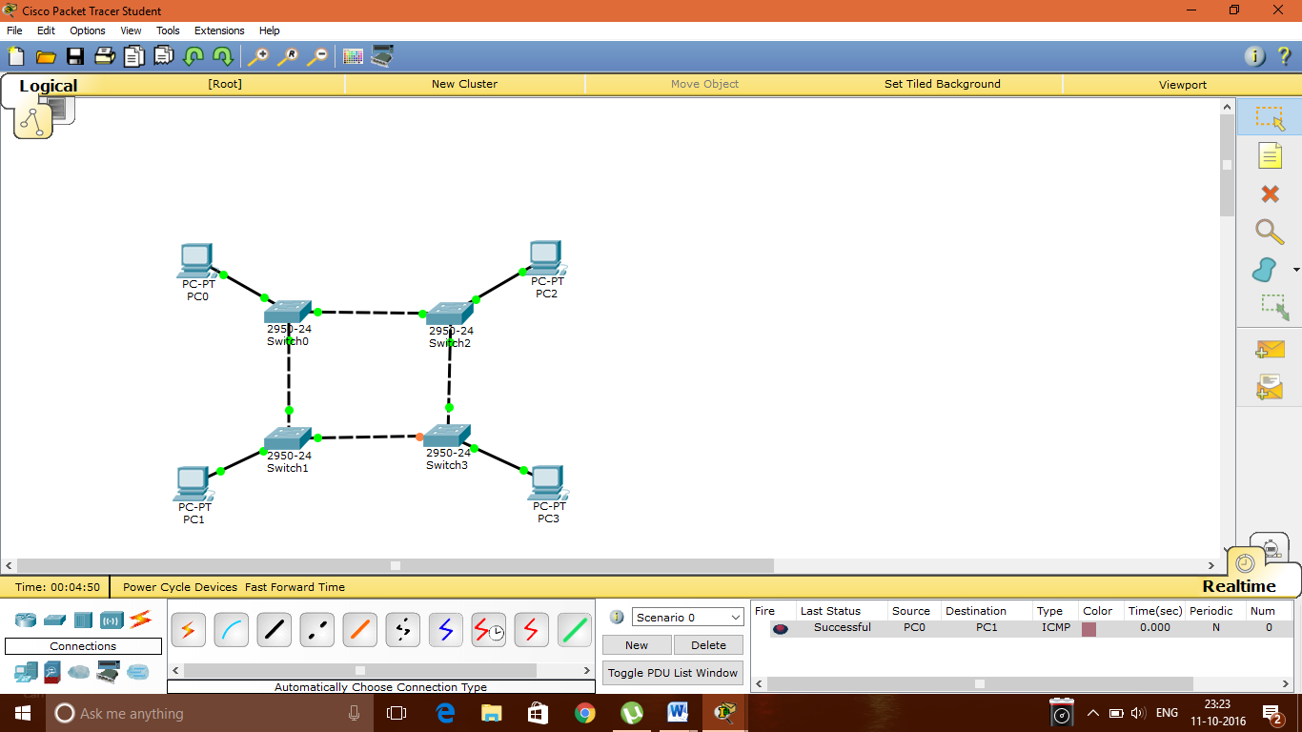

**IP Configuration of PC0:**

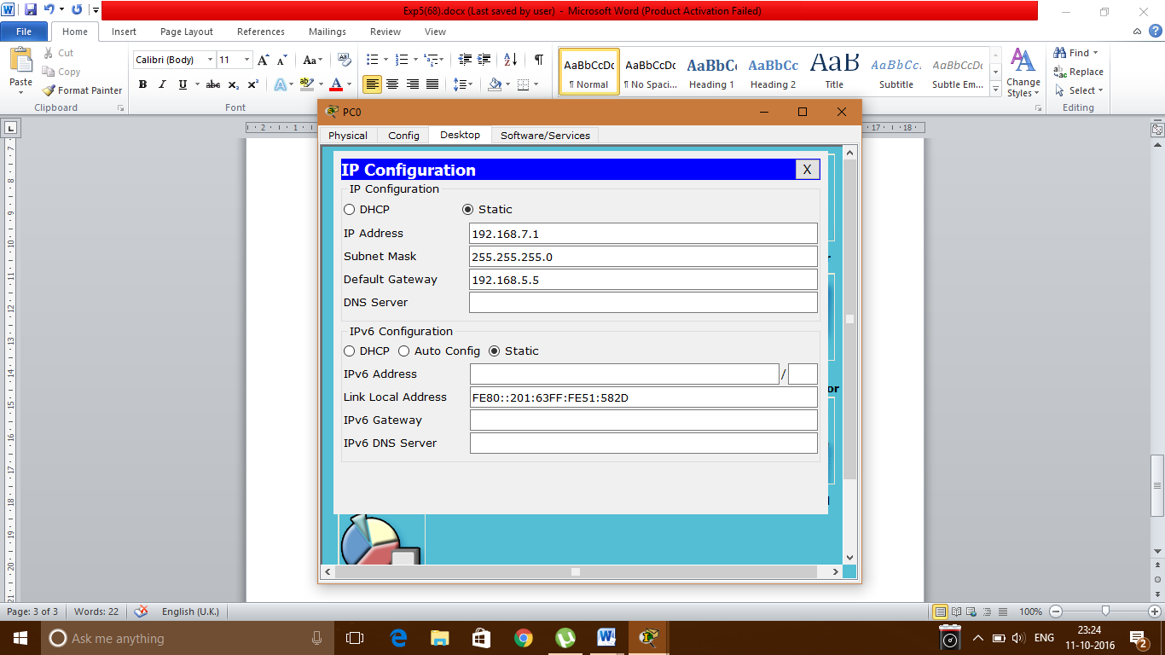

**IP Configuration of PC1:**

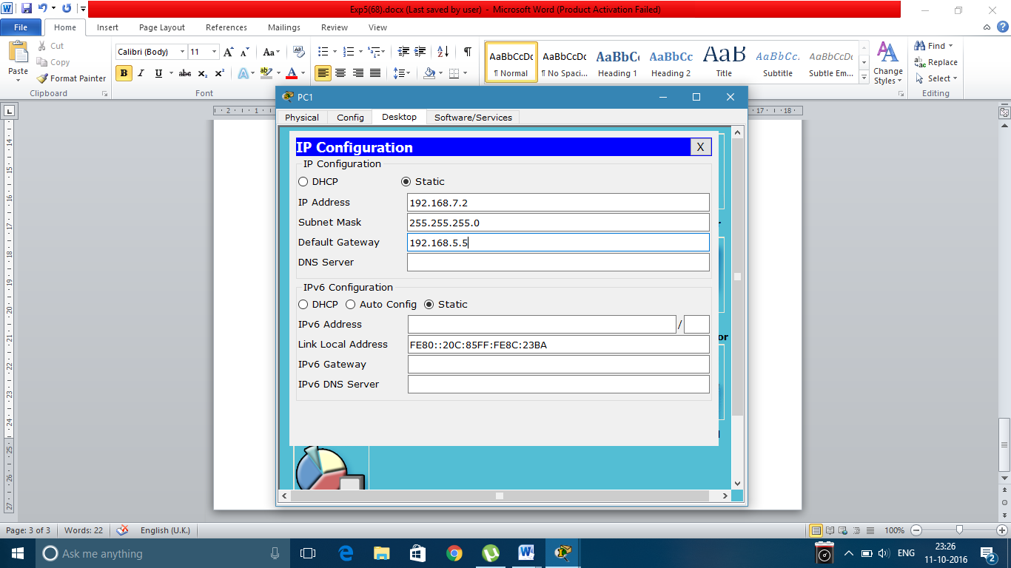

**IP Configuration of PC2:**

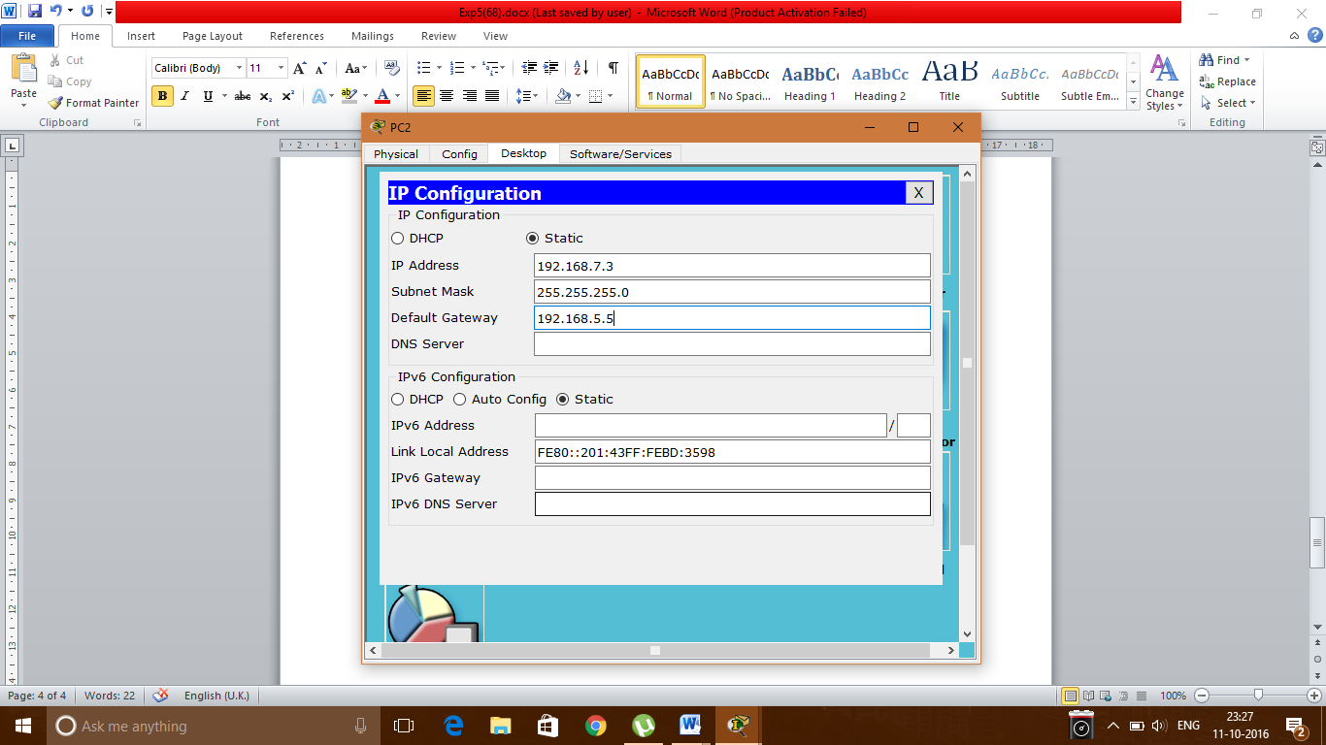

**IP Configuration of PC3:**

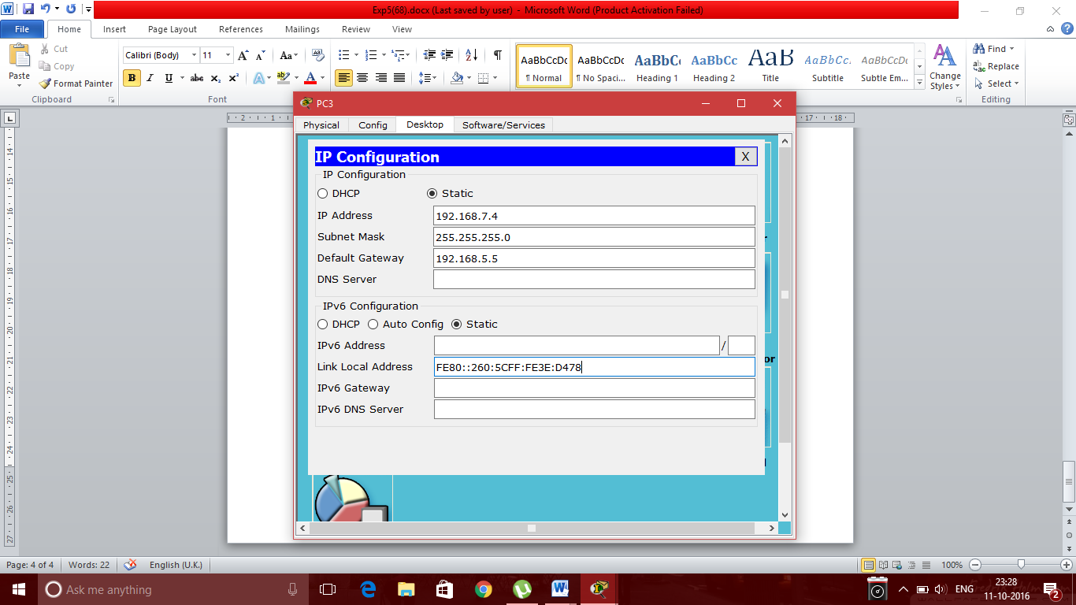

1. **STAR Topology:**

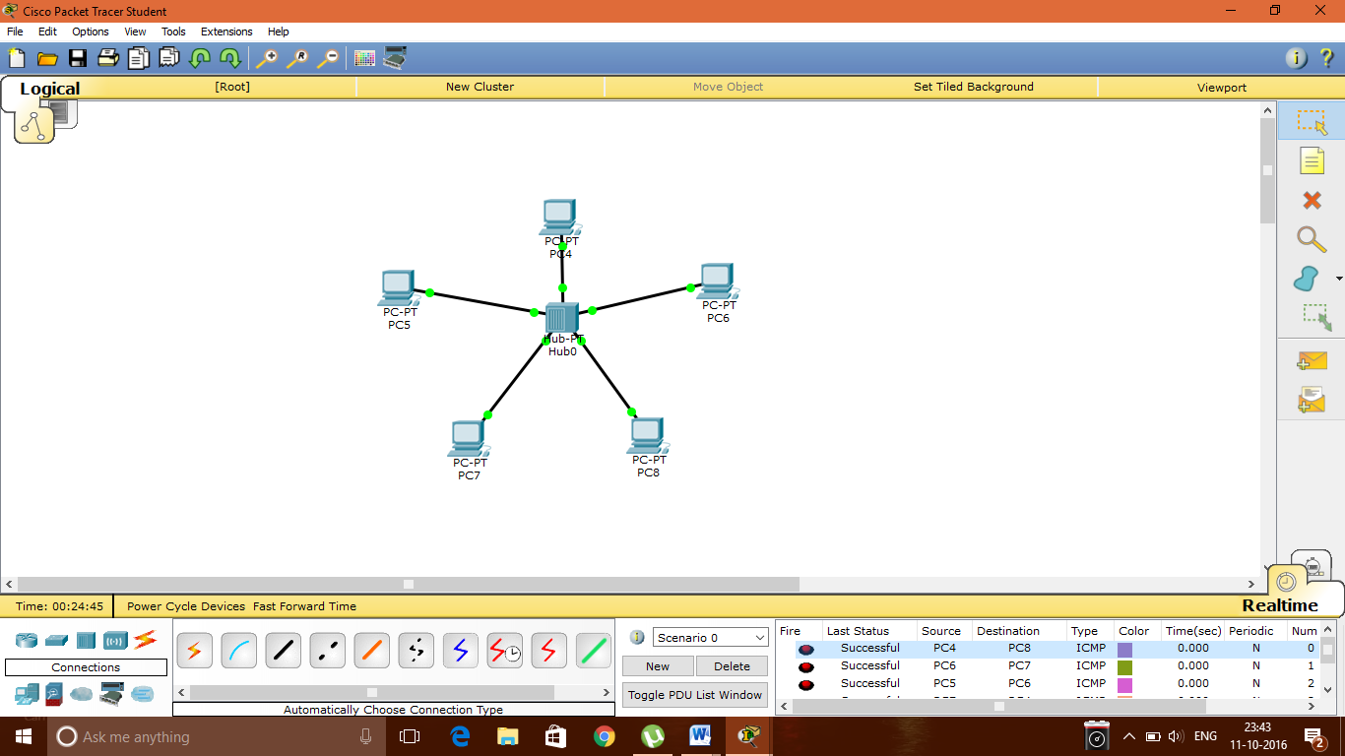

**IP Configuration of PC4:**

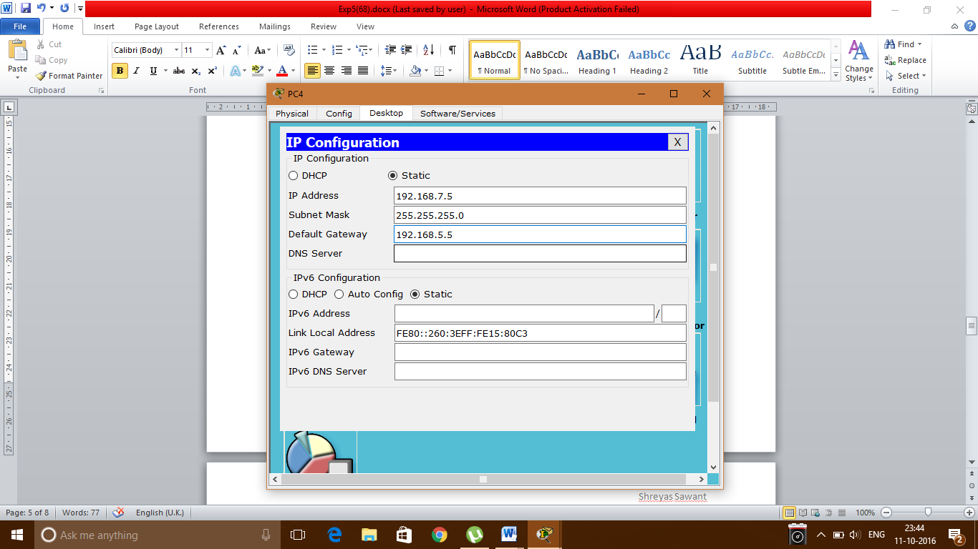

**IP Configuration of PC5:**

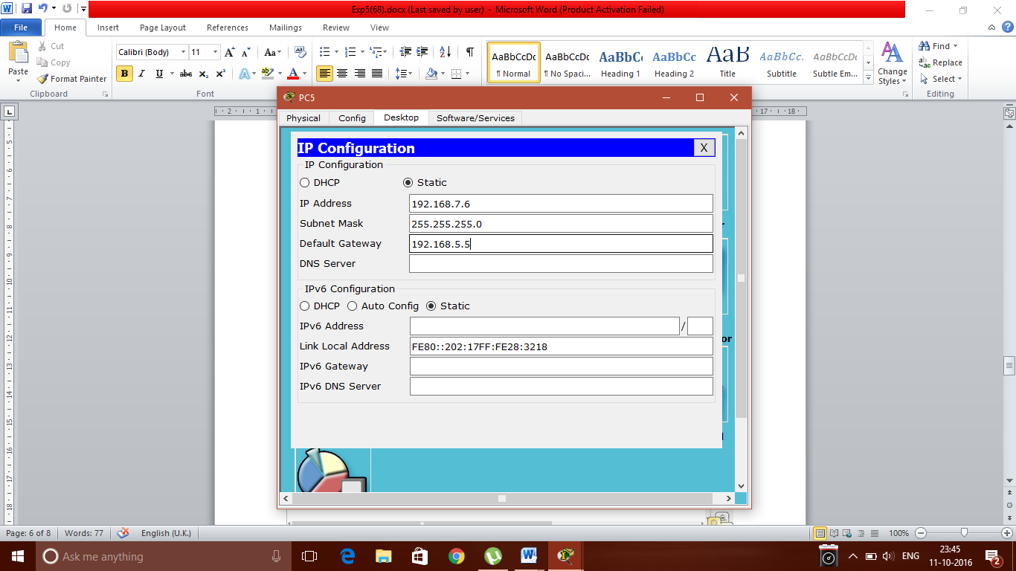

**IP Configuration of PC6:**

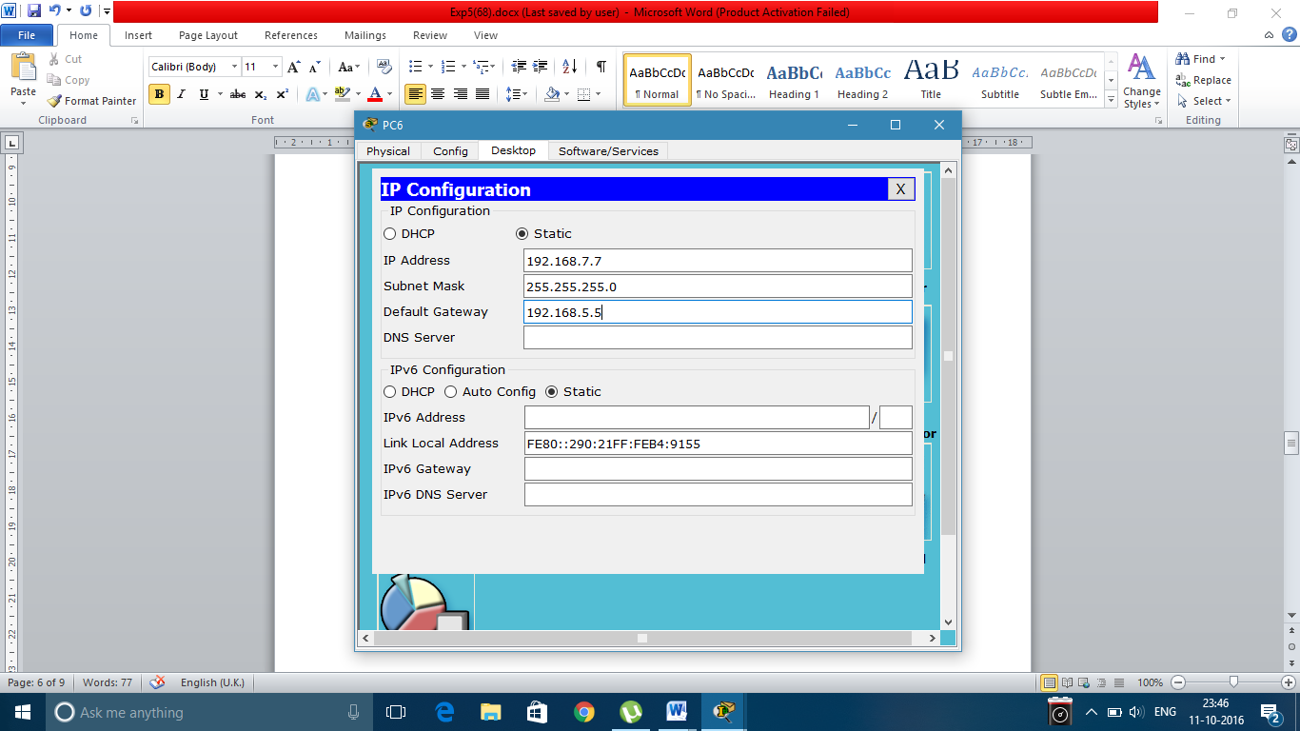

**IP Configuration of PC7:**

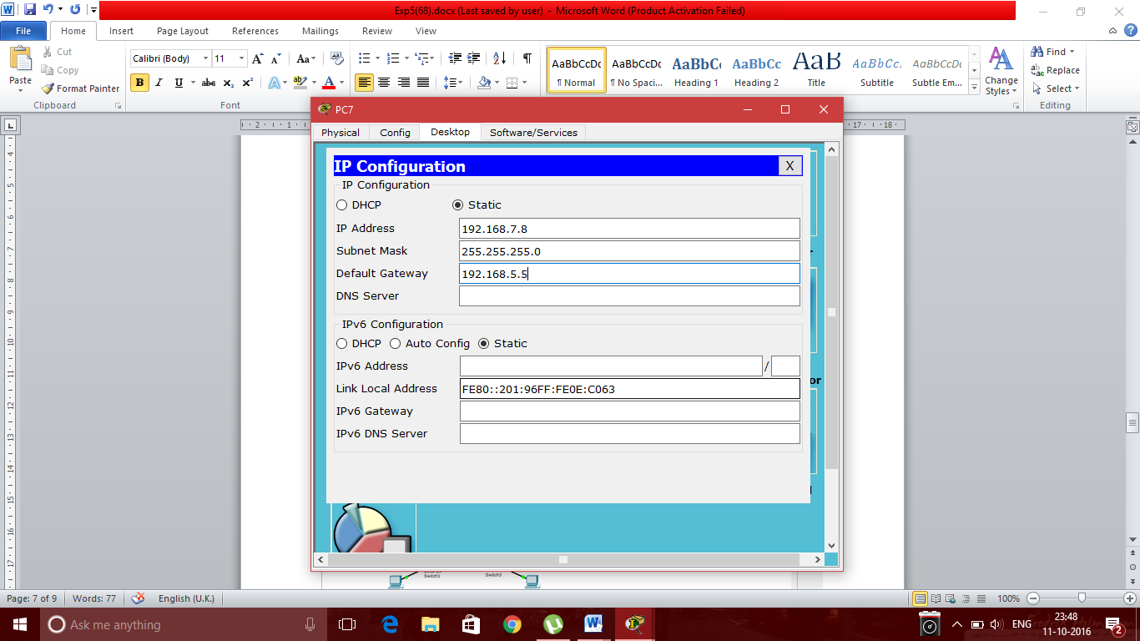

**IP Configuration of PC8:**

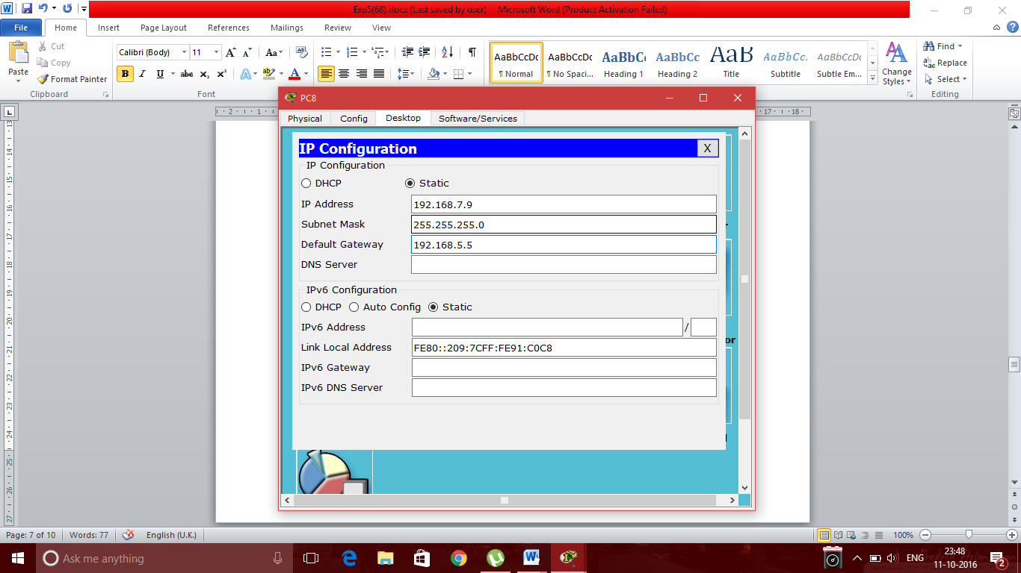

1. **MESH Topology:**

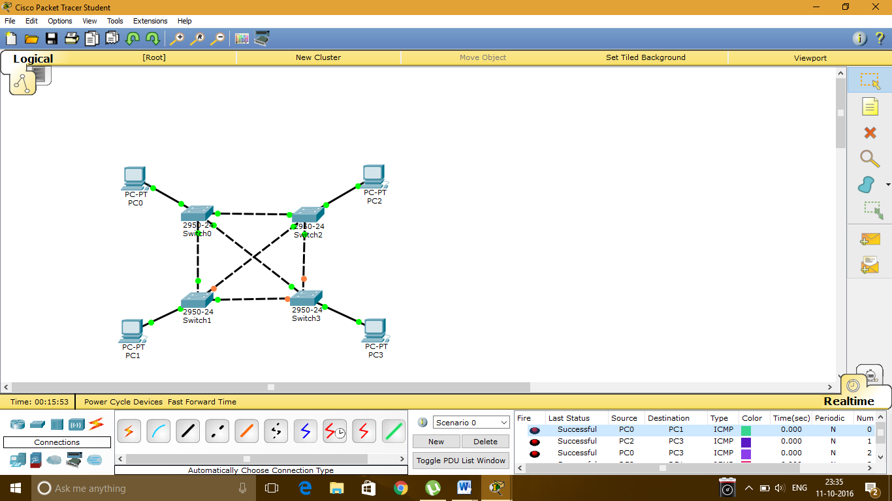

**IP Configuration of PC0:**



**IP Configuration of PC1:**



**IP Configuration of PC2:**



**IP Configuration of PC3:**



**Conclusion:** Thus we have studied and simulated BUS RING STAR and MESH topologies using Packet tracer tool