PRACTICAL 1 TEJAS NALAWADE TCOD 01

BFS.py

Code

from collections import defaultdict, deque
class Graph:
def __init__(self):
# Adjacent List is made for the graph
self.graph = defaultdict(list)

def addEdge(self, u ,v):
self.graph[u].append(v)
def BFS(self, s):
# visited set
visited = set()
# Deque
queue = deque()
visited.add(s)
queue.append(s)

while queue:
s= queue.popleft()
print(s, end=" ")

for i in self.graph[s]:
if i not in visited:
queue.append(i)
visited.add(i)

if __name__ == '__main__':
g = Graph()
g.addEdge(0, 1)
g.addEdge(0, 2)
g.addEdge(1, 2)
g.addEdge(2, 4)
g.addEdge(1, 3)
g.addEdge(3, 4)

print("BFS from vetex 2")
g.BFS(0)

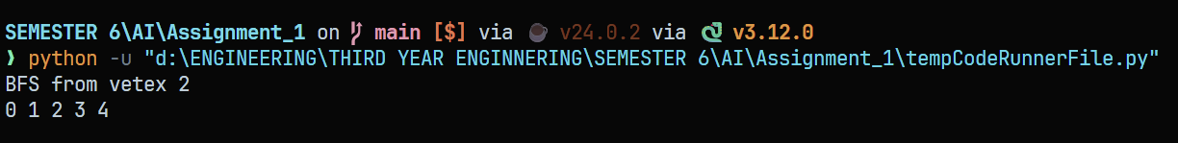
OUTPUT

DFS.py

Code

from collections import defaultdict
class Graph:
def __init__(self):
self.graph = defaultdict(list)

def add_edge(self, u, v):
self.graph[u].append(v)

def dfs_util(self, v, visited):
visited.add(v)
print(v, end=' ')

for neighbour in self.graph[v]:
if neighbour not in visited:
self.dfs_util(neighbour, visited)

def dfs(self, v):
visited = set()

self.dfs_util(v, visited)

if __name__ == "__main__":
g = Graph()
g.add_edge(0, 1)
g.add_edge(0, 2)
g.add_edge(1, 2)
g.add_edge(2, 0)
g.add_edge(2, 3)
g.add_edge(3, 3)

print("DFS from vertex 2:")
g.dfs(2)

OUTPUT :

