**Assignment No.2**

**Title:** Demonstrate the different types of topologies and types of transmission media by using a packet tracer tool.

**Theory:**

**Different Types of Transmission Media**

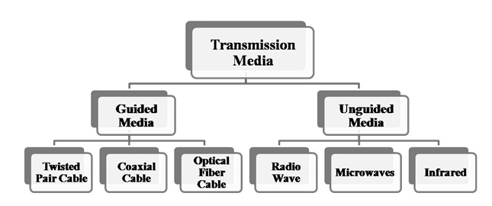

## Twisted Pair Cable

Copper wires are the most common wires used for transmitting signals because of good performance at low costs. They are most commonly used in telephone lines. However, if two or more wires are lying together, they can interfere with each other’s signals. To reduce this electromagnetic interference, pair of copper wires are twisted together in helical shape like a DNA molecule. Such twisted copper wires are called **twisted pair**. To reduce interference between nearby twisted pairs, the twist rates are different for each pair.

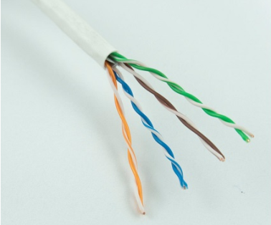

Up to 25 twisted pair are put together in a protective covering to form twisted pair cables that are the backbone of telephone systems and Ethernet networks.

Shielding twisted pair cable

To counter the tendency of twisted pair cables to pick up noise signals, wires are shielded in the following three ways −

* Each twisted pair is shielded.
* Set of multiple twisted pairs in the cable is shielded.
* Each twisted pair and then all the pairs are shielded.

Such twisted pairs are called **shielded twisted pair (STP) cables**. The wires that are not shielded but simply bundled together in a protective sheath are called **unshielded twisted pair (UTP) cables**. These cables can have maximum length of 100 metres.

Shielding makes the cable bulky, so UTP are more popular than STP. UTP cables are used as the last mile network connection in homes and offices.

Coaxial Cable

**Coaxial cables** are copper cables with better **shielding** than twisted pair cables, so that transmitted signals may travel longer distances at higher speeds. A coaxial cable consists of these layers, starting from the innermost −

* Stiff copper wire as **core**
* **Insulating material** surrounding the core
* Closely woven braided mesh of **conducting material** surrounding the **insulator**
* Protective **plastic sheath** encasing the wire

Coaxial cables are widely used for **cable TV** connections and **LANs**.

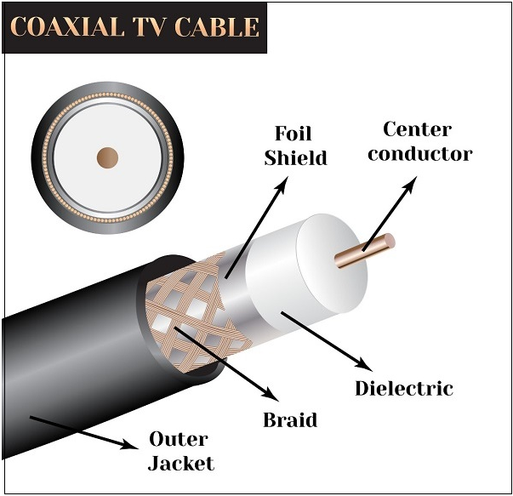

Optical Fibre

Thin glass or plastic threads used to transmit data using light waves are called **optical fibre**. Light Emitting Diodes (LEDs) or Laser Diodes (LDs) emit light waves at the **source**, which is read by a **detector** at the other end. **Optical fibre cable** has a bundle of such threads or fibres bundled together in a protective covering. Each fibre is made up of these three layers, starting with the innermost layer −

* **Core** made of high quality **silica glass** or **plastic**
* **Cladding** made of high quality **silica glass** or **plastic**, with a lower refractive index than the core
* Protective outer covering called **buffer**

Note that both core and cladding are made of similar material. However, as **refractive index** of the cladding is lower, any stray light wave trying to escape the core is reflected back due to **total internal reflection**.



Optical fibre is rapidly replacing copper wires in telephone lines, internet communication and even cable TV connections because transmitted data can travel very long distances without weakening. **Single node** fibre optic cable can have maximum segment length of 2 kms and bandwidth of up to 100 Mbps. **Multi-node** fibre optic cable can have maximum segment length of 100 kms and bandwidth up to 2 Gbps.

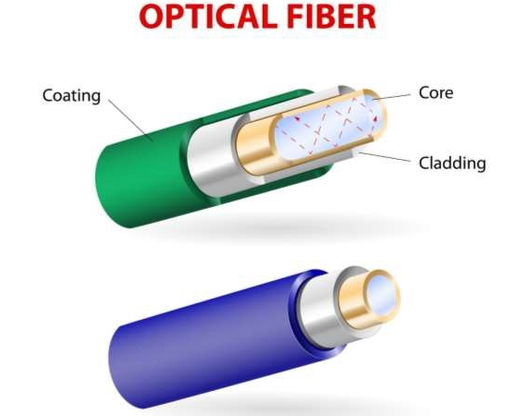

Infrared

Low frequency infrared waves are used for very short distance communication like TV remote, wireless speakers, automatic doors, hand held devices etc. Infrared signals can propagate within a room but cannot penetrate walls. However, due to such short range, it is considered to be one of the most secure transmission modes.

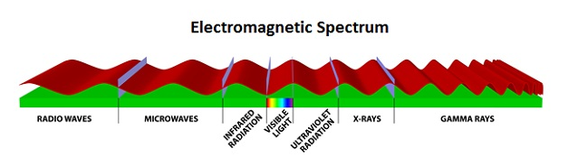

Radio Wave

Transmission of data using radio frequencies is called **radio-wave transmission**. We all are familiar with radio channels that broadcast entertainment programs. Radio stations transmit radio waves using **transmitters**, which are received by the receiver installed in our devices.

Both transmitters and receivers use antennas to radiate or capture radio signals. These radio frequencies can also be used for **direct voice communication** within the **allocated range**. This range is usually 10 miles.

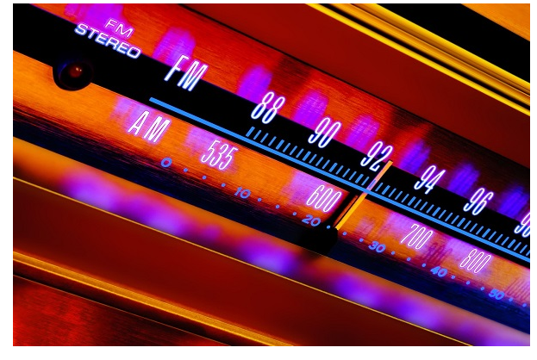

## What is Topology?

Network topologies describe the methods in which all the elements of a network are mapped. The topology term refers to both the physical and logical layout of a network.

Different types of Physical Topologies are:

* P2P Topology
* Bus Topology
* Ring Topology
* Star Topology
* Tree Topology
* Mesh Topology
* Hybrid Topology

## Point to Point

Point-to-point topology is the easiest of all the network topologies. In this method, the network consists of a direct link between two computers.

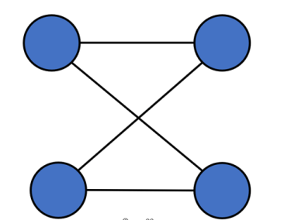

P2P Topology Diagram

## Bus Topology

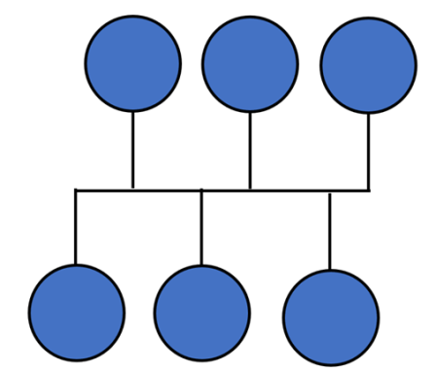

Bus Topology Diagram

Bus topology uses a single cable which connects all the included nodes. The main cable acts as a spine for the entire network. One of the computers in the network acts as the computer server. When it has two endpoints, it is known as a linear bus topology.

**Ring Topology**

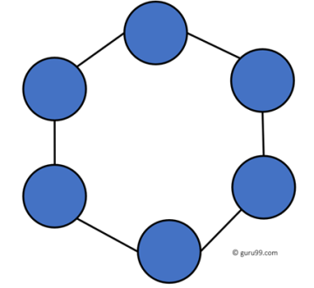

Ring Topology Diagram

In a ring network, every device has exactly two neighboring devices for communication purpose. It is called a ring topology as its formation is like a ring. In this topology, every computer is connected to another computer. Here, the last node is combined with a first one.

This topology uses token to pass the information from one computer to another. In this topology, all the messages travel through a ring in the same direction.

**Star Topology**

In the star topology, all the computers connect with the help of a hub. This cable is called a central node, and all other nodes are connected using this central node. It is most popular on LAN networks as they are inexpensive and easy to install.

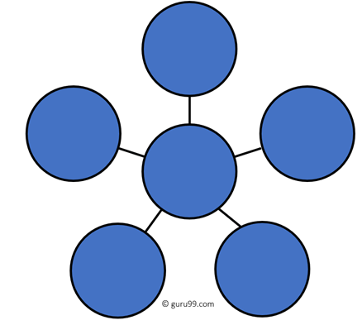

## Mesh Topology

The mesh topology has a unique network design in which each computer on the network connects to every other. It is develops a P2P (point-to-point) connection between all the devices of the network. It offers a high level of redundancy, so even if one network cable fails, still data has an alternative path to reach its destination.

### Types of Mesh Topology:

* **Partial Mesh Topology:**In this type of topology, most of the devices are connected almost similarly as full topology. The only difference is that few devices are connected with just two or three devices.
* **Full Mesh Topology:**In this topology, every nodes or device are directly connected with each other.

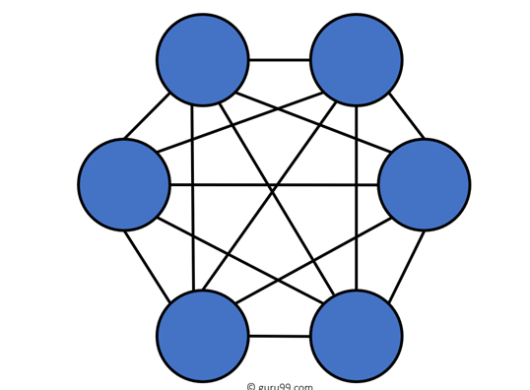

## Tree Topology

Tree topologies have a root node, and all other nodes are connected which form a hierarchy. So it is also known as hierarchical topology. This topology integrates various star topologies together in a single bus, so it is known as a Star Bus topology. Tree topology is a very common network which is similar to a bus and star topology.

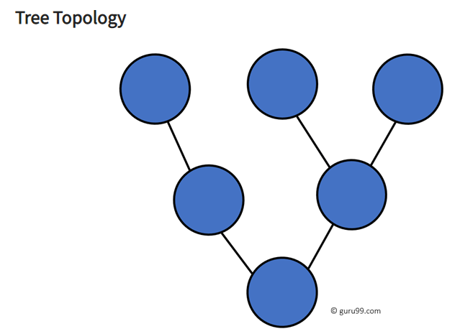

## Hybrid Topology

Hybrid topology combines two or more topologies. You can see in the above architecture in such a manner that the resulting network does not exhibit one of the standard topologies.

For example, as you can see in the above image that in an office in one department, Star and P2P topology is used.A hybrid topology is always produced when two different basic network topologies are connected.

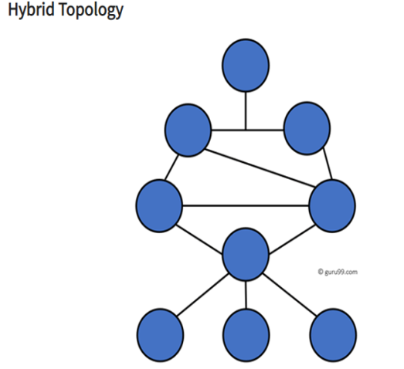

## How to select a Network Topology?

Here are some important considerations for selecting the best topology to create a network in your organization:

* Bus topology is surely least expensive to install a network.
* If you want to use a shorter cable or you planning to expand the network is future, then star topology is the best choice for you.
* Fully mesh topology is theoretically an ideal choice as every device is connected to every other device.
* If you want to use twisted pair cable for networking, then you should build star topologies.

### Cisco Packet Tracer Tool

It is a specialized tool developed by **Cisco Systems**. It allows the construction, visualization and simulation of various practical implementations involved in the field of **Computer Networking**.

**Cisco Packet Tracer**provides different tools for constructing and simulating *Networking Concept*scenarios.

User interface provides different tabs. Each tab contains different tools. You can easily drag and drop these devices on to the drawing area. From tools menu you can find a variety of tools. Each of these tools will help you in building and simulating your practical scenario. *Cisco Packet Tracer* provides the following tools:

* Different types of **Network Cables**
* **Server**, **Client**, **Desktop Computers**and **Laptops**
* Various Cisco System **Switches**, **Hubs** and other **Network Devices**

One of the major advantage of *Cisco Packet Tracer* is that its cross-platform compatability. You can use it on any **Operating Systems**including **Android**and **iOS** Students enrolled in [Cisco Certified Network Associate (CCNA) Program](https://en.wikipedia.org/wiki/CCNA) get it perfectly free of cost.

However, for commercial and professional use you have to pay considerable fee for using it. For this tutorial, all you need is just to **Download and Install Cisco Packet Tracer**.

Before beginning this assignment you should fulfill following requirements:

1. **Download and Install Cisco Packet Tracer**
2. **Run Cisco Packet Tracer**

### How to Make Ring Topology in Cisco Packet Tracer?

### In Ring Topology connects the Network Devices in a completely closed path. This closed path can be in any form like circle, triangle, square or whatever else. So, whenever we connect Network Nodes like Computers and other Types of Network Nodes in the Ring Topology Configuration, we can say that our Computer Network is actually a Ring Network.

### Step1: Place Computers on Drawing Area

In this step you will need to place *Computers*or *Computing Devices*on the main drawing area. You can find *Computers*easily in the tools menu (bottom left corner). In the tools menu, find **‘End Devices’**option to find *Computing Devices*. There are plenty of *end devices* like *Server*, *Laptop*, *Desktop*, *Tablet PC*and many more that you can use. Click on the *end device*you want to use. After clicking on the device place your pointer on the drawing area. After that click again. You will see clearly that device is placed on the drawing area. Repeat this same process for placing any number of *end devices*you want.

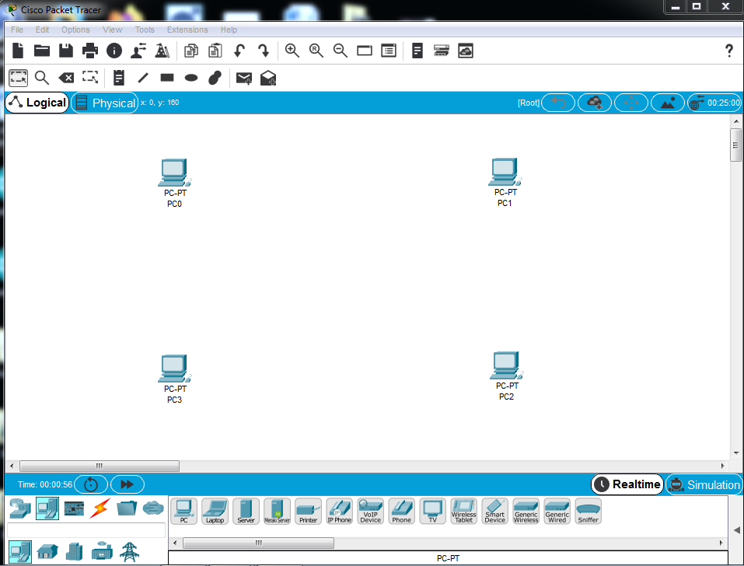

### Step2: Draw Switches on Drawing Area

You can`t connect *computers*directly with each other. You obviously need an intermediate device that will serve this purpose. There are variety of options available in *Cisco Packet Tracer Toolbox*. For example, you have separate sections labelled as **Routers**, **Switches**, **Hubs** and **Wireless Devices** in the tools menu. Each of these devices have specialized usage. *Hub*and *Switch*are two suitable devices for making *Ring Topology Network in Cisco Packet Tracer*. Now, draw four *Switch Devices*from the tools menu using the same process you used while drawing *computers*.

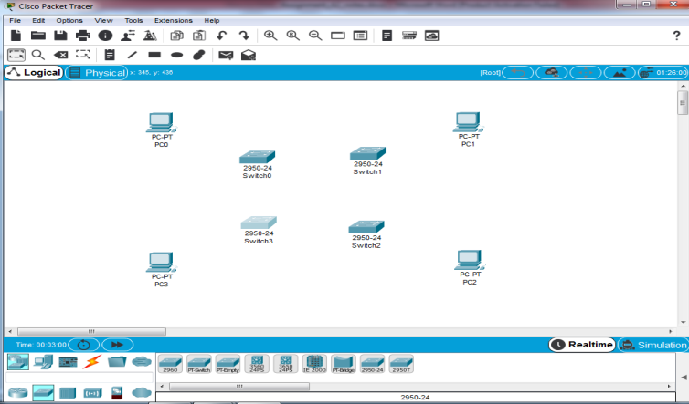

### Step3: Create Communication Links

So far we have just placed *Computers* and *Switches*. It is is evident from picture that there is no *Communication Channel* between these devices. For communication to occur, we must have a proper *communication link*or *channel*. In this step we will be creating *communication link*between each pair of *computer*and its corresponding *switch*. We will connect PC0 with Switch0, PC1 with Switch1 and so on.  I will use standard **Un-shielded Twisted Pair (UTP) Cable**or **Ethernet Cable**for this purpose. In order to find *Ethernet Cable* go to icon labelled as **‘Connections’** in *Cisco Packet Tracer Tools Menu*. There are plenty of cable types in this menu. However, you will not any cable named *Ethernet* *Cable*. In *Packet Tracer*, an *Ethernet Cable* is named as **‘Copper Cable’**. Moreover, you will find two options for this cable type:

1. **Straight-Trough**
2. **Cross-Over**

* **Copper Straight-Through Cable**is used to connect different devices. If you want to connect a *computer*and *switch*, you will use this type of cable. *Cisco Packet Tracer*labels this type in the form of a strong  black colored line.
* **Cross-Over Copper Cable** connects same devices. For connecting one *Switch*to another one, you will use this type of cable. A dashed black line represents this type of cable.

For creating a working *Ring Topology in Cisco Packet Tracer*we need following two types of connections:

1. Connection between a *Computer*and *Switch*via *Straight-Through Cable*
2. Connection among *Switches*using *Cross-Over Cable*

#### Connect Computer to Switch

1. Select *Ethernet Straight-Through* from *Cisco Packet Tracer Tool Menu*. This is easily done by clicking on the designated cable icon.
2. After selecting cable type, move to drawing area. Click on the *Computer*and you will be able to see option menu. As we are working with *Ethernet Cable*so we will select **Fast Ethernet**from the menu. You will be able to see a black colored line along-with mouse pointer.
3. Move mouse pointer to extend line up to *Switch*where you want to connect *Computer*and click on it. Again you will see the same menu as before. But this time you will see multiple options. However, each option labeling will be **Fast Ethernet**. Each option represents a *Port of* *Switch*. You can connect cable to any *port* you want.
4. Repeat this process and connect each pair of *Computer*and corresponding *Switch*. If you carefully follow these steps, your *Network*will look like following one.

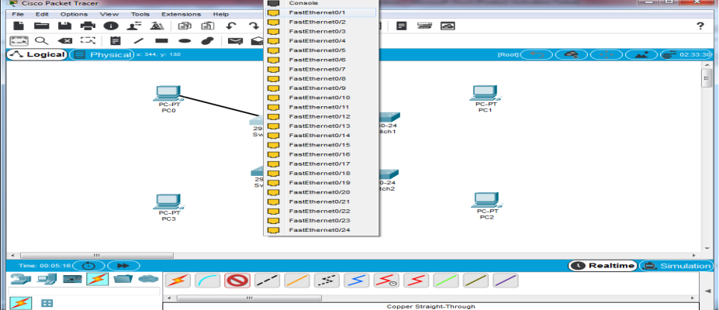

#### Connect Switches

Still our *Ring Topology Network*is looking incomplete. Now, this is time to connect *Switches*together. You can use the following steps to accomplish this task.

1. Select *Ethernet Cross-Over Cable* from *Cisco Packet Tracer Tool Menu*. Again click on the icon for selecting cable.
2. After selecting cable type, move to drawing area. Click on the *Switch*and you will be able to see option menu containing multiple *Fast Ethernet Switch Port* options. Each *port* will contain numbering for identification. Click on the *port* you wish to connect cable. After this you will see a black colored dashed-line along-with mouse pointer.
3. Move mouse pointer to extend line up to *Switch*where you want to connect *Computer*and click on it. Again you will see the same menu as before. Again you will see multiple *Switch Ports*. Connect cable to a *port* you want to connect to.
4. Repeat this process for all four *Switches*. After this your *Ring Topology Network*will look life following in *Cisco Packet Tracer*.

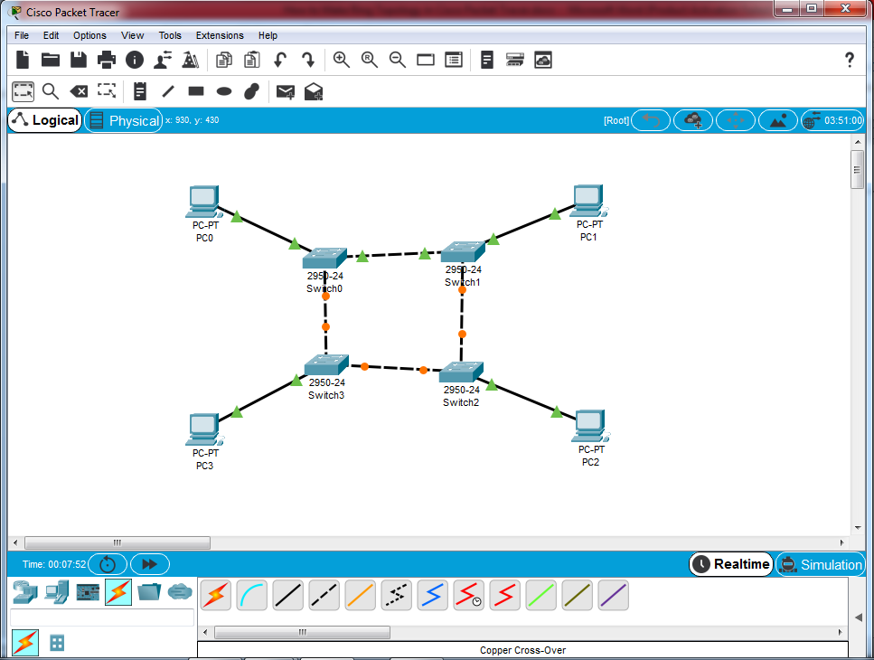

### Step4: Configure IP Address

Still our *Example Network*will not be working. This is because we have only connected *Network Devices*so far. We have not assigned any addresses to *Computers*. So, how one *computer*will identify another one? Each *Network Device*is identified with the help of address. For this we have to configure **IP Address** of each *computer*in our *Network*.

**IP Address**

**Internet Protocol (IP) Addres**s is logical addressing mechanism which identifies various *Network Devices* on a *Computer Network*. It is 32-bit address. This address contains four (3-digit) portions separated by full stop. Each portion comprises of 8 bits. In this way each portion value can vary from 0-255. Each Device on Network has unique *IP Address*. **Example of IP Address** is 127.0.0.1

After proper configuration of *IP Address*you can test working of *Ring Topology in Cisco Packet Tracer*to ensure that its working or not. For configuring *IP Addresses*you just need to follow these tasks:

### Tasks to Configure IP Address

1. Click on *Computer*for displaying additional options. You can do a lot of configurations in these options. All these options are present in different tabs. However, for creating *Ring Topology in Cisco Packet Tracer*you just need to configure IP Address. For configuring move to tab labelled **‘Desktop’**.

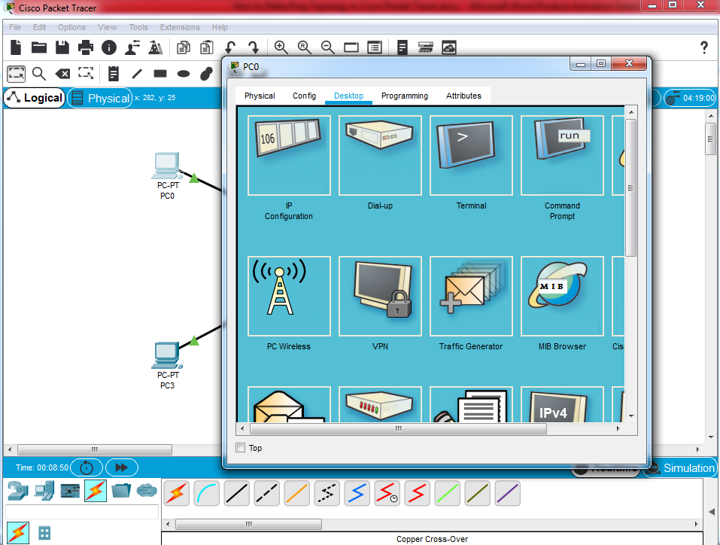

1. First option in **‘Desktop’**tab is **IP Configuration**. Click on this option to open *IP Configuration* dialog box. Don`t get confused. Configuration process is really simple one. You just have to enter two *IP Addresses* in fields **‘IP Address’**and **‘Subnet Mask’**.

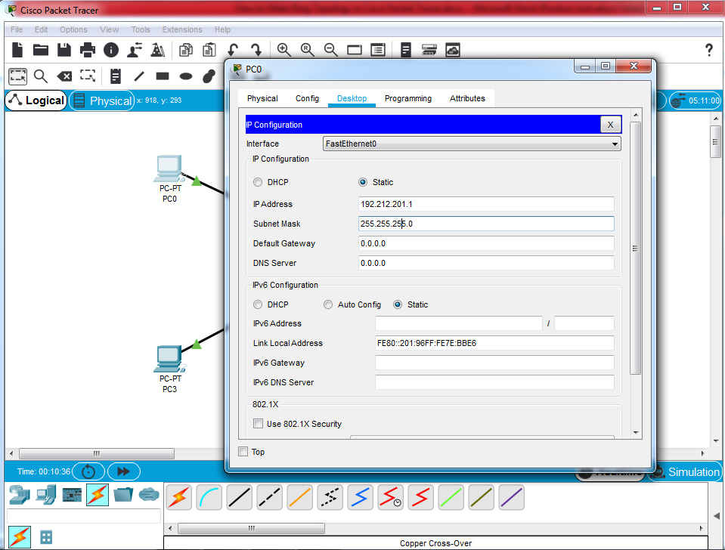

| **Computer** | **IP Address** | **Subnet Mask** |
| --- | --- | --- |
| PC0 | 193.212.200.1 | 255.255.255.0 |
| PC1 | 193.212.200.2 | 255.255.255.0 |
| PC2 | 193.212.200.3 | 255.255.255.0 |
| PC3 | 193.212.200.4 | 255.255.255.0 |

1. You have to fill *IP Address* and *Subnet Mask* for configuration. There is option for you to use any *IP Address* and corresponding *Subnet Mask*. But for the sake of convenience and learning you can use the following *IP Address* and *Subnet Mask* configuration:

**IMPORTANT POINT**

All the *IP Addresses* should be from same **IP Class**. *IP Class* is identified by **Subnet Mask**. If you use IP Addresses from different classes then your *Ring Network*will not work properly.

### Test Ring Topology Network in Cisco Packet Tracer (Step 5)

This step ensures that your *Network*is communicating properly. Its always good to test functioning of *Computer Network*. But one thing I would like to mention is that this is logical testing. When you physically establish *Ring Network*then again you will have to test it. This is because in real time implementation there are a variety of *Network Devices*involved in it. There may be problem in the cable you have used. **Network Interface Card (NIC)**may have malfunctioning in it. One of the *Switch Ports*may be problematic. So, it is always good to perform both logical and physical testing. You can logically test *Ring Topology in Cisco Packet Tracer*easily. Just take a couple of steps to accomplish this:

1. Select Simple PDU from right hand side of *Cisco Packet Tracer*. It is basic tool for testing any *Computer Network*. You will see a message sign on mouse pointer. Click on *computer*from where you want to generate a message. That is the one you need.
2. After selecting the **Sender**now its time to select **Receiver**. All you need to do is simply click on *computer*you wish to be receiver.
3. In Real Time window right at the bottom, you can clearly see message. In case of success message, you can infer that your *Ring Network*is good to go.

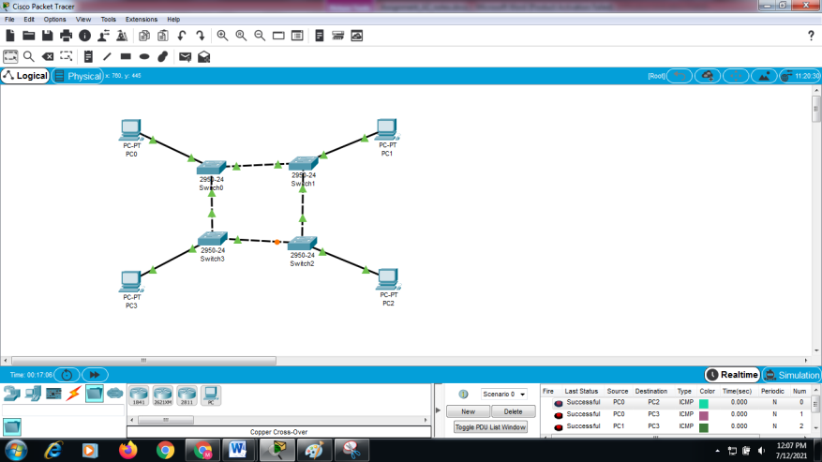

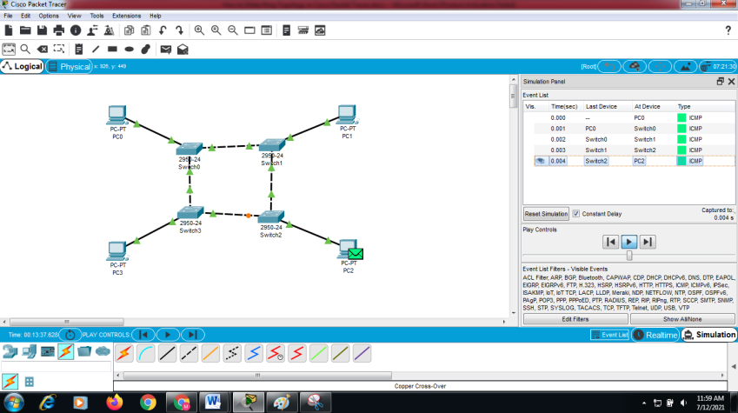

**Conclusion:**

Successfully demonstrated the different types of topologies and types of transmission media by using a packet tracer tool (Cisco packet tracer tool).

**Source:**

<https://topologynetwork.com/how-to-make-ring-topology-in-cisco-packet-tracer-tutorial/>

https://www.guru99.com/type-of-network-topology.html