# Assignment Group-4

## Problem Definition:

Write a program to simulate Go back N and Selective Repeat Modes of Sliding Window Protocol in peer to peer mode and demonstrate the packets captured traces using Wireshark Packet Analyzer Tool for peer to peer mode. (Use JAVA/PYTHON)

## 1. Prerequisite:

1. Data Link Layer: Roles, Protocols
2. Java Programming Syntax
3. Wireshark Tool

## Learning Objectives:

* + Students will able to understand Go back N and Selective Repeat Modes of Sliding Window Protocol

## Theory

Data-link layer is responsible for implementation of point-to-point flow and error control mechanism.

### Flow Control

When a data frame (Layer-2 data) is sent from one host to another over a single medium, it is required that the sender and receiver should work at the same speed. That is, sender sends at a speed on which the receiver can process and accept the data. What if the speed (hardware/software) of the sender or receiver differs? If sender is sending too fast the receiver may be overloaded, (swamped) and data may be lost.

Two types of mechanisms can be deployed to control the flow:

### Stop and Wait

This flow control mechanism forces the sender after transmitting a data frame to stop and wait until the acknowledgement of the data-frame sent is received.

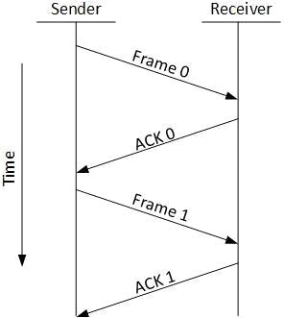

### Sliding Window

In this flow control mechanism, both sender and receiver agree on the number of data-frames after which the acknowledgement should be sent. As we learnt, stop and wait flow control mechanism wastes resources, this protocol tries to make use of underlying resources as much as possible.

### Error Control

When data-frame is transmitted, there is a probability that data-frame may be lost in the transit or it is received corrupted. In both cases, the receiver does not receive the correct data- frame and sender does not know anything about any loss.In such case, both sender and receiver are equipped with some protocols which helps them to detect transit errors such as loss of data-frame. Hence, either the sender retransmits the data-frame or the receiver may request to resend the previous data-frame.

Requirements for error control mechanism:

* + **Error detection** - The sender and receiver, either both or any, must ascertain that there is some error in the transit.
  + **Positive ACK** - When the receiver receives a correct frame, it should acknowledge it.
  + **Negative ACK** - When the receiver receives a damaged frame or a duplicate frame, it sends a NACK back to the sender and the sender must retransmit the correct frame.
  + **Retransmission:** The sender maintains a clock and sets a timeout period. If an acknowledgement of a data-frame previously transmitted does not arrive before the timeout the sender retransmits the frame, thinking that the frame or it’s acknowledgement is lost in transit.

There are three types of techniques available which Data-link layer may deploy to control the errors by Automatic Repeat Requests (ARQ):

1. **Stop-and-wait ARQ**

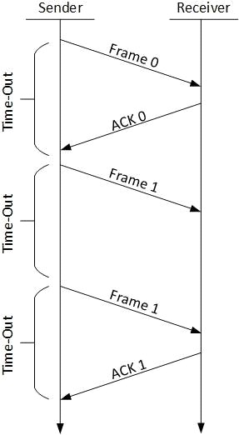

The following transition may occur in Stop-and-Wait ARQ:

* + The sender maintains a timeout counter.
  + When a frame is sent, the sender starts the timeout counter.
  + If acknowledgement of frame comes in time, the sender transmits the next frame in queue.
  + If acknowledgement does not come in time, the sender assumes that either the frame or its acknowledgement is lost in transit. Sender retransmits the frame and starts the timeout counter.
  + If a negative acknowledgement is received, the sender retransmits the frame.

### Go-Back-N ARQ

Stop and wait ARQ mechanism does not utilize the resources at their best. When the acknowledgement is received, the sender sits idle and does nothing. In Go-Back-N ARQ method, both sender and receiver maintain a window.

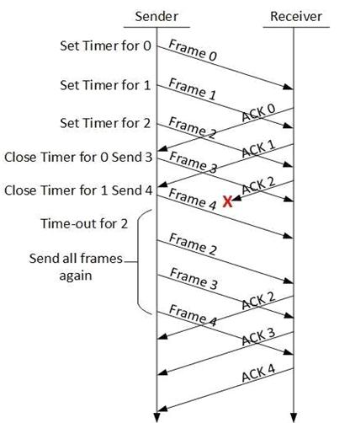

The sending-window size enables the sender to send multiple frames without receiving the acknowledgement of the previous ones. The receiving-window enables the receiver to receive multiple frames and acknowledge them. The receiver keeps track of incoming frame’s sequence number.

When the sender sends all the frames in window, it checks up to what sequence number it has received positive acknowledgement. If all frames are positively acknowledged, the sender sends next set of frames. If sender finds that it has received NACK or has not receive any ACK for a particular frame, it retransmits all the frames after which it does not receive any positive ACK.

### Selective Repeat ARQ

In Go-back-N ARQ, it is assumed that the receiver does not have any buffer space for its window size and has to process each frame as it comes. This enforces the sender to retransmit all the frames which are not acknowledged.

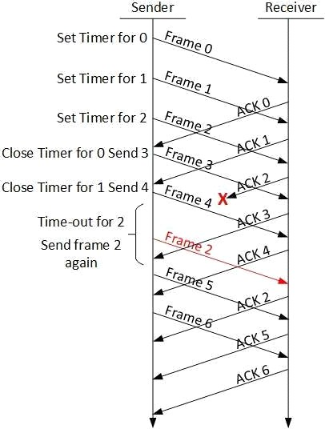

In Selective-Repeat ARQ, the receiver while keeping track of sequence numbers, buffers the frames in memory and sends NACK for only frame which is missing or damaged.

The sender in this case, sends only packet for which NACK is received.

### Testing

1. Run Wireshark tool
2. Run program
3. Capture packets in Wireshark

## Conclusion:

Hence we have studied Go back N and Selective Repeat Modes of Sliding Window Protocol and captured packets in Wireshark tool.