# Assignment No.9

## Title:

Write a program using UDP Sockets to enable file transfer (Script, Text, Audio and Video

one file each between two machines.

## Theory:

### Server-Client file transfer using UDP Server:

* + Include appropriate header files.
  + Create a UDP Socket using socket() system call.
  + Fill in the socket address structure (with server information)
  + Specify the port where the service will be defined to be used by client.
  + Bind the address and port using bind() system call
  + Receive a file name of text, audio or video from the Client using recvfrom() system call.
  + Sends file to client using sendto() system call.
  + Close the server socket
  + Stop

### Client:

* + Include appropriate header files.
  + Create a UDP Socket.
  + Fill in the socket address structure (with server information)
  + Specify the port of the Server, where it is providing service
  + Send a file name to the server using sendto() system call.
  + Receive a file from the Server using recvfrom() system call.
  + Close the client socket
  + Stop

### Socket functions for UDP client/server in Connectionless Scenario

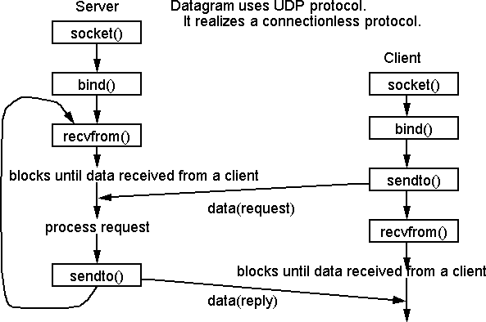

**Testing**

1. Run Wireshark tool
2. Run client and server program
3. Send and receive file
4. Capture UDP packets in Wireshark

## Conclusion:

Hence we have studied UDP Socket Programming in C for file transmission of text, audio and video and captured UDP packets in Wireshark tool.