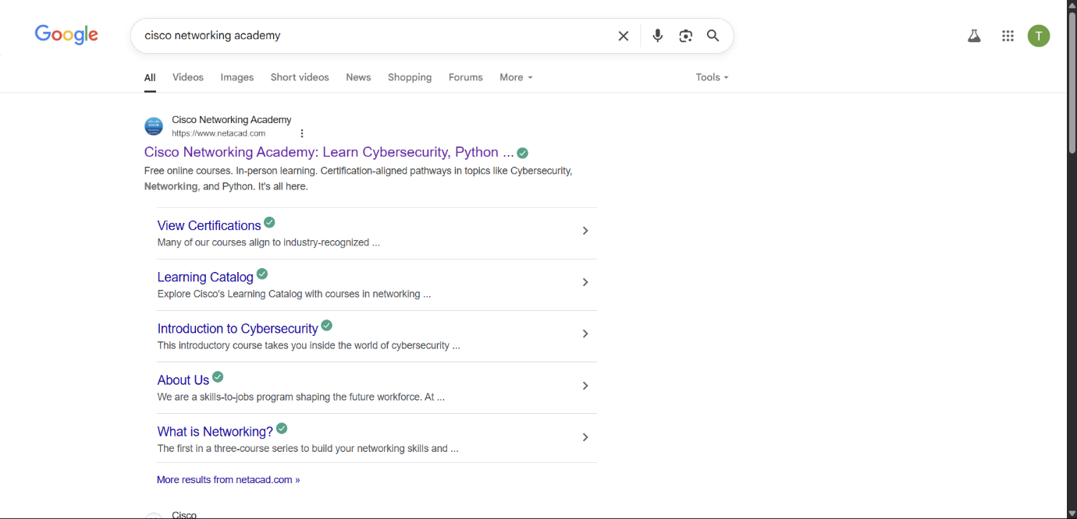Search Cisco Networking Academy on Google

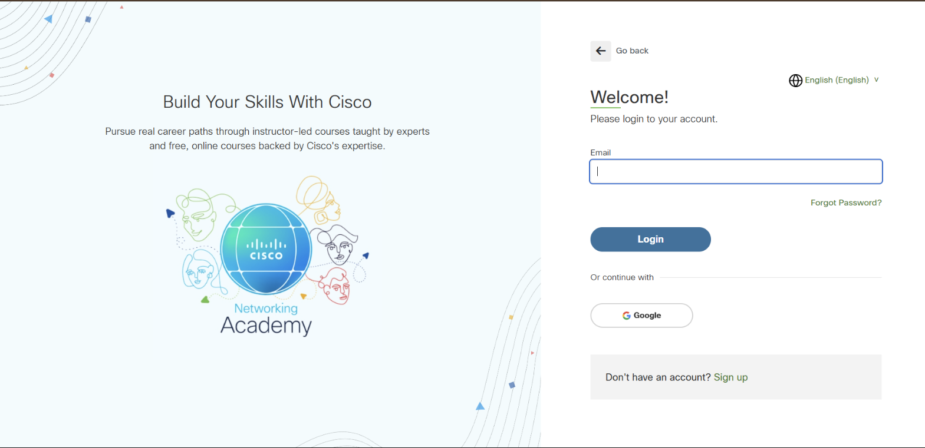  
Create an Account using Google

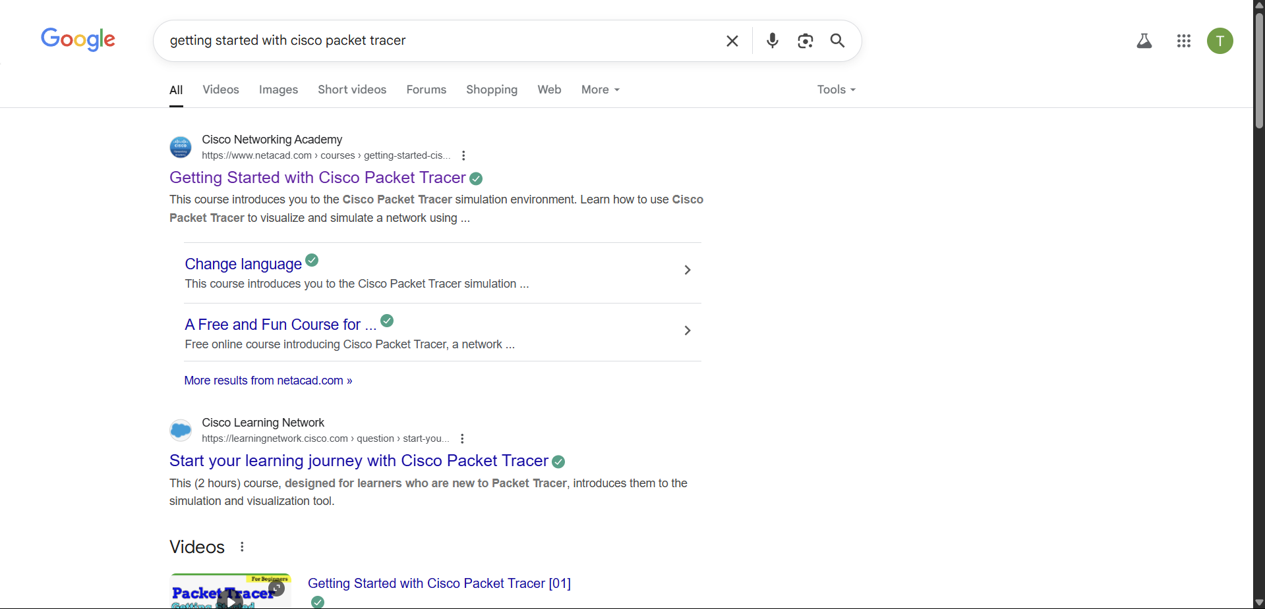  
Search getting started with cisco packet tracer on google

Enrol for the course

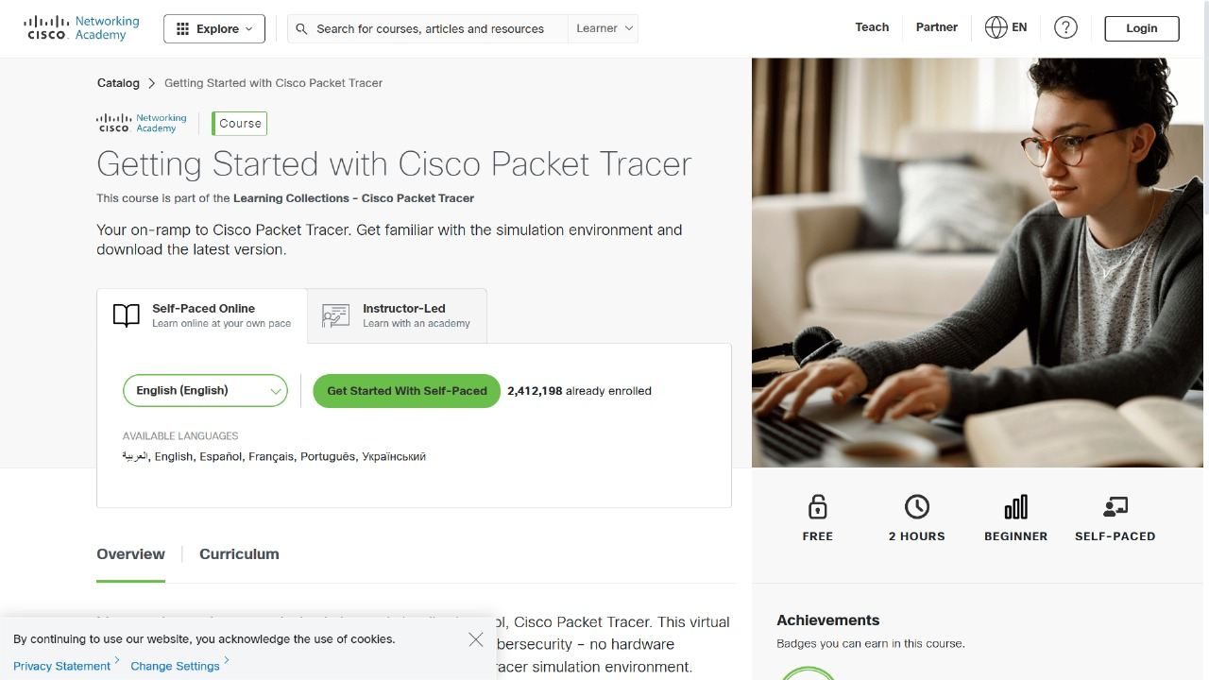  
  
  
  
  
  
Install Cisco Package Tracer

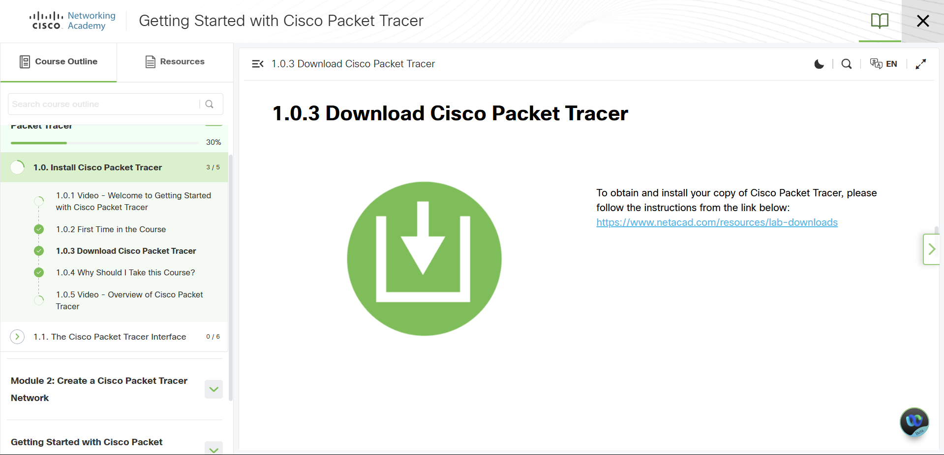Install your cisco packet tracer through given link in your system.