**Name: Tejas Santosh Nalawade Roll No: TCOD 01**

**Assignment 02**

Q. Demonstrate the different types of topologies and types of transmission media by using a

packer tracer tool.

**Tree Topology**

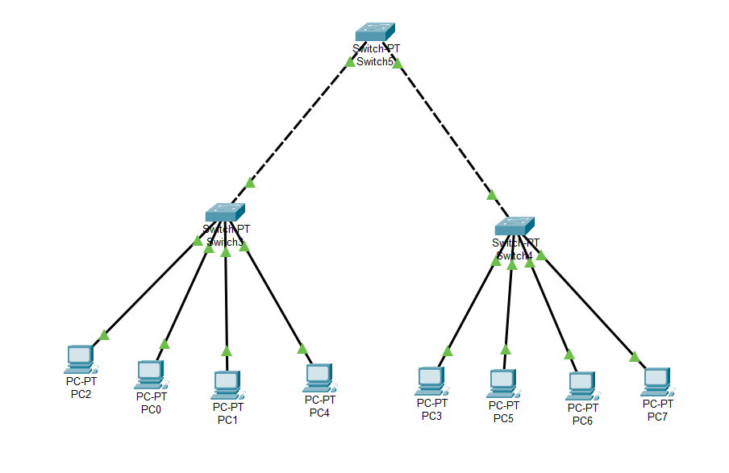

**Status:**

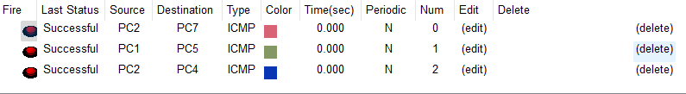

**Mesh Topolog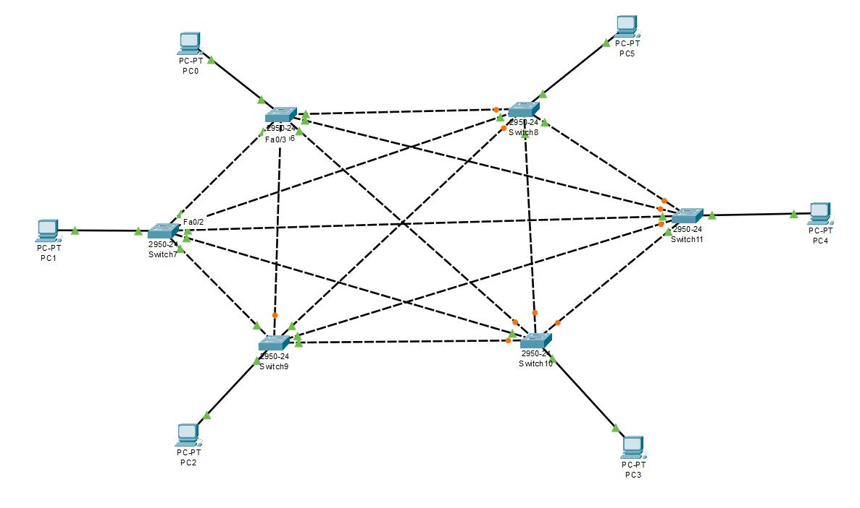y**

**Status:**

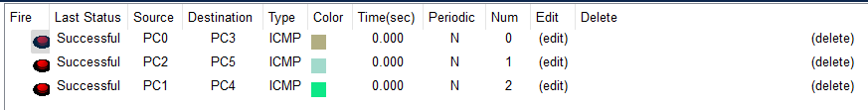

**Hybrid Topology**

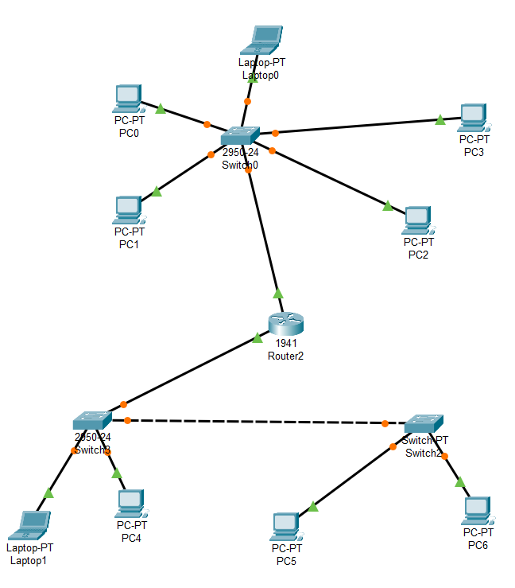

**Status:**

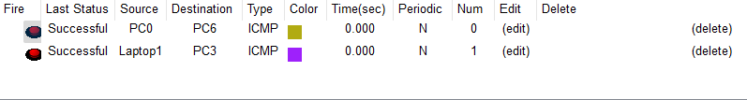

**Ring Topology**

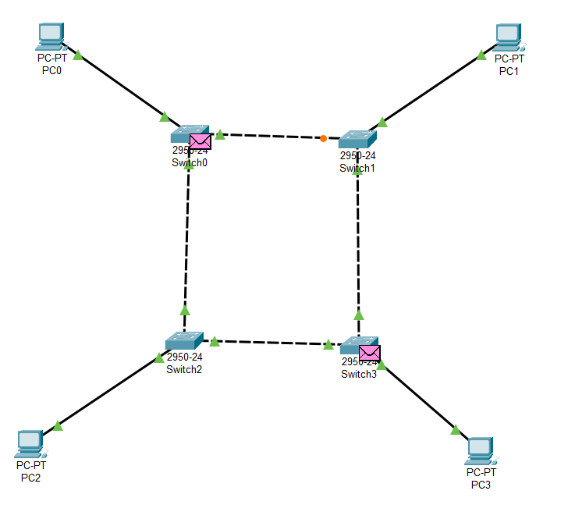

**Status:**

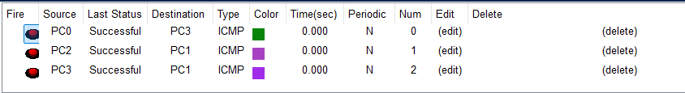

**Star Topology**

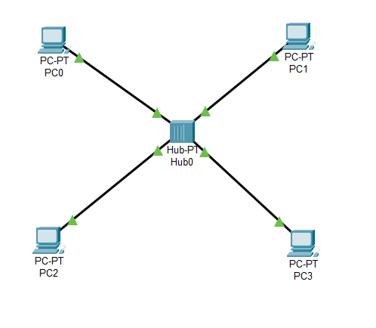

**Status:**

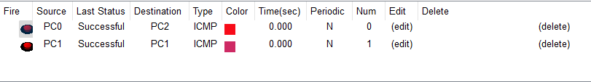

**Bus Topology**

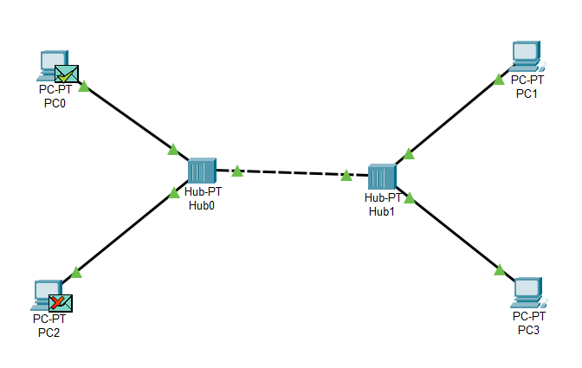

**Status:**

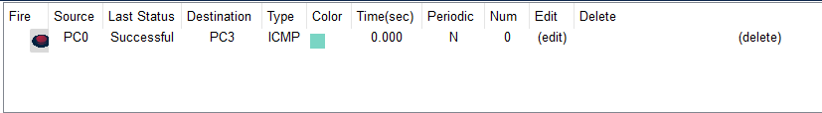

**Point to Point Topology**

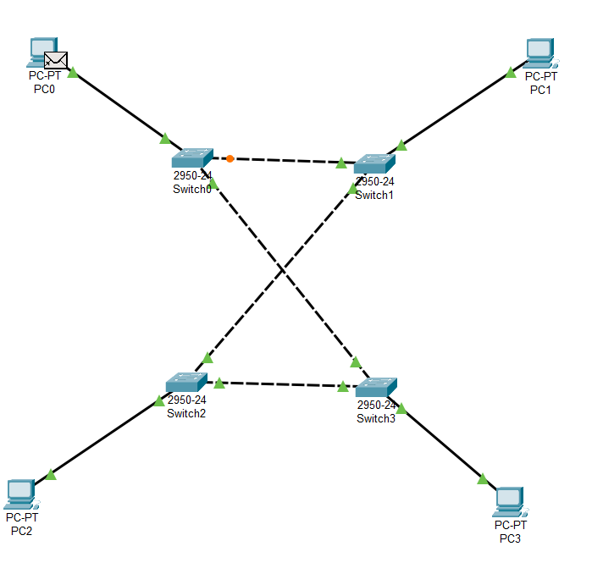

**Status:**

