NAME: TEJAS NALAWADE PRACTICAL NO: 2 ROLL NO: TCOD01
a. Design and Develop SQL DDL statements which demonstrate the use of SQL objects such as Table, View, Index, Sequence, Synonym, different constraints etc.

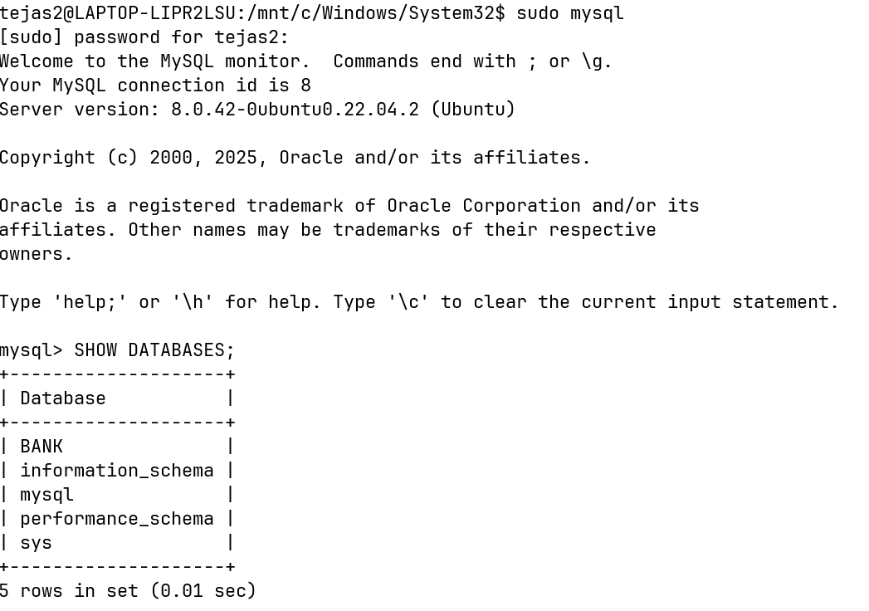
b. Write at least 10 SQL queries on the suitable database application using SQL DML statements.
DATABASE
TABLES
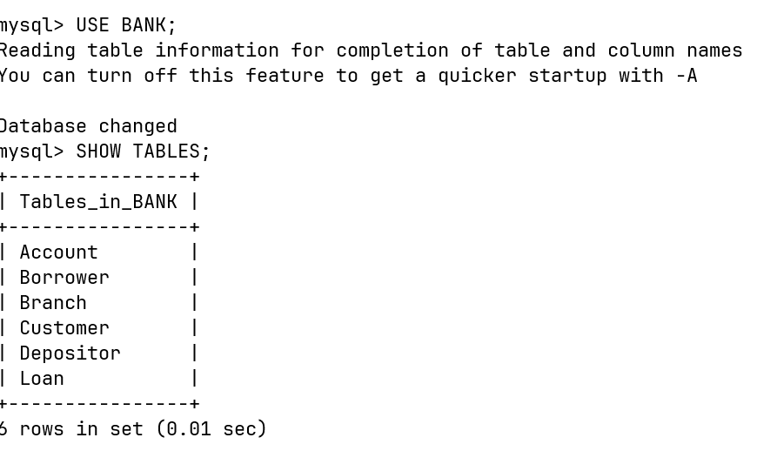

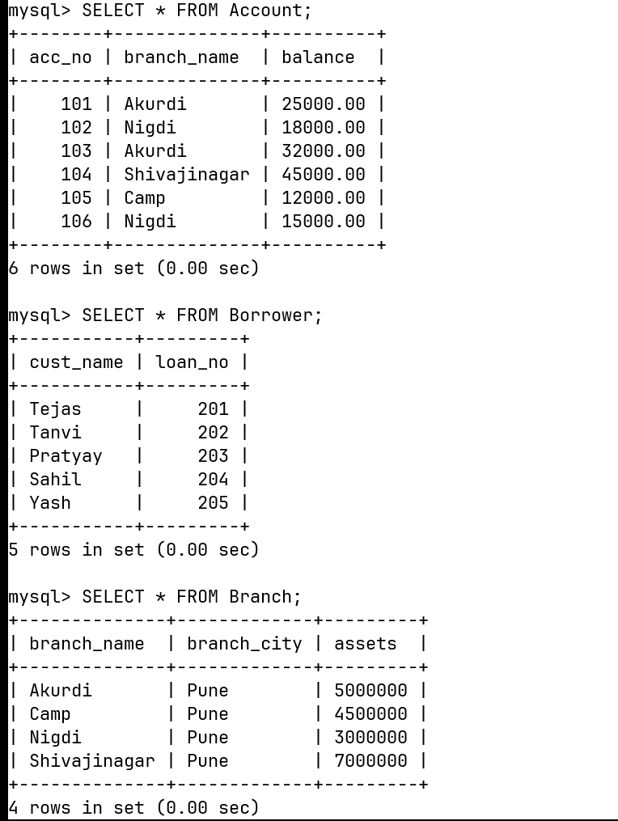

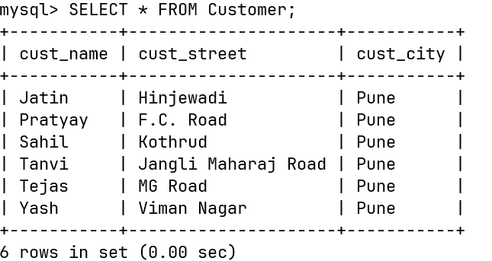

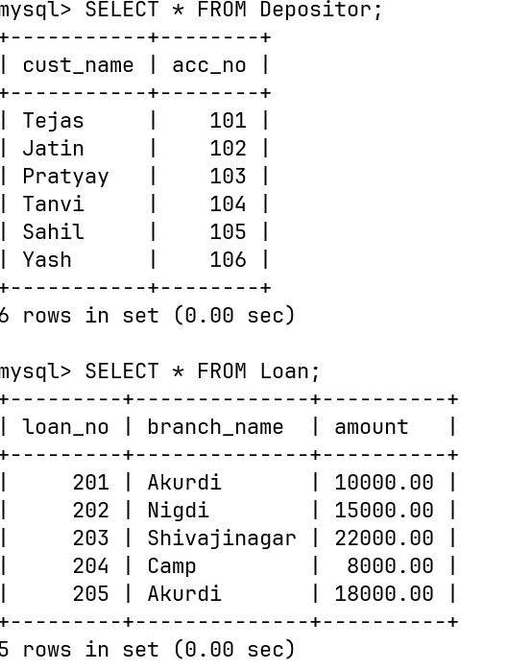

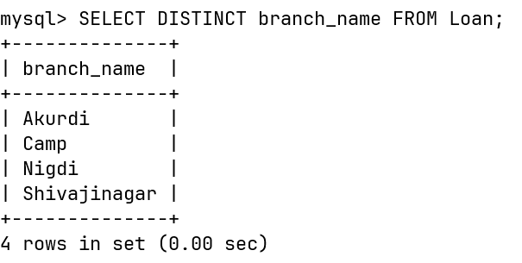
Q1. Find the names of all branches in the Loan relation.

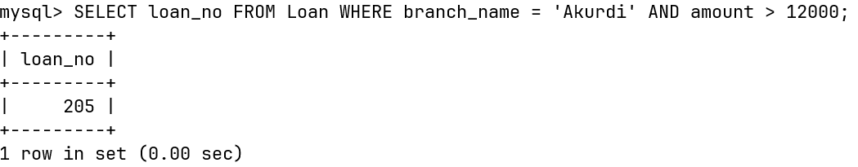
Q2. Find all loan numbers for loans made at Akurdi Branch with loan amount > 12000.
Q3. Find all customers who have a loan from bank. Find their names, loan_no and loan amount

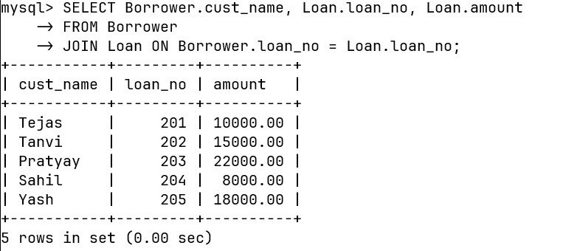

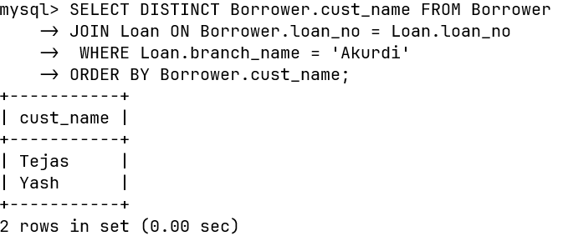
Q4. List all customers in alphabetical order who have loan from Akurdi branch.
Q5. Find all customers who have an account or loan or both at bank.
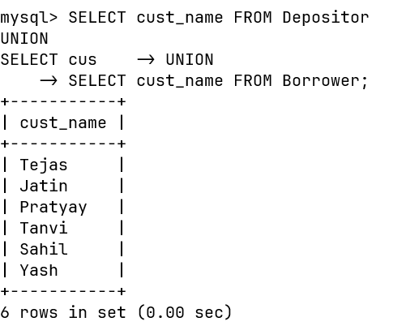

Q6. Find all customers who have both account and loan at bank.

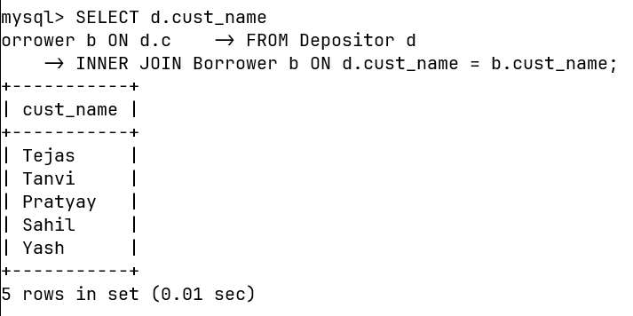

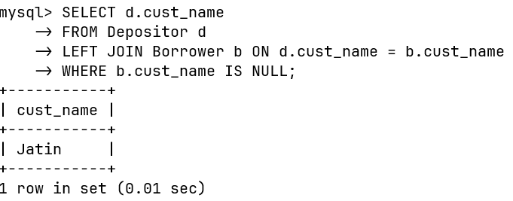
Q7. Find all customers who have account but no loan at the bank.

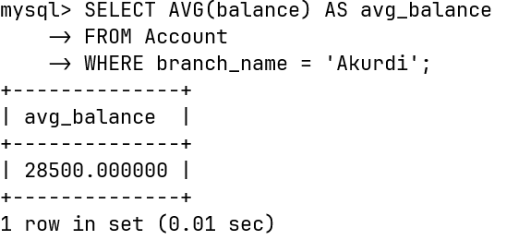
Q8. Find average account balance at Akurdi branch.

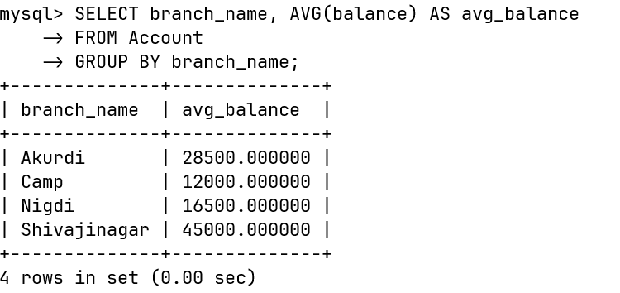
Q9. Find the average account balance at each branch.

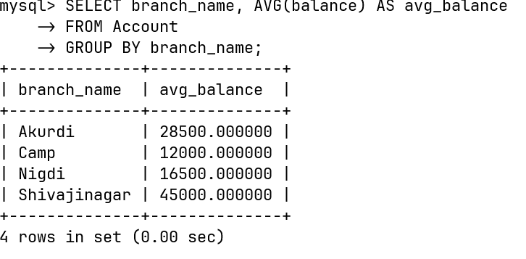
Q10. Find number of depositors at each branch.

SEQUENCE

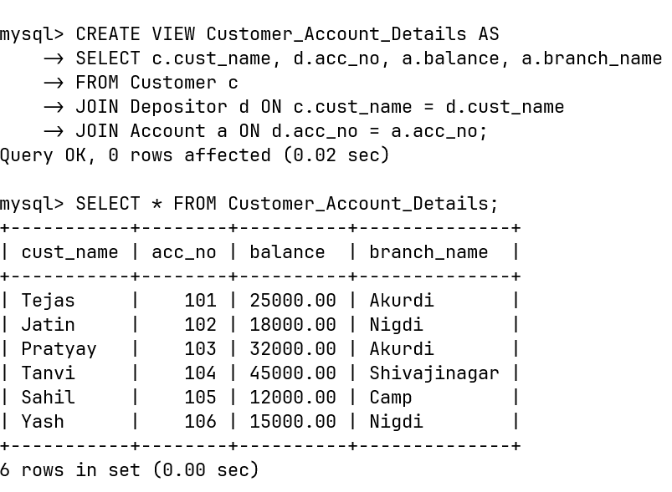
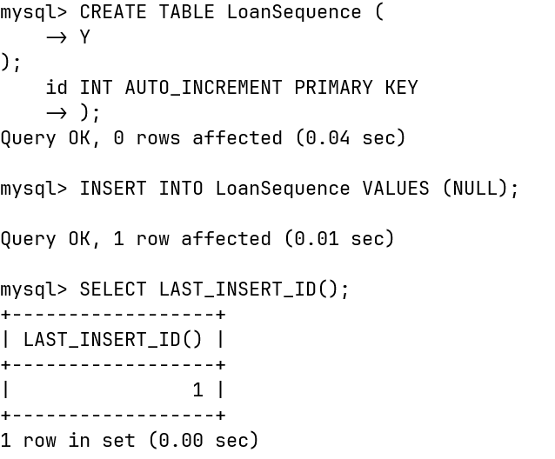
VIEW
Synonym

