NAME: TEJAS NALAWADE PRACTICAL NO: 5 ROLL NO: TCOD01
AIM: Named PL/SQL Block: PL/SQL Stored Procedure and Stored Function.
Write a Stored Procedure namely proc_Grade for the categorization of student. If marks scored by students in
examination is <=1500 and marks>=990 then student will be placed in distinction category if marks scored are
between 989 and900 category is first class, if marks 899 and 825 category is Higher Second Class.

TABLES

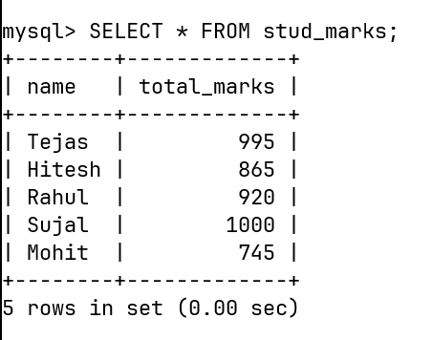

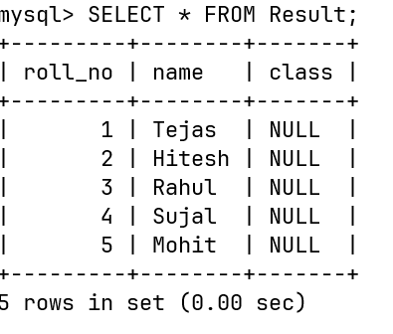

PROCUDURE
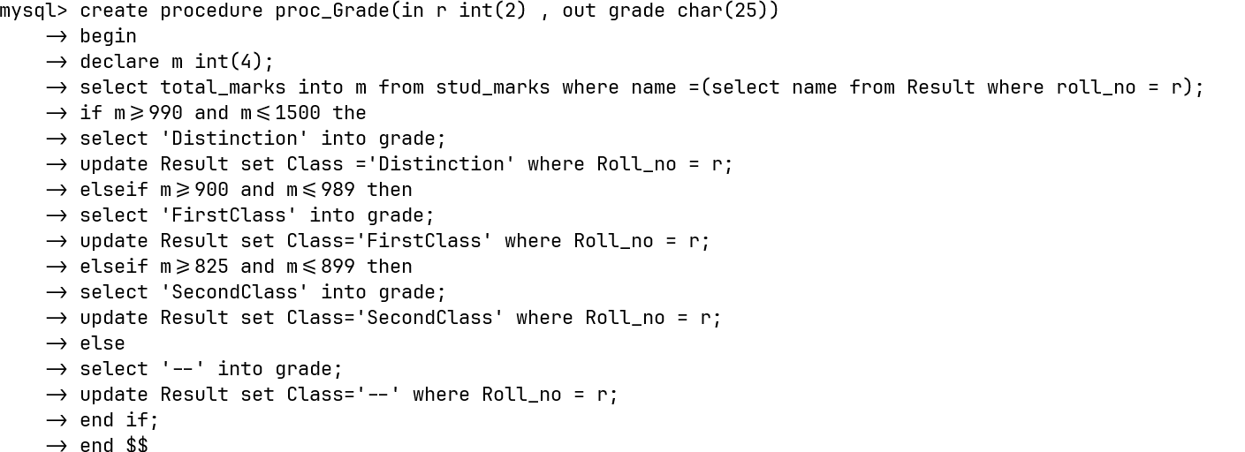

FUNCTION

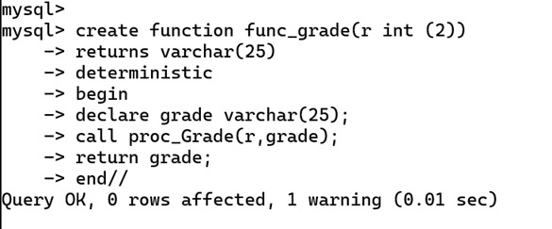

FUNCTION CALL

