NAME: TEJAS NALAWADE PRACTICAL NO: 6 ROLL NO: TCOD01
AIM: Cursors :( All types: Implicit, Explicit, Cursor FOR Loop, Parameterized Cursor)

Problem Statement: Write a PL/SQL block of code using parameterized Cursor that will merge the data available in the newly created table N_Roll Call with the data available in the table O_RollCall. If the data in the first table already exist in the second table then that data should be skipped. Note: Instructor will frame the problem statement for writing PL/SQL block using all types of Cursors in line with above statement.

TABLES

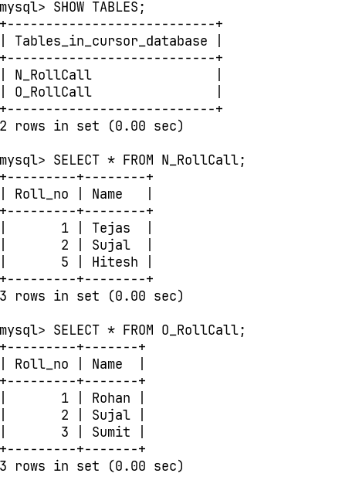

PROCUDURE & CALL
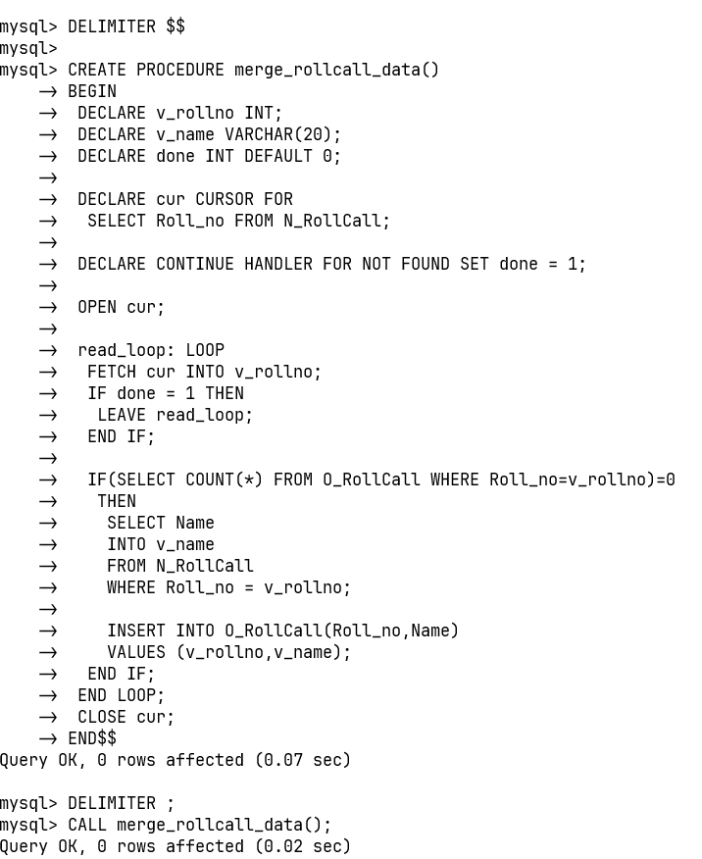

OUTPUT
