TITLE OF THE INVENTION

Question Paper AI Analyzer with Study Material

APPLICANT (S)

Sr. No. | Name of Inventor(s) | Sign
1 | Mrs. Trupti Deshmukh | 
2 | Tejas Santosh Nalawade | 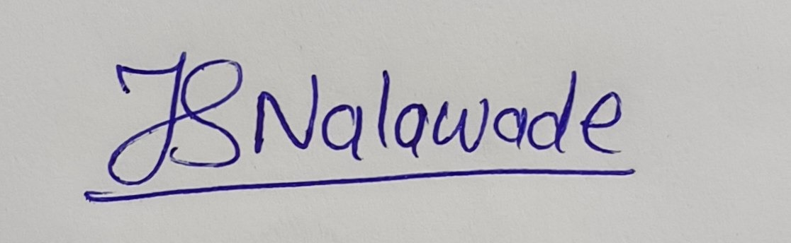
3 | Hitesh Sanjay Khare | 
4 | Naresh Ashok Mali | 
5 | Sahil Sandip Khamkar | 
6 | Mrs.Sunita Patil | 
7 | Mrs. Zarina Shaikh | 

Dr. D. Y. Patil Institute of Technology, Pimpri, Pune - 18
PREAMBLE TO THE DESCRIPTION: -
THE FOLLOWING SPECIFICATION PARTICULARLY DESCRIBES THE NATURE OF THE INVENTION AND THE MANNER IN WHICH IS TO BE PERFORMED
COMPLETE

- Field of the Invention: -
This is an Educational Technology (EdTech) invention, aimed at developing an AI learning platform for college students. The platform aims at providing free academic resources, includes study guides, video recommendations, student community forum, and AI powered academic support. A fundamental part of this invention is the incorporation of an AI model which respond to the queries from students on different subjects, using machine learning algorithms and NLP, this AI chatbot will provide frequency-based analysis of topics, study plan, mock test, web app navigation. It also includes and intelligent recommendation mechanism which recommends suitable YouTube videos and study materials to the user based on their needs, community support to user for there doubts solving, discussion and knowledge sharing.

2) Background of the Innovation: -
Preamble to the Description

- This project aims to build an AI-based educational Web platform to accommodate free academic resources, AI based question answering and customized video recommendations for university students. It assimilates machine learning, natural language processing and interactive chatbot interface for user engagement.
- AI Chatbot – It will use NLP and deep learning to immediately reply to student’s academic questions with frequency based analysis for specific subjects.
- Personalized Video Recommendation System – It will use machine learning algorithms for analysis of student preference and provide YouTube videos and study materials.
- Centralized Study Material Platform – This comprise of free educational contents in structure of lecture notes, reference books and, previous year university paper, and research paper in and organized manner.
- Community Engagement Platform – Peer-to-Peer forums on platform will enable students to share knowledge, collaborate with interactive Q&A sessions with one another, doubt solving and networking with alum
- AI-Driven Learning Analytics – Tracks Engagement, learning patterns, recommend steps for improvement in effective learning. Interactive responses, graphical representation of progress and scope of improvement.
- Authentication Privacy & Security – OAuth authorization, JWT authentication for user security, data protection and data privacy.
- Storage and Database – Google Drive used for managing study material uploads, downloads and for training models and using cloud technology.
- Deployment & Accessibility – It is hosted on Vercel, with responsive frontend made using React framework (Next.js), backend made using Node.js and database used are SQL and MongoDB. Chatbot is made using NLP Rasa and utilizes Python language for seamless accessibility, SEO and performance on various devices.

3) Summary of the Invention: -
Question paper analyser is a tool designed to enhance student exam preparation. At its core, the system features a Question Paper Analyzer which utilizes AI to predict most likely questions by analysing past questions papers and also provides a visual representation of the most important topics. This tool extracts questions from the PDF’s and images which are provided and identifies patterns, frequently asked topics and question weightage. By using advanced NLP and machine learning techniques it provides us with predictive insights for exams.
Additionally, an AI-powered chatbot answers queries of the users and for subject related issues suggests relevant YouTube lessons, provides study plans, mock tests and also aids the users in finding relevant resources on our platform. The platform will contain study resources such as lecture notes, presentations, reference books, question papers etc. Community features allow students to engage in peer discussions. Authentication is managed via OAuth, and Google Drive integration ensures secure storage. The web application, developed using Next.js react framework, Node.js stack and deployed on Vercel. This tool provides a seamless, efficient study aid for students.
4) Prior Art Search: -

Below are some of the prior research papers and studies which are relevant our present invention:

Chatbots Applications in Education: A Systematic Review

Okonkwo & Ade-Ibijola
Description: This study reviews 53 research articles on how chatbots could be leveraged to enhance student engagement, personalize learning experience, and automate academic support.
Relevance: It validates the usage of AI in our project supporting the way chatbot could be used to get academic assistance.

Adoption of Chatbot Technology to Enhance Student Learning Experience in Indian Higher Education Sector
Description: This study investigates the factors influencing the adoption of chatbot technology in Indian higher education, focusing on its ability to improve student engagement and learning experiences.

Relevance: It reinforces the integration of a chatbot in our platform and showcases the practical benefits of AI in academic support.

The Impact of Educational Chatbot on Student Learning Experience
Ait Baha et al.
Description: An experimental study which demonstrates how an AI chatbot significantly improves student engagement, motivation, and knowledge retention through personalized instruction.
Relevance: It reinforces our approach of using a chatbot which offers on-demand academic support and enhances overall learning outcomes.

Personalized Learning Recommendation System in E-learning Platforms Using Collaborative Filtering and Machine Learning
Alanya-Beltran
Description: This work presents a machine learning-based recommendation system that uses collaborative filtering to find the most suitable learning materials based upon student preferences.
Relevance: It underpins our strategy to deliver personalized study resources, such as curated YouTube videos and study materials, based on student’s needs.

Development of a Web-Based Community Management Information System
Description: This study details a centralized system which manages the community data to improve organizational effectiveness and resource accessibility.
Relevance: It supports our platform’s integration of a community-driven learning forum, which facilitates academic discussions and peer-to-peer support, enhancing the digital learning experience.

5) Brief Description of Drawing: -

The flowchart represents the structure and working mechanism of an AI-powered educational assistance platform. Below is the breakdown of its key components:

AI Module (Self-Trained)

Helps user to navigate the website

Uses predictive analysis to provide insights upon the important topics, most likely asked questions.

Website Integration

Acts as the main interface for the users

Frontend Technologies

Built using Next.js, Tailwind CSS, and other web technologies for a seamless user experience.

Dataset Management

The system stores the study materials and question papers on google drive for ease of access.

6) Detailed Description of the Preferred Embodiment: -

Next.js Chatbot UI
The user will interact with the chatbot through a Next.js-based interface embedded within the website. This interface will act as a means between the chatbot and the user so that the user may ask his queries, ask for website navigation etc. When a user enters a query, the UI forwards the query to the backend where it’s processed and a response is given in real-time thus ensuring a smooth and interactive user experience.

FastAPI Backend
The FastAPI framework is utilized to create a lightweight, high-performance REST API that serves as the bridge between the frontend, chatbot, database, and storage. It handles users request and ensures there is proper connection between the different components i.e is getting the data from the database, get the processed data from the analyzer etc.

SQL Database
The database stores the data essential for the chatbot's functionality, which includes its predefined chatbot responses, website navigation data like sections, categories, and links, user queries along with their responses and processed question paper data. This approach allows the ease of retrieval of past interactions and hence enables the chatbot to provide the user context-based answer.

Rasa Chatbot for Website Navigation
The Rasa NLP model processes user queries related to website navigation using intent classification and entity recognition. It understands the user intents with predefined navigation paths, provides direct responses to some of the queries, and suggests relevant website sections based on the query naked by the user.

NLP Model for Question Paper Analysis
The question paper analysis module predicts important topics by extracting key insights from PDFs and images. It identifies frequently asked questions using statistical models and applies deep learning techniques to detect patterns, providing the most important questions based upon statistics.

Google Drive (Dataset Storage)
The storage module contains the uploaded question papers for analysis, processed question sets for predictions, and study materials. The FastAPI backend retrieves these documents as needed.

7) Object of the Invention: -

Centralized Education Platform: It will help university students to get curated resources at one place including free study resources, specific YouTube videos.

AI Enabled Learning: AI chatbot made using machine learning and NLP will provide the most optimized study plan and visual progress and trends for questions.

Community Support: It encourages peer discussion, learning in public, sharing resources and knowledge, doubt clearing, self-paced learning.

Data Protection & Security: Using OAuth and JWT for authentication and authorization for data protection and no data to be misused and leaked, user data uploaded securely managed.

8) Obviousness: -

The concept of using AI for educational assistance is not new, as various platforms already provide content recommendations and question paper analysis. Many platforms have chatbots, offer study materials or give recommendations to users. The integration of an AI that aids in navigating the website is also not new. Also, storing datasets on cloud platforms like Google Drive is widely used for managing academic content. The use of React.js, Tailwind CSS, and backend technologies for front-end development is a standard practice in modern web applications. Predictive analysis, which utilizes machine learning to recognize patterns and suggest key questions, is a common technique in adaptive learning systems. Many platforms such as Coursera, Khan Academy, and Chegg use AI-driven recommendations to provide users with recommendations for courses which at its core utilizes predictive analysis. Given these existing technologies and methodologies, the core ideas behind the project are considered obvious, as they use well-known AI and web development techniques. However, the uniqueness of the project depends on how effectively it combines these elements in a novel, user-centric approach that enhances learning efficiency.

9) Non-obviousness: -

The non-obviousness of this platform is that despite the presence of the AI powered educational module, the uniqueness of this project lies in its self-trained AI module which auto train itself and auto learn from the dataset which are the previous year question papers and study materials. Traditional recommendation system which depends only on the predefined rules which are static but here all things are dynamic. The chatbot not only helps in navigation in the platform but also AI enabled insights, combination of frontend and backend technologies for scalability, performance and responsiveness. Adaptability and multifunctional support contribute and valuable innovation in the educational sector.

10) Novelty: -

The novelty of this project is that our system uses AI powered predictive analysis by using previous year question papers as a dataset for training models to identify the frequently asked questions, and our system will generate study plans based upon user requirement. Our platform includes community discussion forums, allowing students to interact and learn from one another and share knowledge with each other.

11) Industrial Applications: -

- Exam Preparation for Students: Helps students prepare efficiently for college by providing study plans, predictive question analysis.
- Coaching Centers & Online Tutors: Can be used by coaching institutes to provide structured study material.
- Government & Educational Institutions: It can be used by government education departments to provide free, AI-powered study resources to students in rural areas.
- AI-Powered Self-Learning Platform: Enables students to learn at their own pace using AI-generated recommendations and real-time assistance.

I/we claim (Benefits)
Claim 1: High-Quality Study Materials: Verified and high-quality resources will enhance concept clarity and academic performance.
Claim 2: Predictive Analysis for Exam Preparation: The system will analyse past question papers to identify frequently asked topics, helping students prioritize their study efforts.
Claim 3: Community-Driven Learning: The system will provide the discussion forums and peer-to-peer interaction features where students can ask questions and share resources.
Claim 4: Cost-Effective Education Solution: While many platforms require high subscription fees, our system will provide all its study materials for free.
Claim 5: Time-Saving and Efficient Study Approach: With the help of the AI powered search student can quickly find the relevant study material without spending time to search it manually.

Sr. No. | Name of Inventor(s) | Sign
1 | Mrs. Trupti Deshmukh
2 | Tejas Santosh Nalawade
3 | Hitesh Sanjay Khare
4 | Naresh Ashok Mali
5 | Sahil Sandip Khamkar
6 | Mrs.Sunita Patil
7 | Mrs. Zarina Shaikh

Drawing 1 of 3: Block Diagram for Website

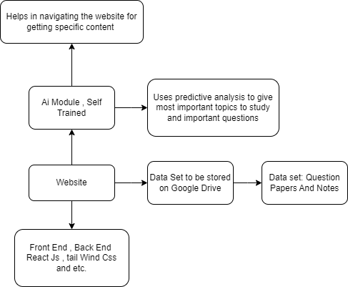

Sr. No. | Name of Inventor(s) | Sign
1 | Mrs. Trupti Deshmukh
2 | Tejas Santosh Nalawade
3 | Hitesh Sanjay Khare
4 | Naresh Ashok Mali
5 | Sahil Sandip Khamkar
6 | Mrs.Sunita Patil
7 | Mrs. Zarina Shaikh

Drawing 2 of 3: Diagram for Components of Website

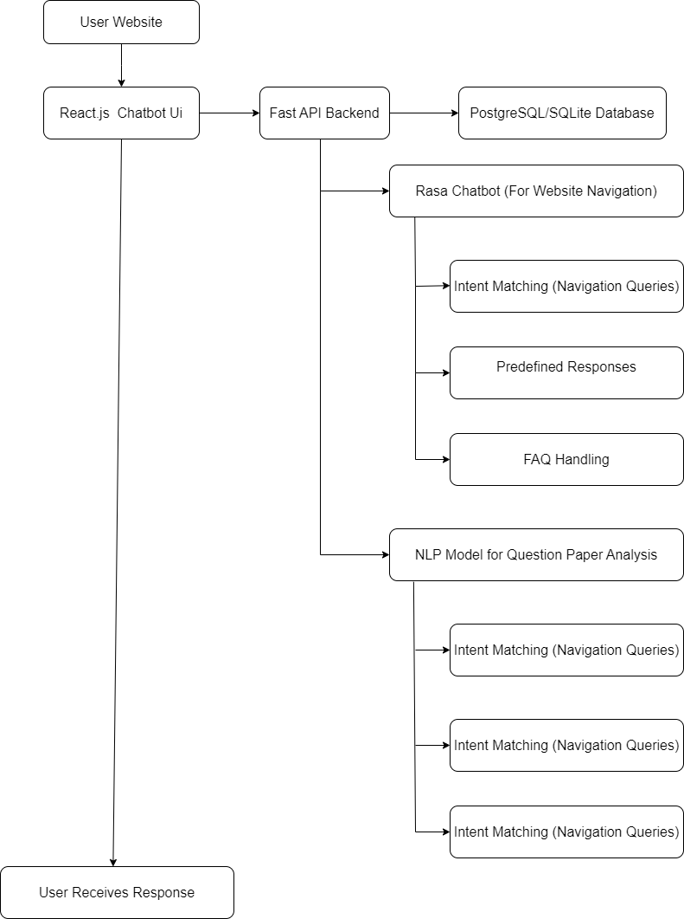

Sr. No. | Name of Inventor(s) | Sign
1 | Mrs. Trupti Deshmukh
2 | Tejas Santosh Nalawade
3 | Hitesh Sanjay Khare
4 | Naresh Ashok Mali
5 | Sahil Sandip Khamkar
6 | Mrs.Sunita Patil
7 | Mrs. Zarina Shaikh

Drawing 3 of 3: Work Flow Diagram for Website
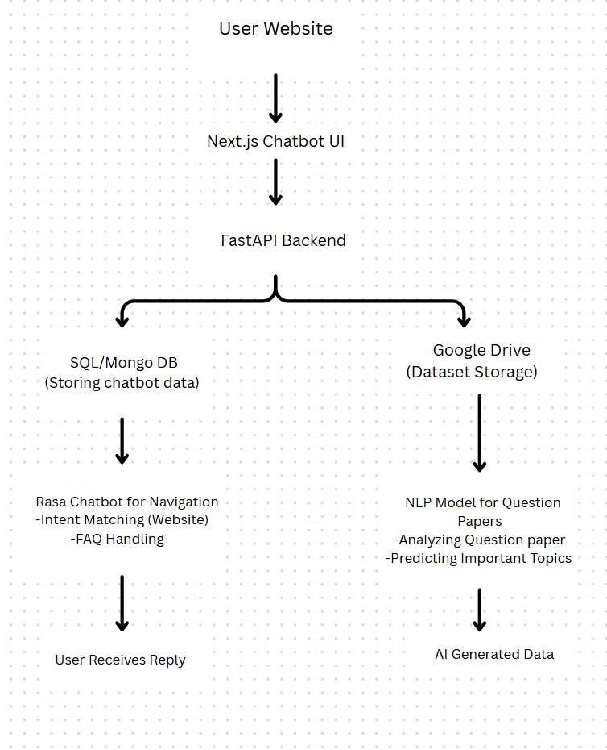

Abstract:

In today’s digital era, Digital education has provided the availability of online study material platforms. The existing platforms suffer and contain drawbacks such as poor personalization, outdated content, lack of inactivity and inefficient search functionalities. These limitations affect students' ability to efficiently prepare for exams and learn concepts effectively. To solve this challenge, we developed the AI Driven study material platform that enhances the learning experience through NLP and Machine Learning. This developed system will provide personalized study plan, AI powered chatbot, predictive analysis of question papers, interactive learning tools and a community discussion forum for peer-to-peer learning with self-paced features. Additionally we will offer a well structured, mobile friendly and responsive UI allowing students to study anytime, anywhere. Many paid platforms contain limited access to the content and provide it through expensive subscriptions, but our platform offers free content ensuring that quality education is accessible to all students. The students will be able to ask questions, share resources, and engage in subject discussions, creating a community-driven learning experience. Machine learning and NLP are used in the system that will provide the most relevant and optimized study plan as per the use case of the user and the time remaining and preparation deadline. The predictive analysis module helps students to focus on important topics based on past question papers and improve exam preparation and good academic performance. The AI chatbot will be able to provide study plans and mock tests to prepare for examinations. Additionally, an AI-powered chatbot answers queries of the users with subject related issues, suggests relevant YouTube video lectures, provides study plans, mock tests and also helps users in finding relevant resources on our platform. The platform will contain study resources such as lecture notes, presentations, reference books, question papers etc. This way of learning with AI enabled learning will aim to make learning easier and accessible to everyone. The goal of the system is to create a smart, easy-to-use platform that helps student’s study better and succeed in their exams and score good marks and excel in their academics.

TITLE: Question Paper AI Analyzer

