NAME: TEJAS NALAWADE PRACTICAL NO: 2 ROLL NO: TCOD01

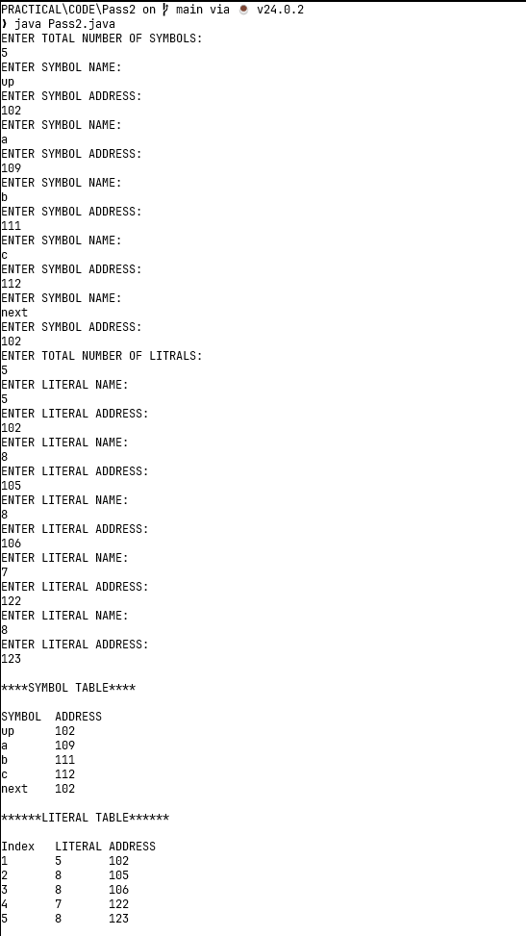

**OUTPUT**

