Shortest Job First(SJF) Scheduling
Shortest Job First scheduling works on the process with the shortest burst time or duration first.
- This is the best approach to minimize waiting time.
- This is used in Batch Systems.
- It is of two types:
  - Non Pre-emptive
  - Pre-emptive
- To successfully implement it, the burst time/duration time of the processes should be known to the processor in advance, which is practically not feasible all the time.
- This scheduling algorithm is optimal if all the jobs/processes are available at the same time. (either Arrival time is 0 for all, or Arrival time is same for all)

Non Pre-emptive Shortest Job First
Algorithm:
- Sort all the process according to the arrival time.
- Then select that process which has minimum arrival time and minimum Burst time.
- After completion of process make a pool of process which after till the completion of previous process and select that process among the pool which is having minimum Burst time.
How to compute below times in SJF using a program?
- Completion Time: Time at which process completes its execution.
- Turn Around Time: Time Difference between completion time and arrival time.
Turn Around Time = Completion Time – Arrival Time
- Waiting Time(W.T): Time Difference between turnaround time and burst time.
Waiting Time = Turn Around Time – Burst Time

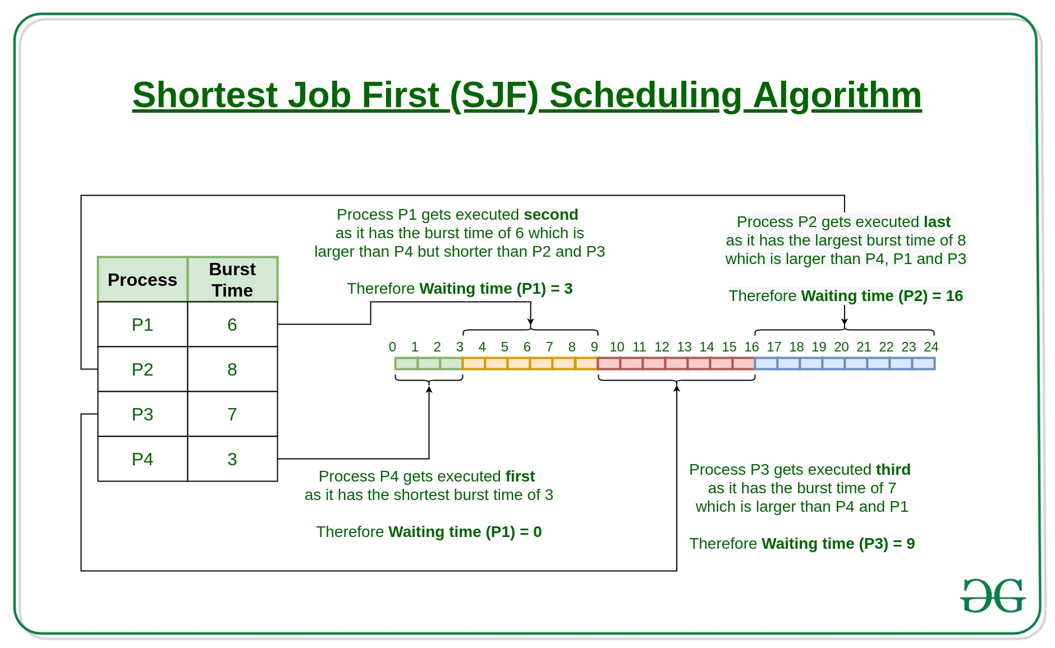
How to compute below times in SJF using a program?
- Completion Time: Time at which process completes its execution.
- Turn Around Time: Time Difference between completion time and arrival time.
Turn Around Time = Completion Time – Arrival Time
- Waiting Time(W.T): Time Difference between turn around time and burst time.
Waiting Time = Turn Around Time – Burst Time
Example:01
Process ID Arrival Time Burst Time
1 2 3
2 0 4
3 4 2
4 5 4
Final Result...

Process ID Arrival Time Burst Time Waiting Time Turnaround Time
2 0 4 0 4
3 4 2 0 2
1 2 3 4 7
4 5 4 4 8

Example:02
Consider the below processes available in the ready queue for execution, with arrival time as 0 for all and given burst times.
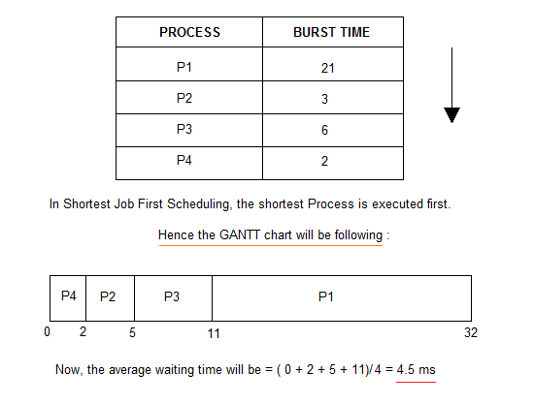
As you can see in the GANTT chart above, the process P4 will be picked up first as it has the shortest burst time, then P2, followed by P3 and at last P1.
We scheduled the same set of processes using the First come first serve algorithm in the previous tutorial, and got average waiting time to be 18.75 ms, whereas with SJF, the average waiting time comes out 4.5 ms.

Problem with Non Pre-emptive SJF
If the arrival time for processes are different, which means all the processes are not available in the ready queue at time 0, and some jobs arrive after some time, in such situation, sometimes process with short burst time have to wait for the current process's execution to finish, because in Non Pre-emptive SJF, on arrival of a process with short duration, the existing job/process's execution is not halted/stopped to execute the short job first.
This leads to the problem of Starvation, where a shorter process has to wait for a long time until the current longer process gets executed. This happens if shorter jobs keep coming, but this can be solved using the concept of aging.

Pre-emptive Shortest Job First
In Preemptive Shortest Job First Scheduling, jobs are put into ready queue as they arrive, but as a process with short burst time arrives, the existing process is preempted or removed from execution, and the shorter job is executed first.
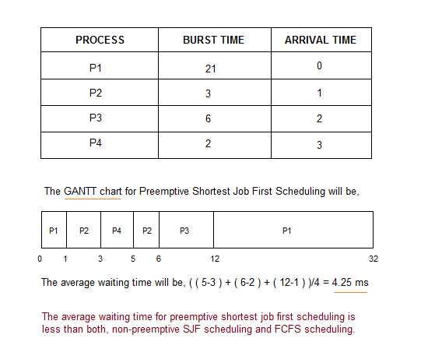
As you can see in the GANTT chart above, as P1 arrives first, hence it's execution starts immediately, but just after 1 ms, process P2 arrives with a burst time of 3 ms which is less than the burst time of P1, hence the process P1(1 ms done, 20 ms left) is preemptied and process P2 is executed.
As P2 is getting executed, after 1 ms, P3 arrives, but it has a burst time greater than that of P2, hence execution of P2 continues. But after another millisecond, P4 arrives with a burst time of 2 ms, as a result P2(2 ms done, 1 ms left) is preemptied and P4 is executed.
After the completion of P4, process P2 is picked up and finishes, then P2 will get executed and at last P1.
The Pre-emptive SJF is also known as Shortest Remaining Time First, because at any given point of time, the job with the shortest remaining time is executed first.

Shortest Job First (SJF) scheduling (Preemptive)
In previous post, we have discussed Set 1 of SJF i.e. non-preemptive. In this post we will discuss the preemptive version of SJF known as Shortest Remaining Time First (SRTF).

Shortest Remaining Time First (SRTF) scheduling
In the Shortest Remaining Time First (SRTF) scheduling algorithm, the process with the smallest amount of time remaining until completion is selected to execute. Since the currently executing process is the one with the shortest amount of time remaining by definition, and since that time should only reduce as execution progresses, processes will always run until they complete or a new process is added that requires a smaller amount of time.

Shortest Remaining Time First (Preemptive SJF): Example
Process | Duration | Order | Arrival Time
P1 | 9 | 1 | 0
P2 | 2 | 2 | 2
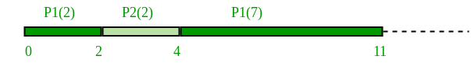
P1 waiting time: 4-2 = 2
P2 waiting time: 0
The average waiting time(AWT): (0 + 2) / 2 = 1
Advantage:
1- Short processes are handled very quickly.
2- The system also requires very little overhead since it only makes a decision when a process completes or a new process is added.
3- When a new process is added the algorithm only needs to compare the currently executing process with the new process, ignoring all other processes currently waiting to execute.
Disadvantage:
1- Like shortest job first, it has the potential for process starvation.
2- Long processes may be held off indefinitely if short processes are continually added.

Program implementation
import java.io.*;

public class FCFS {

public static void main(String args[]) throws Exception
{
int n,at[],bt[],wt[],tat[],ft[],pid[];
int fwt[],ftat[],temp;
float awt=0,att=0;
InputStreamReader isr=new InputStreamReader(System.in);
BufferedReader br=new BufferedReader(isr);
System.out.println("Enter no of process");
n=Integer.parseInt(br.readLine());
ft=new int[n];
wt=new int[n];
tat=new int[n];
bt=new int[n];
at=new int[n];
ftat=new int[n];
fwt=new int[n];
pid=new int[n];
System.out.println("Enter Enter Arrival Time and Burst time for each process\n");
for(int i=0;i<n;i++)
{
System.out.println("P["+(i+1)+"]");
at[i]=Integer.parseInt(br.readLine());
System.out.println("Process["+(i+1)+"]");
bt[i]=Integer.parseInt(br.readLine());
pid[i] = i+1;
}

System.out.println("\n");

for(int i = 0 ; i <n; i++)
{
for(int j=0; j < n-(i+1) ; j++)
{
if(at[j]==at[j+1]);
if( at[j] > at[j+1] )
{
temp = at[j];
at[j] = at[j+1];
at[j+1] = temp;
temp = bt[j];
bt[j] = bt[j+1];
bt[j+1] = temp;
temp = pid[j];
pid[j] = pid[j+1];
pid[j+1] = temp;
}
}
}

System.out.println("PROCESS\t\tARRIVAL-TIME\t\tBURST-TIME\n");
for(int i=0;i<n;i++)
{
System.out.println(" "+ pid[i] + "\t\t"+ at[i] + "\t\t"+bt[i]);
}
wt[0]=at[0];
tat[0]=bt[0]+at[0];
//ft[0]=bt[0]-at[0];
for(int i=1;i<n;i++)
{
if(at[i]<tat[i-1])
{
wt[i]=tat[i-1];
tat[i]=wt[i]+bt[i];
}
else
{
wt[i]=at[i];
tat[i]=wt[i]+bt[i];
}
}
for(int i=0;i<n;i++)
{
ftat[i]=tat[i]-at[i];
fwt[i]=wt[i]-at[i];
}
System.out.println("PROCESS\t\tARRIVAL-TIME\tBURST-TIME\tWAITING-TIME\tTURN AROUND-TIME\n");
for(int i=0;i<n;i++)
{
System.out.println(" "+ pid[i] + "\t\t"+ at[i] + "\t\t"+bt[i]+"\t\t"+fwt[i]+"\t\t"+ftat[i]);
}
for(int i=0;i<n;i++)
{
awt=fwt[i]+awt;
att=ftat[i]+att;
}
awt=awt/n;
att=att/n;
System.out.println("\n");
System.out.println("Avg waiting time="+awt+"\n");
System.out.println("\n");
System.out.println("Avg Turn around time="+att+"\n");
}

}

Preemptive Implementation:
1- Traverse until all process gets completely
executed.
a) Find process with minimum remaining time at
every single time lap.
b) Reduce its time by 1.
c) Check if its remaining time becomes 0
d) Increment the counter of process completion.
e) Completion time of current process =
current_time +1;
e) Calculate waiting time for each completed
process.
wt[i]= Completion time - arrival_time-burst_time
f)Increment time lap by one.
2- Find turnaround time (waiting_time+burst_time).

import java.util.*;

public class sjfprim {
public static void main (String args[])
{
Scanner sc=new Scanner(System.in);
System.out.println ("enter no of process:");
int n= sc.nextInt();
int pid[] = new int[n]; // it takes pid of process
int at[] = new int[n]; // at means arrival time
int bt[] = new int[n]; // bt means burst time
int ct[] = new int[n]; // ct means complete time
int ta[] = new int[n];// ta means turn around time
int wt[] = new int[n]; // wt means waiting time
int f[] = new int[n]; // f means it is flag it checks process is completed or not
int k[]= new int[n]; // it is also stores brust time
int i,j,temp,st=0,tot=0;
float avgwt=0, avgta=0;

for (i=0;i<n;i++)
{
pid[i]= i+1;
System.out.println ("enter process " +(i+1)+ " arrival time:");
at[i]= sc.nextInt();
System.out.println("enter process " +(i+1)+ " burst time:");
bt[i]= sc.nextInt();
k[i]= bt[i];
f[i]= 0;
}
for(i=0;i<n;i++)
{
for(j=0;j<n-(i+1);j++)
{
if(at[j]>at[j+1] )
{
temp = at[j];
at[j] = at[j+1];
at[j+1] = temp;
temp = bt[j];
bt[j] = bt[j+1];
bt[j+1] = temp;
temp = pid[j];
pid[j] = pid[j+1];
pid[j+1] = temp;
}
}
}
for (i=0;i<n;i++)
{k[i]= bt[i];
}

while(true)
{
int min=99,c=n;
if(tot==n)
break;

for(i=0;i<n;i++)
{
if((at[i]<=st) && (f[i]==0) && (bt[i]<min))
{
min=bt[i];
c=i;
}
}

if(c==n)
st++;
else
{
bt[c]--;
st++;
if(bt[c]==0)
{
ct[c]= st;
f[c]=1;
tot++;
}
}
}

for(i=0;i<n;i++)
{
ta[i] = ct[i] - at[i];
wt[i] = ta[i] - k[i];
avgwt+= wt[i];
avgta+= ta[i];
}

System.out.println("pid arrival burst complete turn waiting");
for(i=0;i<n;i++)
{
System.out.println(pid[i] +"\t"+ at[i]+"\t"+ k[i] +"\t"+ ct[i] +"\t"+ ta[i] +"\t"+ wt[i]);
}

System.out.println("\naverage tat is "+ (float)(avgta/n));
System.out.println("average wt is "+ (float)(avgwt/n));
sc.close();
}
}

Implementation from geeks for geeks
// Java program to implement Shortest Remaining Time First
// Shortest Remaining Time First (SRTF)

class Process
{
int pid; // Process ID
int bt; // Burst Time
int art; // Arrival Time

public Process(int pid, int bt, int art)
{
this.pid = pid;
this.bt = bt;
this.art = art;
}
}

public class GFG
{
// Method to find the waiting time for all processes
static void findWaitingTime(Process proc[], int n, int wt[])
{
int rt[] = new int[n];

// Copy the burst time into rt[]
for (int i = 0; i < n; i++)
rt[i] = proc[i].bt;

int complete = 0, t = 0, minm = Integer.MAX_VALUE;
int shortest = 0, finish_time;
boolean check = false;

// Process until all processes gets completed
while (complete != n) {

// Find process with minimum remaining time among the processes that arrives till the current time
for (int j = 0; j < n; j++)
{
if ((proc[j].art <= t) &&
(rt[j] < minm) && rt[j] > 0) {
minm = rt[j];
shortest = j;
check = true;
}
}

if (check == false) {
t++;
continue;
}

// Reduce remaining time by one
rt[shortest]--;

// Update minimum
minm = rt[shortest];
if (minm == 0)
minm = Integer.MAX_VALUE;

// If a process gets completely executed
if (rt[shortest] == 0) {

// Increment complete
complete++;
check = false;

// Find finish time of current process
finish_time = t + 1;

// Calculate waiting time
wt[shortest] = finish_time - proc[shortest].bt - proc[shortest].art;

if (wt[shortest] < 0)
wt[shortest] = 0;
}
// Increment time
t++;
}
}

// Method to calculate turn around time
static void findTurnAroundTime(Process proc[], int n, int wt[], int tat[])
{
// calculating turnaround time by adding
// bt[i] + wt[i]
for (int i = 0; i < n; i++)
tat[i] = proc[i].bt + wt[i];
}

// Method to calculate average time
static void findavgTime(Process proc[], int n)
{
int wt[] = new int[n], tat[] = new int[n];
int total_wt = 0, total_tat = 0;

// Function to find waiting time of all processes
findWaitingTime(proc, n, wt);

// Function to find turn around time for all processes
findTurnAroundTime(proc, n, wt, tat);

// Display processes along with all details
System.out.println("Processes " + " Burst time " + " Waiting time " + Turn around time");

// Calculate total waiting time and total turnaround time
for (int i = 0; i < n; i++) {
total_wt = total_wt + wt[i];
total_tat = total_tat + tat[i];
System.out.println(" " + proc[i].pid + "\t\t"+ proc[i].bt + "\t\t " + wt[i] + "\t\t" + tat[i]);
}

System.out.println("Average waiting time = " + (float)total_wt / (float)n);
System.out.println("Average turn around time = " + (float)total_tat / (float)n);
}

// Driver Method
public static void main(String[] args)
{
Process proc[] = { new Process(1, 6, 1), new Process(2, 8, 1), new Process(3, 7, 2),
new Process(4, 3, 3)};

findavgTime(proc, proc.length);
}
}
Output
Processes Burst time Waiting time Turn around time
1 6 3 9
2 8 16 24
3 7 8 15
4 3 0 3
Average waiting time = 6.75
Average turn around time = 12.75

Consider the following five processes each having its own unique burst time and arrival time.
Process Queue | Burst time | Arrival time
P1 | 6 | 2
P2 | 2 | 5
P3 | 8 | 1
P4 | 3 | 0
P5 | 4 | 4
Step 0) At time=0, P4 arrives and starts execution.
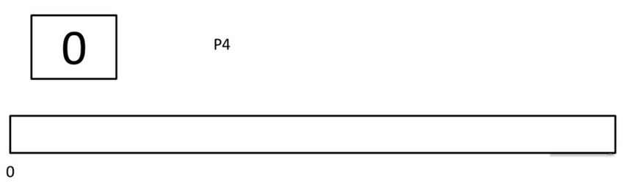
Step 1) At time= 1, Process P3 arrives. But, P4 still needs 2 execution units to complete. It will continue execution.
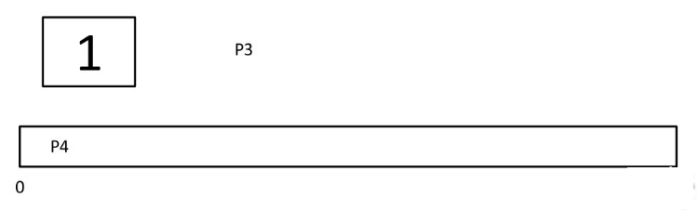
Step 2) At time =2, process P1 arrives and is added to the waiting queue. P4 will continue execution.
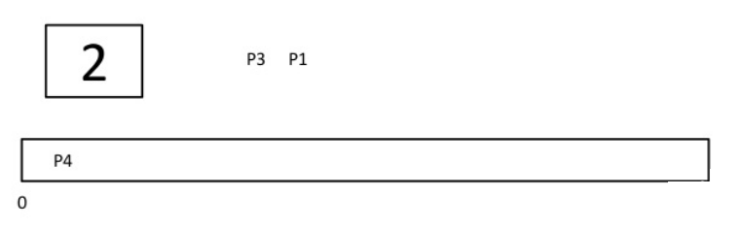
Step 3) At time = 3, process P4 will finish its execution. The burst time of P3 and P1 is compared. Process P1 is executed because its burst time is less compared to P3.
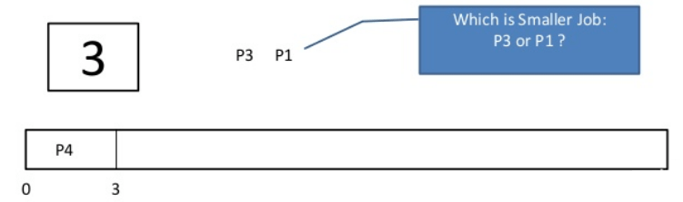
Step 4) At time = 4, process P5 arrives and is added to the waiting queue. P1 will continue execution.
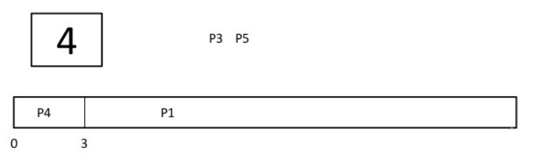
Step 5) At time = 5, process P2 arrives and is added to the waiting queue. P1 will continue execution.
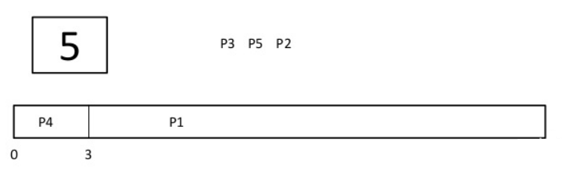
Step 6) At time = 9, process P1 will finish its execution. The burst time of P3, P5, and P2 is compared. Process P2 is executed because its burst time is the lowest.
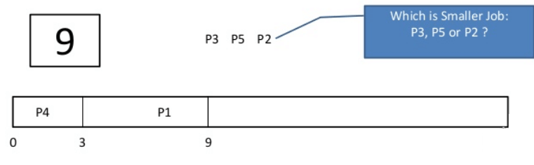
Step 7) At time=10, P2 is executing and P3 and P5 are in the waiting queue.
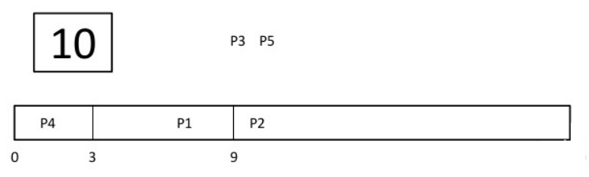
Step 8) At time = 11, process P2 will finish its execution. The burst time of P3 and P5 is compared. Process P5 is executed because its burst time is lower.
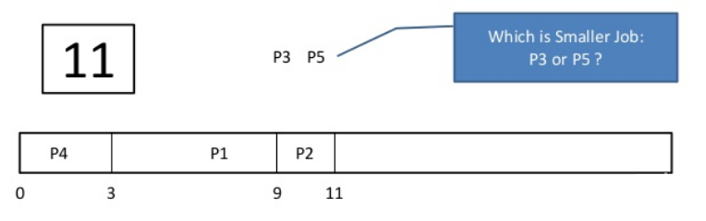
Step 9) At time = 15, process P5 will finish its execution.
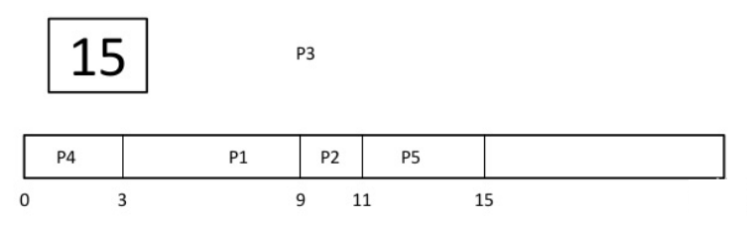
Step 10) At time = 23, process P3 will finish its execution.
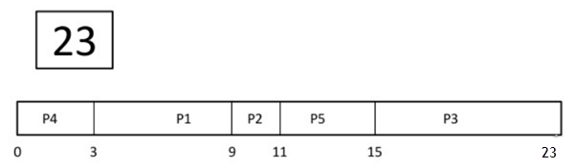
Step 11) Let's calculate the average waiting time for above example.
Wait time
P4= 0-0=0
P1= 3-2=1
P2= 9-5=4
P5= 11-4=7
P3= 15-1=14
Average Waiting Time= 0+1+4+7+14/5 = 26/5 = 5.2

Consider the following five process:
Process Queue | Burst time | Arrival time
P1 | 6 | 2
P2 | 2 | 5
P3 | 8 | 1
P4 | 3 | 0
P5 | 4 | 4
Step 0) At time=0, P4 arrives and starts execution.
Process Queue | Burst time | Arrival time
P1 | 6 | 2
P2 | 2 | 5
P3 | 8 | 1
P4 | 3 | 0
P5 | 4 | 4
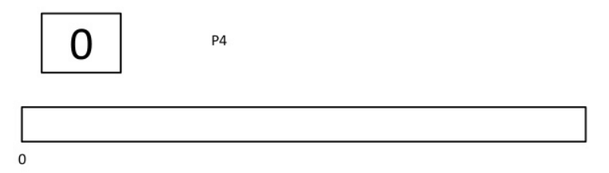
Step 1) At time= 1, Process P3 arrives. But, P4 has a shorter burst time. It will continue execution.
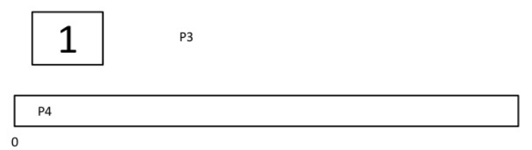
Step 2) At time = 2, process P1 arrives with burst time = 6. The burst time is more than that of P4. Hence, P4 will continue execution.
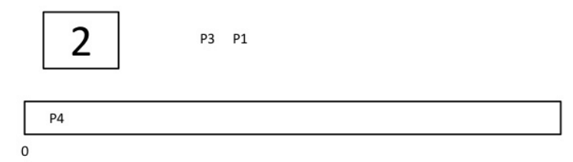
Step 3) At time = 3, process P4 will finish its execution. The burst time of P3 and P1 is compared. Process P1 is executed because its burst time is lower.
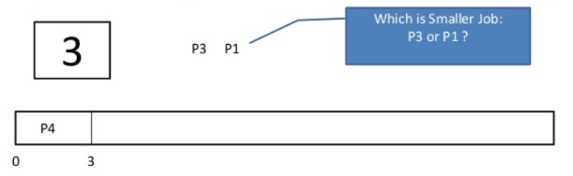
Step 4) At time = 4, process P5 will arrive. The burst time of P3, P5, and P1 is compared. Process P5 is executed because its burst time is lowest. Process P1 is preempted.
Process Queue | Burst time | Arrival time
P1 | 5 out of 6 is remaining | 2
P2 | 2 | 5
P3 | 8 | 1
P4 | 3 | 0
P5 | 4 | 4
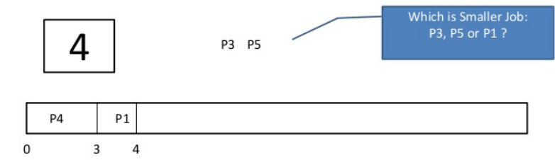
Step 5) At time = 5, process P2 will arrive. The burst time of P1, P2, P3, and P5 is compared. Process P2 is executed because its burst time is least. Process P5 is preempted.
Process Queue | Burst time | Arrival time
P1 | 5 out of 6 is remaining | 2
P2 | 2 | 5
P3 | 8 | 1
P4 | 3 | 0
P5 | 3 out of 4 is remaining | 4
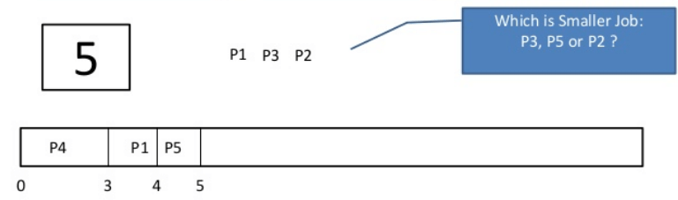
Step 6) At time =6, P2 is executing.
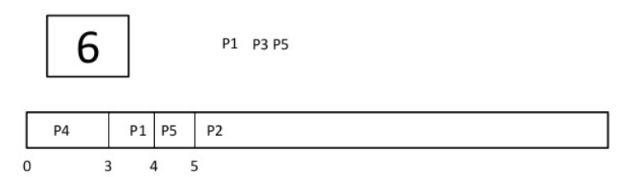
Step 7) At time =7, P2 finishes its execution. The burst time of P1, P3, and P5 is compared. Process P5 is executed because its burst time is lesser.
Process Queue | Burst time | Arrival time
P1 | 5 out of 6 is remaining | 2
P2 | 2 | 5
P3 | 8 | 1
P4 | 3 | 0
P5 | 3 out of 4 is remaining | 4
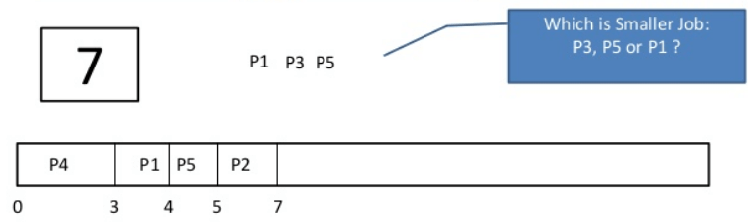

Step 8) At time =10, P5 will finish its execution. The burst time of P1 and P3 is compared. Process P1 is executed because its burst time is less.
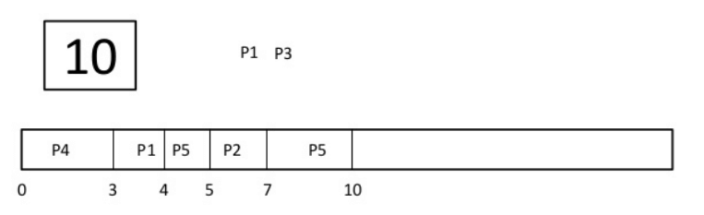
Step 9) At time =15, P1 finishes its execution. P3 is the only process left. It will start execution.
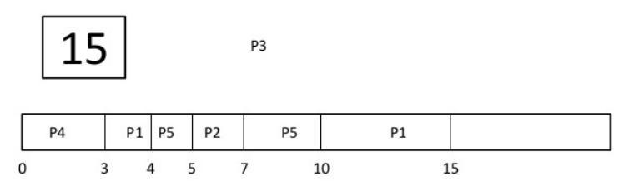
Step 10) At time =23, P3 finishes its execution.
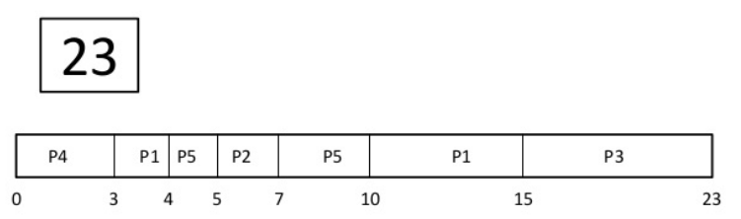
Step 11) Let's calculate the average waiting time for above example.
Wait time
P4= 0-0=0
P1= (3-2) + 6 =7
P2= 5-5 = 0
P5= 4-4+2 =2
P3= 15-1 = 14
Average Waiting Time = 0+7+0+2+14/5 = 23/5 =4.6

