First Come First Serve Scheduling
In the "First come first serve" scheduling algorithm, as the name suggests, the process which arrives first, gets executed first, or we can say that the process which requests the CPU first, gets the CPU allocated first.
- First Come First Serve, is just like FIFO(First in First out) Queue data structure, where the data element which is added to the queue first, is the one who leaves the queue first.
- This is used in Batch Systems.
- It's easy to understand and implement programmatically, using a Queue data structure, where a new process enters through the tail of the queue, and the scheduler selects process from the head of the queue.
- A perfect real life example of FCFS scheduling is buying tickets at ticket counter.

Calculating Average Waiting Time
For every scheduling algorithm, Average waiting time is a crucial parameter to judge it's performance.
AWT or Average waiting time is the average of the waiting times of the processes in the queue, waiting for the scheduler to pick them for execution.
Lower the Average Waiting Time, better the scheduling algorithm.
Consider the processes P1, P2, P3, P4 given in the below table, arrives for execution in the same order, with Arrival Time 0, and given Burst Time, let's find the average waiting time using the FCFS scheduling algorithm.
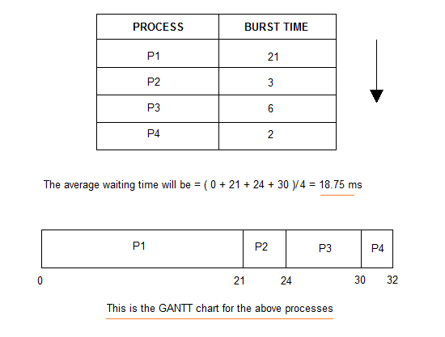
The average waiting time will be 18.75 ms
For the above given proccesses, first P1 will be provided with the CPU resources,
- Hence, waiting time for P1 will be 0
- P1 requires 21 ms for completion, hence waiting time for P2 will be 21 ms
- Similarly, waiting time for process P3 will be execution time of P1 + execution time for P2, which will be (21 + 3) ms = 24 ms.
- For process P4 it will be the sum of execution times of P1, P2 and P3.
The GANTT chart above perfectly represents the waiting time for each process.

Problems with FCFS Scheduling
Below we have a few shortcomings or problems with the FCFS scheduling algorithm:
- It is Non Pre-emptive algorithm, which means the process priority doesn't matter.
If a process with very least priority is being executed, more like daily routine backup process, which takes more time, and all of a sudden some other high priority process arrives, like interrupt to avoid system crash, the high priority process will have to wait, and hence in this case, the system will crash, just because of improper process scheduling.
- Not optimal Average Waiting Time.
- Resources utilization in parallel is not possible, which leads to Convoy Effect, and hence poor resource(CPU, I/O etc) utilization.

What is Convoy Effect?
Convoy Effect is a situation where many processes, who need to use a resource for short time are blocked by one process holding that resource for a long time.
This essentially leads to poort utilization of resources and hence poor performance.

Program for FCFS scheduling
import java.util.*;

public class FCFS
{
public static void main(String args[])
{
Scanner sc = new Scanner(System.in);
System.out.println("enter no of process: ");
int n = sc.nextInt();
int pid[] = new int[n]; // process ids
int ar[] = new int[n]; // arrival times
int bt[] = new int[n]; // burst or execution times
int ct[] = new int[n]; // completion times
int ta[] = new int[n]; // turn around times
int wt[] = new int[n]; // waiting times
int temp;
float avgwt=0,avgta=0;

for(int i = 0; i < n; i++)
{
System.out.println("enter process " + (i+1) + " arrival time: ");
ar[i] = sc.nextInt();
System.out.println("enter process " + (i+1) + " brust time: ");
bt[i] = sc.nextInt();
pid[i] = i+1;
}

//sorting according to arrival times
for(int i = 0 ; i <n; i++)
{
for(int j=0; j < n-(i+1) ; j++)
{
if( ar[j] > ar[j+1] )
{
temp = ar[j];
ar[j] = ar[j+1];
ar[j+1] = temp;
temp = bt[j];
bt[j] = bt[j+1];
bt[j+1] = temp;
temp = pid[j];
pid[j] = pid[j+1];
pid[j+1] = temp;
}
}
}

System.out.println("PROCESS\t\tARRIVAL-TIME\t\tBURST-TIME\n");
for(int i=0;i<n;i++)
{
System.out.println(" "+ pid[i] + "\t\t"+ ar[i] + "\t\t"+bt[i]);
}

// finding completion times
for(int i=0;i<n;i++)
{
if(i==0)
{
ct[i]=ar[i]+bt[i];
}
else
{
if(ar[i] > ct[i-1])
{
ct[i]=ar[i]+bt[i];
}
else
ct[i] = ct[i-1] + bt[i];
}
ta[i] = ct[i] - ar[i] ; // turnaround time= completion time- arrival time
wt[i] = ta[i] - bt[i] ; // waiting time= turnaround time- burst time
avgwt += wt[i] ; // total waiting time
avgta += ta[i] ; // total turnaround time
}
System.out.println("\npid arrival brust complete turn waiting");
for(int i = 0 ; i< n; i++)
{
System.out.println(pid[i] + " \t " + ar[i] + "\t" + bt[i] + "\t" + ct[i] + "\t" + ta[i] + "\t" + wt[i] ) ;
}
sc.close();
System.out.println("\naverage waiting time: "+ (avgwt/n)); // printing average waiting time.
System.out.println("average turnaround time:"+(avgta/n)); // printing average turnaround time.
}
}
/*=================output======================
hduser@ADMIN:~$ cd Downloads/
hduser@ADMIN:~/Downloads$ javac fcfs.java
hduser@ADMIN:~/Downloads$ java fcfs
enter no of process:
5
enter process 1 arrival time:
0
enter process 1 brust time:
2
enter process 2 arrival time:
5
enter process 2 brust time:
4
enter process 3 arrival time:
4
enter process 3 brust time:
2
enter process 4 arrival time:
4
enter process 4 brust time:
4
enter process 5 arrival time:
0
enter process 5 brust time:
1

pid arrival brust complete turn waiting
1 0 2 2 2 0
5 0 1 3 3 2
3 4 2 6 2 0
4 4 4 10 6 2
2 5 4 14 9 5

average waiting time: 1.8
average turnaround time:4.4
*/

