DATA FLOW DIAGRAM (DFD) DOCUMENTATION
Phishing Awareness Portal
AI-Based Phishing Domain Detection using Machine Learning
Levels 0 – 3
Team Members | Tejas Singh, Shashwat Singh,  Sarvesh Ranjan, Sunny Kumar
Institution | KIET Group of Institutions
Document Type | Technical / Academic Project Documentation
Version | 1.0

Document Control
Field | Value
Document Title | Data Flow Diagram (DFD) Documentation — Phishing Awareness Portal
Associated Project | AI-Based Phishing Domain Detection using Machine Learning
Version | 1.0
Status | Final
Team Members | Tejas Singh, Shashwat Singh, Sarvesh Ranjan, Sunny Kumar

Table of Contents

1. Executive Summary
The Phishing Awareness Portal is a web-based system that lets a user submit a URL and receive an instant machine-learning-based verdict on whether that URL is legitimate or phishing, along with practical safety guidance. It also gives users access to a library of cybersecurity awareness content, in support of the broader research goal of proactive phishing prevention.
This document is the formal Data Flow Diagram (DFD) specification for the portal. It models how data moves through the system at four levels of increasing detail: a whole-system context view (Level 0), the five major processing stages (Level 1), a breakdown of the three most significant stages (Level 2), and a full trace of a single URL through the machine learning detection pipeline (Level 3). Together, these diagrams form a complete and unambiguous reference for the system's data behaviour, independent of its eventual implementation technology.

2. Introduction

2.1 Background
This document supports the academic research project “AI-Based Phishing Domain Detection using Machine Learning,” undertaken at KIET Group of Institutions. The core of the project is a Random Forest classifier trained to distinguish phishing URLs from legitimate ones using structural, lexical, and security-related features extracted from the URL itself.

2.2 Purpose of this Document
- Provide a clear, leveled visual representation of how data moves between the user, system processes, and data stores.
- Serve as a reference for development, testing, and academic evaluation of the system design.
- Document the internal structure of the URL feature-extraction and phishing-classification pipeline in enough detail to guide implementation.

2.3 Scope
The diagrams cover the complete request–response cycle of the portal: URL submission and validation, feature extraction, ML-based classification, result generation, and the awareness/education module. Deployment infrastructure, user authentication, and administrative back-office functions are outside the scope of this document.

2.4 DFD Notation Used
Four notational elements are used throughout, consistent with standard Data Flow Diagram conventions:
Element | Notation | Description
External Entity | Rounded rectangle | A source or destination of data outside the system boundary (e.g., the User).
Process | Ellipse | A transformation of incoming data flows into outgoing data flows (e.g., 3.0 Phishing Detection).
Data Store | Open-ended rectangle | A repository where data is held for later use (e.g., D1: ML Model).
Data Flow | Labeled arrow | The movement of data between entities, processes, and data stores.

3. System Overview
Before decomposing the data flows, it is useful to summarise the portal's two functional pillars, which recur throughout every diagram level in this document:
Module | Responsibility
Phishing Detection | Accepts a URL from the user, extracts a set of numerical features from it, passes those features through a trained Random Forest model, and returns a Legitimate / Phishing verdict with safety recommendations.
Awareness Management | Serves educational, curated cybersecurity content to users on request, independent of the detection pipeline.
The remainder of this document decomposes these two modules — and the detection module in particular — across four levels of increasing granularity.

4. Level 0 DFD — Context Diagram
The Level 0 (context) diagram represents the Phishing Awareness Portal as a single process, showing its interaction with the sole external entity: the User. This establishes the system boundary before any internal decomposition.
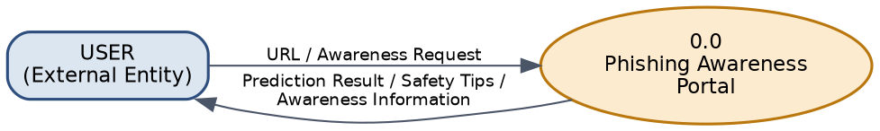
Figure 1: Level 0 DFD — Context Diagram

4.1 Description
Item | Details
Process 0 | Phishing Awareness Portal — the entire system, treated as a single unit.
Input from User | URL to be scanned; Awareness/information request.
Output to User | Phishing prediction; Safety recommendations; Awareness information.

5. Level 1 DFD — Major Processes
The Level 1 diagram decomposes the single Level 0 process into five major sub-processes, and introduces the system’s four data stores.

5.1 Processes
- 1.0 URL Input & Validation
- 2.0 URL Feature Extraction
- 3.0 Phishing Detection
- 4.0 Result Generation
- 5.0 Awareness Management

5.2 Data Stores
- D1 — ML Model
- D2 — Phishing Dataset
- D3 — Awareness Content
- D4 — Scan History (persisted scan records)
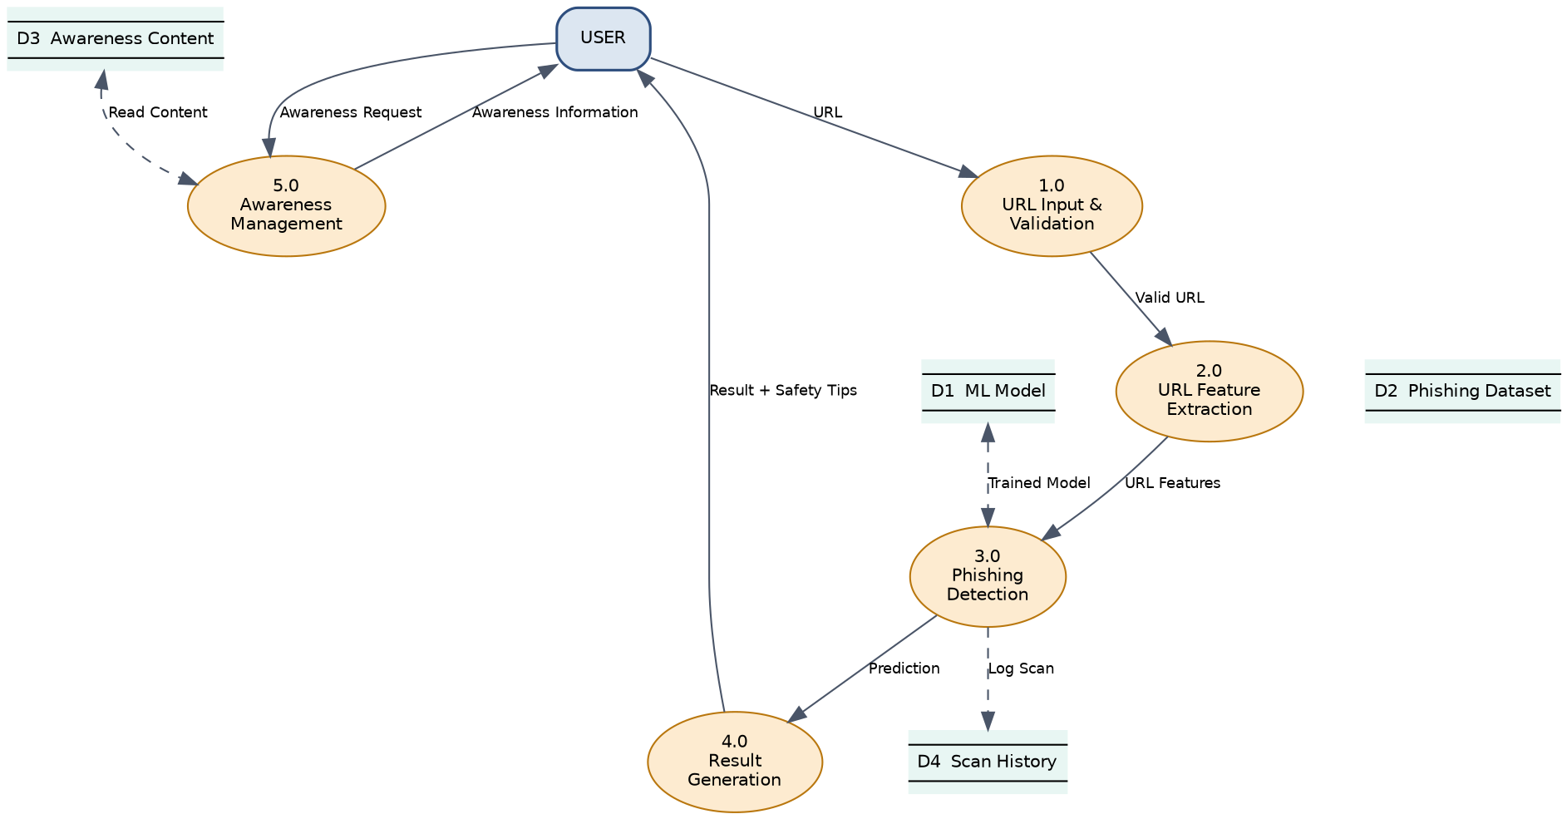
Figure 2: Level 1 DFD — Major System Processes

5.3 Data Flow Summary
From | Data | To
User | URL | 1.0 URL Input & Validation
1.0 URL Input & Validation | Valid URL | 2.0 URL Feature Extraction
2.0 URL Feature Extraction | URL Features | 3.0 Phishing Detection
D1: ML Model | Trained Model | 3.0 Phishing Detection
3.0 Phishing Detection | Prediction | 4.0 Result Generation
3.0 Phishing Detection | Scan Record | D4: Scan History
4.0 Result Generation | Result + Safety Tips | User
User | Awareness Request | 5.0 Awareness Management
D3: Awareness Content | Awareness Content | 5.0 Awareness Management
5.0 Awareness Management | Awareness Information | User

6. Level 2 DFDs — Process Decomposition
Level 2 diagrams expand the three most significant Level 1 processes — URL Feature Extraction, Phishing Detection, and Awareness Management — into their constituent sub-processes.

6.1 Decomposition of Process 2.0 — URL Feature Extraction
Process 2.0 is broken down into five sequential sub-processes that transform a validated URL into a structured feature vector suitable for the classification model.
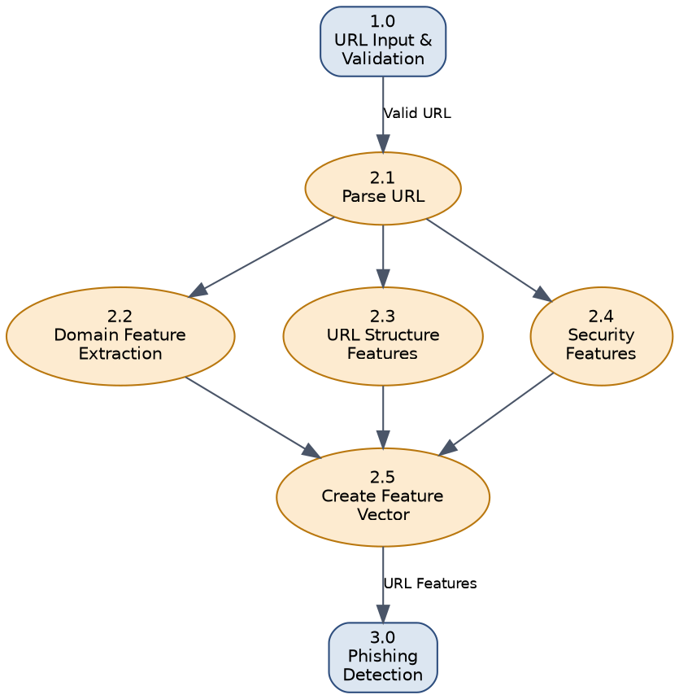
Figure 3: Level 2 DFD — URL Feature Extraction
- 2.1 Parse URL
- 2.2 Extract Domain Features
- 2.3 Extract URL Structure Features
- 2.4 Extract Security Features
- 2.5 Create Feature Vector

6.2 Decomposition of Process 3.0 — Phishing Detection
Process 3.0 covers loading the trained Random Forest model and applying it to the incoming feature vector to produce a classification.
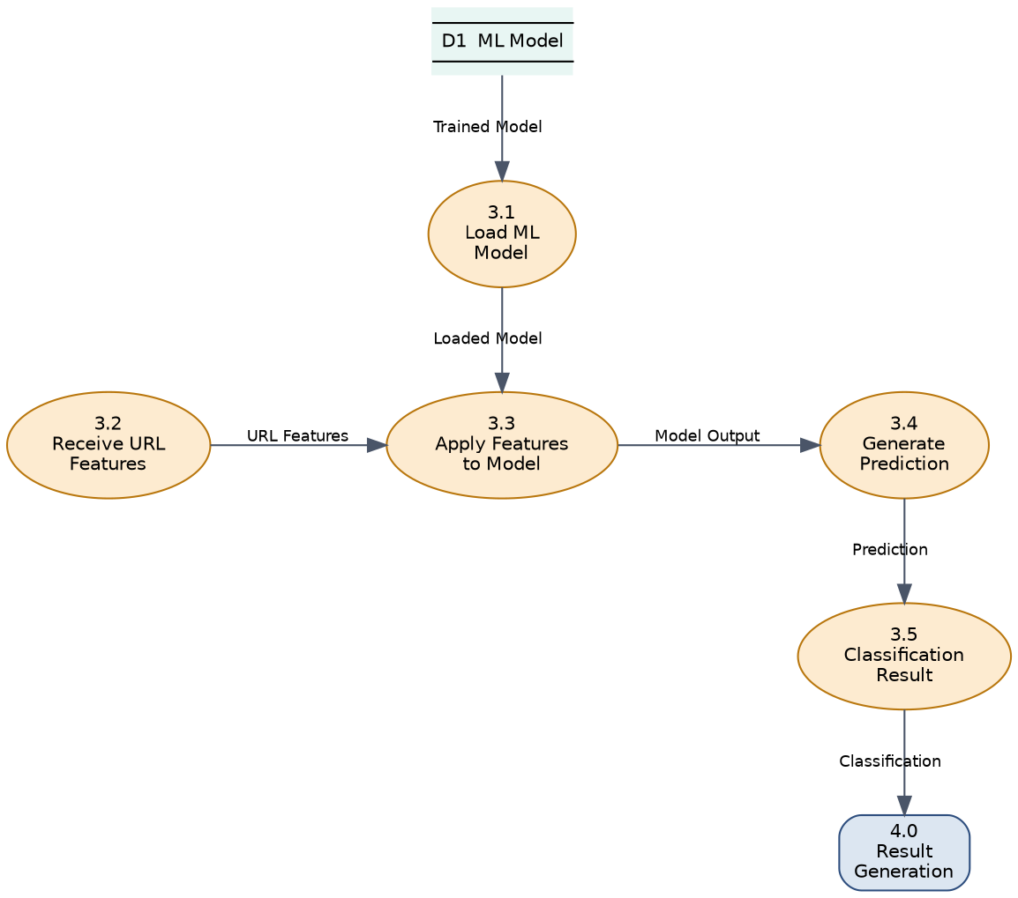
Figure 4: Level 2 DFD — Phishing Detection
- 3.1 Load ML Model
- 3.2 Receive Extracted Features
- 3.3 Apply Features to Model
- 3.4 Generate Prediction
- 3.5 Calculate Confidence / Classification

6.3 Decomposition of Process 5.0 — Awareness Management
Process 5.0 handles a user’s request for cybersecurity awareness content, retrieving and formatting material stored in D3 before presenting it back to the user.
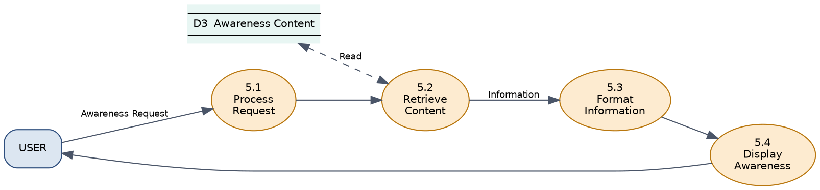
Figure 5: Level 2 DFD — Awareness Management
- 5.1 Process Request
- 5.2 Retrieve Content
- 5.3 Format Information
- 5.4 Display Awareness

7. Level 3 DFD — Detailed URL Detection Pipeline
The Level 3 diagram provides the most granular view of the system, tracing a single URL from submission through parsing, parallel feature extraction, model classification, and final result generation with safety recommendations.
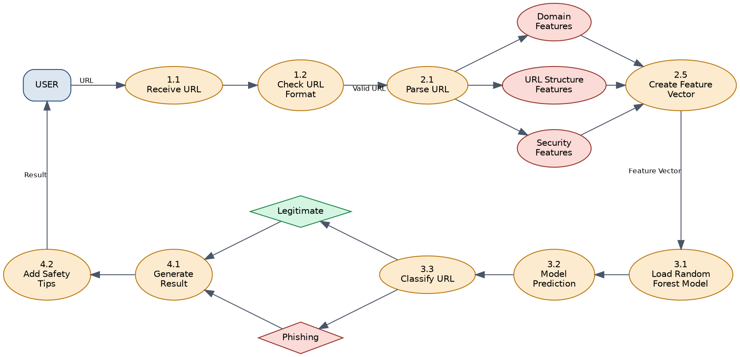
Figure 6: Level 3 DFD — Detailed ML Detection Pipeline

7.1 Pipeline Walkthrough
- 1.1 Receive URL — the submitted URL enters the system.
- 1.2 Check URL Format — basic syntactic validation of the URL.
- 2.1 Parse URL — the URL is decomposed into its components (scheme, domain, path, query).
- Domain Features, URL Structure Features, Security Features — extracted in parallel from the parsed URL.
- 2.5 Create Feature Vector — all extracted features are consolidated into a single input vector.
- 3.1 Load Random Forest Model — the trained classifier is loaded from D1.
- 3.2 Model Prediction — the feature vector is passed through the model.
- 3.3 Classify URL — the model output is mapped to a class: Legitimate or Phishing.
- 4.1 Generate Result — the classification outcome is formatted into a user-facing result.
- 4.2 Add Safety Tips — contextual safety recommendations are appended before the response reaches the user.

8. DFD Hierarchy Overview
The table below summarises how the four levels of this documentation relate to one another, moving from the whole-system context view down to the detailed ML pipeline.
Level | Focus | Description
Level 0 | Context Diagram | Entire system as one process; single external entity (User).
Level 1 | Main Processes | Five major processes; four data stores introduced.
Level 2 | Sub-Process Detail | Expansion of URL Feature Extraction, Phishing Detection, and Awareness Management.
Level 3 | Detailed ML Pipeline | Full trace of a single URL through parsing, feature extraction, classification, and result delivery.

9. Notation Reference
The following conventions were used consistently when drawing these diagrams (e.g., in draw.io):
Shape | Represents
Rounded rectangle | External Entity — e.g., User
Ellipse | Process — e.g., 1.0 URL Validation
Open-ended rectangle | Data Store — e.g., D1 ML Model
Labeled arrow | Data Flow, carrying the data item named on the arrow

10. Assumptions and Constraints
- The classification model (Random Forest) is pre-trained offline on the phishing dataset (D2); this document does not model the training pipeline itself, only its use at inference time.
- A single URL is processed per request; batch or bulk URL submission is not covered by these diagrams.
- Awareness content in D3 is treated as pre-populated, static reference material rather than user-editable content.
- Scan History (D4) is an optional persistence layer; systems that do not require historical logging may omit process 3.0's write path to D4 without affecting the rest of the design.

11. Glossary
Term | Definition
DFD | Data Flow Diagram — a graphical representation of how data moves through a system.
Feature Vector | A structured, numerical representation of a URL's characteristics, used as input to the ML model.
Random Forest | An ensemble machine learning algorithm used here to classify URLs as legitimate or phishing.
Data Store | A named repository (e.g., D1–D4) where data is held between processes.
External Entity | A person or system outside the boundary of the Phishing Awareness Portal that supplies or consumes data — in this system, the User.

12. Conclusion
The four DFD levels presented in this document give a complete, unambiguous picture of how data flows through the Phishing Awareness Portal — from a single URL entering the system to a classified, explainable result reaching the user, alongside the independent awareness-content pathway. This model can be used directly to guide implementation, to verify that the built system matches its intended design, and as supporting documentation for academic evaluation of the project.

