GRADE MANAGEMENT SYSTEM
PROJECT DOCUMENTATION

Prepared By: Tejasri Konidena
Role: Java Intern – Developers Arena
Acknowledgement
I would like to express my sincere gratitude to Developers Arena for providing me with the opportunity to work on the Grade Management System project as part of my Java Internship Program.
This project has been an excellent learning experience that allowed me to strengthen my understanding of Java programming concepts, including Object-Oriented Programming (OOP), arrays, collections, exception handling, input validation, and menu-driven application development. Through the development of this project, I gained practical exposure to designing, implementing, testing, and documenting a real-world software application.
I would also like to thank the mentors and reviewers at Developers Arena for their valuable guidance, constructive feedback, and continuous support throughout the internship. Their suggestions helped me improve my coding practices, project organization, documentation standards, and overall software development skills.
Special thanks to the Java development community and educational resources that provided valuable knowledge and references during the development process. The experience gained through this project has significantly enhanced my confidence in building Java applications and solving programming challenges.
Finally, I would like to express my gratitude to everyone who contributed directly or indirectly to the successful completion of this project.
Tejasri Konidena
Java Intern – Developers Arena
June 2026

Table of Contents
S. No | Contents
1 | Acknowledgement
2 | Table of Contents
3 | Project Overview
4 | Objectives
5 | Technologies Used
6 | System Architecture
7 | Project Structure
8 | Installation Guide
9 | Code Structure Explanation
10 | Grading System Explanation
11 | Algorithms Used
12 | Screenshots of Working Application
13 | Test Cases and Validation
14 | Conclusion
15 | References

Project Overview

The Grade Management System is a Java-based console application developed to efficiently manage and analyze student academic performance. The system allows users to enter student marks for multiple subjects, calculate average scores, assign grade categories, identify top-performing students, and generate comprehensive performance reports.

This project was designed to demonstrate fundamental and intermediate Java programming concepts, including arrays, ArrayLists, methods, loops, conditional statements, exception handling, input validation, and Object-Oriented Programming (OOP) principles. The application provides a menu-driven interface that enables users to perform various operations in a simple and user-friendly manner.

The primary purpose of the system is to automate the process of managing student grades, reducing manual calculations, and ensuring accurate performance evaluation. By implementing grade calculation algorithms and report generation features, the application provides valuable insights into student performance and academic achievement.

The project also emphasizes software development best practices such as modular programming, code reusability, proper documentation, error handling, and structured project organization. Through the development of this application, practical experience was gained in designing, implementing, testing, and documenting a real-world Java application.

Overall, the Grade Management System serves as an effective educational project that demonstrates the application of Java programming techniques to solve real-world academic management problems.

Objectives

The main objectives of the Grade Management System project are:

To develop a user-friendly Java console application for managing student academic records.

To provide an efficient system for storing and processing student marks across multiple subjects.

To calculate average marks automatically and reduce manual calculation errors.

To implement a grading system that categorizes student performance based on predefined grade criteria.

To generate performance reports that help analyze individual and overall student achievement.

To identify top-performing students based on their academic results.

To implement input validation techniques to ensure data accuracy and reliability.

To handle invalid inputs and runtime errors using exception handling mechanisms.

To provide a menu-driven interface that enables easy navigation and interaction with the system.

To demonstrate the practical application of Java programming concepts such as arrays, ArrayLists, methods, loops, conditional statements, and Object-Oriented Programming (OOP).

To improve problem-solving, programming, and software development skills through the creation of a real-world academic management application.

To follow software engineering best practices including modular programming, code reusability, documentation, and testing.

By achieving these objectives, the project provides a comprehensive understanding of Java application development and the implementation of student performance management systems.

Technologies Used

The Grade Management System was developed using the following technologies and programming concepts:
Technology / Concept | Purpose
Java | Primary programming language used for developing the application.
JDK 8+ | Java Development Kit required for compiling and running Java programs.
Arrays | Used to store subject marks for each student.
ArrayList | Used to dynamically manage and store multiple student records.
Scanner Class | Used to accept user input from the console.
Exception Handling | Used to handle invalid inputs and prevent program crashes.
Object-Oriented Programming (OOP) | Used to organize the application into classes and objects for better code structure and reusability.
Methods | Used to divide the program into reusable and manageable modules.
Conditional Statements | Used for decision-making operations such as grade assignment and menu selection.
Loops | Used to process multiple records and perform repetitive tasks efficiently.
Eclipse IDE | Used as the development environment for coding, testing, and debugging the application.
GitHub | Used for project version control, code hosting, and project submission.

Development Environment

Programming Language: Java

IDE: Eclipse IDE

Version Control: Git & GitHub

Operating System: Windows 10/11

Java Version: JDK 8 or above

The combination of these technologies enabled the development of a structured, reliable, and user-friendly Grade Management System capable of managing student academic performance efficiently.

System Architecture

The Grade Management System follows a simple layered architecture that separates user interaction, business logic, data processing, and reporting functionalities. This structure improves code organization, maintainability, and scalability.

Architecture Overview

User Interface Layer → Business Logic Layer → Data Processing Layer → Reporting Layer

1. User Interface Layer

The User Interface Layer is responsible for interacting with the user through a menu-driven console interface.

Responsibilities

Display application menus

Accept user input

Validate menu selections

Display results and messages

Main Class

GradeManagementSystem.java

2. Business Logic Layer

The Business Logic Layer processes user requests and performs application operations.

Responsibilities

Add student records

Search student information

Calculate averages

Determine grades

Identify top performers

Main Classes

GradeManagementSystem.java

GradeCalculator.java

3. Data Processing Layer

The Data Processing Layer manages student data and performs calculations.

Responsibilities

Store student information

Manage subject marks

Perform mathematical calculations

Process academic records

Main Class

StudentGrade.java

4. Reporting Layer

The Reporting Layer generates performance summaries and analytical reports.

Responsibilities

Generate student reports

Display grades

Calculate class averages

Present performance statistics

Main Class

ReportGenerator.java

System Workflow

The user selects an option from the menu.

The User Interface Layer receives the input.

The Business Logic Layer processes the request.

The Data Processing Layer performs calculations and data operations.

The Reporting Layer generates output and displays results to the user.

The user receives the requested information on the console.

Architecture Diagram

+------------------------+

| User Interface Layer |

| (GradeManagementSystem)|

+-----------+------------+

|

v

+------------------------+

| Business Logic Layer |

| (GradeCalculator) |

+-----------+------------+

|

v

+------------------------+

| Data Processing Layer |

| (StudentGrade) |

+-----------+------------+

|

v

+------------------------+

| Reporting Layer |

| (ReportGenerator) |

+------------------------+

The layered architecture ensures that each component has a specific responsibility, making the application easier to understand, maintain, and extend in future versions.

Project Structure

The Grade Management System project is organized into multiple directories and source files to ensure proper code management, maintainability, and readability. Each file has a specific responsibility within the application.

Directory Structure

GradeManagementSystem/

│

├── README.md

│

├── src/

│ ├── StudentGrade.java

│ ├── GradeCalculator.java

│ ├── ReportGenerator.java

│ └── GradeManagementSystem.java

│

├── docs/

│ ├── ProjectDocumentation.docx

│ ├── InstallationGuide.md

│ └── UserManual.md

│

├── examples/

│ └── sample-test-data.txt

│

└── screenshots/

├── main-menu.png

├── add-student.png

├── search-student.png

├── report.png

└── top-performer.png

Source Code Files

StudentGrade.java

Purpose:
Represents a student and stores all academic information.

Responsibilities:

Store student name

Store subject marks

Provide getter methods

Display student information

Act as the data model of the application

GradeCalculator.java

Purpose:
Performs all grade-related calculations.

Responsibilities:

Calculate average marks

Determine highest mark

Determine lowest mark

Assign grade categories

Process academic performance calculations

ReportGenerator.java

Purpose:
Generates performance reports and summaries.

Responsibilities:

Generate student performance reports

Display class statistics

Calculate class average

Present grade summaries

GradeManagementSystem.java

Purpose:
Main application entry point and user interface controller.

Responsibilities:

Display menu options

Accept user input

Perform application operations

Coordinate communication between classes

Handle exceptions and validations

Documentation Folder (docs)

The docs folder contains all project-related documentation.

Files Included
File Name | Description
ProjectDocumentation.docx | Complete project report
InstallationGuide.md | Setup and installation instructions
UserManual.md | Guide for using the application

Examples Folder

The examples folder contains sample data used for testing and demonstration purposes.

Files Included
File Name | Description
sample-test-data.txt | Sample student records and marks

Screenshots Folder

The screenshots folder contains images demonstrating application functionality.

Screenshots Included

Main Menu

Add Student Marks

View Students

Search Student

Calculate Averages

Top Performer

Generate Report

Benefits of This Structure

Improves project organization

Separates source code and documentation

Simplifies maintenance and future enhancements

Makes the project easier for reviewers to understand

Follows professional software development practices

This structured organization ensures that the Grade Management System remains scalable, maintainable, and easy to navigate for both developers and reviewers.

Installation Guide

Introduction

This section provides step-by-step instructions for setting up, compiling, and running the Grade Management System on a local machine. The application is developed using Java and can be executed on any system with a compatible Java Development Kit (JDK) installed.

System Requirements

Before installing and running the application, ensure that the following requirements are met:
Requirement | Details
Operating System | Windows 10/11, Linux, or macOS
Programming Language | Java
Java Version | JDK 8 or higher
IDE (Optional) | Eclipse, IntelliJ IDEA, VS Code
Storage Space | Minimum 100 MB
Memory | Minimum 2 GB RAM

Software Installation

Step 1: Install Java Development Kit (JDK)

Download the latest JDK from the official Oracle website.

Run the installer and follow the installation instructions.

Verify the installation by opening Command Prompt and running:

java -version

Expected Output:

java version "1.8.0" or higher

Step 2: Download the Project

Clone the repository using Git:

git clone https://github.com/Tejas-Web-Design/Grade-Management-System

Or download the project ZIP file and extract it to a local folder.

Step 3: Open the Project

Open the project using any Java IDE such as:

Eclipse IDE

IntelliJ IDEA

Visual Studio Code

Navigate to the project folder and import it into the IDE.

Compilation Process

Open Command Prompt or Terminal inside the src folder.

Compile all Java source files using:

javac *.java

This command generates the required .class files for execution.

Running the Application

After successful compilation, execute the program using:

java GradeManagementSystem

The application will launch and display the main menu.

Expected Application Startup

====================================================

GRADE MANAGEMENT SYSTEM

====================================================

Developer : Tejasri Konidena

Role : Java Intern - Developers Arena

====================================================

1. Add Student Marks

2. View All Students

3. Search Student

4. Calculate Averages

5. Find Top Performer

6. Generate Report

7. Exit

Troubleshooting

Java Not Found Error

If the system displays:

'java' is not recognized as an internal or external command

Solution:

Ensure Java is installed correctly.

Configure the JAVA_HOME environment variable.

Add Java to the system PATH.

Compilation Errors

Possible causes:

Missing source files

Incorrect file names

Typographical errors in code

Solution:

Verify all files exist in the src directory.

Recompile the project.

Runtime Errors

If unexpected errors occur:

Verify valid user input.

Ensure marks are entered between 0 and 100.

Restart the application and test again.

Installation Verification

The installation is considered successful if:

✅ The project compiles without errors.

✅ The application launches successfully.

✅ Menu options are displayed correctly.

✅ Student records can be added and viewed.

✅ Reports are generated successfully.

This confirms that the Grade Management System is properly installed and ready for use.

Code Structure Explanation

The Grade Management System follows a modular design approach, where each class is assigned a specific responsibility. This improves code readability, maintainability, and reusability. The project is divided into four main Java classes that work together to provide the complete functionality of the application.

1. StudentGrade.java

Purpose

The StudentGrade class represents a student and serves as the data model of the application. It stores student information and subject marks.

Responsibilities

Store student name

Store marks obtained in different subjects

Provide getter methods to access student data

Display student information in a formatted manner

Act as a container for academic records

Key Attributes

name – Stores the student's name

marks[] – Stores marks for all subjects

Example Functions

getName()

getMarks()

displayStudent()

2. GradeCalculator.java

Purpose

The GradeCalculator class contains all methods related to academic calculations and grade determination.

Responsibilities

Calculate average marks

Determine highest mark

Determine lowest mark

Assign grade categories based on average marks

Process student performance data

Key Functions
Method | Purpose
calculateAverage() | Computes average marks
getHighestMark() | Finds highest mark
getLowestMark() | Finds lowest mark
getGrade() | Assigns grade category

Benefits

Centralizes all calculation logic

Reduces code duplication

Improves maintainability

3. ReportGenerator.java

Purpose

The ReportGenerator class is responsible for generating performance reports and summaries.

Responsibilities

Generate student performance reports

Display average scores

Display grade categories

Calculate class average

Present academic statistics

Key Functions
Method | Purpose
generateReport() | Creates performance reports

Output Generated

Student Name

Average Marks

Grade

Class Average

4. GradeManagementSystem.java

Purpose

The GradeManagementSystem class serves as the main entry point of the application and controls the overall program flow.

Responsibilities

Display menu options

Accept user input

Perform CRUD-like operations

Coordinate communication between classes

Handle exceptions and validations

Execute application logic

Main Features

Add Student Marks

View All Students

Search Student

Calculate Averages

Find Top Performer

Generate Report

Exit Application

Validation Features

Prevents invalid menu choices

Ensures marks remain between 0 and 100

Handles non-numeric inputs using exception handling

Class Interaction Flow

User

│

▼

GradeManagementSystem

│

├── StudentGrade

│ Stores student data

│

├── GradeCalculator

│ Performs calculations

│

└── ReportGenerator

Generates reports

Workflow

The user selects an option from the menu.

The GradeManagementSystem processes the request.

Student data is stored using the StudentGrade class.

Academic calculations are performed using GradeCalculator.

Reports and summaries are generated using ReportGenerator.

Results are displayed to the user.

Advantages of the Code Structure

Modular and easy to understand

Promotes code reusability

Simplifies debugging and maintenance

Follows Object-Oriented Programming principles

Improves scalability for future enhancements

This structured design ensures that each class has a clearly defined responsibility, resulting in a clean, organized, and maintainable Java application.

Grading System Explanation

The Grade Management System uses a predefined grading scale to evaluate student academic performance based on their average marks. After calculating the average score across all subjects, the system automatically assigns a grade category that reflects the student's overall performance.

The grading system helps in standardizing student evaluation and provides a clear indication of academic achievement. This automated process eliminates manual grading errors and ensures consistency in performance assessment.

Grade Classification Table
Average Marks (%) | Grade | Performance Level
90 – 100 | A+ | Outstanding
80 – 89 | A | Excellent
70 – 79 | B | Very Good
60 – 69 | C | Good
50 – 59 | D | Satisfactory
Below 50 | F | Fail

Grade Calculation Process

The application follows these steps to determine a student's grade:

Step 1: Enter Subject Marks

The user enters marks for the following subjects:

Mathematics

Science

English

History

Computer

Step 2: Calculate Average Marks

The system calculates the average using the formula:

Average Marks = Total Marks Obtained ÷ Number of Subjects

For example:
Subject | Marks
Mathematics | 85
Science | 90
English | 88
History | 80
Computer | 92

Total Marks = 85 + 90 + 88 + 80 + 92 = 435

Average Marks = 435 ÷ 5 = 87.00

Step 3: Assign Grade

Based on the calculated average:

Average = 87.00

Assigned Grade = A

Performance Level = Excellent

Example Grade Evaluation
Student Name | Average Marks | Grade
Alice Johnson | 93.40 | A+
Bob Wilson | 84.20 | A
Charlie Brown | 75.60 | B
Diana Smith | 64.80 | C
Ethan Davis | 54.20 | D
John Miller | 42.10 | F

Benefits of the Grading System

Provides a standardized method of evaluating student performance.

Reduces manual calculation and grading errors.

Enables quick identification of top-performing students.

Improves transparency in academic assessment.

Helps generate meaningful performance reports.

Implementation in the Application

The grading logic is implemented in the GradeCalculator.java class through the getGrade() method. After calculating the average marks, the method compares the result against predefined grade ranges and returns the appropriate grade category.

This grading mechanism ensures accurate, consistent, and automated evaluation of student academic performance throughout the Grade Management System.

Algorithms Used

The Grade Management System utilizes several algorithms to process student data, calculate academic performance, and generate reports. These algorithms ensure accurate calculations, efficient data processing, and meaningful performance evaluation.

1. Average Calculation Algorithm

Purpose

To calculate the average marks obtained by a student across all subjects.

Formula

Average Marks = Total Marks ÷ Number of Subjects

Steps

Initialize a variable to store the total marks.

Traverse through all subject marks.

Add each mark to the total.

Divide the total by the number of subjects.

Return the calculated average.

Pseudocode

total = 0

FOR each mark IN marks

total = total + mark

END FOR

average = total / number_of_subjects

RETURN average

Time Complexity

O(n)

where n is the number of subjects.

2. Highest Marks Algorithm

Purpose

To identify the highest mark obtained by a student among all subjects.

Steps

Assume the first mark is the highest.

Compare each mark with the current highest mark.

Update the highest value when a larger mark is found.

Return the highest mark.

Pseudocode

highest = marks[0]

FOR each mark IN marks

IF mark > highest

highest = mark

END IF

END FOR

RETURN highest

Time Complexity

O(n)

3. Lowest Marks Algorithm

Purpose

To determine the lowest mark obtained by a student.

Steps

Assume the first mark is the lowest.

Compare each mark with the current lowest mark.

Update the lowest value when a smaller mark is found.

Return the lowest mark.

Pseudocode

lowest = marks[0]

FOR each mark IN marks

IF mark < lowest

lowest = mark

END IF

END FOR

RETURN lowest

Time Complexity

O(n)

4. Grade Assignment Algorithm

Purpose

To assign a grade category based on the student's average marks.

Grading Criteria
Average Marks | Grade
90 – 100 | A+
80 – 89 | A
70 – 79 | B
60 – 69 | C
50 – 59 | D
Below 50 | F

Steps

Calculate the average marks.

Compare the average with predefined grade ranges.

Assign the corresponding grade.

Return the grade.

Pseudocode

IF average >= 90

grade = "A+"

ELSE IF average >= 80

grade = "A"

ELSE IF average >= 70

grade = "B"

ELSE IF average >= 60

grade = "C"

ELSE IF average >= 50

grade = "D"

ELSE

grade = "F"

END IF

Time Complexity

O(1)

5. Search Algorithm

Purpose

To locate a student record based on the student's name.

Algorithm Used

Linear Search

Steps

Start from the first student record.

Compare the entered name with each stored name.

If a match is found, display the student's details.

If no match is found after checking all records, display "Student Not Found".

Pseudocode

FOR each student IN studentList

IF student.name == searchName

DISPLAY student details

RETURN

END IF

END FOR

DISPLAY "Student Not Found"

Time Complexity

O(n)

where n is the number of student records.

Algorithm Summary
Algorithm | Purpose | Complexity
Average Calculation | Calculate average marks | O(n)
Highest Marks | Find highest subject score | O(n)
Lowest Marks | Find lowest subject score | O(n)
Grade Assignment | Assign grade category | O(1)
Linear Search | Search student by name | O(n)

Benefits of the Implemented Algorithms

Simple and easy to understand.

Efficient for small to medium-sized datasets.

Provides accurate academic performance evaluation.

Supports automated report generation.

Demonstrates practical implementation of Java programming concepts.

These algorithms form the core logic of the Grade Management System and enable reliable management and analysis of student academic performance.

Screenshots of Working Application

This section provides visual evidence of the successful implementation and execution of the Grade Management System. The screenshots demonstrate the application's user interface, functionality, and output generated during testing.

Screenshot 1 – Main Menu

Description:
Displays the main menu of the Grade Management System with all available options including Add Student Marks, View Students, Search Student, Calculate Averages, Find Top Performer, Generate Report, and Exit.

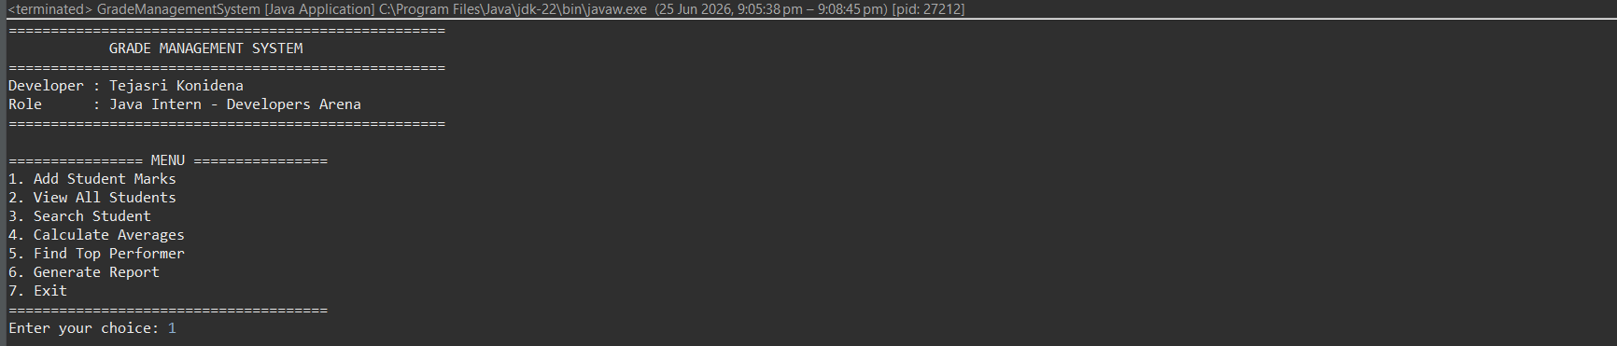

Screenshot 2 – Add Student Marks
Description:
Shows the process of entering student details and marks for all subjects. The system validates the entered marks before storing the record.
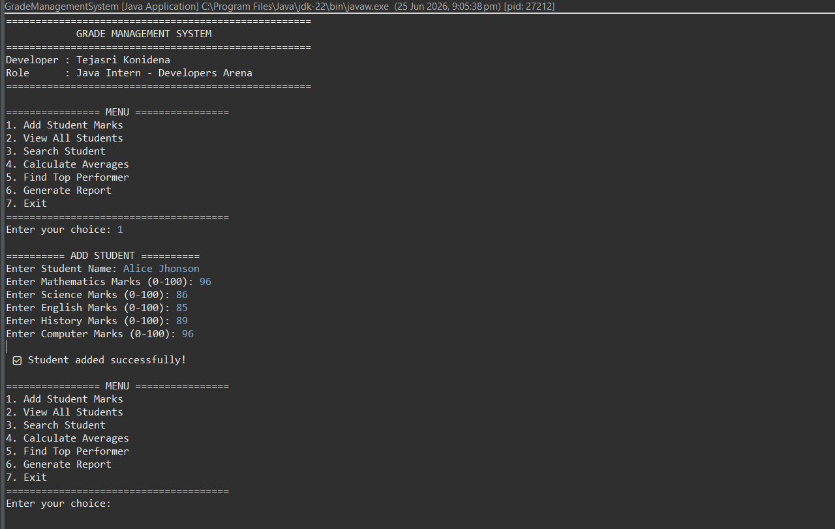

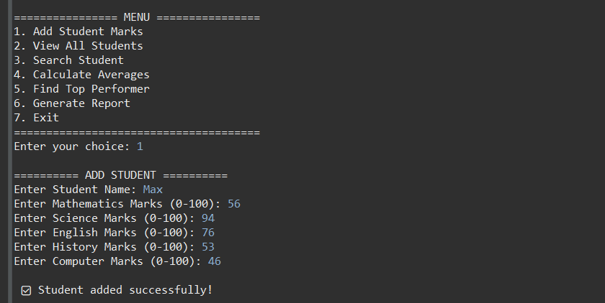

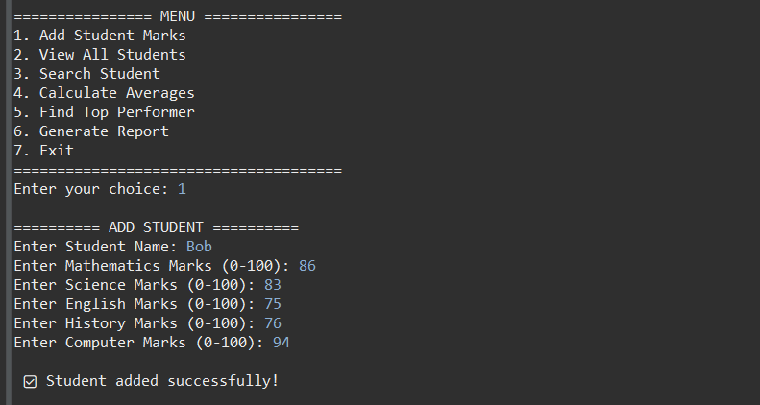

Screenshot 3 – View All Students

Description:
Displays all stored student records in a formatted tabular structure, including subject marks and calculated averages.

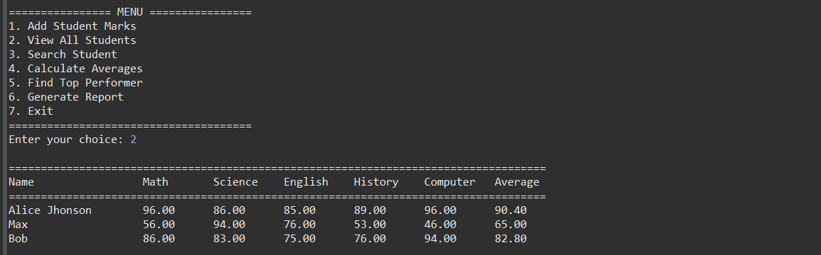

Screenshot 4 – Search Student

Description:
Demonstrates the student search functionality using the student's name and displays the corresponding academic details.
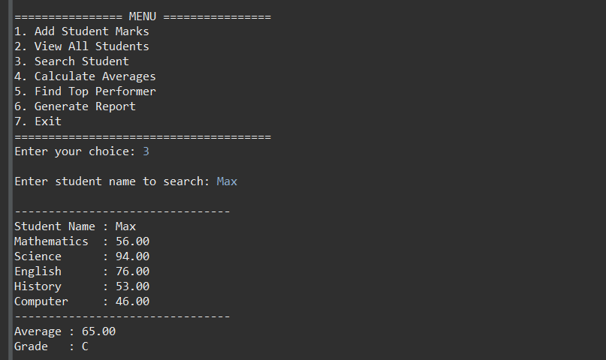
Screenshot 5 – Calculate Averages
Description:
Shows the calculation of average marks and grade assignment for each student.
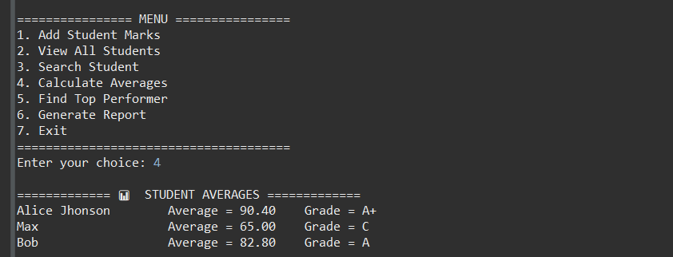

Screenshot 6 – Top Performer

Description:
Displays the student with the highest average marks and the corresponding grade category.
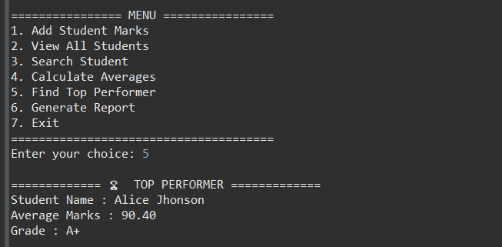

Screenshot 7 – Generate Report

Description:
Shows the generated performance report containing student averages, grades, and class statistics.
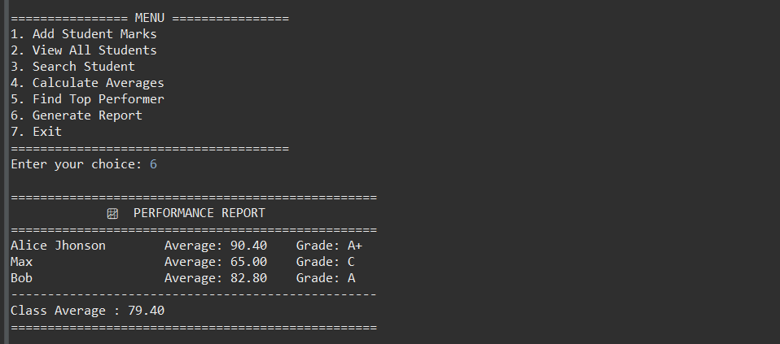

Test Cases and Validation

Testing was conducted to ensure that all functionalities of the Grade Management System operate correctly under both valid and invalid input conditions.

Functional Test Cases
Test Case ID | Test Scenario | Input | Expected Result | Status
TC-01 | Add Student | Valid student data | Student added successfully | Pass
TC-02 | Add Student | Empty student name | Validation error message | Pass
TC-03 | Add Student | Marks greater than 100 | Validation error message | Pass
TC-04 | Add Student | Negative marks | Validation error message | Pass
TC-05 | Search Student | Existing student name | Student details displayed | Pass
TC-06 | Search Student | Non-existing student name | Student not found message | Pass
TC-07 | Calculate Average | Valid marks | Correct average calculated | Pass
TC-08 | Grade Assignment | Average = 92 | Grade A+ assigned | Pass
TC-09 | Grade Assignment | Average = 75 | Grade B assigned | Pass
TC-10 | Generate Report | Multiple students | Performance report generated | Pass
TC-11 | Top Performer | Multiple student records | Highest performer identified | Pass
TC-12 | Invalid Input | Alphabet entered for marks | Error handled successfully | Pass

Validation Techniques Implemented

The application includes several validation mechanisms to ensure data accuracy and system reliability:

Student name cannot be empty.

Marks must be numeric values.

Marks must be within the range of 0 to 100.

Invalid menu selections are rejected.

Exception handling prevents application crashes due to incorrect user input.

Search operations verify the existence of student records before displaying results.

These validations improve the reliability, usability, and robustness of the application.

Conclusion

The Grade Management System successfully fulfils all project requirements and demonstrates the practical application of Java programming concepts in an academic performance management environment.

The system provides a user-friendly menu-driven interface that enables users to manage student marks efficiently, calculate averages automatically, assign grades accurately, identify top-performing students, and generate meaningful performance reports. The implementation of input validation and exception handling ensures data integrity and enhances application reliability.

Through the development of this project, valuable experience was gained in Object-Oriented Programming (OOP), arrays, ArrayLists, methods, loops, conditional statements, exception handling, and software documentation. The project also reinforced best practices related to modular programming, code organization, testing, and reporting.

Overall, the Grade Management System serves as an effective learning project and demonstrates the ability to design, develop, test, and document a complete Java application that addresses a real-world academic management problem.

References

The following resources were used during the development of the Grade Management System:

Oracle Java Documentation

Java SE Development Kit (JDK) Documentation

Eclipse IDE Documentation

Java Programming Tutorials and Learning Resources

Developers Arena Internship Guidelines

Official Java API Documentation

Object-Oriented Programming (OOP) Concepts and Reference Materials

Academic Project Documentation Standards

These references provided valuable technical knowledge, programming guidance, and best practices that contributed to the successful completion of the project.

