📘Library Management System

Submitted By
Tejasri Konidena
Java Intern
Developers Arena

Submission Date: 28-06-2026
Acknowledgement
I would like to express my sincere gratitude to Developers Arena for providing me with the opportunity to work on the Library Management System project as part of my Java Internship. This project has been a valuable learning experience that allowed me to apply theoretical Java concepts to a practical, real-world application.
During the development of this project, I strengthened my understanding of Object-Oriented Programming (OOP), Java Collections, file handling, exception handling, input validation, and modular programming. Working on this project also helped me improve my problem-solving abilities, coding practices, and software development skills.
I am sincerely thankful to the mentors and reviewers at Developers Arena for their guidance, encouragement, and constructive feedback throughout the internship. Their suggestions motivated me to improve the quality of my code, documentation, and overall project presentation.
Finally, I would like to thank everyone who supported and encouraged me during the successful completion of this project. This internship has been an enriching experience that has enhanced both my technical knowledge and confidence in developing Java applications, and it has motivated me to continue learning and growing as a software developer.
Tejasri Konidena
Java Intern – Developers Arena
June 2026

Table of Contents
S. No | Contents
1 | Acknowledgement
2 | Table of Contents
3 | Project Overview
4 | Objectives
5 | Technologies Used
6 | System Architecture
7 | Project Structure
8 | Installation Guide
9 | Code Structure Explanation
10 | Grading System Explanation
11 | Algorithms Used
12 | Screenshots of Working Application
13 | Test Cases and Validation
14 | Conclusion
15 | References

Project Overview

The Library Management System is a Java-based console application developed to efficiently manage books, library members, and day-to-day library operations through a user-friendly, menu-driven interface. The system enables librarians to perform essential tasks such as adding new books, registering members, searching for books, borrowing and returning books, viewing available books, generating reports, and maintaining library records.

The project has been designed using Object-Oriented Programming (OOP) principles to ensure modularity, maintainability, and code reusability. It also incorporates Java Collections, file handling, exception handling, and input validation to provide a reliable and efficient library management solution.

The application stores book and member information using text files, allowing data to persist between program executions. This project demonstrates the practical implementation of core Java programming concepts while simulating a real-world library management environment.

This project was developed as part of the Java Internship at Developers Arena to strengthen practical Java development skills and gain hands-on experience in designing, developing, and documenting software applications.

Objectives

The primary objectives of the Library Management System are:

Develop a menu-driven Java application for managing library operations.

Apply Object-Oriented Programming concepts such as classes, objects, encapsulation, constructors, and modular design.

Efficiently manage book and member records using Java Collections (Array List).

Implement book borrowing and returning functionality.

Provide search functionality using ISBN, title, and author.

Validate user inputs to improve application reliability.

Generate library reports and statistical summaries.

Store and retrieve data using file handling techniques.

Implement exception handling for robust error management.

Improve software modularity, readability, maintainability, and code organization.

Technologies Used

The Library Management System was developed using the following technologies and programming concepts:
Technology / Concept |  |  | Purpose
Java |  |  | Primary programming language used for developing the application.
JDK 8+ |  |  | Java Development Kit required for compiling and running Java programs.
Arrays |  |  | Used to store subject marks for each student.
ArrayList |  |  | Used to dynamically manage and store multiple student records.
Scanner Class |  |  | Used to accept user input from the console.
Exception Handling |  |  | Used to handle invalid inputs and prevent program crashes.
Object-Oriented Programming (OOP) |  |  | Used to organize the application into classes and objects for better code structure and reusability.
Methods |  |  | Used to divide the program into reusable and manageable modules.
Conditional Statements |  |  | Used for decision-making operations such as grade assignment and menu selection.
Loops |  |  | Used to process multiple records and perform repetitive tasks efficiently.
Eclipse IDE |  |  | Used as the development environment for coding, testing, and debugging the application.
GitHub |  |  | Used for project version control, code hosting, and project submission.
 | BufferedReader | Reads book and member data from text files

BufferedWriter | Writes book and member data to text files

Development Environment

Programming Language: Java

IDE: Eclipse IDE

Version Control: Git & GitHub

Operating System: Windows 10/11

Java Version: JDK 8 or above

The combination of these technologies enabled the development of a structured, reliable, and user-friendly Library Management System capable of managing student academic performance efficiently.

System Architecture

Overview

The Library Management System follows a simple layered architecture that separates user interaction, business logic, data management, and file storage. This modular design improves code readability, maintainability, and scalability while promoting the principles of Object-Oriented Programming (OOP).

The system begins with the user interacting through a menu-driven console interface. User requests are processed by the main application, which delegates operations to the appropriate classes responsible for validation, business logic, and data storage.

Architecture Flow

User

│

▼

LibrarySystem.java

(Menu-Driven User Interface)

│

┌─────────────┼─────────────┐

▼ ▼ ▼

ValidationUtils Library.java FileHandler.java

(Input Validation) (Business Logic) (File Operations)

│

┌──────────┴──────────┐

▼ ▼

Book.java Member.java

(Book Information) (Member Information)

│

▼

books.txt / members.txt

(Persistent Storage)

Layer Description

1. User Interface Layer

The LibrarySystem.java class serves as the main entry point of the application. It displays the menu, accepts user input, invokes the required operations, and presents results to the user.

2. Validation Layer

The ValidationUtils.java class validates all user inputs before processing. It ensures that ISBN numbers, member IDs, names, and contact numbers follow the required format and prevents invalid data from entering the system.

3. Business Logic Layer

The Library.java class contains the core business logic of the application. It manages all library operations, including adding books, registering members, searching records, borrowing books, returning books, removing records, generating reports, and calculating library statistics.

4. Data Model Layer

The Book.java and Member.java classes represent the application's data models. These classes encapsulate book and member information using private attributes, constructors, getters, and setters while supporting Object-Oriented Programming principles such as encapsulation and abstraction.

5. File Management Layer

The FileHandler.java class is responsible for saving and loading data using text files. It uses Java's BufferedReader and BufferedWriter classes to maintain persistent storage, ensuring that book and member records remain available even after the application is closed.

Benefits of the Architecture

Clear separation of responsibilities between classes.

Improved code readability and maintainability.

Modular design that simplifies future enhancements.

Reusable validation and file handling components.

Efficient management of books and members using Java Collections.

Reliable data persistence through file handling.

Easy integration of additional features without affecting existing functionality.

Project Structure

The Library Management System is organized into separate folders and Java source files to ensure a clean, modular, and maintainable project structure. Each file has a specific responsibility, making the application easier to understand, develop, test, and maintain.
Project Directory Structure
LibraryManagementSystem/
│
├── README.md
│
├── src/
│ ├── Book.java
│ ├── Member.java
│ ├── Library.java
│ ├── ValidationUtils.java
│ ├── FileHandler.java
│ └── LibrarySystem.java
│
├── docs/
│ ├── ProjectDocumentation.docx
│ ├── InstallationGuide.md
│ └── UserManual.md
│
├── examples/
│ ├── books.txt
│ ├── members.txt
│ └── sample-data.txt
│
└── screenshots/
├── MainMenu.png
├── AddBook.png
├── RegisterMember.png
├── ViewBooks.png
├── BorrowBook.png
├── ReturnBook.png
└── Report.png
Folder Description
src/
This folder contains all Java source code files required for the application.
- Book.java – Represents a book with details such as ISBN, title, author, genre, and availability status.
- Member.java – Represents library members and manages borrowing and returning books.
- Library.java – Implements the core business logic, including book management, member management, searching, borrowing, returning, and report generation.
- ValidationUtils.java – Contains reusable methods for validating user input such as ISBN, member ID, names, and contact numbers.
- FileHandler.java – Handles reading from and writing to text files, ensuring data persistence.
- LibrarySystem.java – The main application class that provides the menu-driven interface and coordinates all library operations.
docs/
Contains all project documentation submitted with the project.
- ProjectDocumentation.docx – Complete project report.
- InstallationGuide.md – Steps for setting up and running the project.
- UserManual.md – Instructions for using the application.
examples/
Contains sample files used for testing and demonstrating the application's functionality.
- books.txt – Sample book records.
- members.txt – Sample member records.
- sample-data.txt – Additional sample data for testing.
screenshots/
Contains screenshots demonstrating the application's functionality, including the main menu, adding books, registering members, borrowing and returning books, viewing reports, and other features.
README.md
Provides an overview of the project, setup instructions, features, technologies used, project structure, and usage guidelines for GitHub.

Code Structure Explanation

Code Structure Explanation
The Library Management System follows a modular and object-oriented design. Each Java class is responsible for a specific functionality, making the application easy to understand, maintain, and extend. This separation of responsibilities improves code readability and promotes software reusability.

Book.java
Purpose:
The Book class represents a book available in the library. It encapsulates all the information related to a book and provides methods to access and modify its details.
Responsibilities:
- Store book information such as ISBN, title, author, genre, and availability status.
- Provide constructors for object initialization.
- Implement getters and setters for encapsulation.
- Display book details in a formatted manner.
- Convert book data into a file-friendly format for storage.
- Create book objects from stored file data.

Member.java
Purpose:
The Member class represents a library member who can borrow and return books.
Responsibilities:
- Store member information including member ID, name, and contact details.
- Maintain a list of borrowed books using ArrayList.
- Allow members to borrow and return books.
- Display member information.
- Support saving and loading member data from files.

Library.java
Purpose:
The Library class contains the core business logic of the application and manages all library operations.
Responsibilities:
- Add and remove books.
- Register and remove members.
- Search books by ISBN, title, or author.
- Borrow and return books.
- Display all books and available books.
- Display member information.
- Generate library reports and statistics.
- Manage collections of books and members using ArrayList.

ValidationUtils.java
Purpose:
The ValidationUtils class provides reusable methods for validating user inputs before processing them.
Responsibilities:
- Validate ISBN format.
- Validate Member ID.
- Validate names and contact numbers.
- Validate integer menu choices.
- Prevent invalid or empty inputs.
- Improve application reliability by handling incorrect user input.

FileHandler.java
Purpose:
The FileHandler class manages all file operations required for data persistence.
Responsibilities:
- Save book records to text files.
- Load book records from text files.
- Save member records to text files.
- Load member records from text files.
- Handle file input/output exceptions.
- Ensure that data remains available after the application is closed.

LibrarySystem.java
Purpose:
The LibrarySystem class serves as the main entry point of the application and provides the menu-driven user interface.
Responsibilities:
- Display the main menu.
- Accept user input using the Scanner class.
- Invoke appropriate library operations.
- Coordinate interactions between all classes.
- Load library data when the application starts.
- Save library data before exiting.
- Handle overall program flow and user interaction.

Overall Code Design
The project follows a modular architecture where each class has a clearly defined responsibility. This design follows Object-Oriented Programming principles such as encapsulation, abstraction, modularity, and reusability. The separation of concerns makes the application easier to maintain, debug, and enhance with additional features in the future.
The use of Java Collections (ArrayLists), file handling, input validation, and exception handling ensures that the application is efficient, reliable, and capable of managing library records effectively.

Library Management System Explanation

The Library Management System is a Java-based console application developed to simplify and automate the management of books and library members. It provides a menu-driven interface through which users can perform various library operations such as adding books, registering members, searching books, borrowing and returning books, viewing available books, and generating reports.

The application follows a modular Object-Oriented Programming (OOP) design, where each class is responsible for a specific task. This separation of responsibilities improves code readability, maintainability, and scalability.

System Workflow

Start Application

│

▼

Display Main Menu

│

▼

User Selects an Option

│

┌───────────────┼────────────────┐

▼ ▼ ▼

Book Module Member Module Reports Module

│ │ │

▼ ▼ ▼

Add/Search Books Register Members Statistics

Borrow/Return Manage Members Library Report

│ │ │

└───────────────┼────────────────┘

▼

ValidationUtils

(Input Validation)

│

▼

Library Class

(Business Logic)

│

▼

FileHandler

(Save & Load Data)

│

▼

books.txt & members.txt

User Interaction Flow

User

│

▼

LibrarySystem.java

│

▼

Select Menu Option

│

├── Add Book

├── Register Member

├── Search Book

├── Borrow Book

├── Return Book

├── View Books

├── Generate Report

└── Exit

│

▼

Library.java

│

▼

Book.java / Member.java

│

▼

FileHandler.java

│

▼

Persistent Storage

Key Features

Add and manage book records.

Register and manage library members.

Search books by ISBN, title, or author.

Borrow and return books with availability checking.

Display available books and member details.

Generate library statistics and summary reports.

Save and load data using text files.

Validate user inputs and handle exceptions gracefully.

Technologies and Concepts Used

Java Programming

Object-Oriented Programming (OOP)

ArrayList Collections

File Handling (BufferedReader & BufferedWriter)

Exception Handling

Input Validation

Modular Programming

The Library Management System demonstrates the practical implementation of Java programming concepts by integrating user interaction, business logic, data management, and file persistence into a structured and efficient console application. Its modular architecture makes the application easy to understand, maintain, and extend with additional features in the future.

Algorithms Used

The Library Management System uses simple and efficient algorithms to perform various operations on books and member records. These algorithms ensure accurate data processing and smooth execution of library functions.
1. Linear Search Algorithm
The Linear Search algorithm is used to locate books and members by sequentially checking each record until a match is found.
Used For:
- Search Book by ISBN
- Search Book by Title
- Search Book by Author
- Search Member by Member ID
Time Complexity: O(n)

2. Book Borrowing Algorithm
This algorithm verifies whether the requested book exists and is available before allowing a member to borrow it. Once borrowed, the book status is updated to unavailable, and the member's borrowed book list is updated.
Steps:
- Verify Member ID.
- Search for the Book.
- Check Book Availability.
- Update Book Status.
- Add Book to Member's Borrowed List.

3. Book Return Algorithm
The return algorithm checks whether the member has borrowed the specified book. If valid, the book is marked as available and removed from the member's borrowed list.
Steps:
- Verify Member ID.
- Verify Borrowed Book.
- Update Book Availability.
- Remove Book from Member's Borrowed List.

4. Input Validation Algorithm
Before processing any operation, the system validates user input to ensure correctness and prevent invalid data entry.
Validation Includes:
- ISBN format
- Member ID
- Book title and author name
- Contact information
- Menu option selection

5. File Storage Algorithm
The system uses file handling to save and retrieve data, ensuring records persist even after the application is closed.
Process:
- Convert objects into text format.
- Write data to books.txt and members.txt.
- Read data from files during application startup.
- Reconstruct objects from stored records.

6. Report Generation Algorithm
The report generation algorithm scans all book and member records to calculate useful library statistics.
Generates:
- Total number of books
- Total registered members
- Available books
- Borrowed books
- Overall library summary

Algorithm Summary
Algorithm | Purpose | Time Complexity
Linear Search | Search books and members | O(n)
Borrow Book | Issue books to members | O(n)
Return Book | Return borrowed books | O(n)
Input Validation | Validate user inputs | O(1)
File Handling | Save and load records | O(n)
Report Generation | Generate library statistics | O(n)
These algorithms were selected because they are simple, reliable, and well-suited for a console-based Library Management System using Java Collections (ArrayList). They provide efficient performance for managing a moderate number of books and members while keeping the implementation easy to understand and maintain.

Screenshots of Working Application

The following screenshots demonstrate the successful implementation and execution of the Library Management System.

Screenshot 1: Main Menu

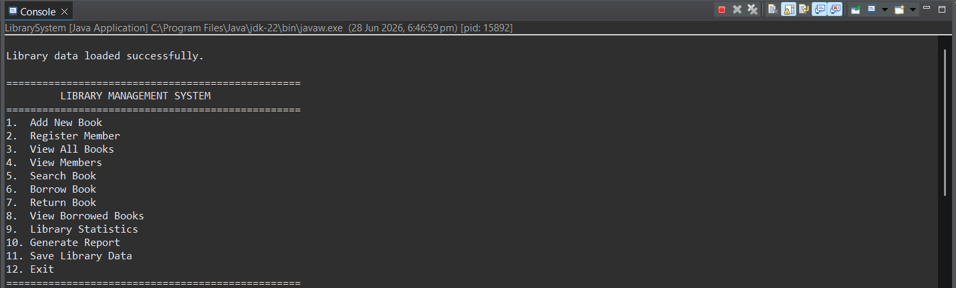

Description: Displays the main menu with all available options such as Add Book, Register Member, Search Book, Borrow Book, Return Book, Generate Report, and Exit.

Screenshot 2: Add New Book

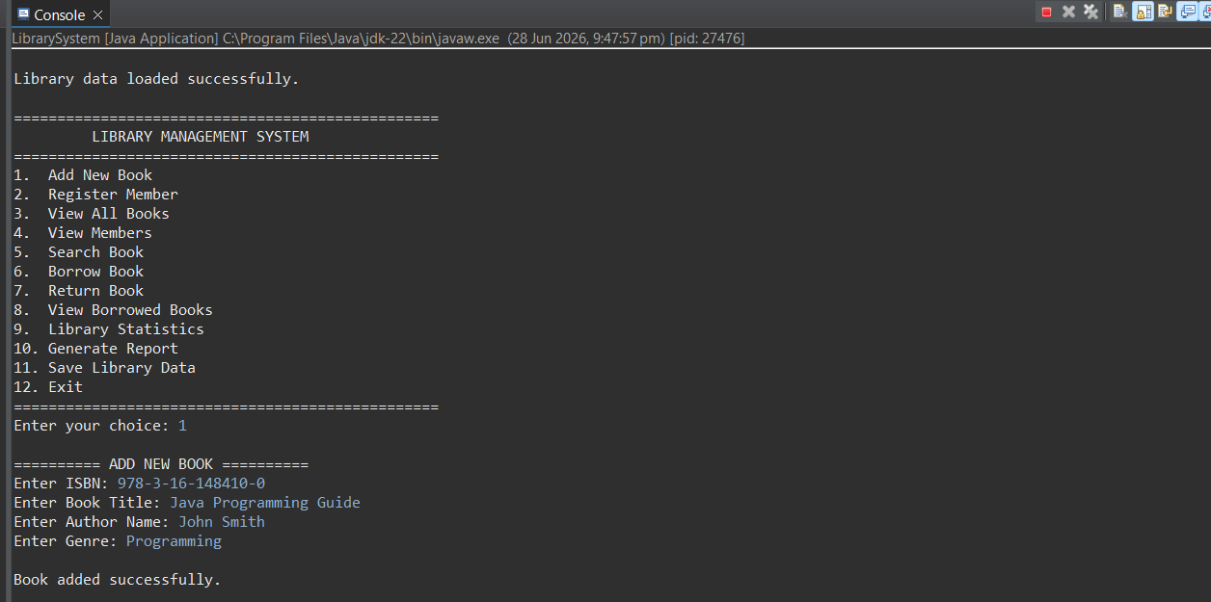

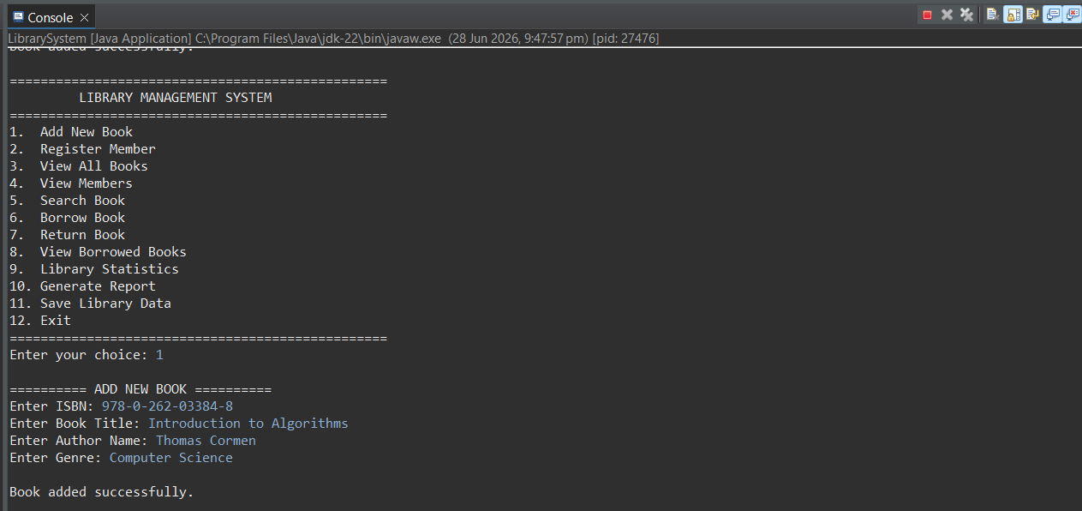

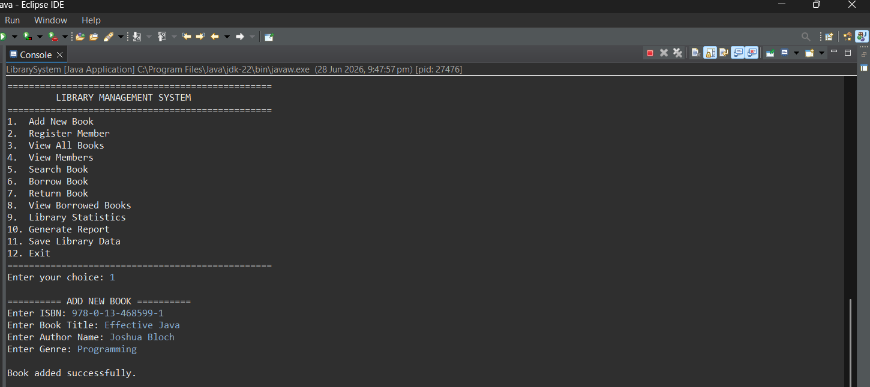

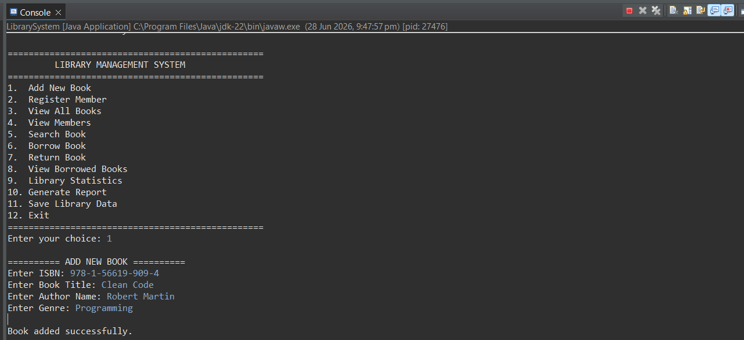

Description: Shows the process of entering book details including ISBN, title, author, and genre.

Screenshot 3: Register Member

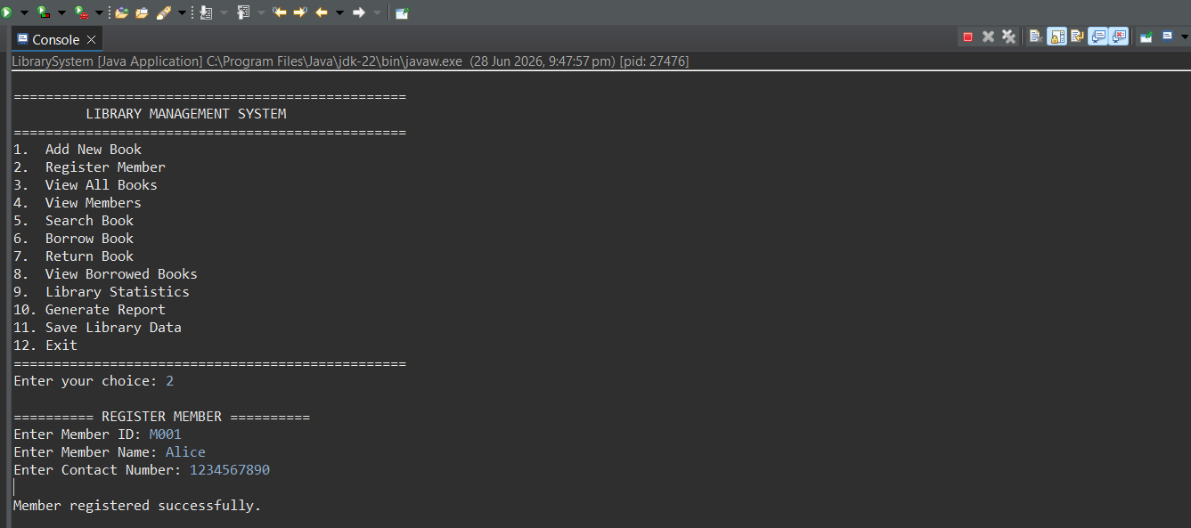

Description: Demonstrates member registration using Member ID, name, and contact number.

Screenshot 4: View All Books

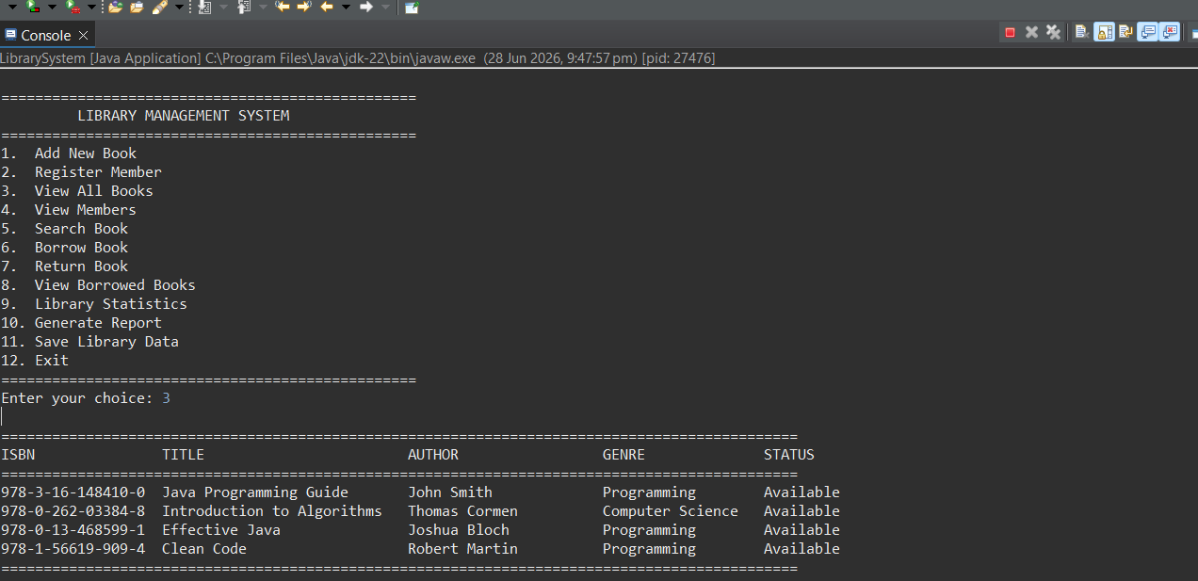

Description: Displays all books in a formatted tabular structure with availability status.

Screenshot 5: Search Book

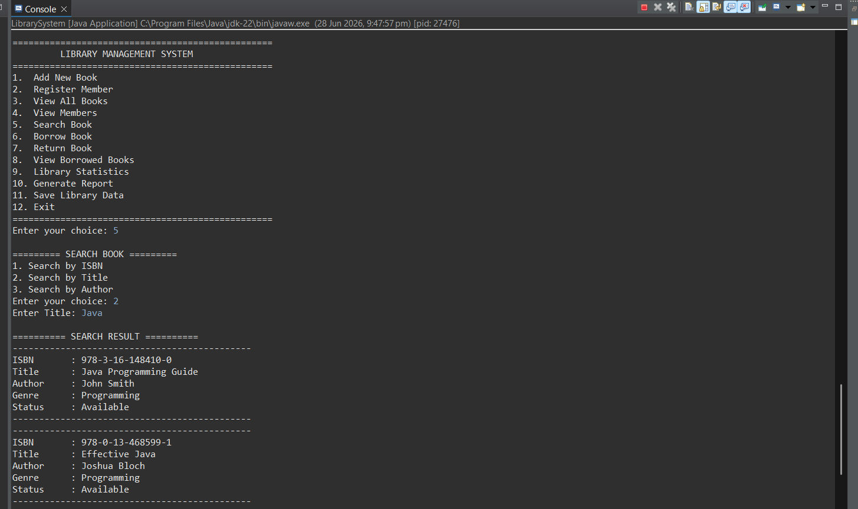

Description: Shows book search functionality using ISBN, title, or author.

Screenshot 6: Borrow Book

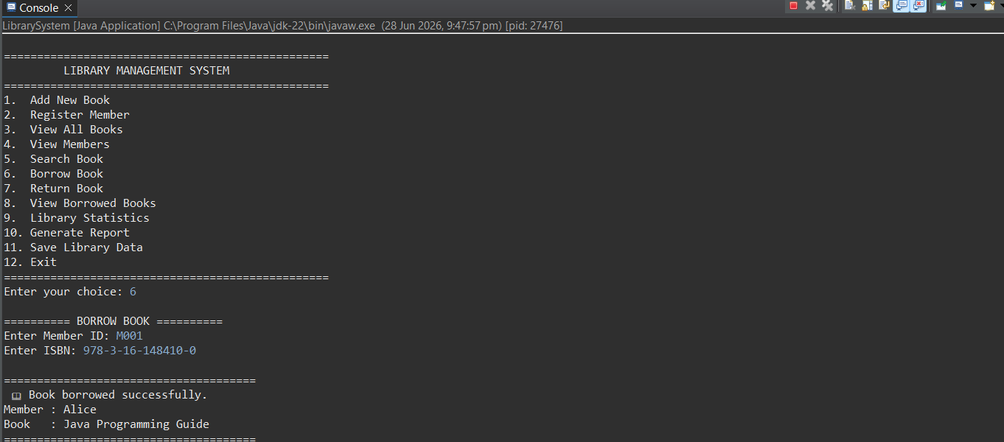

Description: Demonstrates borrowing a book by entering Member ID and ISBN.

Screenshot 7: Return Book

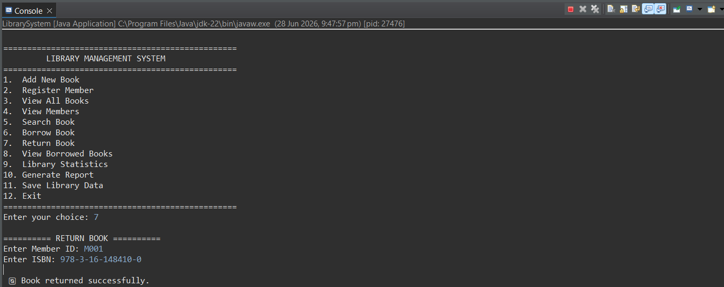

Description: Shows the process of returning a borrowed book.

Screenshot 8: Library Statistics

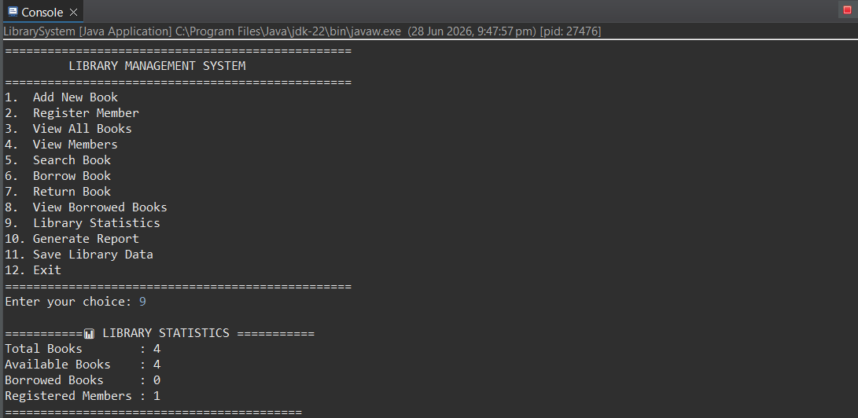

Description: Displays total books, available books, borrowed books, and registered members.

Screenshot 9: Generate Report

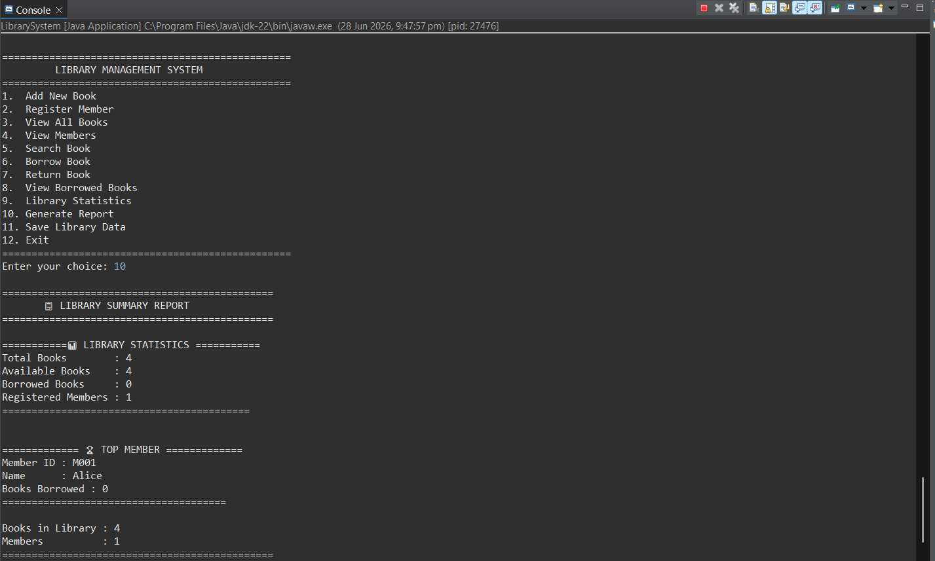

Description: Shows the generated library summary report.

Screenshot 10: Save Data

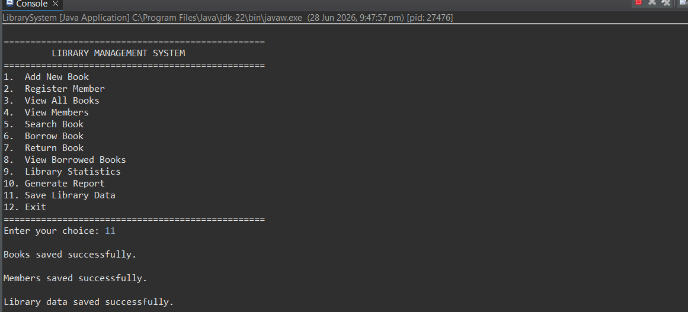

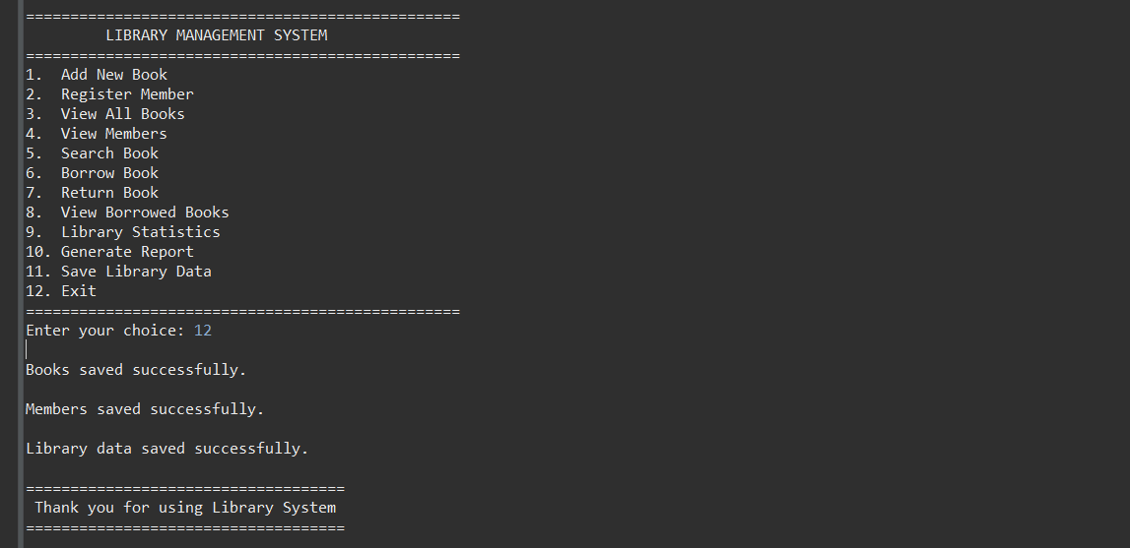

Description: Displays successful saving of library data to files.

Test Cases and Validation

The Library Management System was thoroughly tested using various valid and invalid input scenarios to ensure that all functionalities work correctly. Input validation and exception handling were implemented to prevent incorrect data entry and improve the reliability of the application.

Test Cases
Test Case ID | Feature Tested | Test Input | Expected Result | Status
TC-01 | Add New Book | Valid ISBN, Title, Author, Genre | Book added successfully | ✅ Pass
TC-02 | Add New Book | Duplicate ISBN | Display "Book already exists" message | ✅ Pass
TC-03 | Register Member | Valid Member ID, Name, Contact | Member registered successfully | ✅ Pass
TC-04 | Register Member | Duplicate Member ID | Display duplicate member error | ✅ Pass
TC-05 | Search Book | Existing ISBN | Book details displayed | ✅ Pass
TC-06 | Search Book | Non-existing ISBN | "Book not found" message | ✅ Pass
TC-07 | Borrow Book | Available book | Book borrowed successfully | ✅ Pass
TC-08 | Borrow Book | Already borrowed book | Display "Book not available" message | ✅ Pass
TC-09 | Return Book | Borrowed book | Book returned successfully | ✅ Pass
TC-10 | Return Book | Book not borrowed | Display appropriate error message | ✅ Pass
TC-11 | View Books | Existing records | Display all books in table format | ✅ Pass
TC-12 | View Members | Existing members | Display all registered members | ✅ Pass
TC-13 | Generate Report | Existing data | Display library statistics and report | ✅ Pass
TC-14 | Save Data | Library records | Data saved successfully to text files | ✅ Pass
TC-15 | Load Data | Existing text files | Data loaded successfully on startup | ✅ Pass

Input Validation

The following validation rules were implemented to maintain data integrity:

ISBN cannot be empty and must follow the required format.

Book title cannot be left blank.

Author name cannot be empty.

Genre cannot be empty.

Member ID must be unique.

Member name cannot be empty.

Contact information cannot be empty.

Duplicate books are not allowed.

Duplicate member registrations are prevented.

Books can only be borrowed if they are available.

Books can only be returned if they have been borrowed.

Invalid menu options are handled with appropriate error messages.

Exception Handling

The application includes exception handling to improve reliability and prevent unexpected program crashes.

Handled exceptions include:

Invalid menu input (non-numeric values)

File reading and writing errors

Missing data files

Invalid user input

Duplicate records

Borrowing unavailable books

Returning books that were not borrowed

Testing Summary

All major modules of the Library Management System were successfully tested using both valid and invalid inputs. The application correctly handled exceptional conditions, validated user input, and produced the expected results for all implemented features. The testing confirms that the system is reliable, user-friendly, and meets the functional requirements of the project.

Conclusion

The Library Management System was successfully developed as a Java console-based application that fulfills the project's functional and technical requirements. The application provides an efficient, menu-driven interface for managing books and library members, including features such as book registration, member management, searching, borrowing and returning books, report generation, and data persistence using file handling.

Throughout the development of this project, core Java concepts such as Object-Oriented Programming (OOP), Java Collections (ArrayList), file handling, exception handling, input validation, and modular programming were effectively implemented. These concepts helped create a well-structured, maintainable, and user-friendly application.

The project also strengthened my practical programming skills, problem-solving abilities, and understanding of software development best practices. Additionally, it provided valuable experience in organizing source code, documenting software, testing application functionality, and using GitHub for version control and project submission.

Overall, this project has been a valuable learning experience during my Java Internship at Developers Arena, enhancing both my technical knowledge and confidence in developing real-world Java applications. The modular architecture of the system also provides a strong foundation for future enhancements, such as integrating a graphical user interface (GUI), database connectivity, user authentication, and advanced reporting features.

References

The following resources were referred to during the design, development, testing, and documentation of the Library Management System:

Oracle Java Documentation
https://docs.oracle.com/javase/

Java Platform, Standard Edition (Java SE) API Documentation
https://docs.oracle.com/en/java/javase/

Eclipse IDE Documentation
https://help.eclipse.org/

GitHub Documentation
https://docs.github.com/

Oracle Java Tutorials
https://docs.oracle.com/javase/tutorial/

Developers Arena Internship Guidelines
Project requirements and documentation guidelines provided as part of the Java Internship.

Object-Oriented Programming (OOP) Concepts
Oracle Java Tutorials – Classes and Objects, Inheritance, Encapsulation, and Polymorphism.

Java Collections Framework Documentation
https://docs.oracle.com/javase/8/docs/technotes/guides/collections/

Java File I/O Documentation
https://docs.oracle.com/javase/tutorial/essential/io/

Java Exception Handling Tutorial
https://docs.oracle.com/javase/tutorial/essential/exceptions/

