EcoWatt
1. Selected SDG and Reason for Selection
Selected SDG
SDG 7: Affordable and Clean Energy
What the SDG Focuses On
Sustainable Development Goal 7 aims to ensure access to affordable, reliable, sustainable, and modern energy for all. It promotes energy efficiency, renewable energy adoption, and reducing dependence on fossil fuels. The goal encourages the use of clean energy sources such as solar and wind power while minimizing environmental impact.
Why This Issue Is Important
Electricity consumption is increasing rapidly due to population growth and technological advancements. Many households are unaware of how much electricity they consume and which appliances contribute most to their energy bills. This lack of awareness leads to energy wastage, increased expenses, and higher carbon emissions. Promoting efficient energy usage and renewable energy adoption is essential for achieving a sustainable future.

2. Problem Statement
What is the Problem?
Many households do not have a simple way to monitor their electricity consumption and understand which appliances consume the most energy. As a result, people often receive high electricity bills without knowing the reason behind the excessive consumption.
Where Does This Problem Exist?
This problem exists in households, apartments, residential societies, and small businesses where electricity consumption is not actively monitored.
Who Is Affected?
- Homeowners
- Tenants
- Families
- Residential societies
- Environment due to increased carbon emissions
Why Is It Serious?
High energy consumption leads to:
- Increased electricity bills
- Excessive energy wastage
- Greater dependence on non-renewable energy sources
- Higher carbon emissions and environmental impact
What Could Happen If It Is Not Solved?
If the issue continues:
- Electricity expenses will keep increasing.
- Energy resources will be used inefficiently.
- Carbon emissions will rise further.
- Adoption of renewable energy solutions such as solar power will remain low.

3. Proposed Solution
What is the Project?
EcoWatt is an AI-powered Home Energy Advisor that helps users estimate their electricity consumption, identify high-energy-consuming appliances, calculate their carbon footprint, and receive personalized recommendations for reducing energy usage.
How the System Works
- Users enter appliance details and daily usage hours.
- The system calculates monthly electricity consumption.
- Estimated electricity bills are generated.
- Appliance-wise energy consumption is visualized using interactive charts.
- Carbon footprint is estimated based on electricity consumption.
- Google Gemini AI analyzes the data and generates personalized recommendations.
- A solar advisor recommends suitable solar panel capacity and estimates annual savings.
How It Helps Solve the Problem
The system increases awareness of energy usage patterns and encourages users to adopt energy-efficient practices. It also promotes renewable energy adoption through solar recommendations and helps reduce electricity costs and carbon emissions.
Who Will Use the Application
- Homeowners
- Students
- Families
- Residential societies
- Anyone interested in reducing energy consumption

4. Project Features
User Interface Dashboard
A modern Streamlit-based dashboard allows users to enter appliance details and view energy analysis results in a visually appealing format.
Energy Consumption Analysis
Calculates monthly electricity consumption and estimated electricity bills based on appliance usage patterns.
Energy Breakdown Visualization
Displays appliance-wise energy consumption using interactive donut charts, helping users identify major energy consumers.
AI Energy Advisor
Uses Google Gemini AI to analyze energy usage patterns and generate personalized energy-saving recommendations.
Carbon Footprint Calculator
Estimates monthly and yearly carbon emissions resulting from household electricity consumption.
Solar Advisor
Recommends appropriate solar panel capacity, estimates installation costs, annual savings, CO₂ reduction, and payback period.

5. Technology Stack
Frontend
- Streamlit
Backend
- Python
Data Analysis
- Pandas
Data Visualization
- Plotly
Artificial Intelligence
- Google Gemini API
Environment Management
- Python Dotenv
Version Control
- Git & GitHub

6. Project Screenshots (Proof of Work)
Screenshot 1 – Home Dashboard
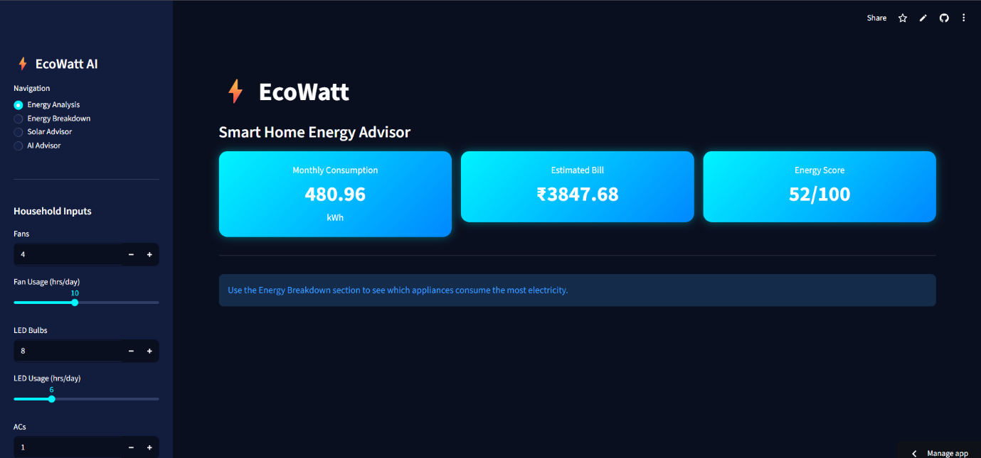
Figure 1: EcoWatt Dashboard
Figure 1 shows the main dashboard of the EcoWatt application. Users can enter the number of household appliances and their daily usage hours through the sidebar. The system calculates the estimated monthly electricity consumption based on the provided inputs. It also estimates the monthly electricity bill and displays an energy efficiency score. These metrics help users understand their energy usage patterns and identify opportunities to reduce consumption. The dashboard serves as the starting point for further analysis and personalized recommendations.
Screenshot 2 – Energy Breakdown
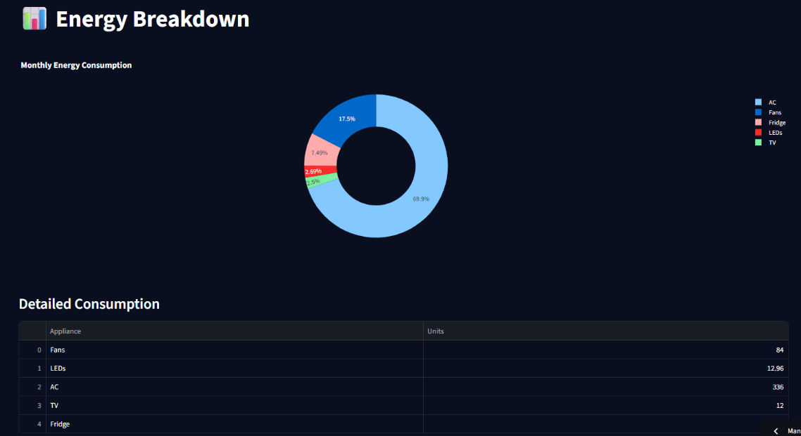
Figure 2: Energy Breakdown analysis
Figure 2 shows the appliance-wise energy consumption breakdown of the household. The donut chart visually represents the percentage contribution of each appliance to the total electricity usage, making it easier for users to understand their consumption patterns at a glance. Users can quickly identify the appliances that consume the most electricity, such as air conditioners, fans, refrigerators, televisions, and lighting systems. This visualization helps highlight the major sources of energy consumption within the household.
In addition to the graphical representation, a detailed consumption table is provided below the chart. The table displays the exact number of units consumed by each appliance, allowing users to compare appliance usage more accurately. By combining visual analytics with numerical data, the Energy Breakdown module enables users to make informed decisions regarding energy conservation. This feature helps identify inefficient usage patterns, encourages responsible energy consumption, and supports efforts to reduce electricity bills and carbon emissions. Through increased awareness of appliance-level energy usage, the system promotes sustainable energy practices and contributes towards achieving SDG 7: Affordable and Clean Energy.
Screenshot 3 – Solar Advisor
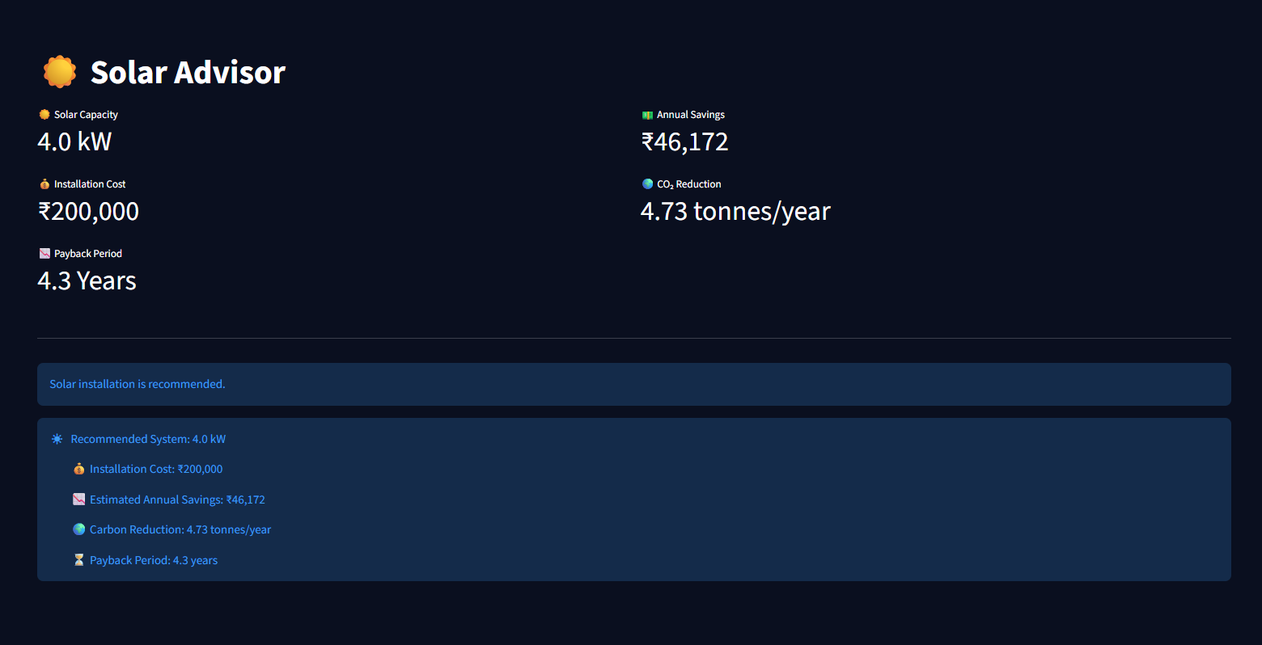
Figure 3: Solar Advisor
Figure 3 shows the Solar Advisor module of the EcoWatt application. This feature analyzes the household's monthly electricity consumption and recommends an appropriate solar panel system size based on the user's energy requirements. The module provides important information such as the recommended solar capacity, estimated installation cost, expected annual savings, carbon emission reduction, and payback period. These calculations help users evaluate the financial feasibility of investing in solar energy and understand the long-term benefits of renewable energy adoption.
In addition to cost analysis, the Solar Advisor estimates the amount of carbon dioxide emissions that can be reduced annually by switching to solar power. This enables users to understand the environmental impact of their decision and promotes sustainable energy consumption. The system also highlights the potential return on investment through the payback period, helping users determine how quickly the installation cost can be recovered through electricity bill savings.

Screenshot 4 – AI Energy Advisor
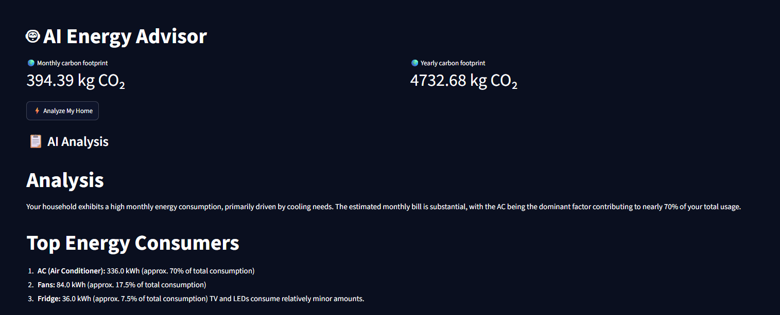
Figure 4: AI Energy Advisor – Carbon Footprint and Initial Analysis
Figure 4 shows the AI Energy Advisor module of the EcoWatt application. This feature utilizes Google Gemini AI to analyze the household's electricity consumption and provide intelligent insights. The system first displays the estimated monthly and yearly carbon footprint, helping users understand the environmental impact of their energy usage. After clicking the "Analyze My Home" button, the AI evaluates the consumption data and generates a detailed analysis of the household's energy usage patterns.
The AI identifies the major energy-consuming appliances and highlights their contribution to the total electricity consumption. This enables users to understand which appliances are responsible for the majority of their energy usage and where improvements can be made. By presenting personalized insights instead of generic advice, the system increases user awareness and encourages informed decision-making. The AI Energy Advisor acts as a virtual energy consultant that helps households improve energy efficiency, reduce carbon emissions, and adopt more sustainable energy practices, thereby supporting SDG 7: Affordable and Clean Energy.
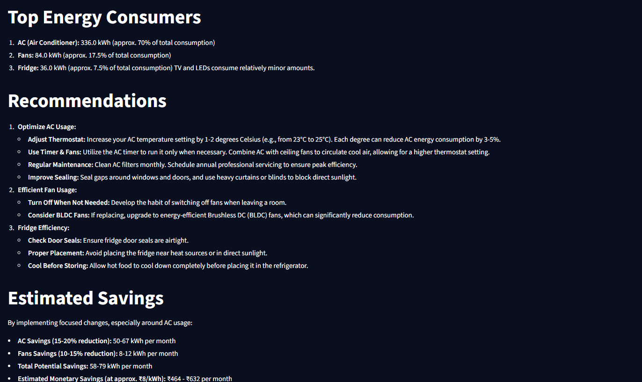
Figure 5: AI Energy Advisor – Personalized Recommendations
Figure 5 presents the personalized recommendations generated by the AI Energy Advisor after analyzing the household's energy consumption data. Based on the identified energy usage patterns, the system provides practical suggestions to improve energy efficiency and reduce electricity costs. The recommendations focus on major energy-consuming appliances such as air conditioners, fans, and refrigerators, as these contribute the most to the overall electricity consumption.
The AI suggests measures such as optimizing AC temperature settings, using energy-efficient BLDC fans, improving appliance maintenance, and adopting better energy-saving habits. In addition to recommendations, the system estimates the potential energy and monetary savings that can be achieved by implementing these changes. This helps users understand the direct benefits of adopting energy-efficient practices. By providing actionable and personalized guidance, the AI Energy Advisor assists households in reducing energy wastage, lowering electricity bills, and promoting sustainable energy consumption in alignment with SDG 7: Affordable and Clean Energy.
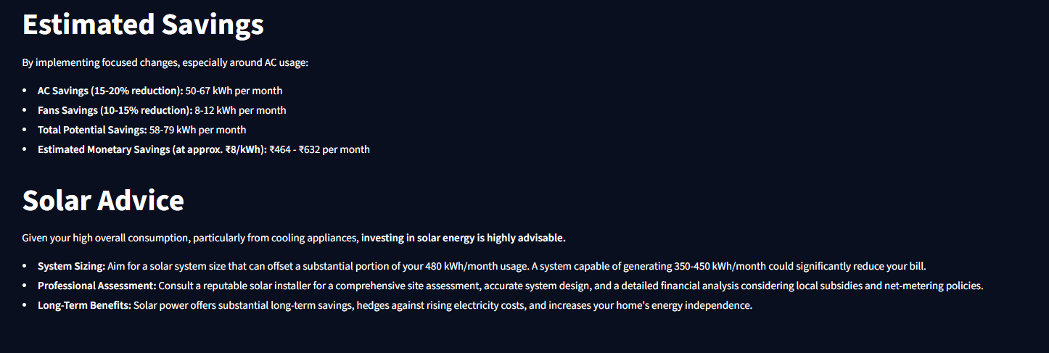
Figure 6: AI Energy Advisor – Savings and Solar Recommendations
Figure 6 shows the estimated savings and solar energy recommendations generated by the AI system. The module calculates potential energy and monetary savings that can be achieved through the suggested improvements. It also recommends the adoption of solar energy based on the user's consumption level and provides guidance regarding system sizing and long-term benefits. The analysis highlights both financial and environmental advantages of switching to renewable energy. This feature directly supports the objectives of SDG 7 by encouraging clean and affordable energy adoption.
7. Open Source Repository
GitHub Repository Link:
https://github.com/Tejas-coder-cloud/EcoWatt
Website Link:
https://ecowatt-l8dn9hv8kzqupshqvbtpnh.streamlit.app/

The repository contains:
- Complete source code
- Project documentation
- Requirements file
- Configuration files

8. Future Scope
The project can be enhanced further by:
- Integrating IoT-based smart meters for real-time monitoring.
- Adding MongoDB for storing historical energy data.
- Generating downloadable PDF reports.
- Developing a mobile application version.
- Integrating weather-based solar energy predictions.
- Providing community-level energy analytics for residential societies.
- Implementing advanced machine learning models for consumption forecasting.
This content is detailed enough for a full academic submission and aligns directly with your implemented EcoWatt project and SDG 7 requirements.

