**EDUNET FOUNDATION**

**INTERSHIP**

**Name :-** Tejas Milind Malode.

**Project 1** :- Exhaustive Analysis of Indian Agriculture using Power BI

**Week 1 Task** :- To upload the dataset to the Power BI and Transform the given Data.

The Step to do the Task is as follows,

**Step 1 :** To open the power BI and Select the Blank report to start with our project.  
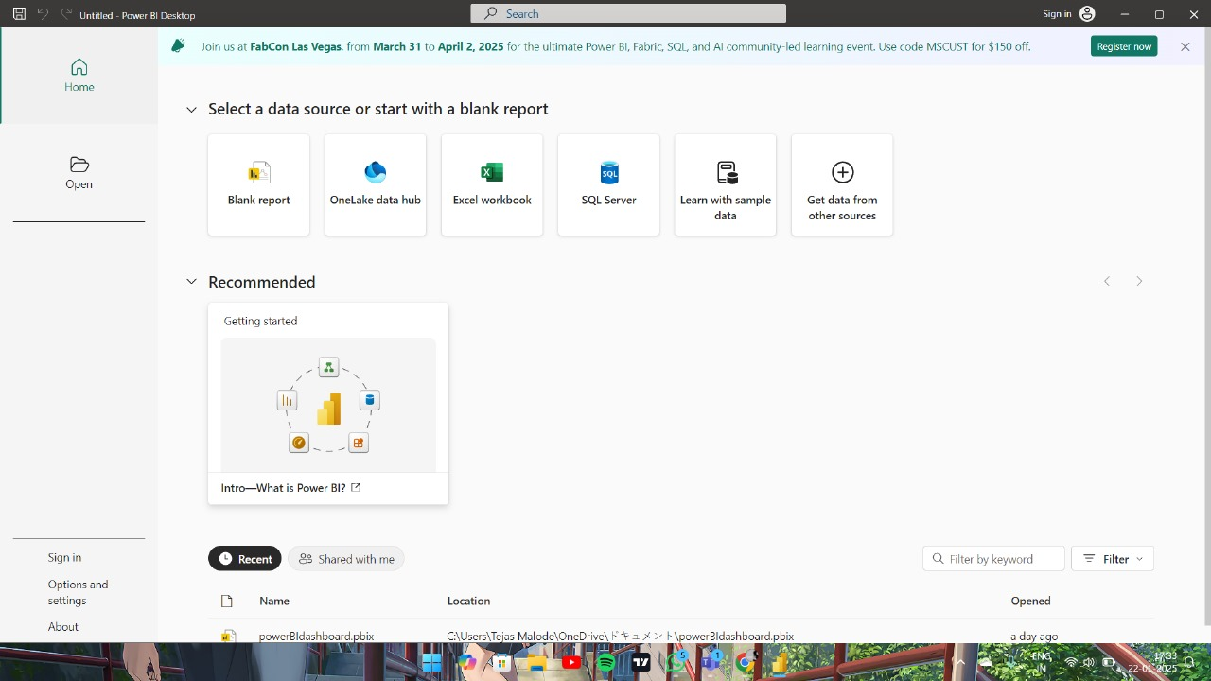

**Step 2 :** We get new tab and Select the Get Data option to upload data.  
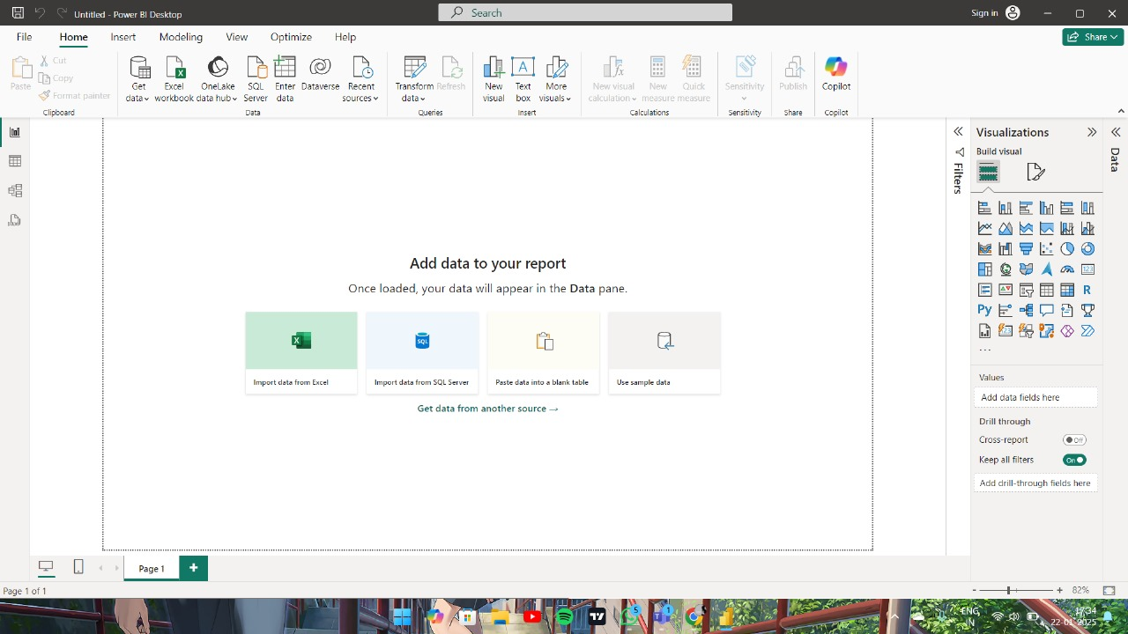

**Step 3 :** In Get data tab Select our Data file, and Click Connect option.

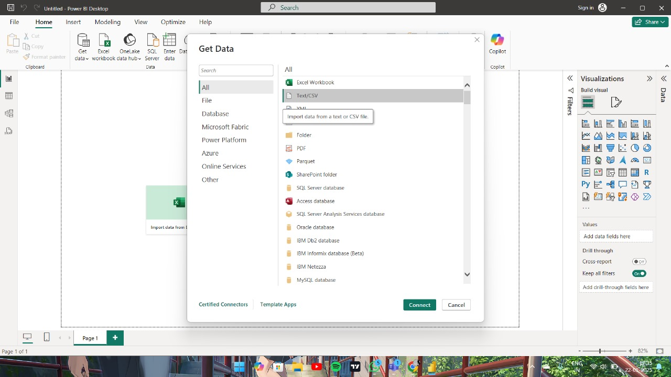

**Step 4 :** After upload the file, Click LOAD option to Load the Data.   
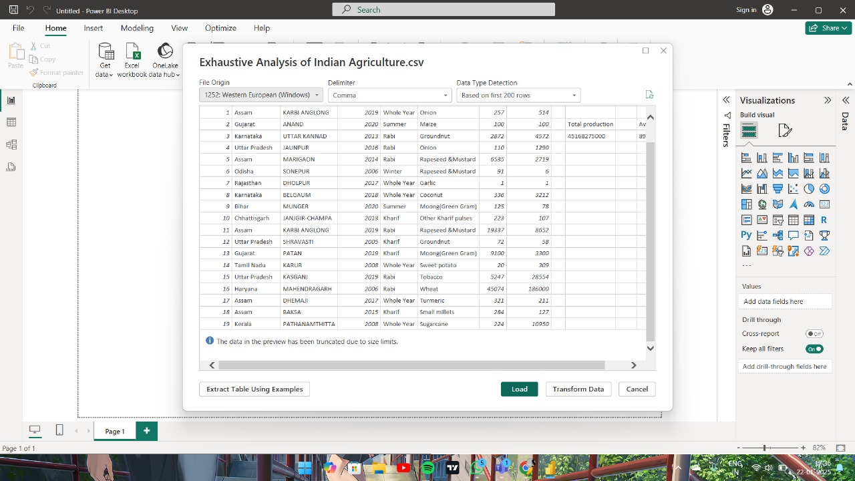

**Step 5:** The Data get load and we can see it at Right side of the screen.

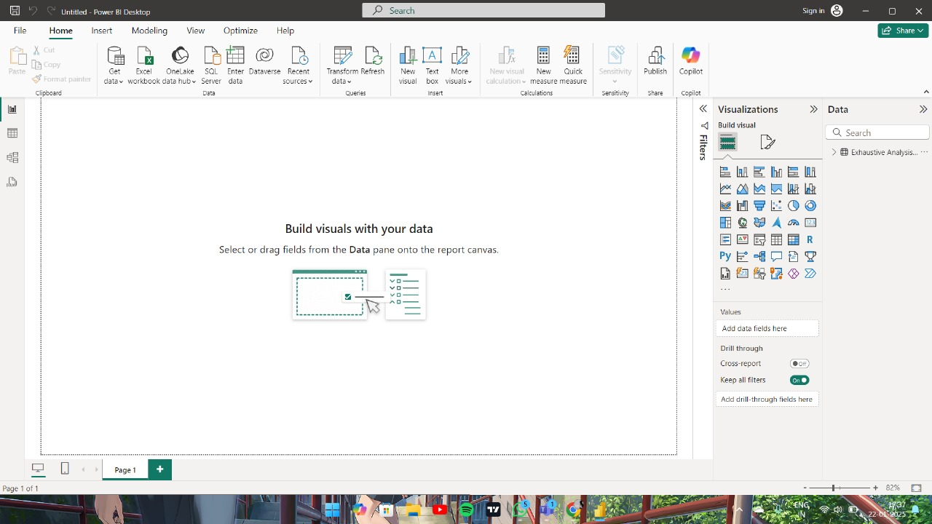

**Step 6 :** To Transform Data Select the Transform Data option.



**Step 7 :** Transform Tab will open.

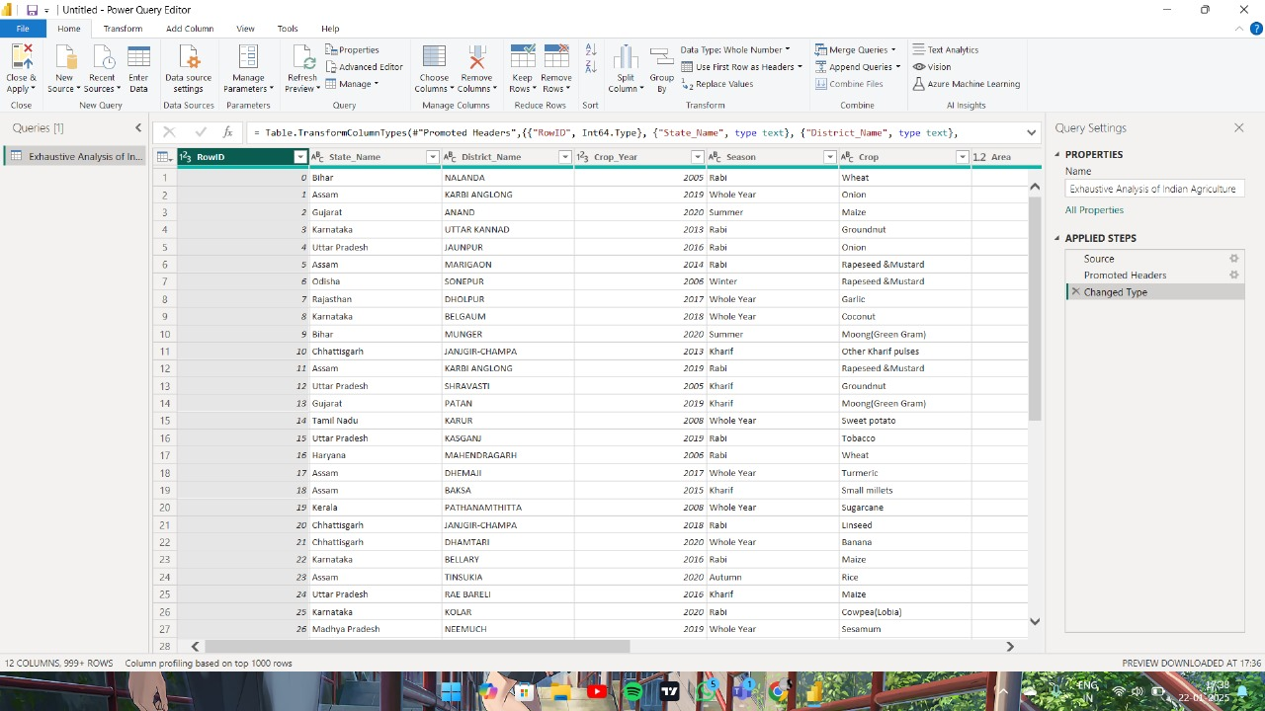

**Step 8 :** Here the Frist and last Rows are Blank and we don’t need them.

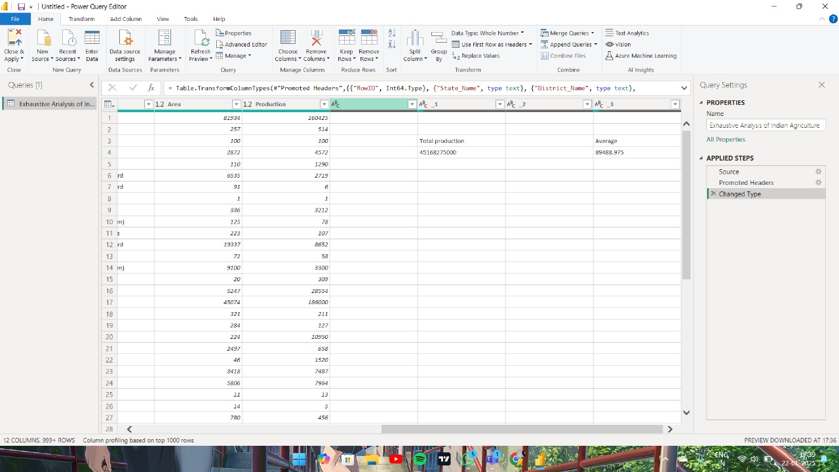

**Step 9 :** To Remove it Select that Row and Click Remove option and the Row will get removed.

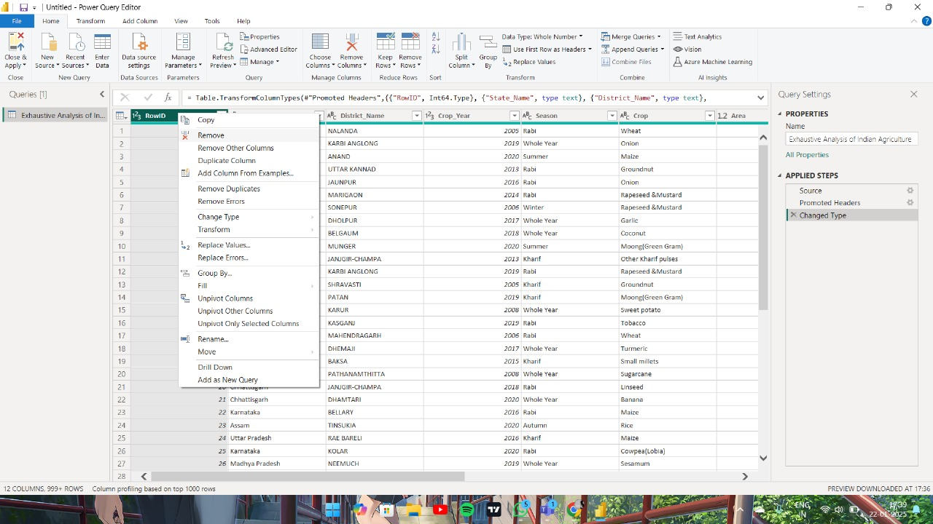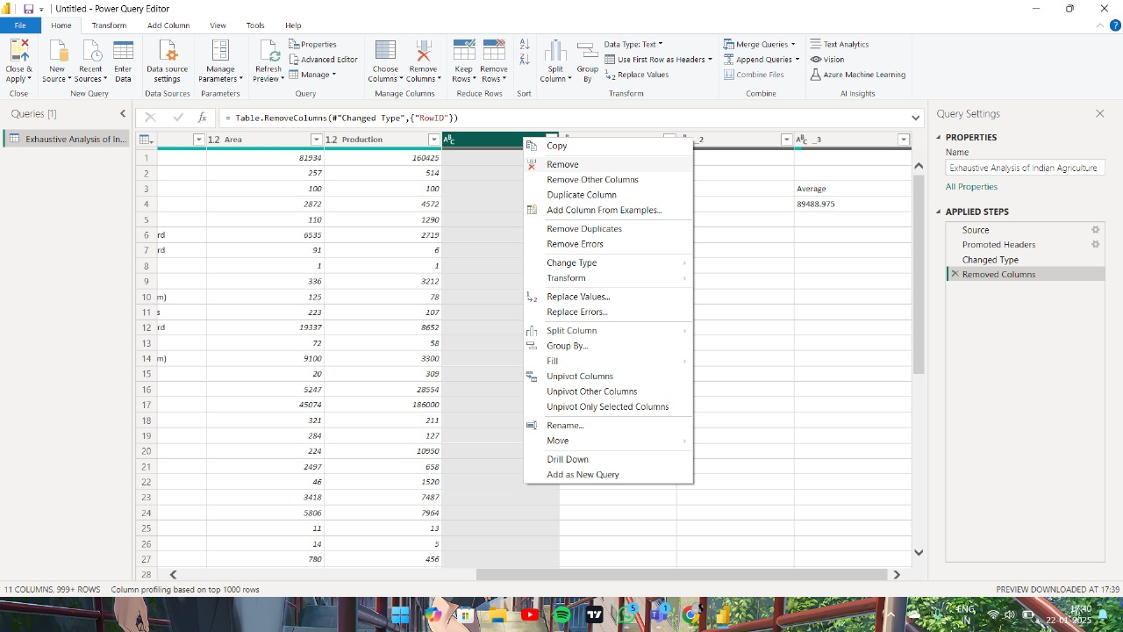

**Step 10 :** Now all the Blank Row are removed and to save this Changes click Close And Apply option.

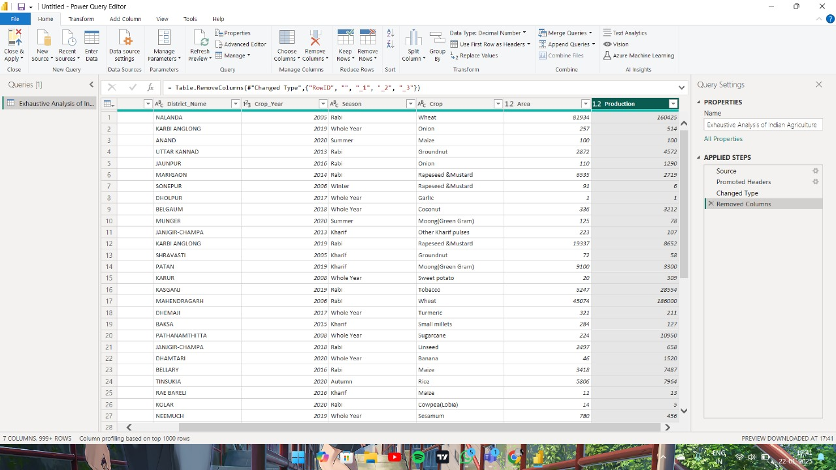

**Step 11 :** Here We Successfully upload the dataset to the Power BI and Transform the given Data.

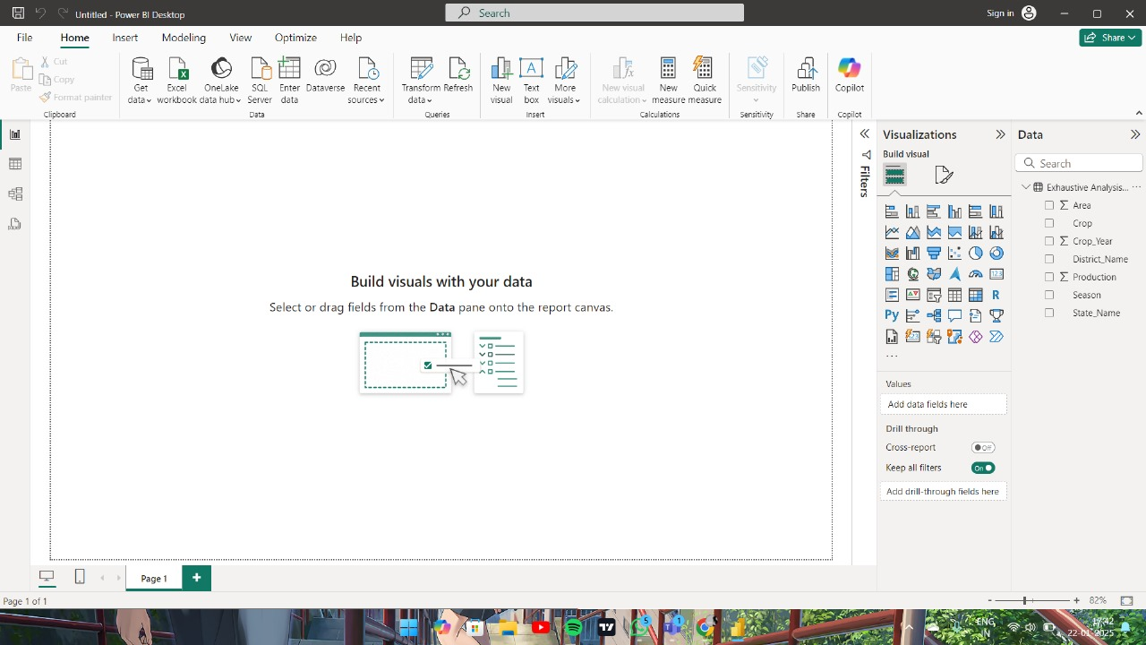

**Conclusion :** We Successfully learn to upload and transform the data in Power BI.