Lab 1

1.
4ITA2@debian:~$ mkdir Tejas_240911600
4ITA2@debian:~$ cd Tejas_240911600
4ITA2@debian:~/Tejas_240911600$ mkdir L1
4ITA2@debian:~/Tejas_240911600$ mkdir L3
4ITA2@debian:~/Tejas_240911600$ mkdir L2
4ITA2@debian:~/Tejas_240911600$ mkdir L4
4ITA2@debian:~/Tejas_240911600$ mkdir L5
4ITA2@debian:~/Tejas_240911600$ mkdir L6
4ITA2@debian:~/Tejas_240911600$ mkdir L7
4ITA2@debian:~/Tejas_240911600$ mkdir L8
4ITA2@debian:~/Tejas_240911600$ mkdir L9
4ITA2@debian:~/Tejas_240911600$ mkdir L10
4ITA2@debian:~/Tejas_240911600$ mkdir L11

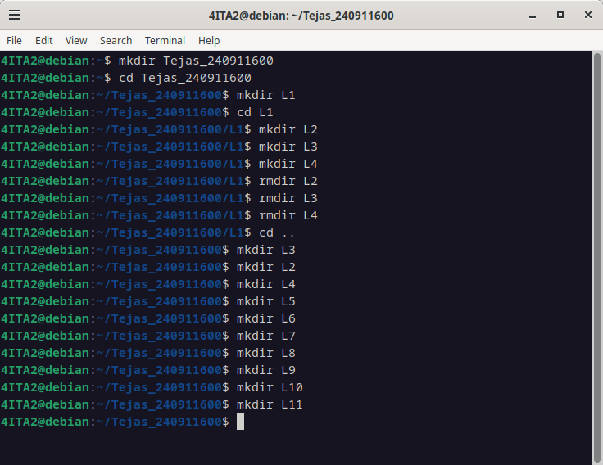

2.

4ITA2@debian:~/Tejas_240911600/L1$ touch lab1_1.txt
4ITA2@debian:~/Tejas_240911600/L1$ cat lab1_1.txt
4ITA2@debian:~/Tejas_240911600/L1$ cat > lab1_1.txt
I understood how to use cd command.
It is used to change directory.

2. man command
It is used to open the manual of the command given as the argument

3.ls
It is used to list all the files present in the current directory.

4.mkdir
It is used to make a new directory.

5.rmdir
It is used to delete the file given as the argument provided it doesnt contain any subfiles or subfolders.

4ITA2@debian:~/Tejas_240911600/L1$ cd ../L1
4ITA2@debian:~/Tejas_240911600/L1$ man cd
No manual entry for cd
4ITA2@debian:~/Tejas_240911600/L1$ man ls
4ITA2@debian:~/Tejas_240911600/L1$ ls
file2.txt file3.txt lab1_1.txt temp.txt
4ITA2@debian:~/Tejas_240911600/L1$ mkdir temp
4ITA2@debian:~/Tejas_240911600/L1$ rmdir temp

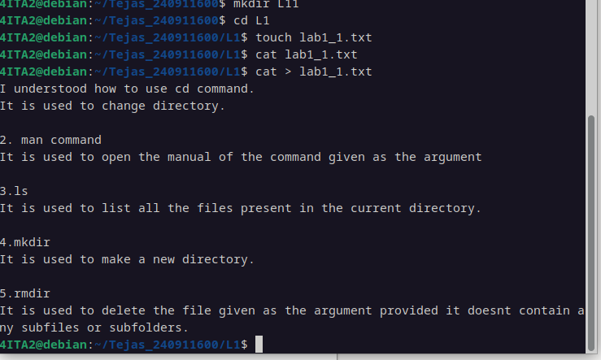

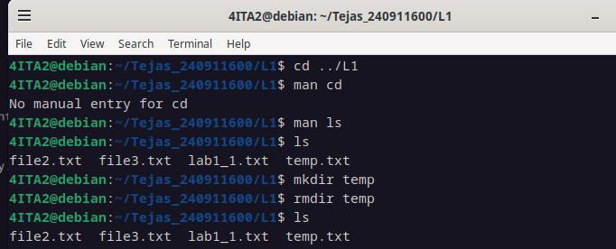

Q3.
CAT

4ITA2@debian:~/Tejas_240911600/L1$ cat lab1_1.txt
I understood how to use cd command.
It is used to change directory.

2. man command
It is used to open the manual of the command given as the argument

3.ls
It is used to list all the files present in the current directory.

4.mkdir
It is used to make a new directory.

5.rmdir
It is used to delete the file given as the argument provided it doesnt contain any subfiles or subfolders.
4ITA2@debian:~/Tejas_240911600/L1$ cat > new.txt
Will overwrite
4ITA2@debian:~/Tejas_240911600/L1$
4ITA2@debian:~/Tejas_240911600/L1$ cat >> new.txt
will not overwrite

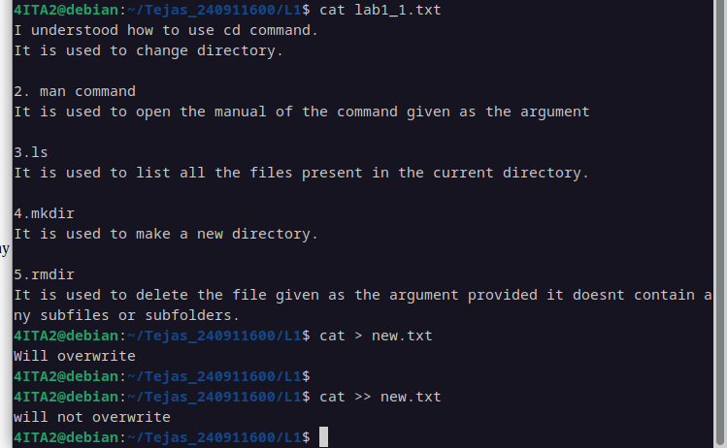

Head and Tail

4ITA2@debian:~/Tejas_240911600/L1$ head -3 lab1_1.txt
I understood how to use cd command.
It is used to change directory.

4ITA2@debian:~/Tejas_240911600/L1$ tail -3 lab1_1.txt

5.rmdir
It is used to delete the file given as the argument provided it doesnt contain any subfiles or subfolders.
4ITA2@debian:~/Tejas_240911600/L1$ head -c3 lab1_1.txt
I u4ITA2@debian:~/Tejas_240911600/L1$ tail -c3 lab1_1.txt
s.

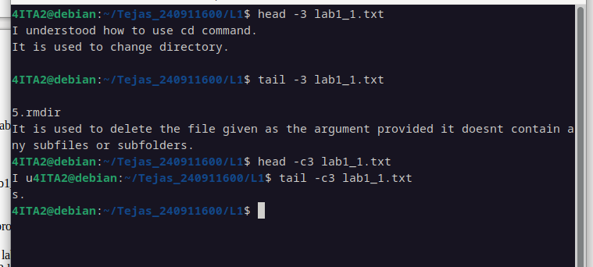
Copy

4ITA2@debian:~/Tejas_240911600/L1$ touch tmep.txt
4ITA2@debian:~/Tejas_240911600/L1$ cp tmep.txt ~/Tejas_240911600/L2
4ITA2@debian:~/Tejas_240911600/L1$ cd ../L2
4ITA2@debian:~/Tejas_240911600/L2$ ls
tmep.txt
4ITA2@debian:~/Tejas_240911600/L2$ echo "i overrides n and n overrides f"
i overrides n and n overrides f
4ITA2@debian:~/Tejas_240911600/L2$ cp -nif tmep.txt ~/Tejas_240911600/L2
cp: 'tmep.txt' and '/home/4ITA2/Tejas_240911600/L2/tmep.txt' are the same file
4ITA2@debian:~/Tejas_240911600/L2$ cd ../L1
4ITA2@debian:~/Tejas_240911600/L1$ touch tmep.txt
4ITA2@debian:~/Tejas_240911600/L1$ cp -nif tmep.txt ~/Tejas_240911600/L2
cp: overwrite '/home/4ITA2/Tejas_240911600/L2/tmep.txt'? Yes

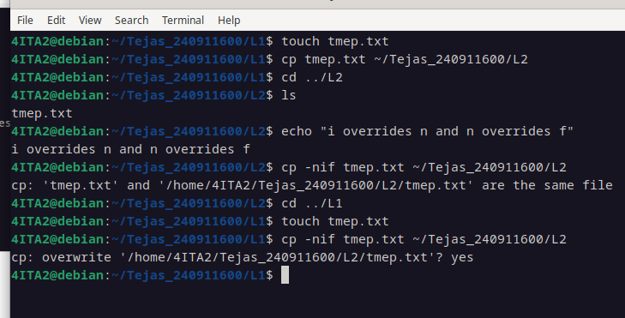
MV
4ITA2@debian:~/Tejas_240911600/L1$ touch temp.txt
4ITA2@debian:~/Tejas_240911600/L1$ cd ../L2
4ITA2@debian:~/Tejas_240911600/L2$ touch temp.txt
4ITA2@debian:~/Tejas_240911600/L2$ mv -i temp.txt ~/Tejas_240911600/L1
mv: overwrite '/home/4ITA2/Tejas_240911600/L1/temp.txt'? n
4ITA2@debian:~/Tejas_240911600/L2$ mv -f temp.txt ~/Tejas_240911600/L1

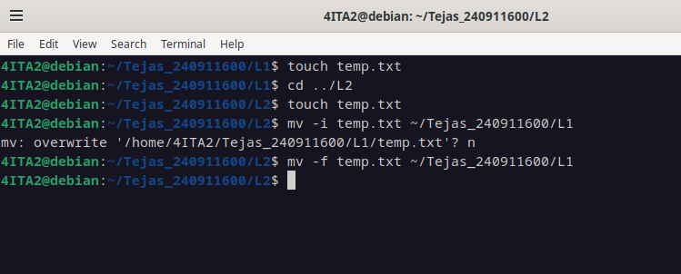
RM

4ITA2@debian:~/Tejas_240911600/L1$ touch temp.txt
4ITA2@debian:~/Tejas_240911600/L1$ cd ../L2
4ITA2@debian:~/Tejas_240911600/L2$ touch temp.txt
4ITA2@debian:~/Tejas_240911600/L2$ mv -i temp.txt ~/Tejas_240911600/L1
mv: overwrite '/home/4ITA2/Tejas_240911600/L1/temp.txt'? n
4ITA2@debian:~/Tejas_240911600/L2$ mv -f temp.txt ~/Tejas_240911600/L1
4ITA2@debian:~/Tejas_240911600/L2$ cd ../L1
4ITA2@debian:~/Tejas_240911600/L1$ mkdir temp
4ITA2@debian:~/Tejas_240911600/L1$ cd temp
4ITA2@debian:~/Tejas_240911600/L1/temp$ touch file1.txt
4ITA2@debian:~/Tejas_240911600/L1/temp$ cd ..
4ITA2@debian:~/Tejas_240911600/L1$ rm -r temp
4ITA2@debian:~/Tejas_240911600/L1$ rm -i temp.txt
rm: remove regular empty file 'temp.txt'? n
4ITA2@debian:~/Tejas_240911600/L1$ rm -f temp.txt
4ITA2@debian:~/Tejas_240911600/L1$ ls
file2.txt file3.txt lab1_1.txt new.txt
4ITA2@debian:~/Tejas_240911600/L1$

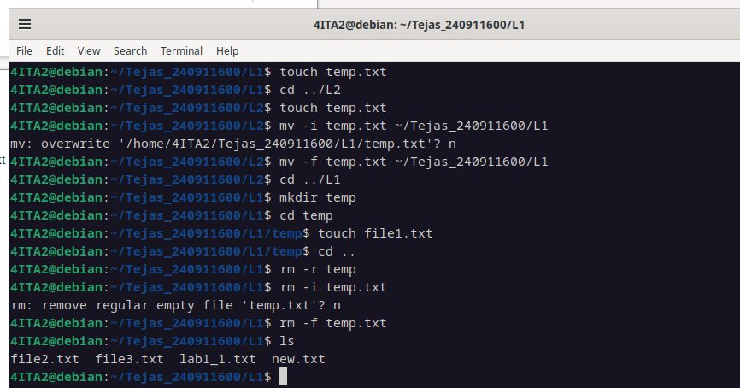
RMDIR

4ITA2@debian:~/Tejas_240911600/L1$ ls
file2.txt file3.txt folder lab1_1.txt new.txt
4ITA2@debian:~/Tejas_240911600/L1$ cd folder
4ITA2@debian:~/Tejas_240911600/L1/folder$ ls
inner_folder
4ITA2@debian:~/Tejas_240911600/L1/folder$ cd ..
4ITA2@debian:~/Tejas_240911600/L1$ man rmdir
4ITA2@debian:~/Tejas_240911600/L1$ rmdir folder
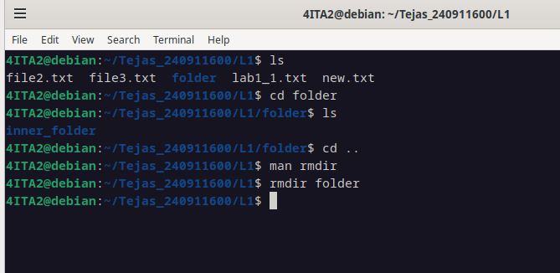
FIND
4ITA2@debian:~/Tejas_240911600/L1$ find file*
file2.txt
file3.txt
4ITA2@debian:~/Tejas_240911600/L1$ find *.txt
file2.txt
file3.txt
lab1_1.txt
new.txt

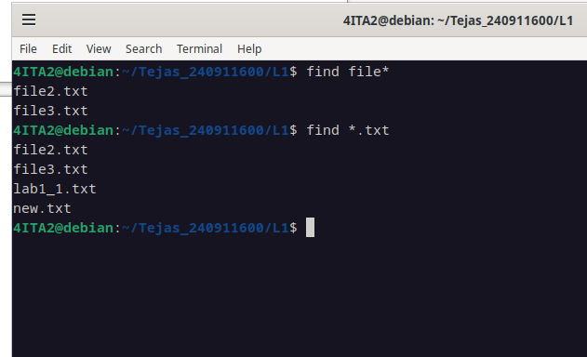
Q4.

4ITA2@debian:~/Tejas_240911600/L1$ find file*
file2.txt
file3.txt
4ITA2@debian:~/Tejas_240911600/L1$ find *.txt
file2.txt
file3.txt
lab1_1.txt
new.txt
4ITA2@debian:~/Tejas_240911600/L1$ find *txt
file2.txt
file3.txt
lab1_1.txt
new.txt
4ITA2@debian:~/Tejas_240911600/L1$ find *[1-9]*
file2.txt
file3.txt
lab1_1.txt
4ITA2@debian:~/Tejas_240911600/L1$ find ____*
find: ‘____*’: No such file or directory
4ITA2@debian:~/Tejas_240911600/L1$ find ????*
file2.txt
file3.txt
lab1_1.txt
new.txt
4ITA2@debian:~/Tejas_240911600/L1$ find [!aeiou]
h
h/g
4ITA2@debian:~/Tejas_240911600/L1$ find [!aeiou]*
file2.txt
file3.txt
h
h/g
lab1_1.txt
new.txt
4ITA2@debian:~/Tejas_240911600/L1$ ls
file2.txt file3.txt h lab1_1.txt new.txt
4ITA2@debian:~/Tejas_240911600/L1$ rmdir h
rmdir: failed to remove 'h': Directory not empty
4ITA2@debian:~/Tejas_240911600/L1$ find [!aeiou]*
file2.txt
file3.txt
lab1_1.txt
new.txt
4ITA2@debian:~/Tejas_240911600/L1$

