BUG/TICKET/DEFECT REPORTING STANDARD

* Summary/Title
* Steps to reproduce
* Expected result
* Actual result
* Attachments (Necessary screenshot or short video) (Priority high)
* Impact

--------------------------------------------------------------------------------------------------------------------------

1. Summary/Title (Priority high)

A brief description of what’s happening.

Incorrect: “Can’t read text on website”

Correct: “Contact page text overlaps after clicking submit”

2. Steps to reproduce (Priority high)

Incorrect:

1. Went to Contact Page 2. Submitted the form 3. Text overlapped

Correct:

1. Click on OR Go to “<https://www.m-anage.com>” then Login (mention specially if require certain account with certain permission ) then go to……………………etc.

2. Click on “INDUSTRY” the click on “ONLINE SHOP”……….etc.

3. Add items to cart then click on “CHECKOUT”

4. Invoice Address is incorrect. (Error)

*Note = ( The steps can be changed, or effective page URL can be provided to avoid long steps writing )*

3. Expected result (Priority medium)

“I clicked SUBMIT but I’m still on the same page.”

Incorrect: “I expected the SUBMIT page to not be broken.” (circular logic)

Correct:

“I expected successful message is displayed after clicking on “SUBMIT” button. *(check entry in DB if required)*

4. Actual result (Priority medium)

*You may have already stated this in the title, in which case this is repetition. Often, however, you will need more data here. If possible, provide a comprehensive description of the result.*

Incorrect: “404 ERROR or Link is not present .”

Correct: Clicked on “SUBMIT”, user is should able to complete order. *Error on this step*

5. Impact (Can be neglected from Ticket/Defect) (Priority medium)

*“Impact” is a statement of your understanding of the effect of the bug on business.****(of course it’s about money****) This allows the engineer, who presumably has more information regarding other bugs and issues going on, to prioritize appropriately.*

I do think that there should be an “urgent” checkbox. This checkbox should simply send a ping or special flag in the message that indicates that the user believes it to be urgent. This can help an engineer get quickly alerted if something major is broken — but he is still setting the actual priority, which should be understood from the user side.

Incorrect:  
“Doesn’t allow user to place order using credit card/Direct Debit/PayPal….etc.”

Correct:  
“If single order {500 €} is not processed, imagine 20 orders in one day then it’s loss of business/revenue and reputation for company. *Need to fix it ASAP*

Example (for reference only { it’s different software than JIRA })

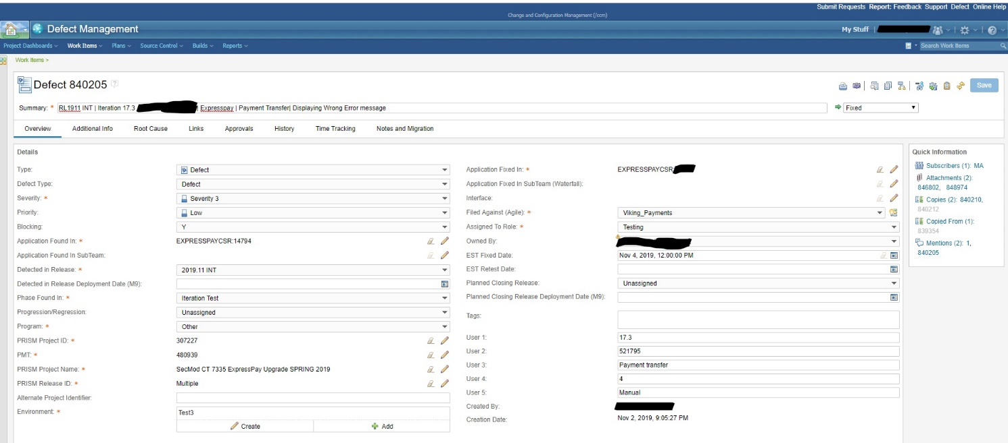

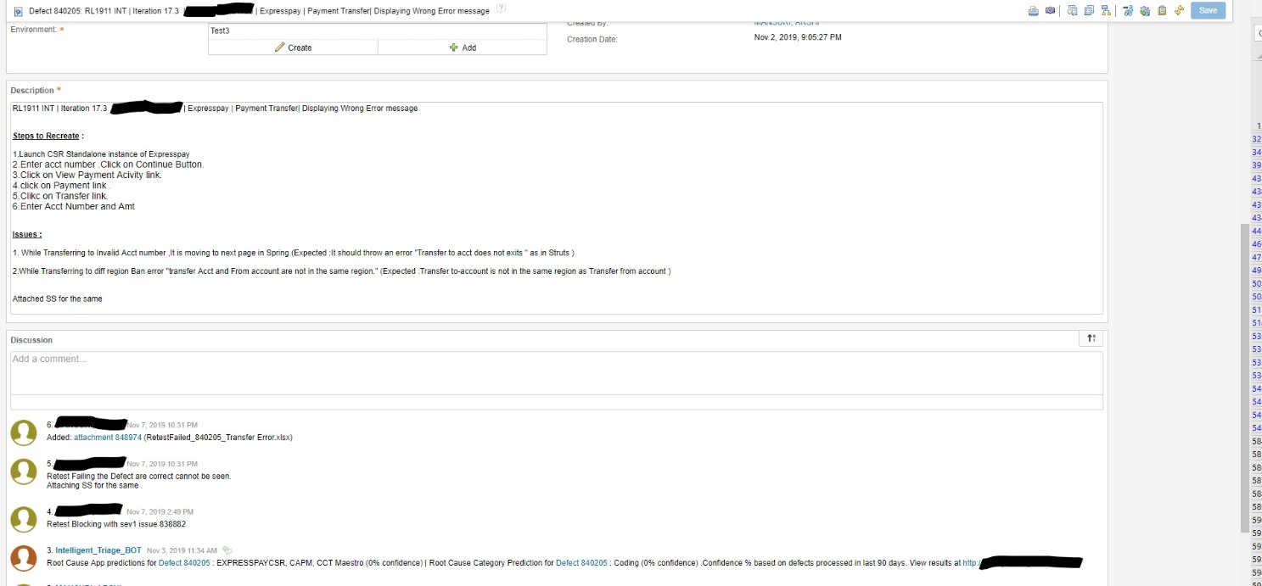

***(use SS for best purpose only)***