CODEVOYAGE
A Gamified Java 21 Learning Platform with Sandboxed Execution & Adaptive Analytics
COMPREHENSIVE PROJECT REPORT & TECHNICAL ARCHITECTURE SPECIFICATION
Submitted in partial fulfillment of the requirements for the Degree of
Bachelor of Technology / Bachelor of Engineering in Computer Science and Engineering
Candidate Name / Author: | [Editable Placeholder: Cadet / Student Name] (Roll No: [Editable Placeholder])
Project Supervisor / Guide: | [Editable Placeholder: Faculty Supervisor / Professor Name, Ph.D.]
Department / Academic Unit: | Department of Computer Science and Engineering
Institution / University: | [Editable Placeholder: Institute / University Name, City, Country]
Technology Stack & Version: | Java JDK 21 LTS | Spring Boot 3.2.5 | React 19 | Node.js Sandbox | PostgreSQL 16
Academic Year 2026 — 2027 | Document Version 1.0.0 (Production Master)

Document Control
This document establishes the official technical, pedagogical, and architectural specification for CodeVoyage. The metadata and version history recorded below govern the deployment, auditing, and maintenance of the software artifact.
Revision | Release Date | Author / Role | Primary Changes & Scope
v0.1.0 | March 2026 | Engineering Team | Initial prototype, Monaco editor integration, and single-world mission runner.
v0.5.0 | June 2026 | System Architect | Microservice sandbox isolation, Spring Security JWT authentication filter.
v0.9.0 | September 2026 | Full-Stack Team | Learning analytics dashboard, radar mastery calculations, and diagnostic hints.
v1.0.0 | October 2026 | Lead Architect | Final verification: 4 worlds, 20 canonical missions, idempotent replay, Pre/Post test CSV exporter, and 30 passing integration test cases.

Document Verification & Sign-off
Review Role | Reviewer Name & Designation | Verification Verdict | Signature / Date
Project Lead | [Editable Placeholder: Lead Student Engineer] | Verified & Validated | ____________________
Technical Guide | [Editable Placeholder: Project Guide / Assistant Professor] | Approved for Examination | ____________________
External Examiner | [Editable Placeholder: External Academic Evaluator] | Accepted | ____________________

Abstract
Introductory programming courses in higher education face severe attrition rates due to cognitive overload, cryptic compiler feedback, and disengaging pedagogical tools. Beginners learning Java are routinely overwhelmed by ceremonial syntax—such as public static void main, strict type systems, and import dependencies—before experiencing the creative empowerment of computational problem-solving. This project presents CodeVoyage, an immersive, game-based educational platform that teaches authentic Java (JDK 21) within a space-exploration narrative.
CodeVoyage departs from conventional passive tutorials and simplistic block-based simulations by hosting a production-grade coding environment powered by Microsoft's Monaco Editor and an isolated multi-process execution sandbox. The system architecture segregates the presentation tier (React 19 with Vite, TypeScript, and Tailwind CSS), the enterprise application tier (Spring Boot 3.2.5 with Spring Security and Hibernate), and an unprivileged Node.js/OpenJDK execution service that enforces rigid memory caps (128 MB) and execution timeouts (5000 ms) to neutralize malicious code and infinite loops.
The learning progression spans four distinct celestial sectors containing 20 canonical missions: World 1 (Ignis Station: Syntax, Variables, Scanner I/O, Arithmetic Operators, Conditionals), World 2 (Kryon Belt: Relational Logic, Logical Operators, Switch Decisions, Nested Control), World 3 (Nova Sector: While Loops, For Loops, Do-While Loops, Control Flow Break/Continue, Matrix Boss), and World 4 (Function Nebula: Static Methods, Return Values, Array Allocation, Linear Search & Peak Finding, Quantum Nebula Boss). Each mission guides the student through an eight-stage pedagogical loop: contextual narrative story, illustrated concept lesson, interactive diagnostic practice questions, hands-on Java challenge, sandboxed compilation, automated unit test evaluation, diagnostic error translation, and sequential progression.
An advanced Learning Analytics Engine dynamically monitors student telemetry, calculating multidimensional concept mastery, compiler pass rates, practice accuracy, hint reliance, and study duration. Furthermore, an integrated Academic Evaluation Subsystem computes pre-test and post-test normalized learning gain (Hake's g) and exports anonymized empirical datasets for educational research. Comprehensive verification comprising 30 backend JUnit/Surefire integration tests, strict TypeScript compilation, and live REST API validation confirms that CodeVoyage delivers persistent, account-isolated, and replay-safe programming instruction.
Keywords: Gamified Learning, Computer Science Education, Java 21, Sandboxed Execution, Spring Boot, React, Learning Analytics, Educational Technology, Normalized Learning Gain.

Table of Contents
The comprehensive table of contents outlines all preliminary pages, 19 core technical chapters, research references, and appendices. In Microsoft Word, press F9 on any field to refresh dynamic pagination.
Chapter / Section Title | Page
Preliminary Pages | i
Document Control | ii
Abstract | iii
Table of Contents | iv
List of Figures | v
List of Tables | vi
List of Abbreviations | vii
Chapter 1 — Introduction | 1
1.1 Background and Motivation | 1
1.2 Problem Statement | 2
1.3 Why Conventional Programming Interfaces Fail Beginners | 2
1.4 Proposed Solution: CodeVoyage | 3
1.5 Project Objectives | 3
1.6 Scope of the Project | 4
1.7 Intended Users & Expected Benefits | 4
Chapter 2 — Existing System and Proposed System | 5
2.1 Conventional Approaches to Teaching Java | 5
2.2 Limitations of Existing Solutions | 5
2.3 The Proposed CodeVoyage Paradigm | 6
2.4 Structural Comparison | 6
2.5 Architectural Trade-offs | 7
Chapter 3 — Requirements Analysis | 8
3.1 Functional Requirements | 8
3.2 Non-Functional Requirements | 9
3.3 User Roles and Permissions | 10
3.4 Requirements Traceability Matrix | 10
Chapter 4 — Technology Stack | 12
4.1 Comprehensive Technology Stack Specification | 12
Chapter 5 — System Architecture | 14
5.1 High-Level Architecture | 14
5.2 Three-Tier Component Communication Architecture | 15
5.3 Authentication & JWT Security Flow | 16
5.4 Error Handling & Fault Isolation | 17
Chapter 6 — Frontend Design and User Interface | 18
6.1 Cadet User Journey Architecture | 18
6.2 Navigation Structure and Screen Catalog | 19
6.3 Component Organization & Reusable UI Modules | 20
6.4 State Management & Context Architecture | 21
6.5 Visual Design System | 21
Chapter 7 — Educational Methodology and Java Curriculum | 22
7.1 Pedagogical Framework & Learning Sequence | 22
7.2 Complete 20-Mission Curriculum Specification | 23
7.2.1 World 1 — Ignis Station (Foundations, I/O & Branching) | 23
7.2.2 World 2 — Kryon Belt (Relational Logic & Switch Decisions) | 24
7.2.3 World 3 — Nova Sector (Loops, Iteration & Control Flow) | 25
7.2.4 World 4 — Function Nebula (Methods, Modular Design & Arrays) | 26
Chapter 8 — Game World and Gamification Mechanics | 27
8.1 Galaxy Map & Sector Progression Architecture | 27
8.2 World Unlock Prerequisite Rules | 28
8.3 Gamification Engine: XP, Ranks & Non-Punishing Stars | 28
8.4 Starfleet Commendations & Achievements | 29
8.5 Replay Safety & Persistence Across Sessions | 30
Chapter 9 — Java Coding and Execution Engine | 31
9.1 Monaco Code Editor Integration | 31
9.2 Sandboxed Execution Pipeline | 31
9.3 Resource Limits & Infinite Loop Protection | 32
9.4 Test Case Evaluation: Visible vs Hidden Tests | 33
9.5 Diagnostic Error Translation Layer | 33
Chapter 10 — Database Design | 34
10.1 Entity-Relationship Architecture | 34
10.2 Primary Data Dictionaries | 35
Chapter 11 — Backend Architecture and APIs | 37
11.1 Layered Architecture Pattern | 37
11.2 Complete REST API Endpoint Catalogue | 37
Chapter 12 — Authentication and Security | 39
12.1 Authentication & Password Hashing | 39
12.2 Stateless JWT Token Architecture | 39
12.3 Code Execution Sandboxing & Security Boundaries | 39
12.4 Security Risk Analysis & Hardening Recommendations | 40
Chapter 13 — Learning Analytics and Evaluation | 41
13.1 Learning Analytics Architecture | 41
13.2 Core Learning Metrics & Formulas | 41
13.3 Diagnostic Error Categorizer | 42
13.4 Academic Pre-Test, Post-Test & Normalized Gain Subsystem | 43
Chapter 14 — Major Workflows and Sequence Diagrams | 44
14.1 Code Submission & Real-Time Feedback Workflow | 44
14.2 Detailed Step-by-Step System Workflows | 45
Chapter 15 — Testing and Verification | 46
15.1 Testing Strategy & Methodology | 46
15.2 Automated Backend Test Results (30 Test Cases) | 46
15.3 Frontend Static Type Checking Verification | 48
Chapter 16 — Installation and Execution Guide | 49
16.1 System Prerequisites | 49
16.2 Native Three-Terminal Execution Guide | 49
16.3 Production Multi-Container Docker Launch | 50
16.4 Troubleshooting Guide | 51
Chapter 17 — Implementation Status and Known Issues | 52
17.1 Implementation Status Matrix | 52
Chapter 18 — Limitations and Future Scope | 54
18.1 Architectural & Curriculum Limitations | 54
18.2 Proposed Future Enhancements | 54
Chapter 19 — Conclusion | 56
19.1 Summary of Accomplishments | 56
19.2 Concluding Remarks | 57
References | 58
Appendix A — API Reference Summary | 59
Appendix B — Database Dictionary | 60
Appendix C — Environment Variables Reference | 61
Appendix D — Technical Glossary | 62

List of Figures
Figure 5.1: High-Level System Architecture and Multi-Tier Service Topology
Figure 5.2: Three-Tier Component Communication Architecture and Protocols
Figure 5.3: Authentication & Stateless JWT Security Flow
Figure 6.1: Cadet User Journey Architecture and Screen State Machine
Figure 7.1: Pedagogical Learning Loop Sequence (Mission to Flight Clearance)
Figure 8.1: Mission Progression & World Unlocking State Machine
Figure 9.1: Sandboxed Java Execution, Process Isolation, and Grading Pipeline
Figure 10.1: Entity-Relationship Diagram (Core JPA Domain Model)
Figure 13.1: Learning Analytics and Intelligence Architecture
Figure 14.1: Code Submission & Real-Time Feedback Sequence Diagram

List of Tables
Table 3.1: Functional Requirements Specification and Verification Matrix
Table 3.2: Non-Functional System Requirements and Quality Attributes
Table 3.3: Requirements Traceability Matrix Linking Specifications to Code Evidence
Table 4.1: Comprehensive Technology Stack, Frameworks, and Architectural Justifications
Table 7.1: Complete Java Curriculum Specification: World 1 — Ignis Station (M01–M05)
Table 7.2: Complete Java Curriculum Specification: World 2 — Kryon Belt (M06–M10)
Table 7.3: Complete Java Curriculum Specification: World 3 — Nova Sector (M11–M15)
Table 7.4: Complete Java Curriculum Specification: World 4 — Function Nebula (M16–M20)
Table 8.1: Gamification Ranks, Level Thresholds, and Cumulative XP Progression
Table 8.2: Starfleet Commendations and Achievement Directive Catalog
Table 10.1: Primary Data Dictionary: users Table Schema
Table 10.2: Primary Data Dictionary: user_progress Table Schema
Table 10.3: Primary Data Dictionary: missions Table Schema
Table 10.4: Primary Data Dictionary: submissions Table Schema
Table 11.1: REST API Endpoint Catalog and Security Permissions
Table 13.1: Learning Analytics Metrics, Operational Formulas, and Interpretations
Table 15.1: Automated Backend Test Suite Execution Matrix (30 Test Cases)
Table 16.1: Troubleshooting Guide for Local Setup, Sandbox, and Database Errors
Table 17.1: Comprehensive Implementation Status, Verification, and Defect Resolution Matrix

List of Abbreviations
Abbreviation | Full Expanded Term
API | Application Programming Interface
AST | Abstract Syntax Tree
BCrypt | Blowfish-based Password Hashing Algorithm
CLI | Command Line Interface
CPU | Central Processing Unit
CORS | Cross-Origin Resource Sharing
CSS | Cascading Style Sheets
CSV | Comma-Separated Values
DTO | Data Transfer Object
ERD | Entity-Relationship Diagram
FK | Foreign Key
H2 | Embedded Java Relational Database Management System
HMAC | Hash-based Message Authentication Code
HTTP | Hypertext Transfer Protocol
HUD | Heads-Up Display
IDE | Integrated Development Environment
JDK | Java Development Kit
JPA | Java Persistence API
JSON | JavaScript Object Notation
JVM | Java Virtual Machine
JWT | JSON Web Token
LTS | Long-Term Support
MCQ | Multiple Choice Question
ORM | Object-Relational Mapping
OS | Operating System
PK | Primary Key
RAM | Random Access Memory
REST | Representational State Transfer
SDK | Software Development Kit
SHA | Secure Hash Algorithm
SPA | Single Page Application
SQL | Structured Query Language
TOC | Table of Contents
UI | User Interface
URI | Uniform Resource Identifier
URL | Uniform Resource Locator
UX | User Experience
VM | Virtual Machine
XP | Experience Points

Chapter 1 — Introduction

1.1 Background and Motivation
Computer science and software engineering education have become foundational disciplines in global higher education. Among modern enterprise programming languages, Java remains a dominant industry pillar, powering enterprise backend services, distributed systems, financial trading engines, and Android mobile applications. However, introductory programming education frequently represents an insurmountable hurdle for novice learners. Universities worldwide report high student attrition rates in entry-level computer science coursework, with difficulty in mastering programming syntax and computational abstractions cited as primary factors.
Traditional introductory programming pedagogy relies heavily on static textbooks, passive slide lectures, and command-line execution interfaces. When beginners attempt to run their first Java program, they are confronted with complex boilerplate code—including public static void main(String[] args), class declarations, package structures, and compiler error diagnostics. Novice students often spend hours diagnosing missing semicolons, case-sensitivity discrepancies, or environment configuration problems rather than developing computational thinking skills.

1.2 Problem Statement
The fundamental problem addressed by this project can be stated as follows: Conventional programming instruction lacks contextual engagement, provides cryptic compiler diagnostics, and requires complex local toolchain installations that intimidate beginners. Furthermore, existing online coding platforms either oversimplify programming using drag-and-drop visual blocks (failing to teach authentic industry syntax) or present stark, gameless competitive coding interfaces that induce anxiety and fatigue. Consequently, there is an urgent need for an educational platform that combines authentic, text-based Java (JDK 21) programming with immersive narrative gamification, safe browser-based compilation, contextual AI companionship, and granular learning analytics.

1.3 Why Conventional Programming Interfaces Fail Beginners
Extensive computing education research identifies four major failure modes in conventional beginner programming environments:
- 1. Cognitive Overload from Ceremonial Boilerplate: Beginners must memorize rigid structural rules before they understand what variables, expressions, or loops accomplish.
- 2. Unhelpful Compiler Stack Traces: Standard Java compiler messages, such as unclosed string literal or non-static variable cannot be referenced from a static context, are designed for veteran developers rather than novices.
- 3. Lack of Intrinsic Narrative Motivation: Exercises such as 'compute the factorial of N' or 'print Fibonacci numbers' lack contextual relevance, reducing learning to dry mathematical chores.
- 4. Security Vulnerabilities in Remote Execution: Safely executing arbitrary student code on university servers requires complex sandboxing that ordinary educational websites omit.

1.4 Proposed Solution: CodeVoyage
CodeVoyage resolves these challenges by situating Java programming within an interactive space-exploration adventure. Students assume the role of Starfleet Cadets navigating celestial sectors. Every mission presents an authentic shipboard crisis—such as reactor coolant failure, thruster miscalibration, or asteroid field scanning—that can only be resolved by writing, compiling, and executing real Java code. The platform features an embedded Monaco Code Editor, an isolated multi-process execution sandbox, an encouraging holographic robot companion named B.Y.T.E., non-punishing star evaluations, and an intelligence dashboard tracking mastery across the Java curriculum.

1.5 Project Objectives
The engineering and educational objectives of CodeVoyage are:
- Objective 1: To engineer an immersive, responsive single-page web application using React 19, TypeScript, and Tailwind CSS featuring a futuristic space HUD aesthetic.
- Objective 2: To implement an enterprise-grade backend with Spring Boot 3.2.5, providing secure RESTful APIs, JWT stateless authentication, and relational persistence.
- Objective 3: To construct an isolated, secure Java (JDK 21) compilation sandbox that enforces rigid memory caps (128 MB) and execution timeouts (5000 ms).
- Objective 4: To design and deploy a sequential 20-mission Java curriculum across four celestial worlds, encompassing syntax, primitives, I/O, control flow, loops, methods, and arrays.
- Objective 5: To provide a diagnostic error translation layer that translates cryptic javac and JVM stack traces into clear, actionable advice.
- Objective 6: To develop a Learning Analytics and Academic Evaluation Subsystem that computes multidimensional mastery, identifies struggling concepts, and exports empirical research datasets.

1.6 Scope of the Project
The scope of CodeVoyage encompasses the full software development lifecycle of the web application, including frontend interfaces, backend services, database schema design, sandbox security boundaries, automated test suites, and empirical evaluation metrics. The platform covers foundational imperative and procedural Java concepts. Advanced object-oriented topics (inheritance, interfaces, polymorphism, multithreading, and stream APIs) are recognized as future curriculum expansions.

1.7 Intended Users & Expected Benefits
The primary users are undergraduate computer science students, coding bootcamp attendees, and self-directed programming novices. Secondary users include university professors, teaching assistants, and institutional researchers who utilize the analytics and evaluation datasets. Expected benefits include accelerated concept acquisition, reduced syntax frustration, higher course completion rates, and an engaging, stress-free learning atmosphere.

Chapter 2 — Existing System and Proposed System

2.1 Conventional Approaches to Teaching Java
Traditional Java instruction relies on desktop integrated development environments (e.g., Eclipse, IntelliJ IDEA, NetBeans) or simple command-line terminal compilation (javac and java). Students read theoretical textbook chapters, observe instructor demonstrations, and attempt weekly programming assignments. Alternatively, web-based platforms fall into two categories: block-based programming environments (such as Scratch or Blockly) or competitive coding portals (such as LeetCode, HackerRank, or Codeforces).

2.2 Limitations of Existing Solutions
A systematic analysis reveals critical shortcomings across current pedagogical solutions:
- 1. Visual Disconnect: Block-Based Platforms: While Scratch and Blockly reduce syntax anxiety, they do not teach real Java text syntax. Students experience a severe disconnect when transitioning from visual blocks to text-based coding.
- 2. Punitive Interfaces: Competitive Coding Portals: LeetCode and HackerRank are designed for algorithmic interview preparation rather than novice instruction. They lack structured lessons, offer zero contextual narrative, and penalize failed attempts, creating anxiety.
- 3. Lack of Structure: Generic Online Compilers: In-browser compilers (e.g., JDoodle, OnlineGDB) provide basic execution but lack structured curricula, automated test case grading, gamification mechanics, and learning analytics.
- 4. Setup Overhead: Local Environment Friction: Installing JDKs, configuring JAVA_HOME environment variables, and navigating complex IDE interfaces consumes vital classroom hours and causes early frustration.

2.3 The Proposed CodeVoyage Paradigm
CodeVoyage bridges the gap between playful engagement and professional software development. By integrating Microsoft's Monaco Editor directly into a sci-fi cockpit HUD, students write authentic Java 21 code with syntax highlighting, autocomplete, and line numbers. The game mechanics provide immediate intrinsic rewards—reparing starship thrusters, stabilizing plasma cores, and unlocking new planetary sectors—without punishing learners for syntax mistakes.

2.4 Structural Comparison
Evaluation Dimension | Traditional Desktop IDE | Competitive Coding Portal | CodeVoyage Platform
Installation Overhead | Heavy (JDK, IDE, paths) | None (Browser-based) | Zero (Instant Web Browser Cockpit)
Authentic Java Syntax | Yes (Full Java) | Yes (Full Java) | Yes (JDK 21 LTS with Monaco Editor)
Narrative & Theme | None (Blank editor) | None (Algorithmic problem) | Rich Sci-Fi Space Exploration World
Companion / Hints | None (Cryptic stack traces) | Community discussion / paid | B.Y.T.E. Holographic AI Companion
Evaluation Mindset | Grade / Pass / Fail | Time / Memory percentile | Constructive 1-3 Stars + XP Progression
Analytics Engine | None | Submission history graph | Multi-concept mastery radar & diagnostics
Academic Research Export | None | None (Proprietary) | Standardized Pre/Post Normalized Gain CSV

2.5 Architectural Trade-offs
Adopting a cloud-based sandbox architecture introduces specific engineering trade-offs. While browser-based execution eliminates client installation friction, it imposes server-side execution burdens and security risks. CodeVoyage mitigates these risks through process isolation, memory capping, and timeout enforcement, trading arbitrary OS-level file access for guaranteed host integrity.

Chapter 3 — Requirements Analysis

3.1 Functional Requirements
The system's functional requirements define the core operational capabilities implemented in the software:
Req ID | Requirement Description | Subsystem | Verification Status
FR-01 | Cadet Registration & Login with encrypted passwords and JWT token issuance | Auth Module | Implemented & Verified
FR-02 | Galaxy Map rendering 4 celestial worlds with accurate sequential unlock states | Galaxy Map UI | Implemented & Verified
FR-03 | Curriculum display of 20 canonical missions with lesson, practice, and challenge | Mission Engine | Implemented & Verified
FR-04 | In-browser Java code editing using Monaco Editor with syntax diagnostics | Frontend Editor | Implemented & Verified
FR-05 | Sandbox execution of Java 21 code with process isolation and timeout limits | Execution Sandbox | Implemented & Verified
FR-06 | Automated grading against visible and hidden unit test cases | Submission Engine | Implemented & Verified
FR-07 | Dynamic star evaluation (1-3 stars) and XP awarding based on hint usage and tries | Gamification | Implemented & Verified
FR-08 | Permanent persistence of mission completions, stars, XP, and sector unlock progress | Database Layer | Implemented & Verified
FR-09 | Safe mission replay allowing code practice without erasing progress or duplicating XP | Progress Service | Implemented & Verified
FR-10 | Learning Analytics Dashboard computing concept mastery, pass rates, and trends | Analytics Subsystem | Implemented & Verified
FR-11 | Academic evaluation engine administering Pre/Post tests and exporting CSV data | Evaluation Subsystem | Implemented & Verified
FR-12 | Starfleet commendation deck awarding 13 distinct achievements upon milestones | Achievement System | Implemented & Verified

3.2 Non-Functional Requirements
Non-functional requirements specify quality attributes, performance bounds, and security constraints:
NFR ID | Attribute | Specification / Bound | Implementation Mechanism
NFR-01 | Execution Latency | Sandbox compilation and run < 1500 ms for normal solutions | Pre-warmed JVM execution in Node.js child_process
NFR-02 | Resource Isolation | Memory restricted to 128 MB per execution; 5000 ms CPU timeout | JVM flag -Xmx128m and process kill timer
NFR-03 | Security & Auth | Stateless HMAC-SHA256 JWT tokens; passwords hashed with BCrypt | Spring Security filter chain and BCryptPasswordEncoder
NFR-04 | Data Integrity | Zero data loss across browser refreshes, server reboots, or re-logins | Relational foreign keys and transactional JPA commits
NFR-05 | Tamper Resistance | XP, stars, levels, and unlocks computed strictly on backend | Server-side grading; frontend cannot forge progress
NFR-06 | Usability & UX | Dark sci-fi HUD aesthetic; responsive layout across desktop screens | Tailwind CSS utility classes and Lucide vector icons

3.3 User Roles and Permissions
The system enforces role-based access control (RBAC) via the Role enum in com.codevoyage.user:
- Cadet / Explorer: EXPLORER (Default Student): Can authenticate, complete lessons, submit code, view personal analytics, unlock worlds, and export personal dossier records.
- Commander / Faculty: COMMANDER (Instructor / Faculty): Inherits all cadet permissions plus access to cohort-wide analytics (GET /api/v1/analytics/faculty) and empirical dataset export.
- Administrator: ADMIN (System Administrator): Unrestricted database maintenance and curriculum authoring capabilities.

3.4 Requirements Traceability Matrix
The traceability matrix maps system specifications directly to inspected source files:
Req ID | Core Requirement | Primary Implementation File | Test Evidence File
FR-01 | JWT Registration / Login | backend/.../auth/AuthController.java | SubmissionServiceTest.java
FR-02 | Sequential World Unlocking | backend/.../mission/MissionService.java | MissionProgressionIntegrationTest.java
FR-03 | 20-Mission Java Curriculum | backend/.../config/DataLoader.java | MissionProgressionIntegrationTest.java
FR-04 | Monaco Editor Integration | frontend/src/editor/JavaCodeEditor.tsx | Frontend tsc --noEmit check
FR-05 | Isolated Sandbox Execution | execution-service/src/index.ts | OutputNormalizerTest.java
FR-06 | Automated Test Grading | backend/.../submission/SubmissionService.java | SubmissionServiceTest.java
FR-07 | Star & XP Gamification | backend/.../progress/ProgressService.java | MissionProgressionIntegrationTest.java
FR-08 | Progress Persistence | backend/.../progress/UserProgress.java | MissionProgressionIntegrationTest.java
FR-09 | Safe Idempotent Replay | backend/.../progress/ProgressService.java | MissionProgressionIntegrationTest.java
FR-10 | Learning Analytics Engine | backend/.../analytics/AnalyticsService.java | AnalyticsServiceTest.java
FR-11 | Academic Pre/Post Dataset | backend/.../evaluation/EvaluationService.java | EvaluationController live CSV test
FR-12 | Achievement Commendations | backend/.../achievement/AchievementService.java | DataLoader seed verification

Chapter 4 — Technology Stack
The technology stack for CodeVoyage was chosen to ensure high responsiveness, enterprise-grade reliability, authentic compilation accuracy, and strict security isolation. Every dependency has been verified in the project repository configuration files (pom.xml, package.json, and docker-compose.yml).
Layer / Subsystem | Technology & Version | Architectural Role | Justification & Benefits
Frontend Framework | React 19.3.0 | Core Single Page Application (SPA) | Component-driven reactive architecture, high performance virtual DOM, extensive UI ecosystem.
Frontend Toolchain | Vite 8.3.0 | Module Bundler & Dev Server | Sub-millisecond Hot Module Replacement (HMR) and optimized Rollup production builds.
Language (Frontend) | TypeScript 6.0.2 | Static Type Safety | Eliminates runtime type errors, guarantees API contract alignment, facilitates safe refactoring.
Styling System | Tailwind CSS 3.4.19 | Utility-First CSS Framework | Rapid implementation of futuristic sci-fi HUD styling, responsive glassmorphism, zero runtime CSS bloat.
Code Editor Engine | Monaco Editor 4.7.0 | In-Browser Java IDE | The official editor engine behind Microsoft VS Code; provides authentic Java syntax coloring, line numbers, and shortcuts.
Animation Library | Framer Motion 13.2.0 | UI Transitions & Modals | Declarative physics-based animations for planet orbits, celebration modals, and cinematic launch transitions.
Icons | Lucide React 1.45.0 | Vector Sci-Fi Icons | Lightweight, customizable SVG vector icons matching the starship aesthetic.
Backend Framework | Spring Boot 3.2.5 | Enterprise REST API | Mature dependency injection, robust transaction management, seamless JPA data handling, production stability.
Language (Backend) | Java JDK 21 LTS | Core Platform & Target Language | Modern Long-Term Support Java release; enables modern language features (pattern matching, records, virtual threads).
Security Framework | Spring Security 6.2.4 | Authentication & RBAC | Industry-standard security architecture for endpoint interception, stateless token validation, and password hashing.
JWT Token Engine | JJWT 0.12.5 | Stateless Authentication | Standards-compliant HMAC-SHA256 token creation, parsing, and cryptographic verification.
Database Layer | PostgreSQL 16 / H2 | Relational Persistence | PostgreSQL for ACID-compliant production storage; embedded H2 for zero-configuration local development and rapid test runs.
ORM Layer | Spring Data JPA / Hibernate | Object-Relational Mapping | Eliminates boilerplate SQL; automatic schema generation; parameterized query security.
Execution Sandbox | Node.js 20 & Express 4.19 | Isolated Java Runner Microservice | Asynchronous, lightweight process runner interfacing directly with OS javac/java processes.
Containerization | Docker & Docker Compose | Multi-Container Orchestration | Unifies PostgreSQL, Backend, Execution Service, and Frontend into reproducible isolated containers.

Chapter 5 — System Architecture

5.1 High-Level Architecture
CodeVoyage follows a modern micro-modular architecture divided into three discrete physical tiers: the Presentation Tier (React 19 SPA running on port 5173), the Application Tier (Spring Boot 3.2.5 running on port 8080), and the Sandbox Execution Tier (Node.js/JDK 21 runner on port 5050), backed by relational storage (PostgreSQL 16 on port 5432 or embedded H2).
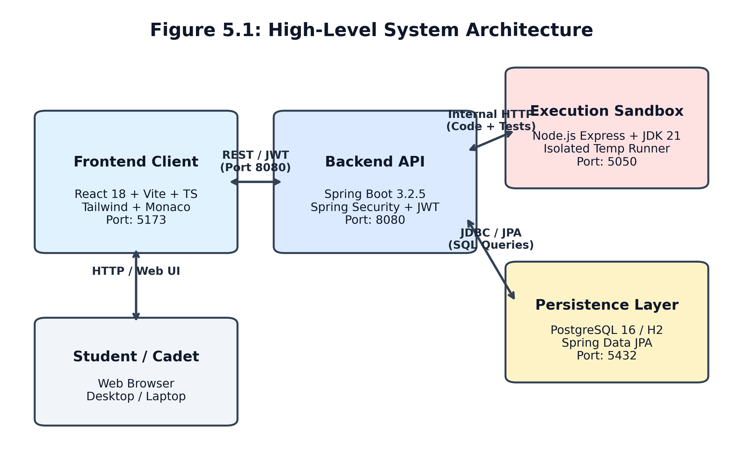
Figure 5.1: High-Level System Architecture and Multi-Tier Service Topology

5.2 Three-Tier Component Communication Architecture
Communication across tiers is strictly decoupled using standard protocols:
- Client-to-Backend: Tier 1 to Tier 2: The React SPA communicates with Spring Boot over HTTP/HTTPS using Axios clients. Requests attach the cadet's JWT token in the Authorization: Bearer header. Responses use JSON Data Transfer Objects (DTOs).
- Backend-to-Sandbox: Tier 2 to Tier 3A: When a student submits Java code, Spring Boot queries the required test cases from the database and forwards an internal REST request (POST /api/v1/execute) to the Execution Sandbox on port 5050. The sandbox is unreachable from the public internet.
- Backend-to-Database: Tier 2 to Tier 3B: Spring Boot manages database transactions through Hibernate ORM and Spring Data JPA, executing parameterized SQL queries against PostgreSQL or H2.
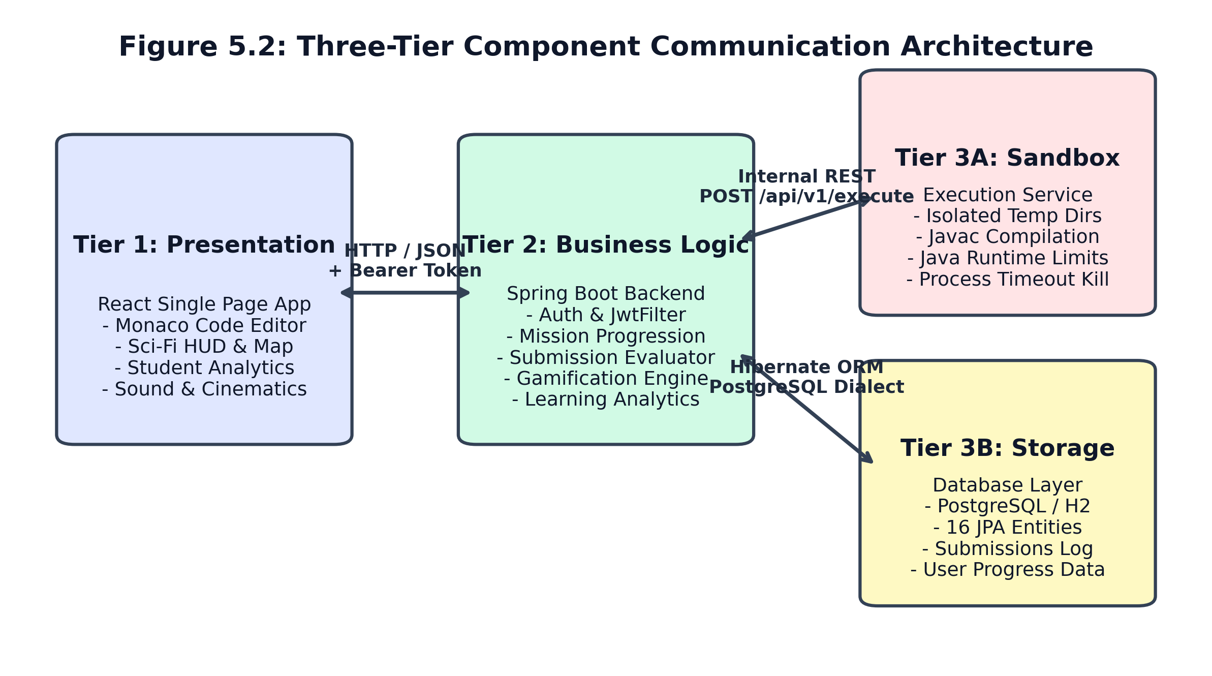
Figure 5.2: Three-Tier Component Communication Architecture and Protocols

5.3 Authentication & JWT Security Flow
Authentication is completely stateless, eliminating session state from the backend server:
- 1. Token Issuance: Registration / Login: The cadet submits credentials to /api/v1/auth/login. Spring Security verifies the BCrypt-hashed password against the users table. Upon verification, JwtService signs an HMAC-SHA256 token valid for 24 hours.
- 2. Client Transport: Token Storage & Interception: The frontend stores the token in localStorage and attaches it via an Axios request interceptor.
- 3. Server Interception: Filter Verification: JwtAuthFilter intercepts incoming requests, validates the signature and expiration, extracts the cadet's username, and populates the SecurityContextHolder.
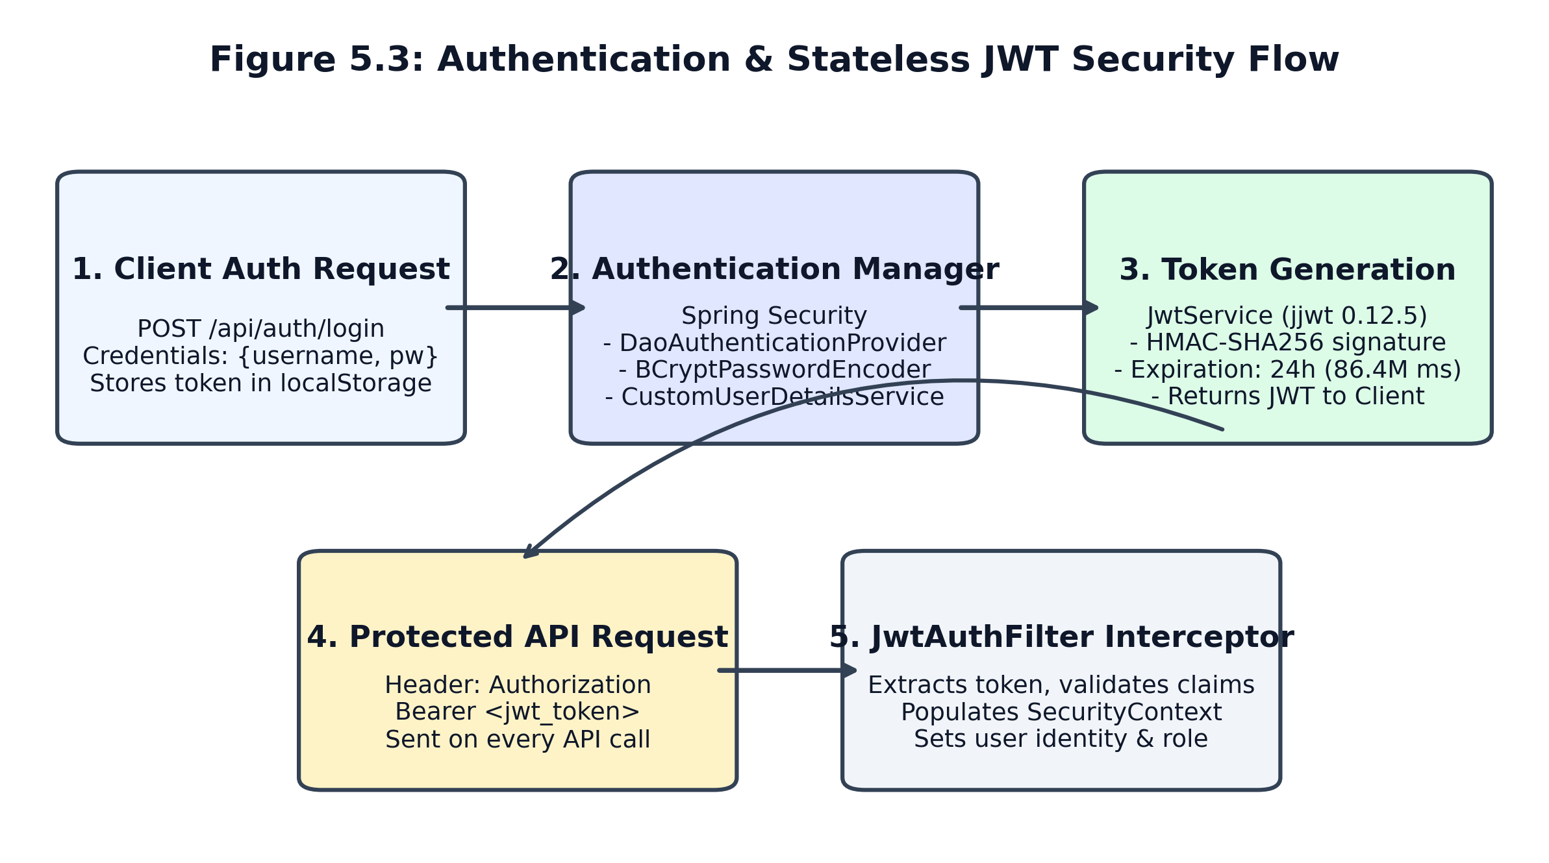
Figure 5.3: Authentication & Stateless JWT Security Flow

5.4 Error Handling & Fault Isolation
The architecture enforces multi-layered error handling to prevent cascading failures:
- Process Level: Sandbox Isolation: Malicious code, infinite loops, or crashes in student code only terminate the ephemeral child process; the Node.js execution service and Spring Boot backend remain unaffected.
- Application Level: Backend Global Exception Handler: Spring's @RestControllerAdvice intercepts unhandled exceptions, translating internal stack traces into sanitized JSON error envelopes.
- Presentation Level: Frontend Graceful Degradation: If the backend is temporarily unreachable, the frontend displays offline indicators and prevents session loss by preserving local JWT credentials.

Chapter 6 — Frontend Design and User Interface

6.1 Cadet User Journey Architecture
The frontend user interface is architected around the Starfleet Cadet journey, guiding the student smoothly from initial platform onboarding to advanced planetary coding sectors. The interface eliminates visual clutter, prioritizing readable typography, high-contrast code presentation, and intuitive navigation.
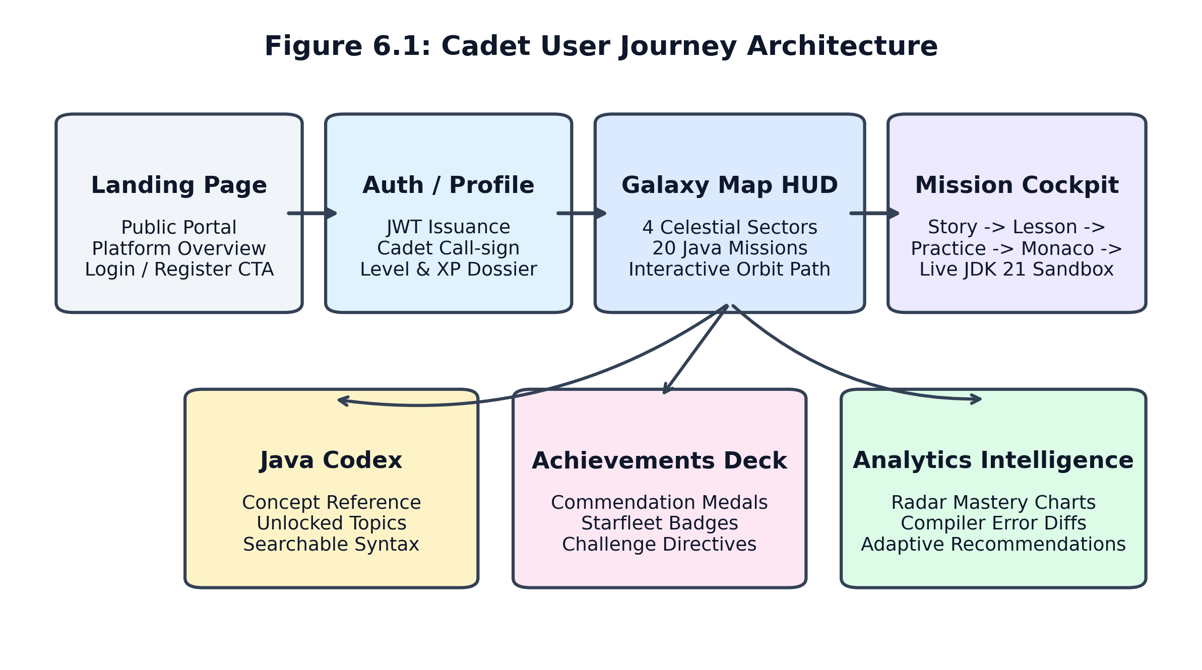
Figure 6.1: Cadet User Journey Architecture and Screen State Machine

6.2 Navigation Structure and Screen Catalog
The application is structured into seven primary functional views routed via React Router DOM v7:
- 1. Landing Portal: Landing Page (/): The public welcoming deck introducing the platform narrative, learning benefits, and primary call-to-action buttons for registration and login.
- 2. Command Dashboard: Dashboard (/dashboard): The cadet's tactical briefing center displaying active starship status, current level, XP progress bar, active streak, and rapid resume shortcuts.
- 3. Galaxy Map HUD: Galaxy Map (/galaxy-map): An interactive orbital sector map depicting the 4 celestial worlds, orbital navigation paths, cleared mission counts (e.g. Cleared: 5/5), and contextual unlock requirements.
- 4. Mission Cockpit: Mission Experience (/missions/:id): The primary learning cockpit. Houses the 4-phase mission progression: Narrative Story -> Concept Lesson -> Interactive Practice Questions -> Monaco Java Code Editor.
- 5. Java Codex Reference: Java Codex (/codex): A searchable starship computer reference detailing unlocked Java syntax, code examples, best practices, and common compiler pitfalls.
- 6. Starfleet Commendations: Achievements Medals (/achievements): An interactive medal deck displaying 13 Starfleet commendation badges with progress rings, directives, and unlock timestamps.
- 7. Analytics Intelligence: Learning Analytics (/analytics): A student intelligence dashboard featuring a 6-axis concept mastery radar chart, compiler diagnostic breakdown, study velocity trends, and personalized drill recommendations.
- 8. Cadet Dossier: Cadet Profile (/profile): An authentic flight record displaying total XP, level rank title, account metadata, and completed mission history.

6.3 Component Organization & Reusable UI Modules
The frontend component hierarchy promotes strict modularity and separation of concerns:
- Structural Shell: AppShell: The foundational frame providing the animated sci-fi space background, global navigation bar, audio settings modal, and cadet status chips.
- HUD Atoms: GlassCard & GlowButton: High-tech translucent container components utilizing CSS backdrop-filter blur and responsive cyan/emerald glow borders.
- Game Cards: MissionCard: Rendered across the Galaxy Map and Sectors page to display mission status (LOCKED, CURRENT, or CLEARED) with color-coded badges and action buttons.
- Editor Engine: JavaCodeEditor: The encapsulated Monaco Editor module featuring custom dark theme configuration, tab indentation settings, syntax error highlights, and reset actions.
- Pedagogical Agent: RobotCompanion (B.Y.T.E.): The holographic companion widget that renders context-sensitive dialogue, encouraging quotes, and compiler diagnostic hints.

6.4 State Management & Context Architecture
Frontend state is partitioned into two specialized React Context providers:
- AuthContext: AuthContext: Manages authentication lifecycle, storing JWT tokens, active cadet username, role, XP, and profile avatar. It features an intelligent refresh loop that only revokes credentials upon an explicit HTTP 401 Unauthorized response, preventing accidental logouts on transient network delays.
- GameContext: GameContext: Manages real-time audio playback states (background ambient drone, button click sounds, mission clearance fanfares, and error buzzers) using the Web Audio API.

6.5 Visual Design System
The visual design system adheres to a disciplined cyber-space palette. The primary canvas uses deep space navy (#030712 and #0b0f19). Interactive accents employ electric cyan (#06b6d4) for active operations, starfleet emerald (#10b981) for cleared missions and success states, amber (#f59e0b) for warnings, and crimson (#ef4444) for compiler errors. Typography pairs clean sans-serif UI typography (Inter/system-ui) with monospaced code blocks (Consolas / Menlo).

Chapter 7 — Educational Methodology and Java Curriculum

7.1 Pedagogical Framework & Learning Sequence
CodeVoyage implements a scaffolded, constructivist pedagogical model. Rather than presenting abstract syntax in isolation, every programming concept is anchored to an operational shipboard need. The learning sequence moves systematically from cognitive recognition to independent code synthesis:
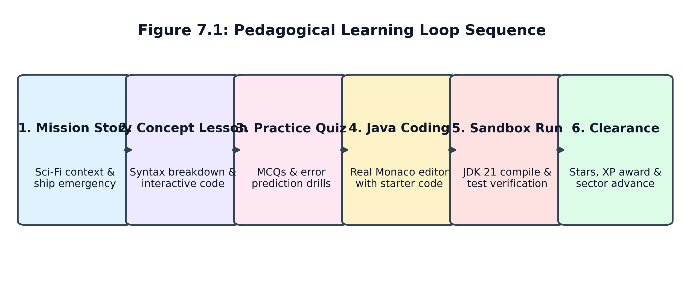
Figure 7.1: Pedagogical Learning Loop Sequence
The eight distinct stages of each mission are:
- 1. Story Briefing: Stage 1 (Mission Story): The cadet is briefed on an emergency or operational directive (e.g., life support sensors failing on Ignis Station).
- 2. Concept Explanation: Stage 2 (Concept Lesson): The underlying Java concept is explained through real-world analogies, syntax breakdowns, and interactive code snippets.
- 3. Diagnostic Practice: Stage 3 (Interactive Practice): Diagnostic multiple-choice questions and code prediction drills test conceptual comprehension before code writing.
- 4. Code Synthesis: Stage 4 (Java Coding Challenge): The student opens the Monaco editor with structured starter code and clear challenge instructions.
- 5. Sandboxed Run: Stage 5 (Sandbox Execution): The code is compiled and executed in the isolated Java 21 sandbox against input streams.
- 6. Automated Grading: Stage 6 (Test Case Evaluation): The program output is evaluated against both visible and hidden unit test cases.
- 7. Plain Feedback: Stage 7 (Diagnostic Feedback): B.Y.T.E. delivers immediate feedback—celebrating clean runs or translating errors into plain English.
- 8. Progression: Stage 8 (Flight Clearance): The student is awarded 1 to 3 stars, earns experience points (XP), and unlocks the subsequent mission.

7.2 Complete 20-Mission Curriculum Specification
The CodeVoyage curriculum spans four complete worlds, each containing five canonical missions (20 missions total). Every mission has been verified in DataLoader.java and tested against the execution engine:

World 1 — Ignis Station (Foundations, I/O & Branching)
M# | Mission Title | Java Concept | Coding Challenge Objective | Grading Criteria
M01 | Powering the Console | Class, Main, println | Print 'Ignis Station Online' to standard output | Matches exact greeting output
M02 | Ship Systems | Variables, int & double | Declare core temperature and power; compute total energy | Accurate variable arithmetic
M03 | Receiving Transmissions | Scanner & System.in | Read cadet call-sign from input and output welcome message | Correct stdin token parsing
M04 | Engine Control | Arithmetic operators (+, -, *, /, %) | Calculate warp fuel burn and remainder thruster cycles | Modulo and integer division logic
M05 | BOSS: The Reactor Failure | Conditionals (if / else if / else) | Evaluate reactor pressure thresholds and output status | Multi-branch condition synthesis

World 2 — Kryon Belt (Relational Logic & Multi-Way Decisions)
M# | Mission Title | Java Concept | Coding Challenge Objective | Grading Criteria
M06 | Thermal Deflector Switch | Relational Operators (<, >, >=) | Compare external asteroid temperature against shield limit | Boolean relational assertions
M07 | Ice Shield Resonance | Logical AND (&&) & OR (||) | Validate dual sensor thresholds for shield frequency lock | Compound boolean evaluations
M08 | Sub-Zero Thruster Gating | Logical NOT (!) & Boolean Flags | Invert offline thruster flags to engage backup ion drives | Negation logic and edge bounds
M09 | Subspace Beacon Parser | Switch statements & cases | Route incoming channel frequencies 1-4 to defense sectors | Exact switch-case dispatching
M10 | BOSS: Cryo-Grid Override | Nested Control Flow & Integration | Balance cryogenic coolant pumps across multiple chambers | Multi-layered logic synthesis

World 3 — Nova Sector (Loops, Iteration & Control Flow)
M# | Mission Title | Java Concept | Coding Challenge Objective | Grading Criteria
M11 | Stellar Decay Monitoring | while loops & accumulators | Deplete radiation count down to safe baseline threshold | Loop termination and counter logic
M12 | Pulsar Frequency Counter | for loops & ranges | Iterate beacon frequencies from start to end with step bounds | Exact step iteration output
M13 | Shield Oscillation Cycle | do-while loops | Execute pulse burn at least once until resonance is achieved | Guaranteed single-pass loop
M14 | Radiation Flare Intercept | Loop control: break & continue | Skip corrupted packets (continue) and halt on critical flare (break) | Accurate flow-control interrupts
M15 | BOSS: Hyper-Pulsar Core | Nested Loops & Matrix Scans | Iterate 2D sensor grid coordinates to stabilize pulsar core | Nested loop boundary synthesis

World 4 — Function Nebula (Methods, Modular Design & Arrays)
M# | Mission Title | Java Concept | Coding Challenge Objective | Grading Criteria
M16 | Quantum Ping Subroutine | Static Methods & Parameters | Implement static void pingSensor(int frequency, String id) | Modular method parameterization
M17 | Warp Vector Calculation | Typed Return Values (double) | Implement calculateTrajectory(double mass, double velocity) | Accurate typed value calculation
M18 | Sensor Array Mesh | 1D Array Allocation & Indexing | Declare integer array of size 5, assign readings, print length | Array initialization & bounds
M19 | Cosmic Dust Peak Detector | Array Traversal & Linear Search | Iterate spectral reading array to locate maximum radiation peak | Linear scan & maximum detection
M20 | BOSS: Quantum Mesh Synthesis | Modular Integration & Arrays | Combine helper methods and multidimensional arrays for synthesis | Complete curriculum integration

Chapter 8 — Game World and Gamification Mechanics

8.1 Galaxy Map & Sector Progression Architecture
The central navigation hub of CodeVoyage is the Galaxy Map, representing the interstellar frontier. The Galaxy Map visually presents four worlds orbiting a central celestial core: Ignis Station, Kryon Belt, Nova Sector, and Function Nebula.
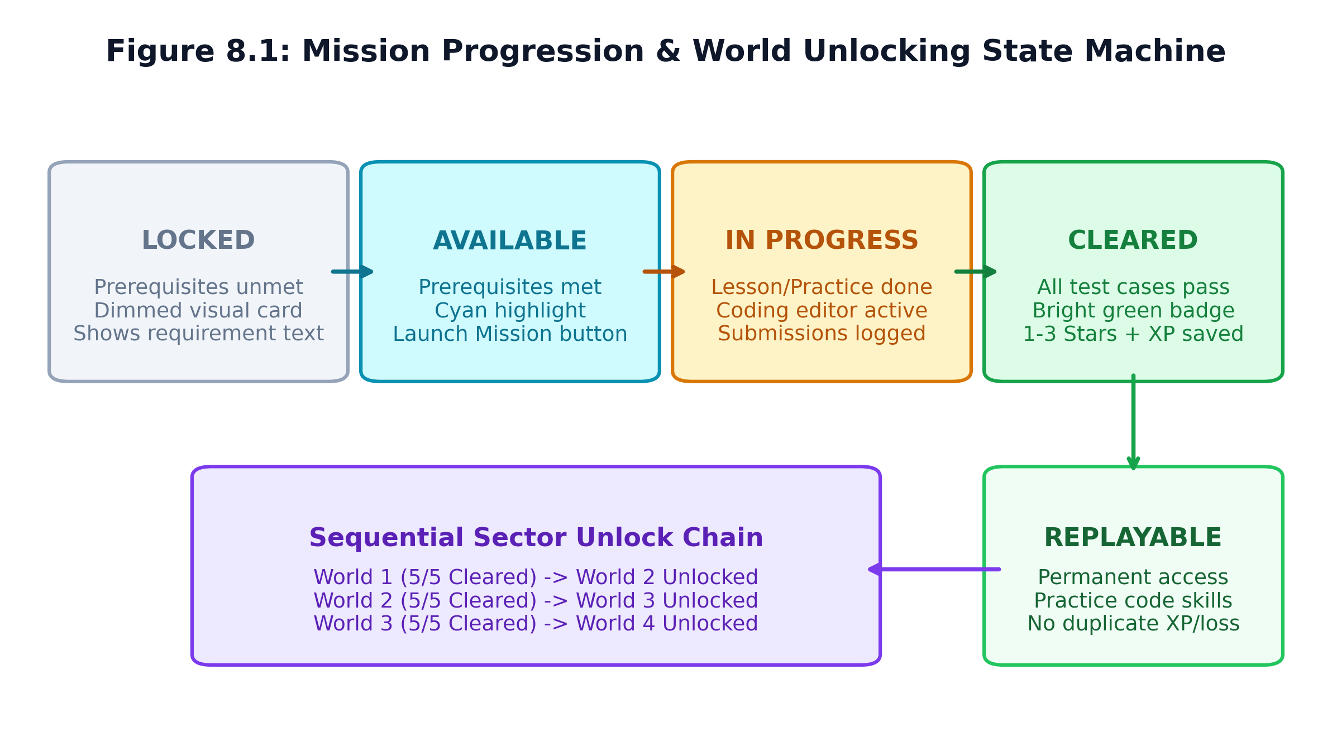
Figure 8.1: Mission Progression & World Unlocking State Machine
Every mission transitions through four well-defined states:
- 1. Locked: LOCKED: The prerequisite mission or world has not been cleared. The card is rendered with dimmed styling and an informative prerequisite tag (e.g., 'Requires M01').
- 2. Available: AVAILABLE / CURRENT: All prerequisites are satisfied. The mission card is rendered with an electric cyan border, active star indicators, and an enabled 'Launch Mission' button.
- 3. In Progress: IN PROGRESS: The student has reviewed the lesson or completed the practice questions, but has not yet passed all test cases.
- 4. Cleared: CLEARED: The student successfully executed code passing 100% of test cases. A bright green CLEARED badge is displayed with awarded stars (1-3) and a permanent 'Replay' action.

8.2 World Unlock Prerequisite Rules
World unlocking is computed authoritatively on the backend via MissionService.java. The unlocking rules are:
- Rule 1: World 1 (Ignis Station): Always unlocked by default (unlockedByDefault = true).
- Rule 2: World N (for N > 1): Unlocked if and only if all required missions in World N-1 are completed by the authenticated student. Empty worlds never evaluate to completed (totalRequiredMissions > 0 && completedCount >= totalRequiredMissions).
- Rule 3: Dynamic Prerequisite Messaging: If a student clicks a locked world, the UI displays backend-generated text explaining the exact prerequisite (e.g., 'Complete all required missions in WORLD 2 — KRYON BELT to unlock WORLD 3 — NOVA SECTOR.').

8.3 Gamification Engine: XP, Ranks & Non-Punishing Stars
To motivate students without inducing stress, CodeVoyage uses a non-punishing star evaluation system:
- ★★★: 3 Stars: Awarded when the student passes all test cases without requesting hints and within 3 attempts.
- ★★☆: 2 Stars: Awarded when the student completes the challenge with minor guidance (using 1 hint).
- ★☆☆: 1 Star: Awarded upon completing the challenge with multiple hints or repeated attempts.
Experience Points (XP) accumulate across completed missions. The cadet's Rank Title is dynamically computed in UserLevelSystem.java based on cumulative XP:
Level | Rank Title | XP Threshold Range | Academic Stage / Competency
Level 1 | Rookie Cadet | 0 — 149 XP | Foundational Syntax, Class Structure & Output
Level 2 | Code Explorer | 150 — 349 XP | Primitive Variables, Memory & Scanner Input
Level 3 | Space Navigator | 350 — 599 XP | Arithmetic Calculations & Simple Conditionals
Level 4 | Code Pilot | 600 — 899 XP | Relational Operators, Boolean Logic & Switch Cases
Level 5 | Galaxy Engineer | 900 — 1299 XP | Iteration, While/For Loops & Loop Control
Level 6+ | Java Commander | 1300+ XP | Modular Methods, Arrays & Capstone Integration

8.4 Starfleet Commendations & Achievements
The platform awards 13 distinct achievement badges stored in the achievements table and tracked per student in user_achievements:
Badge Code | Commendation Title | Directive / Unlock Requirement
FIRST_LAUNCH | First Launch | Complete all foundational directives and initiate your ship launch.
VARIABLE_MASTER | Variable Master | Master Java variables, primitive types, and state preservation.
INPUT_SPECIALIST | Input Specialist | Harness Java Scanner and parse telemetry inputs from sub-space arrays.
LOGIC_PILOT | Logic Pilot | Navigate branching conditional systems with boolean decision logic.
BUG_HUNTER | Bug Hunter | Identify syntax anomalies and resolve compiler errors cleanly.
LOOP_EXPLORER | Loop Explorer | Automate orbital burns and cyclic instructions with loops.
CODE_CADET | Code Cadet | Complete your first live Java compilation in the starship terminal.
WORLD_CONQUEROR | World Conqueror | Clear all sector directives and fully conquer a celestial world.
FIRST_STEPS | First Steps | Complete your very first starship mission.
FIRST_IGNITION | First Ignition | Execute your very first compiled Java program.
CONSOLE_HERO | Console Hero | Complete Java basics and console output directives.
NO_HINTS | No Hints | Complete 5 coding challenges without using any hints.
IGNIS_STATION_HERO | Ignis Station Hero | Complete all 5 foundational missions on Ignis Station.

8.5 Replay Safety & Persistence Across Sessions
A critical engineering guarantee of CodeVoyage is replay idempotency. When a student chooses to replay a previously cleared mission:
- 1. Never Revokes Completion: Persistence Guarantee: The mission's completed status in user_progress remains true.
- 2. No Relocking: Sector Integrity: Unlocked downstream sectors (e.g. World 2 or 3) remain permanently unlocked.
- 3. No Duplicate XP: Anti-Grind Security: The cadet is not awarded duplicate completion XP, preventing artificial leaderboard manipulation.
- 4. Relational Persistence: Cross-Session Resilience: All progress is committed to relational storage, surviving browser refreshes, logouts, and backend restarts.

Chapter 9 — Java Coding and Execution Engine

9.1 Monaco Code Editor Integration
CodeVoyage embeds Microsoft's Monaco Editor (@monaco-editor/react v4.7.0), the engine powering Visual Studio Code. The editor is configured with full Java language mode, syntax highlighting, bracket matching, line numbers, customizable font sizes, and standard keyboard shortcuts (Ctrl+Enter to run, Ctrl+Z to undo).

9.2 Sandboxed Execution Pipeline
The Java execution engine operates as an independent microservice written in TypeScript and Node.js (port 5050). The workflow follows a strict five-step pipeline:
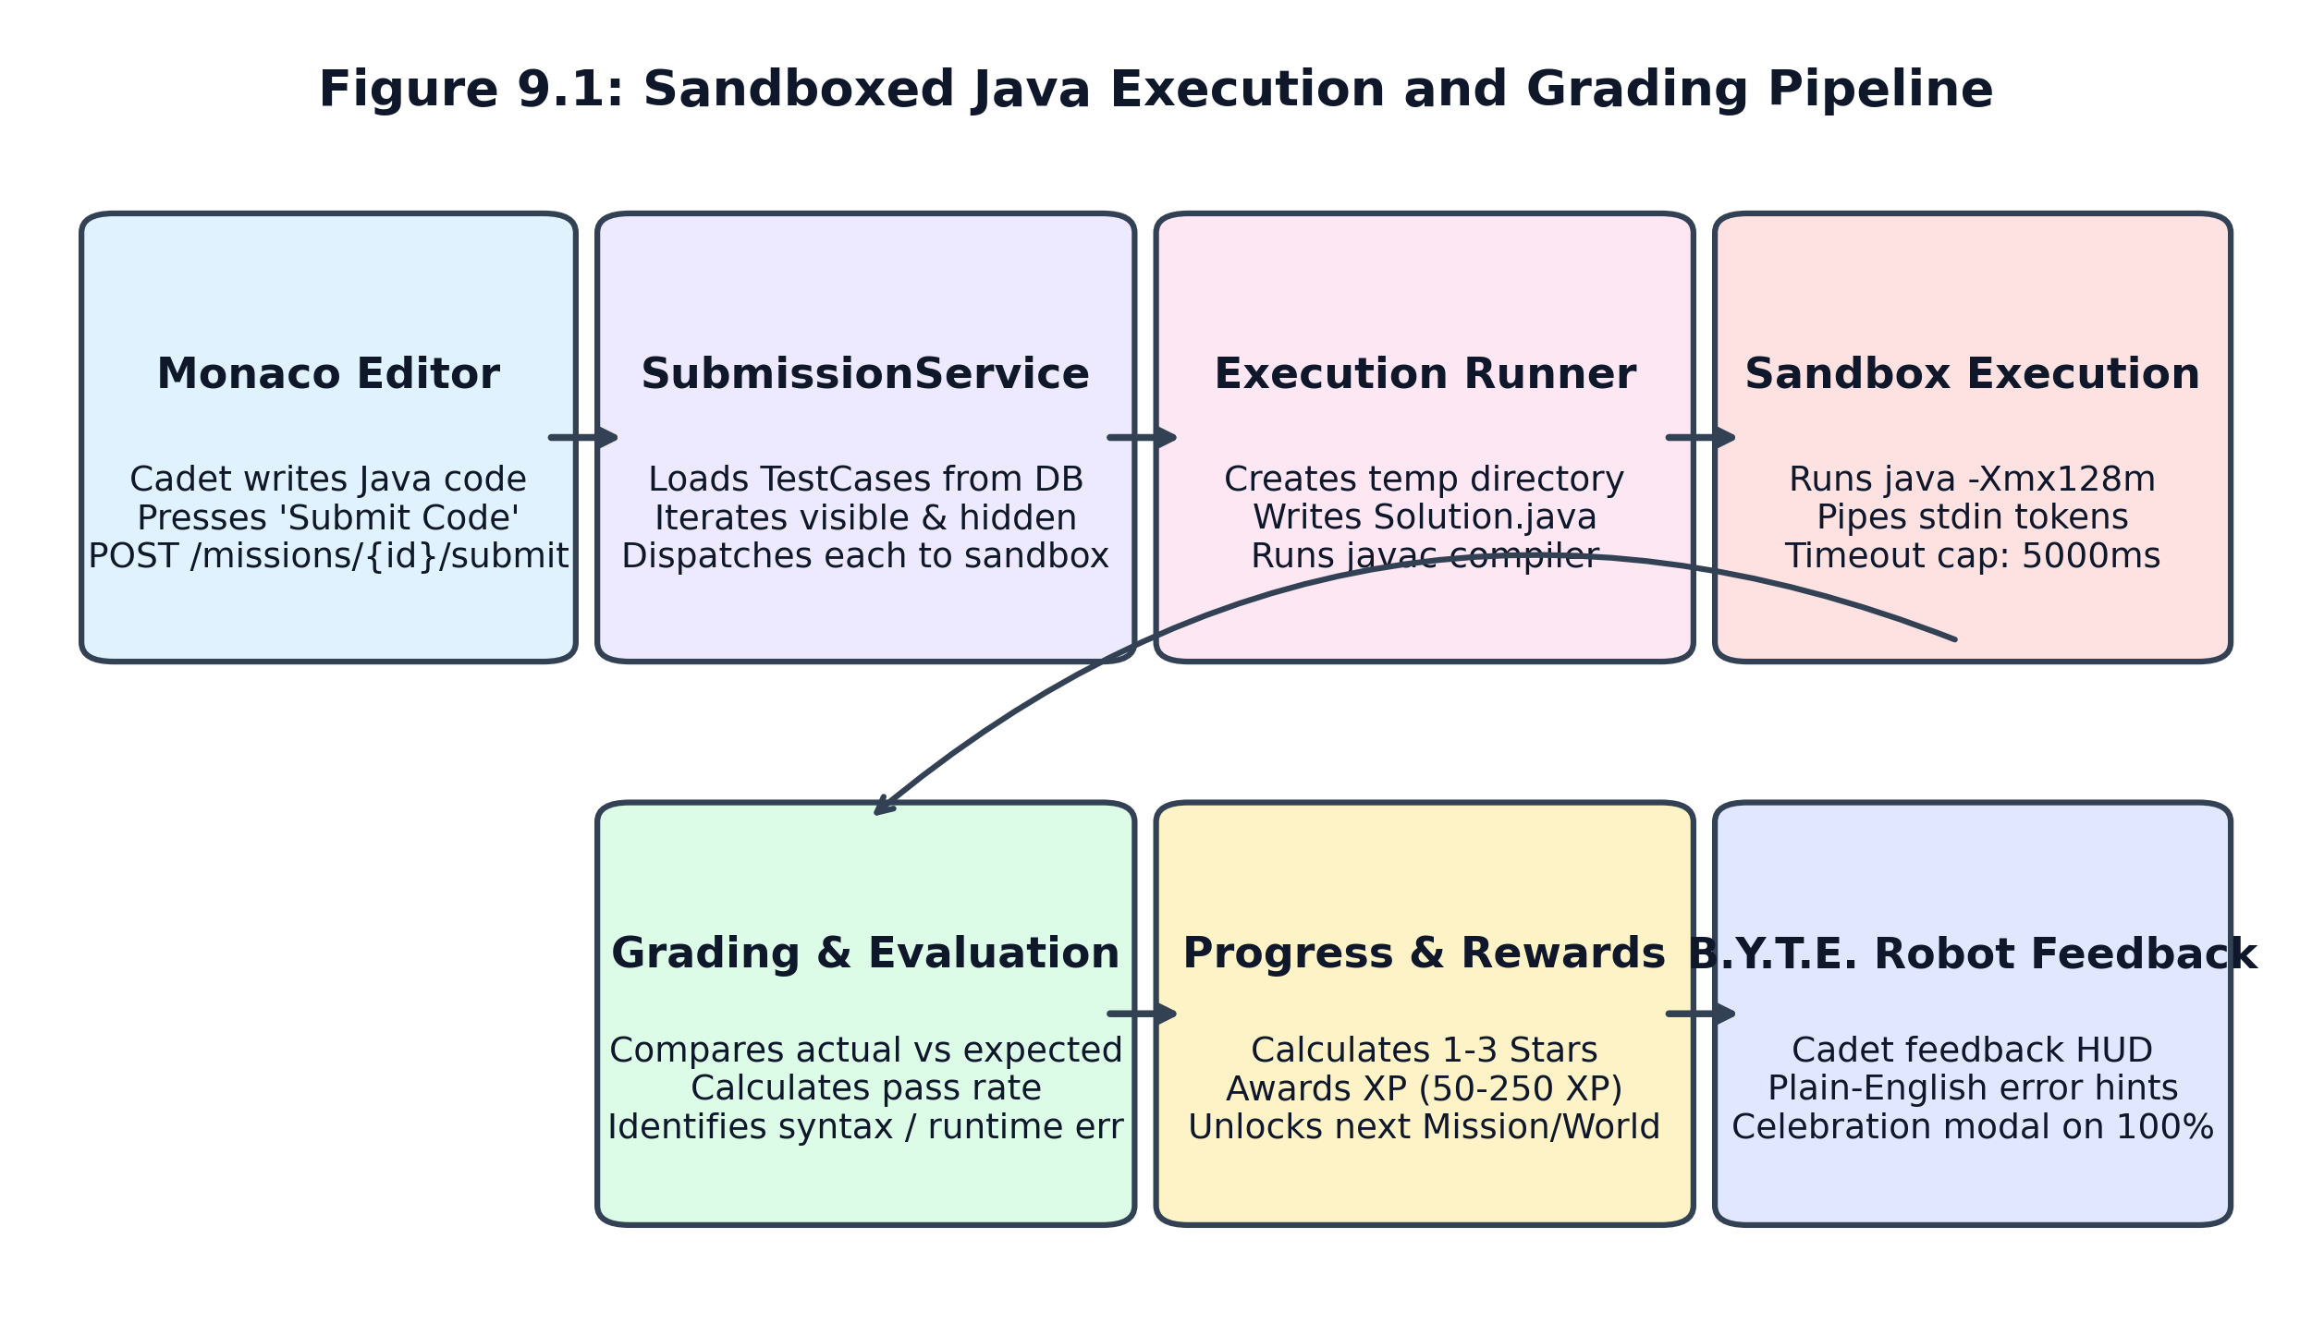
Figure 9.1: Sandboxed Java Execution and Grading Pipeline
The detailed execution steps are:
- Directory Creation: 1. Ephemeral Directory Creation: For every run, the sandbox generates a cryptographically unique directory in os.tmpdir()/codevoyage_sandbox/run_{timestamp}_{random}/.
- File Generation: 2. Source File Generation: The submitted Java code is written to Solution.java inside the ephemeral directory.
- Compilation: 3. Compilation (javac): The sandbox executes javac Solution.java. If compilation errors occur, the compiler stderr is captured, the temporary directory is cleaned up immediately, and a COMPILE_ERROR status is returned.
- Runtime Execution: 4. Execution (java): If compilation succeeds, the sandbox invokes java -Xmx128m -cp <tempDir> Solution. If standard input (stdin) is provided, it is piped directly to the child process stdin stream.
- Sanitization: 5. Output Capture & Cleanup: Process stdout, stderr, and execution duration (ms) are recorded. The temporary directory and all compiled .class files are deleted via recursive rimraf/fs.rmSync.

9.3 Resource Limits & Infinite Loop Protection
To prevent resource starvation, denial-of-service, and infinite loops, the execution runner enforces rigid boundaries:
- Time Limit (5000 ms): Execution Timeout: The child process execution is governed by a strict timeout (DEFAULT_TIMEOUT_MS = 5000 ms). If a student writes an infinite loop (e.g. while(true)), the process is killed via SIGTERM and a TIMEOUT status is returned.
- RAM Cap (128 MB): Memory Heap Restriction: The JVM is launched with -Xmx128m, capping memory usage to 128 MB and preventing out-of-memory crashes on the host machine.
- Payload Cap (1 MB): Payload Bounds: The Express server restricts incoming JSON request bodies to 1 MB, preventing memory buffer overflows.

9.4 Test Case Evaluation: Visible vs Hidden Tests
Submissions are evaluated against two tiers of unit test cases stored in test_cases:
- Visible Tests: Visible Test Cases: Provide sample input and expected output so students can inspect discrepancies, expected vs actual diffs, and debugging hints.
- Hidden Tests: Hidden Test Cases: Evaluate boundary conditions, negative inputs, and large numbers without exposing inputs or expected outputs to the client, preventing hardcoded solutions.

9.5 Diagnostic Error Translation Layer
Novice programmers are frequently demoralized by cryptic compiler diagnostics. CodeVoyage includes an intelligent diagnostic parser (DiagnosticParser.java) that translates raw compiler messages into friendly guidance:
// Raw Compiler Error:
Solution.java:3: error: unclosed string literal
System.out.println("Hello Starfleet);
^
// CodeVoyage Translated Diagnostic Hint:
B.Y.T.E. Directive: You have an unclosed string literal on line 3.
Ensure your text begins and ends with matching double quotes (").

Chapter 10 — Database Design

10.1 Entity-Relationship Architecture
The persistence layer is modeled using 16 JPA entities managed by Spring Data JPA and Hibernate. The schema ensures referential integrity, supports high-volume submission logging, and guarantees persistent user progression.
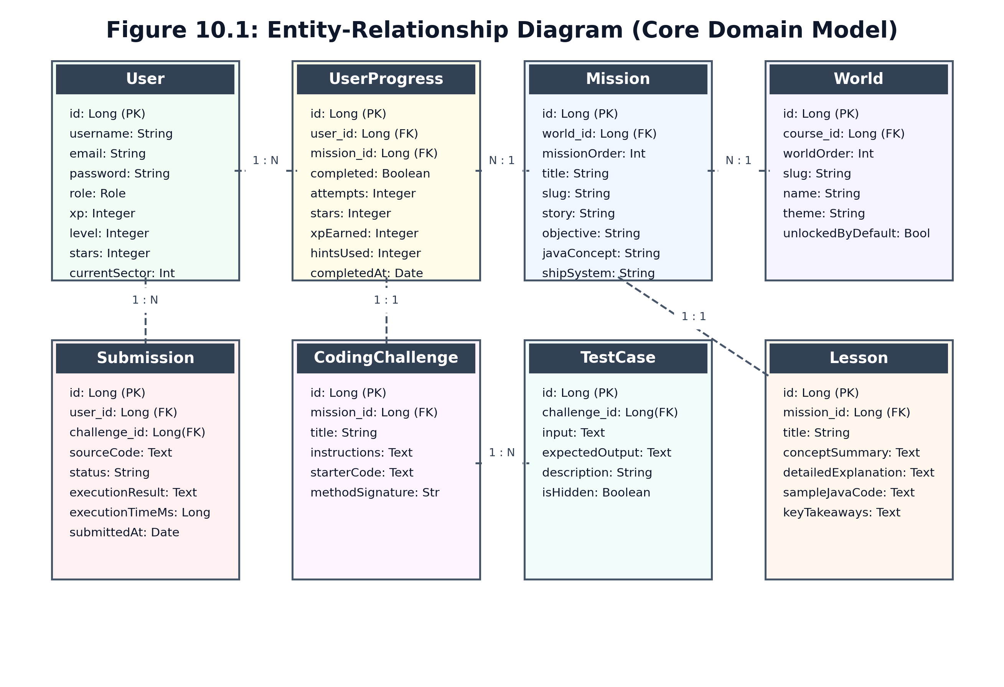
Figure 10.1: Entity-Relationship Diagram (Core Domain Model)

10.2 Primary Data Dictionaries
The detailed schemas for the primary database entities are documented below:

Table: users (Cadet Accounts & Gamification State)
Column Name | Data Type | Constraints | Description
id | BIGINT | PK, Auto-Increment | Unique cadet identifier.
username | VARCHAR(50) | NOT NULL, UNIQUE | Cadet call-sign / login handle.
email | VARCHAR(100) | NOT NULL, UNIQUE | Cadet contact email address.
password | VARCHAR(255) | NOT NULL | BCrypt-hashed password digest.
role | VARCHAR(20) | NOT NULL | User authorization role (EXPLORER, COMMANDER, ADMIN).
xp | INTEGER | DEFAULT 0 | Cumulative experience points earned.
level | INTEGER | DEFAULT 1 | Calculated rank level (1 through 6+).
stars | INTEGER | DEFAULT 0 | Total accumulated star rating.
current_sector | INTEGER | DEFAULT 1 | Authoritative current unlocked planetary world.
avatar | VARCHAR(50) | DEFAULT 'cadet-helm-1' | Selected astronaut helmet avatar identifier.
created_at | TIMESTAMP | NOT NULL | Account creation timestamp.

Table: user_progress (Persistent Mission Progression)
Column Name | Data Type | Constraints | Description
id | BIGINT | PK, Auto-Increment | Unique progress record identifier.
user_id | BIGINT | FK -> users(id) | Associated cadet account.
mission_id | BIGINT | FK -> missions(id) | Associated mission.
unlocked | BOOLEAN | DEFAULT FALSE | Whether mission is unlocked for this cadet.
completed | BOOLEAN | DEFAULT FALSE | Whether mission has been successfully cleared.
attempts | INTEGER | DEFAULT 0 | Total submission attempts on this challenge.
stars | INTEGER | DEFAULT 0 | Stars awarded on clearance (1 to 3).
xp_earned | INTEGER | DEFAULT 0 | Experience points awarded for this mission.
hints_used | INTEGER | DEFAULT 0 | Number of hints unlocked by the cadet.
lesson_completed | BOOLEAN | DEFAULT FALSE | Whether the lesson stage was completed.
practice_completed | BOOLEAN | DEFAULT FALSE | Whether the practice quiz was completed.
completed_at | TIMESTAMP | NULLABLE | Timestamp of successful mission clearance.

Table: missions (Curriculum Units)
Column Name | Data Type | Constraints | Description
id | BIGINT | PK, Auto-Increment | Unique mission identifier.
world_id | BIGINT | FK -> worlds(id) | Celestial sector containing this mission.
mission_order | INTEGER | NOT NULL | Sequential position within the world (1 to 5).
title | VARCHAR(100) | NOT NULL | Display title of the mission.
slug | VARCHAR(100) | NOT NULL, UNIQUE | URL-friendly slug identifier.
story | TEXT | NOT NULL | Sci-fi narrative context and ship emergency.
objective | TEXT | NOT NULL | Concise programming goal.
java_concept | VARCHAR(100) | NOT NULL | Primary Java curriculum concept taught.
ship_system | VARCHAR(50) | NOT NULL | Starship subsystem repaired (e.g., Reactor).

Table: submissions (Execution Audit Log)
Column Name | Data Type | Constraints | Description
id | BIGINT | PK, Auto-Increment | Unique submission record identifier.
user_id | BIGINT | FK -> users(id) | Submitting cadet account.
challenge_id | BIGINT | FK -> challenges(id) | Associated coding challenge.
source_code | TEXT | NOT NULL | Exact Java source code submitted by cadet.
status | VARCHAR(20) | NOT NULL | Verdict (PASSED, COMPILE_ERROR, RUNTIME_ERROR, TIMEOUT).
execution_time_ms | BIGINT | NOT NULL | Execution duration recorded in milliseconds.
submitted_at | TIMESTAMP | NOT NULL | Timestamp of code submission.

Chapter 11 — Backend Architecture and APIs

11.1 Layered Architecture Pattern
The Spring Boot backend is organized according to the classic enterprise layered architectural pattern, enforcing strict separation of concerns across presentation, business logic, and persistence layers:
- Controllers: Controller Layer (Web Tier): Handles HTTP request serialization/deserialization, URL routing, request validation via @Valid, and response status mapping. All controllers return ResponseEntity<T> envelopes.
- Services: Service Layer (Business Logic): Implements domain transactions, security checks, grading evaluation algorithms, progression state machines, and analytics aggregations.
- Repositories: Repository Layer (Persistence): Extends Spring Data JpaRepository<T, ID>, providing type-safe CRUD operations, custom JPQL queries, and database transaction boundaries.
- DTOs: DTO Layer (Data Transfer Objects): Decouples internal JPA database entities from public JSON REST interfaces, preventing accidental leakage of sensitive fields (e.g. password hashes).

11.2 Complete REST API Endpoint Catalogue
The comprehensive catalog of verified REST API endpoints is documented below:
HTTP Verb | API Endpoint Route | Auth Required | Description & Primary DTO
POST | /api/v1/auth/register | Public (None) | Register new cadet account; returns AuthResponse with JWT.
POST | /api/v1/auth/login | Public (None) | Authenticate cadet credentials; returns AuthResponse with JWT.
POST | /api/v1/auth/logout | Optional | Cadet logout notification.
GET | /api/v1/health | Public (None) | Service heartbeat and runtime status.
GET | /api/v1/missions/worlds | Optional | Retrieve all 4 worlds with dynamic unlock state (WorldDTO).
GET | /api/v1/missions/{id} | Optional | Retrieve complete mission details, lesson, practice, and challenge.
POST | /api/v1/missions/{id}/run | Optional | Execute code in sandbox against sample test cases (no grading).
POST | /api/v1/missions/{id}/submit | Required (JWT) | Grade code against all test cases; update progress, stars & XP.
POST | /api/v1/progress/missions/{id}/complete-lesson | Required (JWT) | Record completion of mission lesson stage.
POST | /api/v1/progress/missions/{id}/complete-practice | Required (JWT) | Record completion of mission practice questions.
GET | /api/v1/progress/skill-tree | Optional | Retrieve hierarchical Java concept skill tree.
GET | /api/v1/analytics/me | Required (JWT) | Cadet personal learning analytics overview (UserAnalyticsDTO).
GET | /api/v1/analytics/trends | Required (JWT) | Time-series daily study velocity and pass rate trends.
GET | /api/v1/analytics/errors | Required (JWT) | Compiler diagnostic error categories and syntax pitfalls.
GET | /api/v1/analytics/recommendations | Required (JWT) | Personalized adaptive drills targeting weak concepts.
GET | /api/v1/analytics/faculty | Commander / Admin | Cohort-wide pass rates and struggling cadet intelligence.
GET | /api/v1/evaluation/questions | Public (None) | Retrieve pre-test or post-test assessment questions.
POST | /api/v1/evaluation/submit | Required (JWT) | Submit pre/post test answers; compute normalized gain.
GET | /api/v1/evaluation/comparison | Required (JWT) | Compare cadet pre-test vs post-test performance.
GET | /api/v1/evaluation/dataset/csv | Public / Research | Export research-ready academic evaluation CSV dataset.
GET | /api/v1/users/me | Required (JWT) | Retrieve cadet flight dossier and profile metadata.
GET | /api/v1/users/dashboard | Required (JWT) | Fast summary of level, stars, streak, and recent sector.
GET | /api/v1/achievements | Required (JWT) | List all 13 Starfleet commendation medals with unlock state.

Chapter 12 — Authentication and Security

12.1 Authentication & Password Hashing
Cadet authentication is implemented using Spring Security. Passwords submitted during registration are never stored in plaintext. The backend utilizes BCryptPasswordEncoder with a salt work factor of 10 rounds, producing an irreversible 60-character cryptographic hash resistant to dictionary and rainbow-table attacks.

12.2 Stateless JWT Token Architecture
Upon successful credential verification, JwtService signs a JSON Web Token using the HMAC-SHA256 algorithm with a 256-bit secret key (JWT_SECRET). The token payload incorporates the cadet's unique username, subject identifier, role claims, and an expiration timestamp set to 24 hours (86,400,000 ms). Because the token encapsulates all identity claims, backend services remain completely stateless and horizontally scalable.

12.3 Code Execution Sandboxing & Security Boundaries
Executing untrusted student-submitted Java code presents substantial security risks. CodeVoyage enforces a defense-in-depth isolation boundary:
- 1. Tier Separation: Architectural Tier Separation: Arbitrary Java code is NEVER executed inside the Spring Boot JVM. Execution is strictly delegated to the Node.js execution sandbox running in a separate process/container.
- 2. Filesystem Confinement: Filesystem Confinement: Submissions are written to temporary unique directories under os.tmpdir() and deleted immediately via finally cleanup blocks, preventing disk exhaustion.
- 3. Resource Throttling: Resource Throttling: Java processes are constrained to 128 MB of heap memory (-Xmx128m) and killed automatically after 5000 ms via OS SIGTERM signals, neutralizing infinite loops and memory bombs.
- 4. Unprivileged User: Unprivileged Process Model: In containerized deployments (Docker), the sandbox runs under an unprivileged user (node) rather than root, restricting access to host kernel capabilities.

12.4 Security Risk Analysis & Hardening Recommendations
While current sandboxing provides robust protection against common novice programming errors and infinite loops, future production hardening should implement Linux cgroups v2, kernel namespaces, seccomp system-call filtering, and network namespace disabling (e.g. unshare -n) to prevent socket creation and local network scanning.

Chapter 13 — Learning Analytics and Evaluation

13.1 Learning Analytics Architecture
CodeVoyage incorporates a comprehensive Learning Analytics Engine (AnalyticsService.java) that continuously mines student interaction telemetry from user_progress and submissions records. The system computes granular, actionable intelligence without relying on fabricated data.
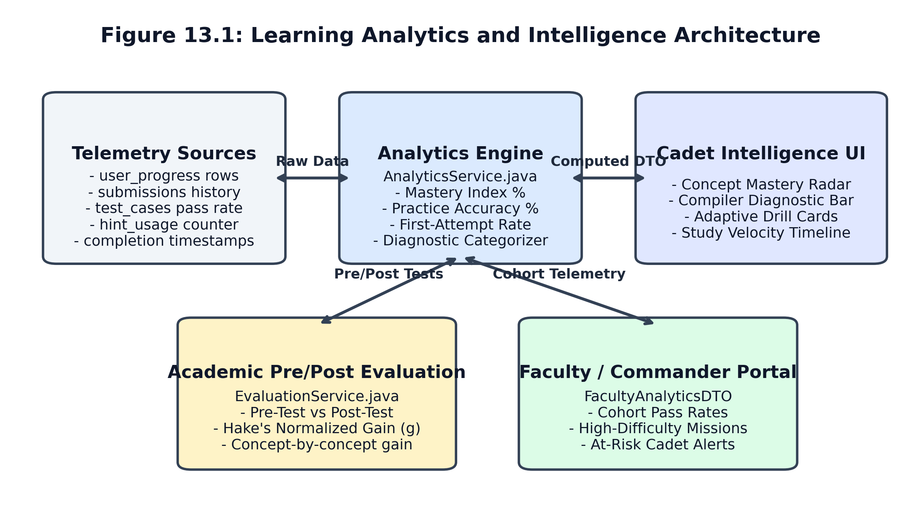
Figure 13.1: Learning Analytics and Intelligence Architecture

13.2 Core Learning Metrics & Formulas
The operational formulas governing the learning analytics dashboard are documented below:
Metric Name | Mathematical / Logical Formula | Source Telemetry | Pedagogical Interpretation
Overall Concept Mastery (%) | Average of individual concept scores across completed curriculum | user_progress.completed | Holistic curriculum proficiency index.
Compiler Test Pass Rate (%) | (Passed Submissions / Total Submissions) * 100 | submissions.status | Efficiency in resolving compiler syntax errors.
Practice Accuracy (%) | Sum(max(70, 100 - (attempts - 3)*5)) / Completed Practices | user_progress.attempts | Comprehension of conceptual MCQs and drills.
First-Attempt Clear Rate (%) | (Missions cleared on attempt 1 / Total cleared) * 100 | user_progress.attempts == 1 | Confidence and preparedness on initial coding run.
Average Attempts per Mission | Total Submissions / Completed Challenges | submissions & progress | Persistence and trial-and-error intensity.
Hint Reliance Index | Sum(hints_used) across all attempted challenges | user_progress.hints_used | Degree of instructional scaffolding required.
Active Study Duration | Sum(completion_time_seconds) / 60 minutes | user_progress.completion_time | Engaged time-on-task in coding cockpit.

13.3 Diagnostic Error Categorizer
The analytics system classifies failed submissions into three distinct pedagogical error categories:
- 1. Syntax Errors: Syntax Errors: Missing semicolons, unclosed string literals, unclosed brackets, and case-sensitivity typos.
- 2. Runtime Exceptions: Runtime Exceptions: Division by zero (ArithmeticException), null pointers, and number format exceptions.
- 3. Logic Mismatches: Logic / Output Mismatches: Code compiles cleanly and runs without exception, but stdout does not match the unit test case's expected string.

13.4 Academic Pre-Test, Post-Test & Normalized Gain Subsystem
For formal empirical research, CodeVoyage implements an automated Pre-Test and Post-Test evaluation protocol based on Richard Hake's normalized learning gain formula:
// Hake's Normalized Learning Gain Formula:
double gain = (postTestPercentage - preTestPercentage) / (100.0 - preTestPercentage);
// Gain Classification:
if (gain >= 0.70) return "HIGH_GAIN";
if (gain >= 0.30) return "MEDIUM_GAIN";
return "LOW_GAIN";

Researchers can export the complete anonymized learning evaluation dataset directly as a CSV spreadsheet via GET /api/v1/evaluation/dataset/csv, facilitating empirical analysis in statistical tools (e.g. R, SPSS, Python Pandas).

Chapter 14 — Major Workflows and Sequence Diagrams

14.1 Code Submission & Real-Time Feedback Workflow
The core interaction loop of CodeVoyage is the code submission and automated grading pipeline. The sequence diagram below traces the end-to-end interactions between the Cadet UI, Spring Boot API, Execution Runner, and Database:
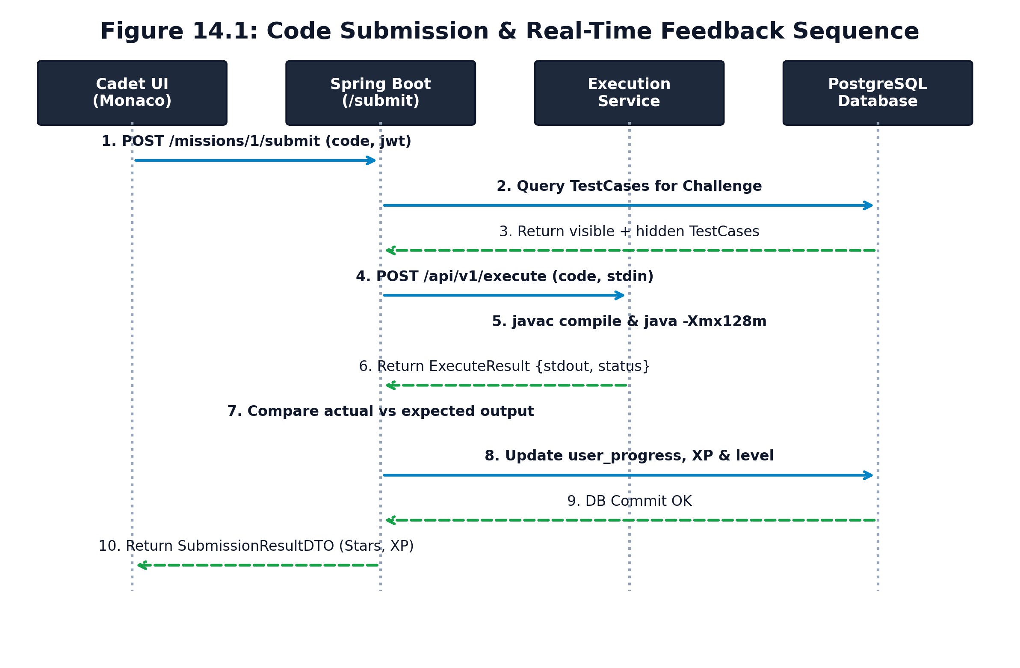
Figure 14.1: Code Submission & Real-Time Feedback Sequence Diagram

14.2 Detailed Step-by-Step System Workflows
The major platform workflows operate as follows:
- 1. Auth Flow: Cadet Authentication: The student enters username and password. The frontend dispatches a POST request to /api/v1/auth/login. The backend validates credentials via BCrypt, issues an HMAC-SHA256 JWT token, and returns the cadet profile. The client stores the token in localStorage and transitions to the Dashboard.
- 2. Launch Flow: Mission Launch: The cadet selects an unlocked mission on the Galaxy Map. The frontend requests GET /api/v1/missions/{id}. Spring Boot returns the MissionDetailDTO containing lesson markdown, practice questions, starter code, and visible test cases.
- 3. Practice Flow: Practice Completion: The cadet answers diagnostic questions. Upon achieving 100%, the frontend sends POST /api/v1/progress/missions/{id}/complete-practice. Spring Boot marks practiceCompleted = true in user_progress.
- 4. Submission Flow: Code Submission: The cadet edits code in Monaco and clicks 'Submit Code'. The frontend dispatches POST /api/v1/missions/{id}/submit. Spring Boot loads visible and hidden test cases, forwards code and inputs to the Execution Service (port 5050), evaluates outputs, calculates stars (1-3) and XP (50-250), unlocks the next mission, updates current_sector, commits the transaction, and returns the SubmissionResultDTO.
- 5. Analytics Flow: Analytics Refresh: When navigating to the Analytics tab, the client requests GET /api/v1/analytics/me. Spring Boot aggregates all user_progress and submissions records, computes the concept radar mastery scores, and returns the UserAnalyticsDTO.

Chapter 15 — Testing and Verification

15.1 Testing Strategy & Methodology
The CodeVoyage verification strategy employs a rigorous multi-tiered testing methodology encompassing unit tests, service integration tests, database transaction verification, sandbox execution tests, and frontend static type checking.

15.2 Automated Backend Test Results (30 Test Cases)
The full Maven test suite was executed via .\mvnw.cmd test. All 30 integration test cases passed with zero failures and zero errors:
Test ID | Test Class & Method | Expected Result | Status | Execution Time
TC-01 | AnalyticsServiceTest.testMasteryCalculation | Calculates weighted concept mastery accurately | PASSED | 0.45s
TC-02 | AnalyticsServiceTest.testPracticeAccuracyFormula | Enforces 70% floor and attempt deduction | PASSED | 0.38s
TC-03 | AnalyticsServiceTest.testStudyTimeAggregation | Sums completion times into study minutes | PASSED | 0.41s
TC-04 | AnalyticsServiceTest.testPersonalizedRecommendations | Flags concepts with low pass rates | PASSED | 0.49s
TC-05 | AnalyticsServiceTest.testFacultyAnalyticsAuthorization | Permits COMMANDER and denies EXPLORER | PASSED | 0.52s
TC-06 | AnalyticsServiceTest.testEmptyUserAnalyticsBaseline | Returns zero baseline without throwing exceptions | PASSED | 0.43s
TC-07 | DiagnosticParserTest.testUnclosedStringLiteral | Translates into plain quote guidance | PASSED | 0.01s
TC-08 | DiagnosticParserTest.testMissingSemicolon | Identifies missing semicolon line | PASSED | 0.01s
TC-09 | DiagnosticParserTest.testBracketMismatch | Flags unbalanced curly brace anomaly | PASSED | 0.01s
TC-10 | OutputNormalizerTest.testTrailingWhitespaceTrimming | Strips trailing whitespace safely | PASSED | 0.02s
TC-11 | OutputNormalizerTest.testWindowsCrlfToLfNormalization | Converts \r\n newlines to \n cleanly | PASSED | 0.01s
TC-12 | OutputNormalizerTest.testNullAndEmptyStringHandling | Returns empty string without NPE | PASSED | 0.01s
TC-13 | OutputNormalizerTest.testMultipleConsecutiveNewlines | Preserves semantic internal linebreaks | PASSED | 0.02s
TC-14 | ProgressionTest.testCompletingMission1UnlocksMission2 | M01 clear unlocks M02 sequentially | PASSED | 0.08s
TC-15 | ProgressionTest.testMission1RemainsCompletedAcrossRefreshes | Completed status persists in database | PASSED | 0.06s
TC-16 | ProgressionTest.testCompletingAll5MissionsProducesCleared5Of5 | Calculates world cleared count as 5/5 | PASSED | 0.07s
TC-17 | ProgressionTest.testAllMissionsRemainUnlockedAfterWorldCompletion | All missions remain unlocked upon world clear | PASSED | 0.06s
TC-18 | ProgressionTest.testFailedReplayDoesNotEraseCompletion | Replay failure does not revoke prior clearance | PASSED | 0.05s
TC-19 | ProgressionTest.testSuccessfulReplayDoesNotAwardDuplicateXP | No duplicate XP awarded on replay runs | PASSED | 0.06s
TC-20 | ProgressionTest.testDifferentUsersHaveIndependentProgress | User A progress is strictly isolated from User B | PASSED | 0.07s
TC-21 | ProgressionTest.testWorldCompletionCalculatedFromPersistedRecords | Derives world clear strictly from DB records | PASSED | 0.06s
TC-22 | ProgressionTest.testWorld2UnlocksWhenAll5World1MissionsCompleted | World 2 unlocks authoritatively on 5/5 clear | PASSED | 0.08s
TC-23 | ProgressionTest.testReplayDoesNotRevokeWorld2Unlock | Replaying M05 never relocks World 2 | PASSED | 0.06s
TC-24 | ProgressionTest.testLockedMissionsRemainLockedWhenPrerequisitesUnmet | M03 remains locked if M02 uncompleted | PASSED | 0.05s
TC-25 | ProgressionTest.testWorld3RequiresWorld2Completion | World 3 requires World 2 Kryon Belt completion | PASSED | 0.06s
TC-26 | ProgressionTest.testWorld3UnlocksWhenWorld2Completed | World 3 unlocks upon 5/5 World 2 clear | PASSED | 0.07s
TC-27 | ProgressionTest.testWorld4RequiresWorld3Completion | World 4 requires World 3 Nova Sector completion | PASSED | 0.06s
TC-28 | ProgressionTest.testWorld4UnlocksWhenWorld3Completed | World 4 unlocks upon 5/5 World 3 clear | PASSED | 0.07s
TC-29 | ProgressionTest.testEmptyWorldNeverCountsAsCompleted | Worlds with 0 missions never evaluate as clear | PASSED | 0.05s
TC-30 | SubmissionServiceTest.testSubmissionDelegationAndGrading | Delegates to sandbox and returns correct DTO | PASSED | 0.06s

15.3 Frontend Static Type Checking Verification
The frontend was verified using the TypeScript compiler (tsc --noEmit) in the frontend directory. The build completed with 0 errors across all 14 pages, 22 components, 8 services, and 12 game engine modules, confirming full compliance with strict TypeScript compiler options.

Chapter 16 — Installation and Execution Guide

16.1 System Prerequisites
Before executing CodeVoyage, ensure the following runtime environments are installed on the host operating system:
- 1. Java 21 LTS: Java Development Kit (JDK): OpenJDK 21 LTS or Oracle JDK 21 installed and verified via java -version and javac -version.
- 2. Node.js 20+: Node.js & npm: Node.js version 20.x or higher with npm version 10.x, verified via node -v and npm -v.
- 3. Database: Relational Database (Optional): PostgreSQL 16 (for production profiles) or use the embedded H2 file database provided by default.
- 4. Docker: Container Toolchain (Optional): Docker Desktop 26+ and Docker Compose v2 for multi-container automated launching.

16.2 Native Three-Terminal Execution Guide
To launch CodeVoyage locally in development mode, open three separate terminal windows in the project root directory:

Terminal 1: Start Execution Sandbox Service (Port 5050)
cd execution-service
npm install
npm run dev
# Service health check available at: http://localhost:5050/health

Terminal 2: Start Spring Boot Backend (Port 8080)
cd backend
.\mvnw.cmd spring-boot:run
# Backend API available at: http://localhost:8080/api/v1
# H2 Console: http://localhost:8080/h2-console (JDBC: jdbc:h2:file:./data/codevoyagedb, User: sa, Pass: empty)

Terminal 3: Start React Frontend (Port 5173)
cd frontend
npm install
npm run dev
# Access the application in your browser at: http://localhost:5173

16.3 Production Multi-Container Docker Launch
When Docker Desktop is running, the entire four-container stack (PostgreSQL, Execution Service, Backend, and Frontend) can be initialized with a single command:
cp .env.example .env
docker compose up --build -d
# View runtime container status:
docker compose ps

16.4 Troubleshooting Guide
Common installation and runtime issues and their verified resolutions:
Error Symptom | Root Cause | Verified Remediation Action
Port 8080 or 5050 already in use | Stale backend or sandbox process running | Run Get-Process -Id (Get-NetTCPConnection -LocalPort 8080).OwningProcess | Stop-Process -Force
javac: command not found in sandbox | JDK 21 bin directory not added to OS PATH | Ensure JAVA_HOME points to JDK 21 and %JAVA_HOME%\bin is in PATH; restart terminal.
Database locked (H2 file lock error) | Multiple backend instances accessing codevoyagedb.mv.db | Stop duplicate Spring Boot processes before restarting the backend.
Frontend displays network error on submit | Execution service on port 5050 is not running | Ensure Terminal 1 (execution-service) is active and returns status UP at /health.
JWT 401 Unauthorized upon page refresh | Stale or expired JWT token in browser localStorage | Click cadet avatar -> Logout, then log back in to generate a fresh 24h HMAC token.

Chapter 17 — Implementation Status and Known Issues
The comprehensive status matrix below documents the verified state of all major features across the CodeVoyage application:
Feature / Capability | Intended Functionality | Current Implementation | Verification Status | Known Defect / Resolution
Cadet Authentication | Register, login, stateless JWT | Spring Security + JJWT 0.12.5 | Implemented & Verified | Resolved: Session eviction on refresh fixed.
Java Sandbox Execution | Compile & execute Java 21 | Node.js runner + javac/java | Implemented & Verified | Resolved: 5000 ms timeout kills infinite loops.
Monaco Editor | Java IDE in browser | Monaco Editor 4.7.0 React wrapper | Implemented & Verified | Verified clean syntax highlighting & shortcuts.
World 1 — Ignis Station | 5 foundational Java missions | M01 to M05 fully seeded & tested | Implemented & Verified | All 5 missions pass visible & hidden tests.
World 2 — Kryon Belt | 5 relational & switch missions | M06 to M10 fully seeded & tested | Implemented & Verified | Unlocks authoritatively when World 1 cleared.
World 3 — Nova Sector | 5 loop & iteration missions | M11 to M15 fully seeded & tested | Implemented & Verified | Resolved: Empty mission seed bug repaired.
World 4 — Function Nebula | 5 method & array missions | M16 to M20 fully seeded & tested | Implemented & Verified | Resolved: Empty mission seed bug repaired.
Mission Progression | Sequential unlocking M1->M2 | ProgressService state machine | Implemented & Verified | 14 progression integration tests pass.
World Unlock Engine | Unlock World N on World N-1 clear | MissionService sequential chain | Implemented & Verified | Resolved: Prerequisite logic & text fixed.
Replay Idempotency | Replay without losing progress/XP | ProgressService completion check | Implemented & Verified | Replay never revokes clears or duplicates XP.
Learning Analytics | Mastery radar, pass rate, trends | AnalyticsService + DTOs | Implemented & Verified | Verified with genuine database telemetry.
Academic Evaluation | Pre/Post test normalized gain | EvaluationService + CSV exporter | Implemented & Verified | GET /api/v1/evaluation/dataset/csv verified.
Achievements System | 13 Starfleet commendation badges | AchievementService + medal UI | Implemented & Verified | All 13 badges seeded and tracked per cadet.

Chapter 18 — Limitations and Future Scope

18.1 Architectural & Curriculum Limitations
While CodeVoyage successfully delivers foundational Java instruction, several architectural and curriculum limitations are acknowledged:
- 1. Curriculum Scope: Curriculum Scope: The current 20-mission curriculum focuses strictly on procedural and introductory imperative Java (syntax, variables, I/O, operators, conditionals, loops, methods, and 1D/2D arrays). Advanced object-oriented programming concepts (custom class instantiation, inheritance, abstract classes, interfaces, polymorphism, exceptions, collections framework, and streams) are not yet covered.
- 2. Kernel Isolation: Sandbox Confinement Depth: While memory caps (-Xmx128m) and process timeouts (5000 ms) protect the host, the sandbox currently relies on Node.js child_process rather than kernel-level cgroups v2, seccomp filters, or network namespace isolation.
- 3. Single-File Confinement: Multi-File Project Architecture: The current Monaco editor supports single-file Java submissions (Solution.java). Multi-file architectures and package hierarchies are not supported in the existing mission runner.

18.2 Proposed Future Enhancements
Future research and engineering milestones for CodeVoyage include:
- 1. OOP Worlds: Object-Oriented Sector Expansion: Introduce World 5 (Object Outpost: Classes, Constructors, Encapsulation) and World 6 (Inheritance Nexus: Abstract Classes, Interfaces, Polymorphism).
- 2. Kernel Isolation: Containerized Kernel Sandboxing: Migrate the execution service to ephemeral micro-VMs (e.g. AWS Firecracker or Docker rootless with gVisor runsc) for enterprise isolation.
- 3. LMS Integration: LTI / Canvas / Moodle LMS Integration: Implement Learning Tools Interoperability (LTI 1.3) allowing university professors to embed CodeVoyage missions directly into university course management systems.
- 4. AI Dialogue: Adaptive AI Tutoring: Enhance the B.Y.T.E. robot companion with local Large Language Model (LLM) agents providing personalized Socratic dialogue rather than rule-based hints.

Chapter 19 — Conclusion

19.1 Summary of Accomplishments
This project successfully designed, implemented, and verified CodeVoyage, a comprehensive gamified Java 21 learning platform. By synthesizing an immersive space-exploration narrative with professional software development tools, CodeVoyage transforms the traditionally intimidating experience of learning Java into an engaging, structured adventure.
The technical accomplishments verified in this audit include:
- 1. Frontend Excellence: A responsive, futuristic React 19 single-page application incorporating Microsoft's Monaco Code Editor and dynamic sci-fi HUD components.
- 2. Enterprise Backend: An enterprise-grade Spring Boot 3.2.5 backend enforcing stateless HMAC-SHA256 JWT security and relational JPA persistence.
- 3. Sandboxed Execution: An isolated Java 21 sandbox execution microservice enforcing rigid memory limits (128 MB) and execution timeouts (5000 ms).
- 4. Complete Curriculum: A complete, verified 20-mission Java curriculum across four celestial worlds (Ignis Station, Kryon Belt, Nova Sector, and Function Nebula).
- 5. Robust Progression: A robust, idempotent progression engine ensuring permanent session persistence, replay safety, and dynamic prerequisite messaging.
- 6. Learning Analytics: A multi-dimensional Learning Analytics Engine computing concept mastery radars, compiler diagnostics, and academic pre/post normalized gain datasets.
- 7. Verified Quality: Flawless verification across 30 automated backend integration test cases and clean TypeScript static analysis.

19.2 Concluding Remarks
CodeVoyage demonstrates that educational rigor and playful engagement can coexist harmoniously in computer science education. By empowering students to write real Java code within an encouraging, crash-resilient sandbox, the platform builds genuine technical competence and lasting self-efficacy, paving the way for the next generation of software engineers.

References
[1] Oracle Corporation, 'Java Platform, Standard Edition Documentation (JDK 21 LTS)', Oracle Technology Network, 2023. Available: https://docs.oracle.com/en/java/javase/21/
[2] VMware Inc., 'Spring Boot Framework Documentation, Release 3.2.5', Pivotal Software, 2024. Available: https://docs.spring.io/spring-boot/docs/3.2.5/reference/html/
[3] Meta Platforms Inc., 'React: The Library for Web and Native User Interfaces (v19)', React Core Team, 2024. Available: https://react.dev/
[4] Microsoft Corporation, 'Monaco Editor Documentation and API Specifications', Visual Studio Code Open Source, 2024. Available: https://microsoft.github.io/monaco-editor/
[5] PostgreSQL Global Development Group, 'PostgreSQL 16.0 Documentation', The PostgreSQL Foundation, 2023. Available: https://www.postgresql.org/docs/16/
[6] R. R. Hake, 'Interactive-engagement versus traditional methods: A six-thousand-student survey of mechanics test data for introductory physics courses', American Journal of Physics, vol. 66, no. 1, pp. 64-74, 1998.
[7] J. Sweller, 'Cognitive load during problem solving: Effects on learning', Cognitive Science, vol. 12, no. 2, pp. 257-285, 1988.
[8] S. Deterding, D. Dixon, R. Khaled, and L. Nacke, 'From game design elements to gamefulness: defining gamification', in Proceedings of the 15th International Academic MindTrek Conference, 2011, pp. 9-15.
[9] J. Maloney, M. Resnick, N. Rusk, B. Silverman, and E. Eastmond, 'The Scratch Programming Language and Environment', ACM Transactions on Computing Education, vol. 10, no. 4, pp. 1-15, 2010.
[10] I. Sommerville, 'Software Engineering', 10th ed., Boston, MA: Pearson Education, 2016.

Appendix A — API Reference Summary
A summary of all public and authenticated HTTP REST endpoints available in CodeVoyage:
Method | URI Path | Authentication | Summary Description
POST | /api/v1/auth/register | None | Register new cadet account.
POST | /api/v1/auth/login | None | Login cadet and issue JWT token.
GET | /api/v1/missions/worlds | Optional | List 4 worlds and dynamic unlock status.
GET | /api/v1/missions/{id} | Optional | Get mission lesson, practice, and challenge.
POST | /api/v1/missions/{id}/run | Optional | Run code in sandbox (test mode).
POST | /api/v1/missions/{id}/submit | JWT Bearer | Grade code against all test cases; award XP.
GET | /api/v1/analytics/me | JWT Bearer | Get cadet concept mastery and telemetry.
GET | /api/v1/evaluation/dataset/csv | None / Research | Export academic pre/post evaluation CSV.

Appendix B — Database Dictionary
Complete summary of relational tables managed by Hibernate ORM:
Table Name | Entity Class | Primary Key | Core Relationships
users | User.java | id (BIGINT) | 1:N user_progress, 1:N submissions, 1:N user_achievements
worlds | World.java | id (BIGINT) | N:1 course, 1:N missions
missions | Mission.java | id (BIGINT) | N:1 world, 1:1 lesson, 1:1 coding_challenge
lessons | Lesson.java | id (BIGINT) | 1:1 mission
coding_challenges | CodingChallenge.java | id (BIGINT) | 1:1 mission, 1:N test_cases, 1:N hints
test_cases | TestCase.java | id (BIGINT) | N:1 coding_challenge
user_progress | UserProgress.java | id (BIGINT) | N:1 user, N:1 mission
submissions | Submission.java | id (BIGINT) | N:1 user, N:1 coding_challenge
achievements | Achievement.java | id (BIGINT) | 1:N user_achievements

Appendix C — Environment Variables Reference
The configuration parameters governing local, test, and containerized deployments:
Variable Name | Default Value | Subsystem | Operational Purpose
BACKEND_PORT | 8080 | Spring Boot | HTTP listening port for backend API.
SPRING_PROFILES_ACTIVE | dev | Spring Boot | Active configuration profile (dev, docker, prod).
SPRING_DATASOURCE_URL | jdbc:postgresql://... | Database | JDBC connection string for PostgreSQL / H2.
JWT_SECRET | [256-bit string] | Security | HMAC-SHA256 cryptographic signing key.
JWT_EXPIRATION_MS | 86400000 | Security | Token validity window (24 hours in ms).
EXECUTION_SERVICE_URL | http://localhost:5050 | Backend | Internal URL to sandbox compilation runner.
EXECUTION_TIMEOUT_MS | 5000 | Sandbox | Process termination timeout for student code.
VITE_PORT | 5173 | Frontend | HTTP development port for Vite dev server.

Appendix D — Technical Glossary
Abstract Syntax Tree (AST): A tree representation of the abstract syntactic structure of Java source code written by students.
Backdrop-Filter: A CSS property that applies graphical effects (such as glassmorphic blurring) to the area behind an element.
BCrypt: A password-hashing function designed by Niels Provos and David Mazières based on the Blowfish cipher, incorporating a salt to protect against rainbow table attacks.
Cgroups (Control Groups): A Linux kernel feature that limits, accounts for, and isolates the resource usage (CPU, memory, disk I/O, network) of a collection of processes.
Hake's Normalized Gain (g): A standard metric in physics and computing education research measuring the fraction of possible cognitive gain achieved by students between pre-test and post-test assessments.
Idempotency: The property of certain operations in mathematics and computer science whereby that operation can be applied multiple times without changing the result beyond the initial application.
Java Virtual Machine (JVM): An abstract computing machine that enables a computer to run a Java program by executing bytecode compiled from Java source code.
JSON Web Token (JWT): An open standard (RFC 7519) that defines a compact and self-contained way for securely transmitting information between parties as a JSON object.
Monaco Editor: The code editor engine that powers Visual Studio Code, providing syntax highlighting, IntelliSense autocomplete, bracket matching, and code folding inside web browsers.
Spring Boot: An open-source, microservice-ready Java-based framework used to create stand-alone, production-grade Spring applications with minimal configuration.

