Docker assignment :

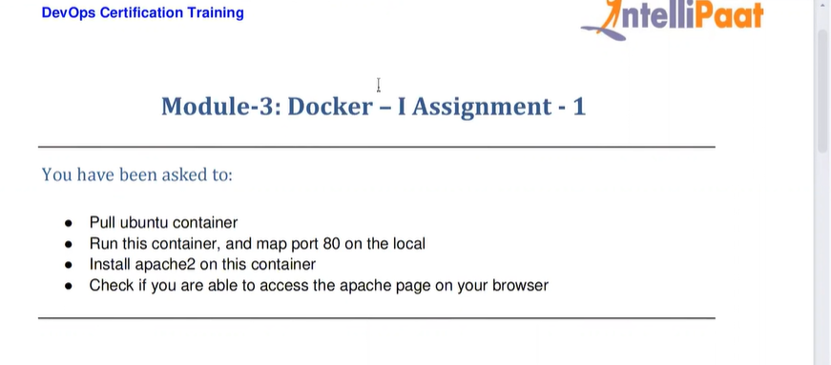

Create ec2 instance

Sudo apt-get update

Sudo apt-get install docker.io

sudo docker pull ubuntu

sudo docker images

REPOSITORY TAG IMAGE ID CREATED SIZE

ubuntu latest 08d22c0ceb15 6 weeks ago 77.8MB

sudo docker run -itd -p 80:80 ubuntu (to run the image)

sudo docker run -itd -p 80:80 ubuntu

b6d72752a84457379823b52e1c18ea5e47659f35f9542810dedd6421ff64ede0

(container ID)

root@ip-172-31-47-90:~# sudo docker ps

CONTAINER ID IMAGE COMMAND CREATED STATUS PORTS NAMES

b6d72752a844 ubuntu "/bin/bash" 22 seconds ago Up 21 seconds 0.0.0.0: 80->80/tcp, :::80->80/tcp hardcore_vaughan

To run this container :

sudo docker exec -it b6d7275 bash (now we get inside the container)

root@b6d72752a844:/# apt-get update

1 apt-get update

2 apt-get install apache2

3 service apache2 status

4 service apache2 start

5 service apache2 status

6 histtory

7 history

