Git ASSIGNMENT = 3 :

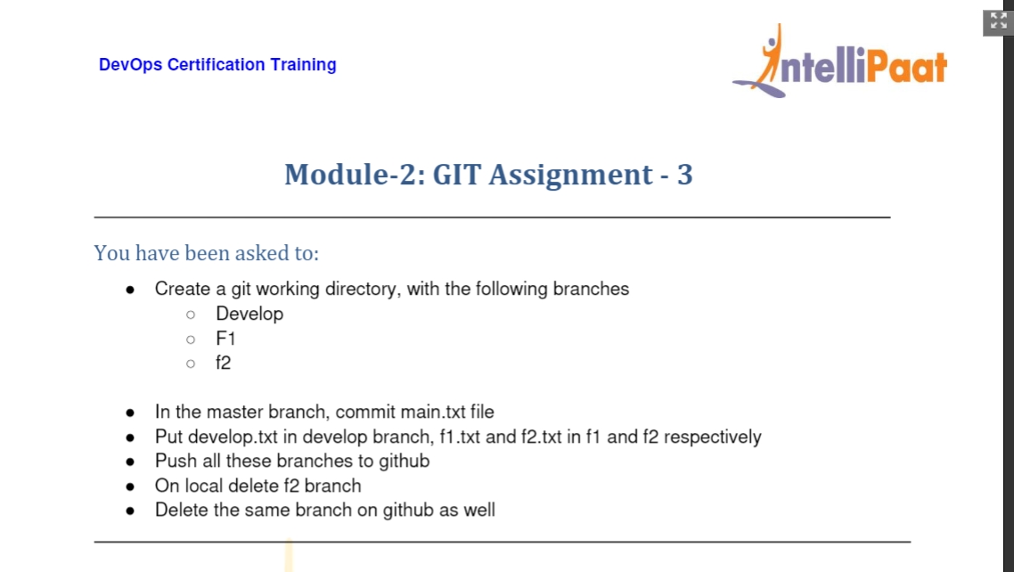

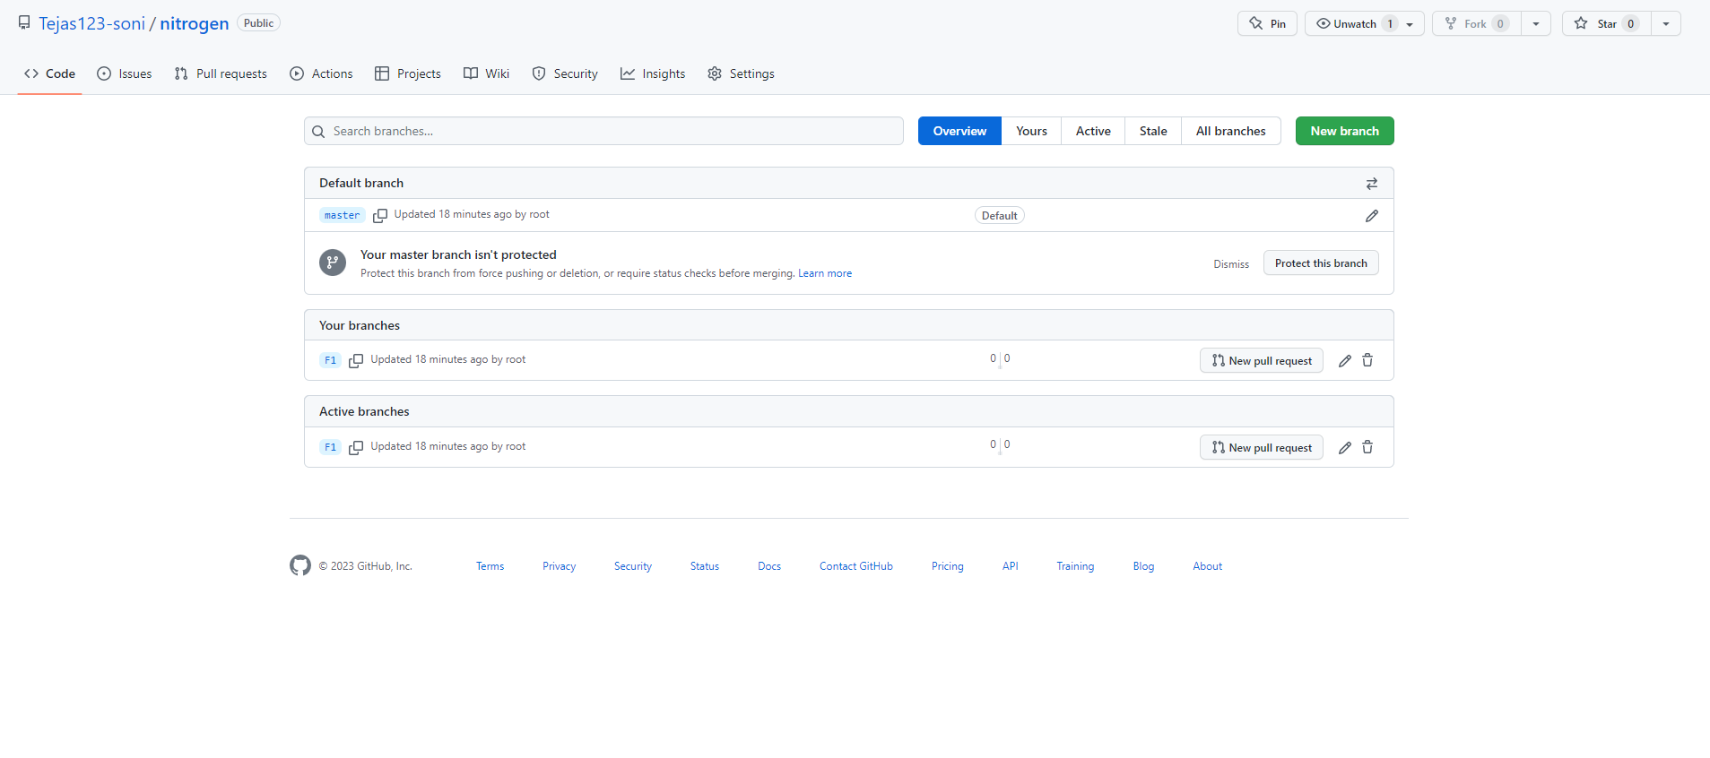

mkdir tst1

2 cd tst1

3 git init

4 yum update -y

5 # yum install git -y

6 yum install git -y

7 git init

8 ls

9 cd tst1

10 mkdir avdh

11 cd avdh

12 ls

13 git init

14 git status

15 git branch

16 git add .

17 git commit -m "first comm"

18 touch hit.txt

19 git add .

20 git commit -m "gghh commit"

21 git status

22 git branch

23 git branch Develop

24 git branch F1

25 git branch F2

26 git checkout master

27 touch main.txt

28 git add .

29 git commit -m "this is main commit "

30 git checkout Develop

31 touch develop.txt

32 ls

33 git checkout F1

34 touch f1.txt

35 ls

36 git checkout F2

37 touch f2.txt

38 git remote add origin https://github.com/Tejas123-soni/nitrogen.git

39 git branch -M master

40 git push -u origin main

41 git push -u origin master

42 git branch

43 git checkout F1

44 git checkout Develop

45 git checkout F1

46 git push -u origin master

47 git push -u origin F1

48 history

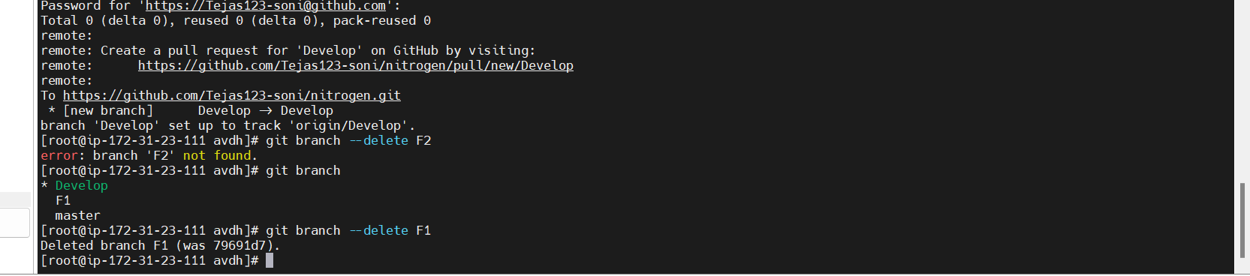

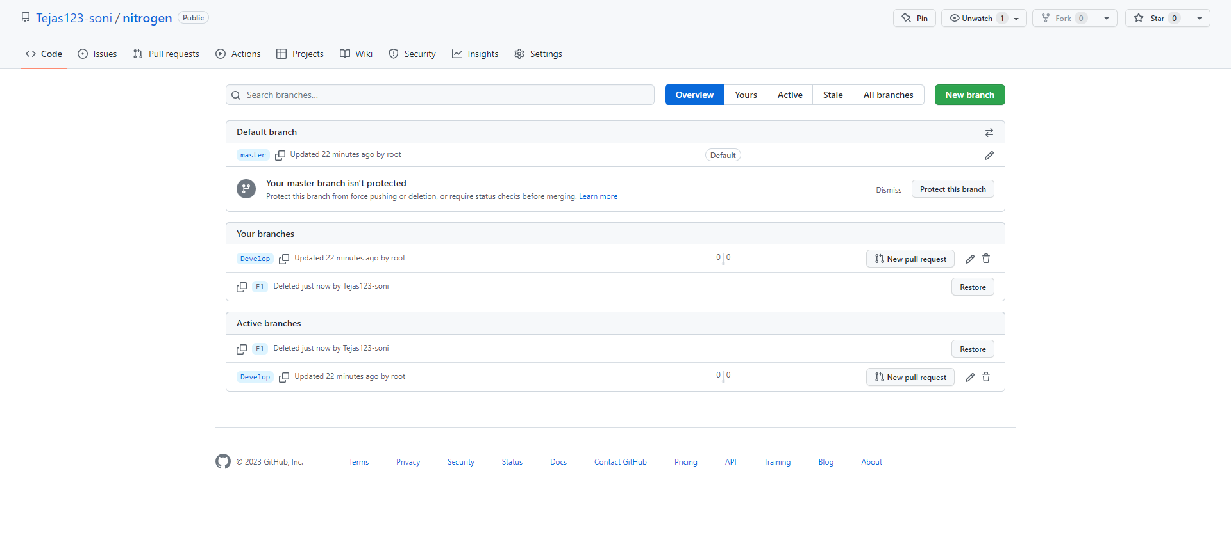

1 mkdir tst1

2 cd tst1

3 git init

4 yum update -y

5 # yum install git -y

6 yum install git -y

7 git init

8 ls

9 cd tst1

10 mkdir avdh

11 cd avdh

12 ls

13 git init

14 git status

15 git branch

16 git add .

17 git commit -m "first comm"

18 touch hit.txt

19 git add .

20 git commit -m "gghh commit"

21 git status

22 git branch

23 git branch Develop

24 git branch F1

25 git branch F2

26 git checkout master

27 touch main.txt

28 git add .

29 git commit -m "this is main commit "

30 git checkout Develop

31 touch develop.txt

32 ls

33 git checkout F1

34 touch f1.txt

35 ls

36 git checkout F2

37 touch f2.txt

38 git remote add origin https://github.com/Tejas123-soni/nitrogen.git

39 git branch -M master

40 git push -u origin main

41 git push -u origin master

42 git branch

43 git checkout F1

44 git checkout Develop

45 git checkout F1

46 git push -u origin master

47 git push -u origin F1

48 history

49 git checkout Develop

50 git push -u origin Develop

51 git branch --delete F2

52 git branch

53 git branch --delete F1

54 history

To delete branch from git hub :

git push origin -d F2

On the remote F2 is deleted

To delete branch on local :

git branch -D F2