 

INSTITUTE FOR ADVANCED COMPUTING AND SOFTWARE DEVELOPMENT AKURDI, PUNE

Documentation On

**“COACHING_CENTER_MANAGEMENT”**

PG-DAC FEB 2020

*Submitted By:*

**Group No: 66**

**Tejas Shete_1192**

**Piyush Ahir_1113**

**Prashant Karhale Mr. Milind Sir**

**Centre Coordinator Project Guide**

# Table of Contents

1. Introduction 4

Document Purpose 4

Problem Statement 4

Product Scope 4

Aim & Objectives 5

1. Overall Description 5

Product Perspective 5

Benefits 5

User and Characteristics 5

Operating Environment 6

Design and Implementation Constraints 6

1. Requirements Specification 7

External Interface Requirements 8

Non-Functional Requirements 8

1. System Diagram 10

Activity Diagram 10

Data Flow Diagram 11

Class Diagram 12

Use Case Diagram 13

ER Diagram 14

1. Table Structure 15

Student 15

Enrollment 15

Course 16

Feedback……………………………………………………………………………….16

Faculty…………………………………………………………………………………16

1. Conclusion 17

Future Scope 17

1. References 17

**List of Figures**

Figure 1 Admin Activity Diagram 10

Figure 2 Data Flow Diagram 11

Figure 3 Class Diagram 12

Figure 4 Use Case Diagram 13

Figure 5 ER Diagram 13

**1. Introduction**

Coaching Center Management is a project for the managing the coaching center efficiently and effectively along with all the details of the student. It is very useful for students and Admin to get information which they want. Admin and Student are the two roles in this project and different functionality is given to them.

**Document Purpose**

The Coaching Center Management System is a website for coaching Institute. Here students can see what kind of courses institute is offering and register according to their interests. It is very convenient to Institute owner to monitor online admission process track students count and organize batches accordingly.

**Problem Statement**

Existing system for a student is based on our traditional way where student needs to find coaching center get the information about center where he has to visit the center and collect the information. Here Admin Of Our Coaching Center has access of these details and papers are not granted to common member in absence of the authority. It is hard to manage all the details system with pen and paper. It gets really hard to maintain the records and then keep track of past records. Hence this system is proposed to overcome the flaws of the existing system and giving power to the admin of the society so that he/she will be able to manage the society easily.

**Product Scope**

**1. Student:**

Student can register for the course. He can give the feedback for the course.

**2. Admin:**

Admin will able to manage the student data, his feedbacks. He can also manage the course and faculty details accordingly. He has also the rights to change enrollment details of a particular student.

## Aims & Objectives

This system allows the users to take admission in institute for particular course in which user is interested in and provided facility to give feedback about the respected trainer of the course. It will provide admin the facility to monitor the entire admission process, schedule and modify batches accordingly.

**2.Overall Description**

The system work on internet server, so it will be operated by two end user one will student and other will be admin. This system will provide an online platform for Coaching Centers which are providing facility for courses and their feedbacks are also given by students.

**Product Perspective**

Registration if student wants to register for course paying registration fees.

After registration students can login to the system by entering valid user id and password and see entire details and give feedback at the of the course.

End User Can Browse courses, content of the course which institute is offering.

Payment for students UPI facility provided.

User logout after the payment done.

**Benefits of Coaching Center Management**

The Coaching Center Management System application helps to manage the admission process and organize batches.

The Coaching Center Management System will use the internet as the sole method for admission of students.

**Users**

1.Admin

2.Student

**Operating Environment**

Server Side:

**Processor:** Intel® Xeon® processor 3500 series

**HDD:** Minimum 500GB Disk Space

**RAM:** Minimum 2GB **OS:** Windows 10

**Database:** MySQL

Client Side (minimum requirement):

**Processor:** Intel Dual Core

**HDD:** Minimum 80GB Disk Space

**RAM:** Minimum 1GB

**OS:** Windows 10

**Design and Implementation Constraints**

* The application will use Angular , Java and CSS as main web technologies.
* Several types of validations make this web application a secured one and SQL Injections can also be prevented.
* Since Coaching Center Management System is a web-based application, internet connection must be established.
* The Coaching Center Management System will be used on PCs and will function via internet or intranet in any web browser.

**3.Requirements Specification**

**External Interface Requirements**

**Application Interfaces:**

**OS:** Windows 10, Linux

**Web Browser:**

The system is a web-based application; clients need a modern web browser such as Mozilla Firebox, Internet Explorer, Opera, and Chrome. The computer must have an Internet connection in order to be able to access the system.

**Communications Interfaces:**

* + This system uses communication resources which includes but not limited to, HTTP protocol for communication with the web browser and web server and TCP/IP network protocol with HTTP protocol.
  + This application will communicate with the database that holds all the booking information. Users can contact with server side through HTTP protocol by means of a function that is called HTTP Service. This function allows the application to use the data retrieved by server to fulfil the request fired by the user.

**Functional Requirement**

This section provides requirement overview of the system. Various functional modules that can be implemented by the system will be-

Description:

If user wants to take benefit of this site so ,It is mandatory to be registered. They can register as Student or Teacher.

User can Login to the system entering valid user id and password.

If User Logs in as a student he can choose class, subject, topic about online class.

If User Logs in as a teacher he can fill class, subject, topic, date and link of his online class.

If Admin Logs in he will manage the data.

Logout after the lecture is over .

The term client/server refers primarily to an architecture or logical division of responsibilities,

the client is the application (also known as the front-end), and the server is the RDBMS (also known as the back-end).

A client/server system is a distributed system in which, Some sites are client sites and others are server sites. All the data resides at the server site All applications execute at the client sites.

**Non-Functional Requirement**

**1.Security:**

**SSL**

The System use SSL (Secure Socket Layer) in all transactions that include any confidential customer information.

The system must automatically log out all customers after a period of inactivity.

The system should not leave any cookies on the customer's computer containing users password.

The system's back-end servers shall only be accessible to authenticated administrators.

Sensitive data will be encrypted before being sent over insecure connections like internet.

The proper firewalls should be developed to avoid intrusions from the internal or external sources.

**2.Reliability:**

The system provides storage of all databases on redundant computers with automatic switchover.

The main pillar of reliability of the system is the backup of the database

which is continuously maintained and update to reflect the most recent changes.

**3: Availability:**

The system should be available at all times .meaning the user can access it using web browser,

only restricted by the down time of the server on which the system runs.

In case of a of a hardware failure or database corruption, a replacement page will be shown. uptime : It mean 24 * 7 availability

100%--------------

99.9%

99.999%

99.9999%

**4: Maintainability:**

A commercial database is used for maintaining the database and application server takes care of the site. The maintainability can be done efficiently.

**5.Portability:**

The application is HTML and scripting language based (JavaScript). So the end user part is fully portable and any system using

Any web browser should be able to use the features of the system ,including any hardware platform that is available or will be available in the future.

An end-user is used this system on an OS either it is Windows or Linux.

The System shall run on PC, Laptops and PDA etc.

The technology should be transferable to different environments easily.

**6.Accessibility:**

Only registered users should be allowed to process the orders after authentications.

Only GUI access of the system should be permitted to end users.

**7.Policies:**

The Host will allowed to remove data of Teacher is any continuous bad feedback is received from the student.

**8.Efficiency:**

The system should provide good throughput and response to multiple users without burdening the system by using appropriate number of servers.

**9.Safety**

Software should not harm ethical and environmental conditions of the end users machine.

**10.Modulariy:**

The system should have user friendly interface.

It should be easily Updated as well as modified and reused.

**4.System Diagram**

**Activity Diagram**

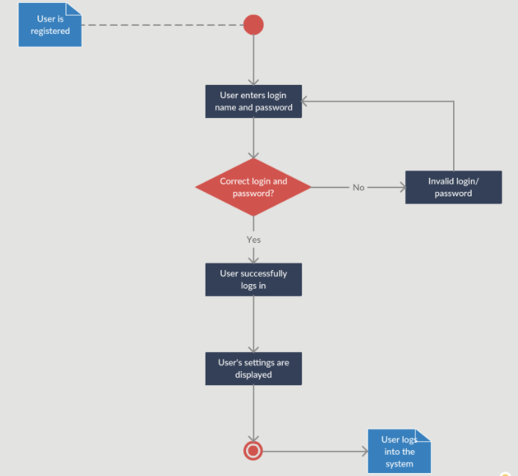

**Fig. Admin Activity Diagram**

**Data Flow Diagram**

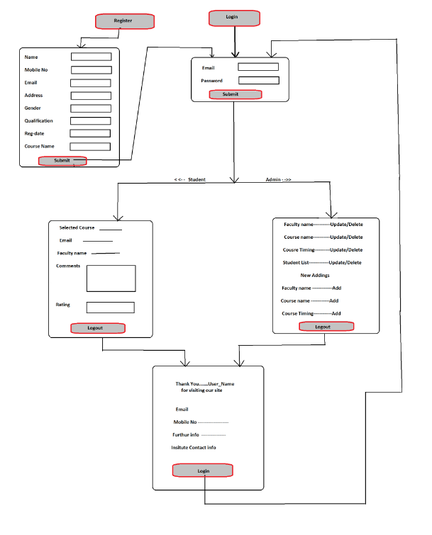

**Fig .Data Flow Diagram**

**Use Case Diagram**

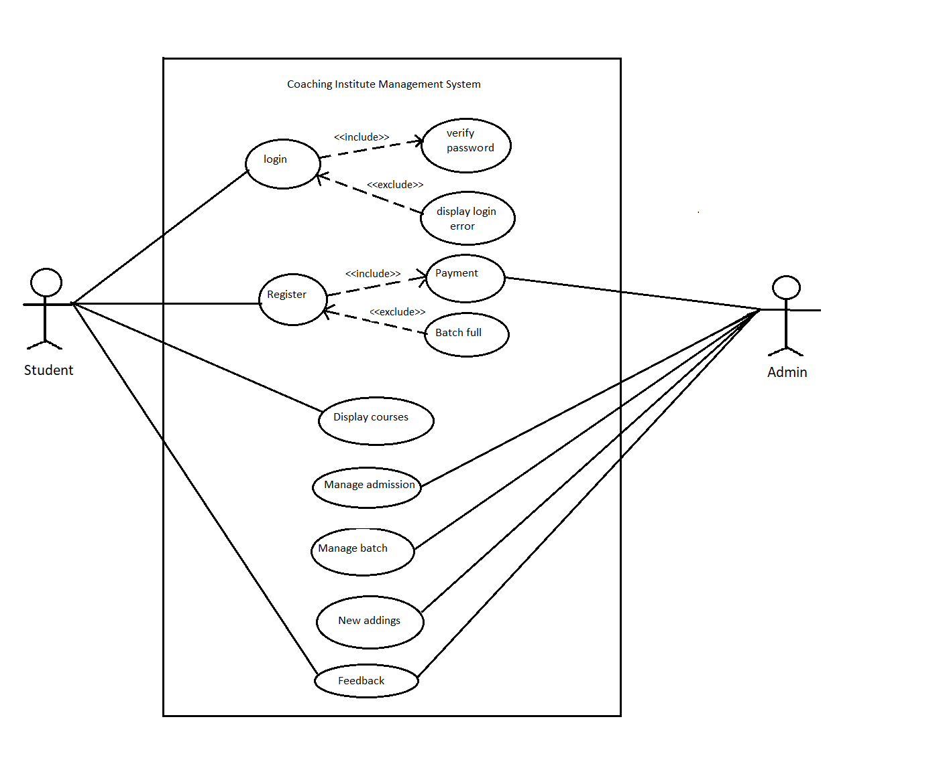

**Fig Use Case Diagram**

**ER Diagram**

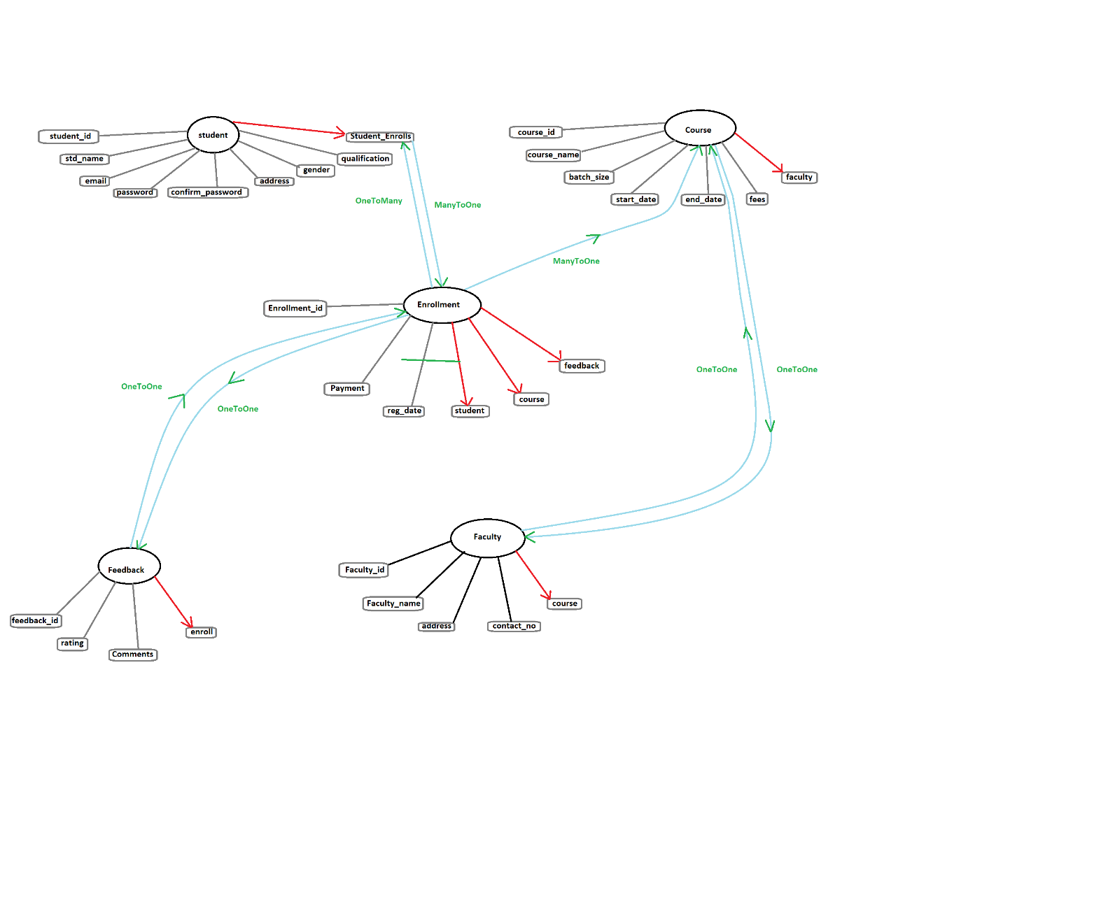

**Fig.ER Diagram**

**5.Table Structure**

* **Student**

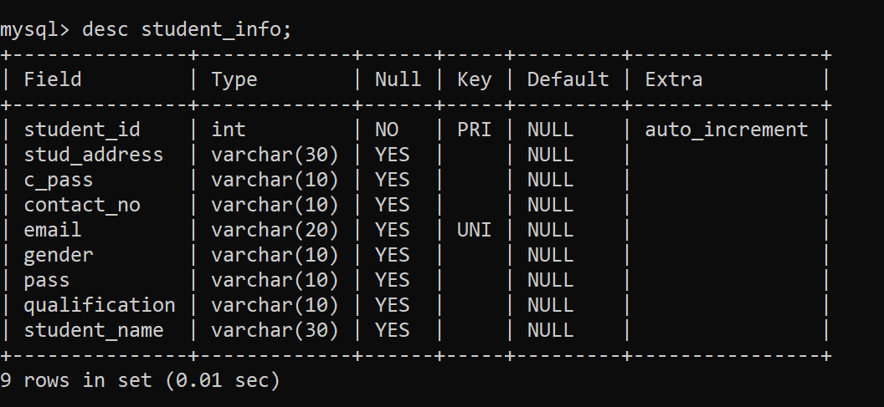

* **Enrollment**

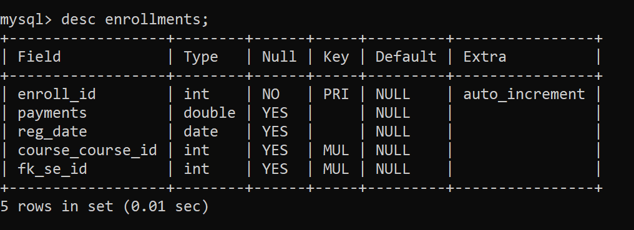

* **Course**

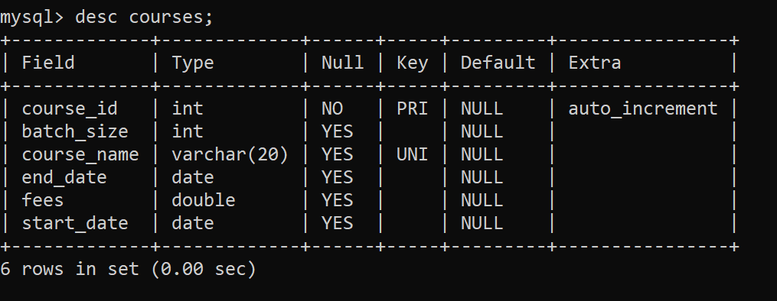

* **Faculty**

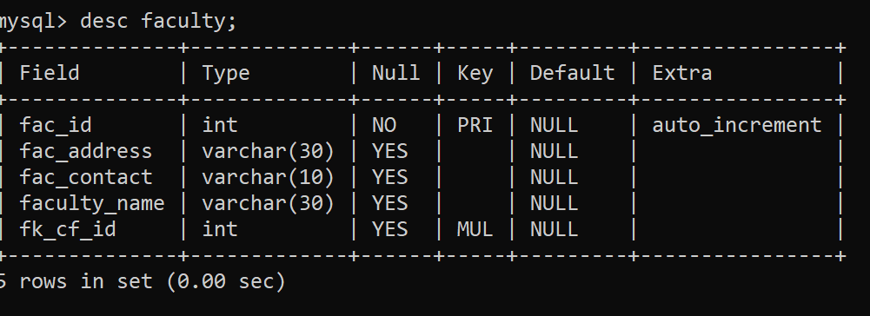

**Feedback**

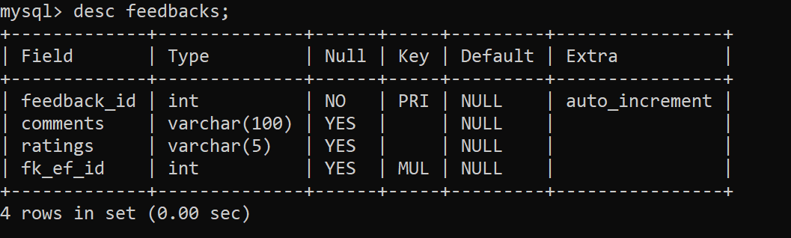

**6.Conclusion**

The User want to take admission, payment through UPI mode. Student will get confirmation message with course content delivery.

Admin can monitor, organize, schedule batches, manage feedbacks, cancel admission, delete feedback.

**Future Scope**

This project can be enhanced further by providing functionality of admit card to the students . providing course data to the students. Giving extra functionality to the student with the help of email and payment get a ways.

**7.References**

<https://smartclasses.in/>