Section 11 – Prompt Engineering Theory

1. What is Language Modeling?
Language modeling is the task of predicting the next token/word based on the previous sequence of tokens

. What is a Vocabulary?
A vocabulary is the collection of tokens that a model can work with.
For example, a simplified vocabulary might contain:
["the", "dog", "cat", "runs", "is", "happy", ...]
Modern LLMs generally work with tokens, not necessarily complete words.
For example:
"unbelievable"
could potentially be represented as multiple tokens/subword pieces.

5. What is an LLM?
LLM = Large Language Model
An LLM is a language model trained on a very large amount of text/data and containing a large number of learned parameters.

1. What is a Prompt?
A prompt is the input/instruction given to an AI model to generate an output.
Prompt = Input provided to an AI model to guide it toward a desired response.

2. Four Main Components of a Prompt
A prompt can be broken down into four components:
Prompt
├── 1. Instruction
├── 2. Context
├── 3. Input Data
└── 4. Output Indicator

① Instruction — What should the model do?
The instruction tells the AI model the task it needs to perform.

② Context — What additional information should the model know?
Context provides additional information that helps the model understand the task correctly.

③ Input Data — What should the model process?
Input data is the actual information that the model needs to process.

④ Output Indicator — What kind of response should we expect?
The output indicator tells or signals the model what type/form of response is expected.
For example:
Return the answer as JSON.

1. What is Context Engineering?
Context engineering is the process of designing, selecting, organizing, and providing the right information to an AI model at the right time so it can produce a useful and accurate response.
Simple way to remember:
Prompt Engineering = How you write the instruction.
Context Engineering = What information you give the model along with the instruction.

2. Why is Context Engineering important?
An LLM only has access to the information available in its current context.
If you provide wrong, irrelevant, outdated, or incomplete context, the model may produce a poor response even if your instruction is good.

4. What can be included in Context?
Depending on the application, context can include:
- User's current question
- Conversation history
- Relevant documents
- Retrieved information from a database
- RAG search results
- User preferences
- System instructions
- Tool results
- API responses
- Previous agent steps
- Current application state
- Structured data

An LLM has a context window, which determines how much input/context it can process within a request.

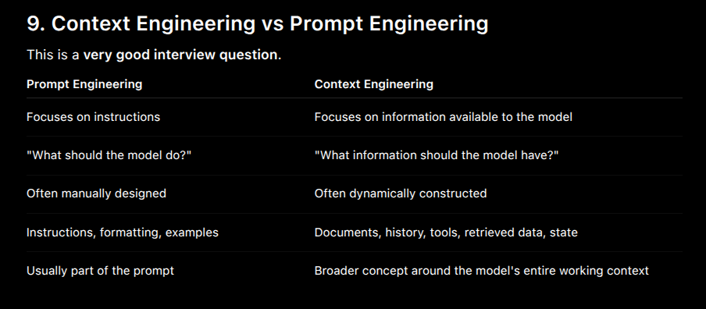

What Factors Matters when Building LLM applications for Production
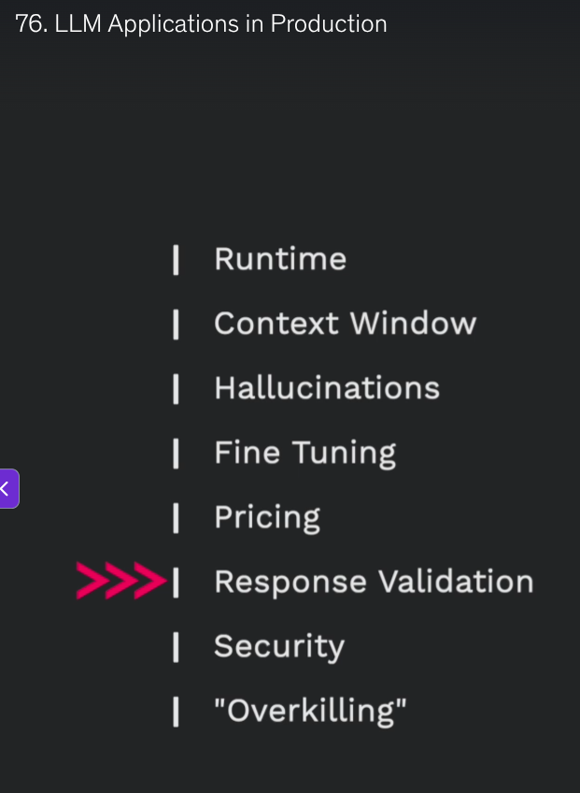

4. Categories of LLM Applications

# | Category | Main Technology | Simple Example
1 | Simple LLM Application | Direct LLM API call | AI story generator
2 | LLM + RAG | Vector DB + Semantic Search + RAG | Chat with your documents
3 | LLM + Agents | Agents + Tools + LLM reasoning | Cybersecurity alert handling
4 | Agents + RAG/Vector DB | Agents + Vector DB + Semantic Search + Memory | Autonomous AI systems

