Chunking :

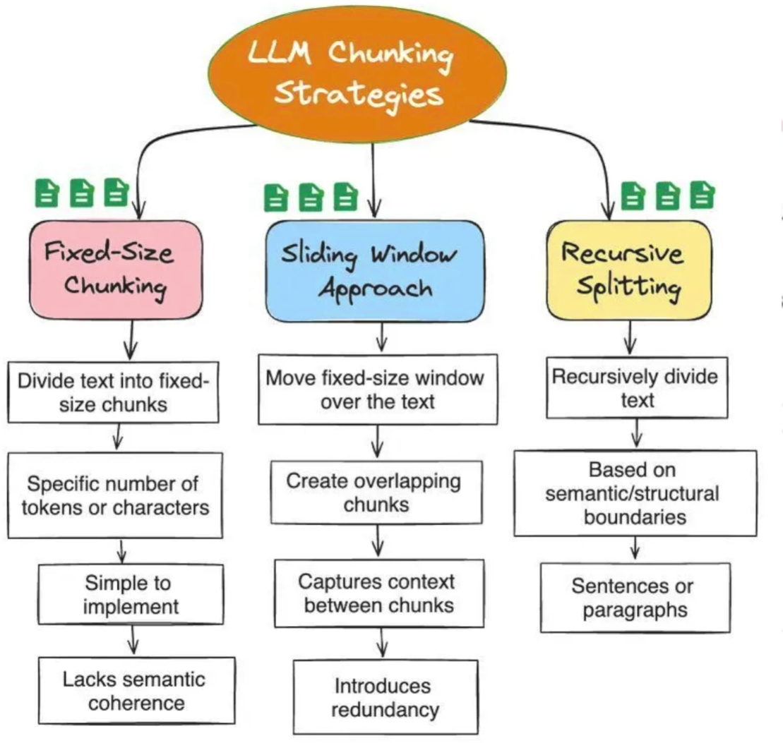

RAG Architecture

Resource : https://docs.langchain.com/oss/javascript/deepagents/retrieval#rag-architectures

Hybrid RAG

Commonly used RAG architecture

