Section 09 : RAG – Retrieval Augmentation Generation

Why RAG ?

It is a technique used in AI applications to give an LLM access to external knowledge before it generates an answer.
The easiest way to understand it is:
Question → Retrieve information → Add information to AI → Generate answer
Retrieval : Retrieval means finding relevant information.
Augmentation : Augmentation means adding the retrieved information to the AI's prompt/context.
Generation :
Now the LLM reads the:
- User's question
- Retrieved context
And generates the final answer called Generation
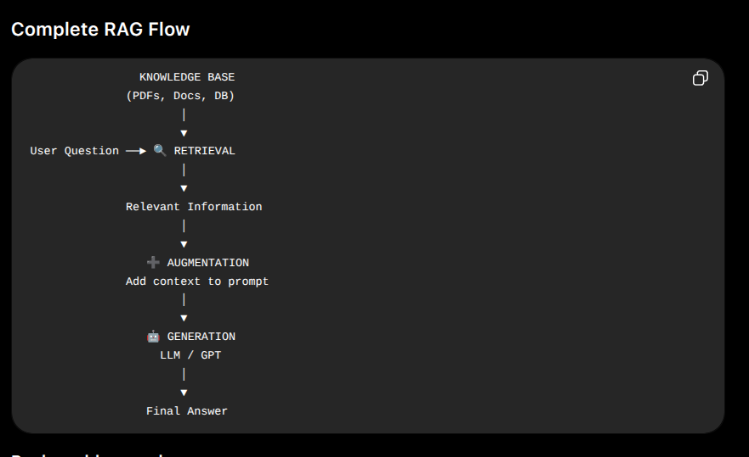

Introduction to Vector Database

Vector

a vector is a long list of numbers that represents the meaning of text.

vector databases so the system can quickly find the right facts to hand over to the language model.

Embeddings

An embedding is a numerical/vector representation of data that captures its semantic meaning.

Example:
"I love programming"
↓
Embedding Model
↓
[0.12, -0.45, 0.89, 0.23, ...]
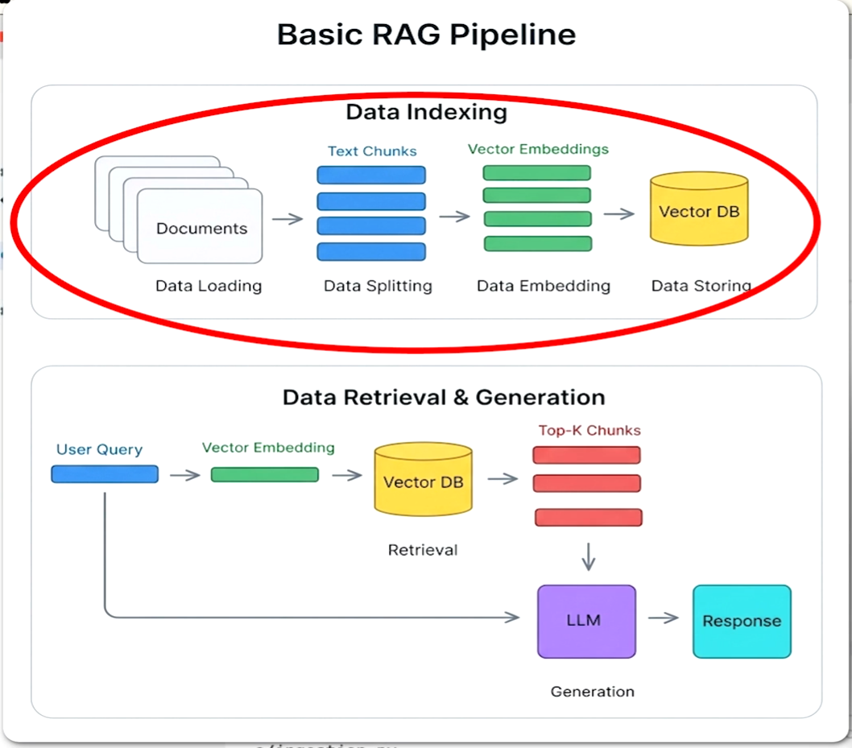

Document = Source of knowledge for your RAG system.
A document does not necessarily mean only a PDF or Word file.
It can come from many sources:
- PDF
- Word document
- TXT file
- Markdown file
- Website
- Database
- CSV / Excel file
- API response
- Email
- Notion page
- Confluence page
- Product documentation
Ingestion

The process of taking data from a source, preparing it, and storing it in a searchable form so the RAG system can retrieve it later.

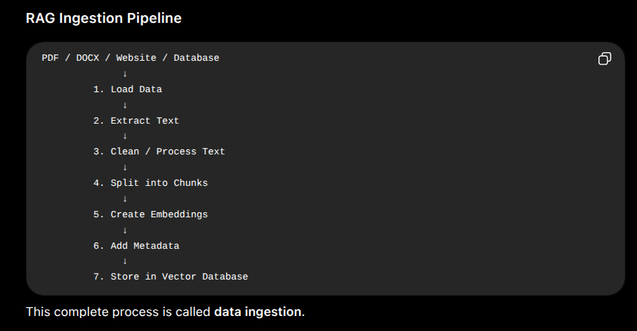

Important Reference Docs Links :

1. Text Splitters : https://docs.langchain.com/oss/python/integrations/splitters
2. Document Loader : https://docs.langchain.com/oss/python/integrations/document_loaders

