Section – 13 – Introduction to LangGraph

https://docs.langchain.com/oss/python/langgraph/graph-api

LangGraph: Agents, Chains, and the Spectrum of AI Systems

1. What is an agent?
An agent is a control flow in which an LLM decides where to go next.
Unlike a fixed sequence of steps, an agent uses the reasoning capabilities of an LLM to decide which step to execute, which tool to use, or whether to return a final answer.
Key characteristics of an agent:
- Dynamic decision-making: The LLM determines the next step.
- Tool calling: The LLM can choose and call tools, such as APIs or database queries.
- Cycles (loops): The agent can execute a step, observe the result, and decide what to do next.
- Flexibility: It can choose different tools or sequences of tools depending on the task.
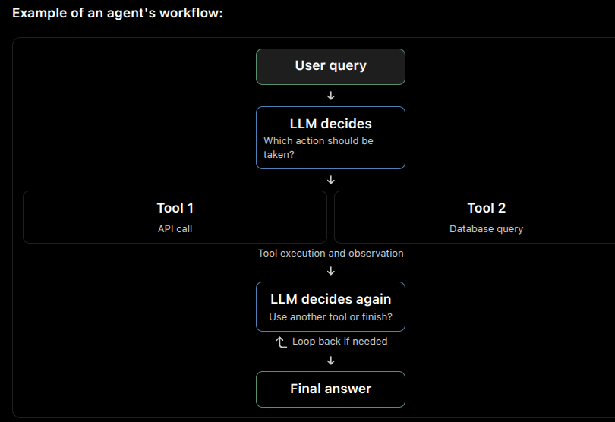
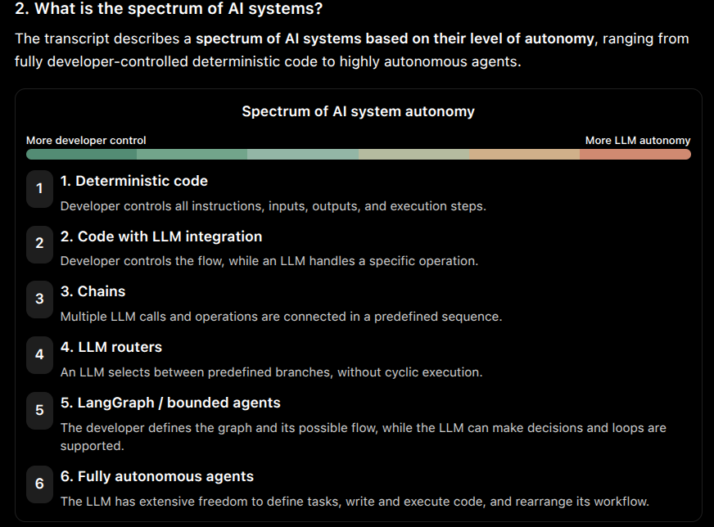
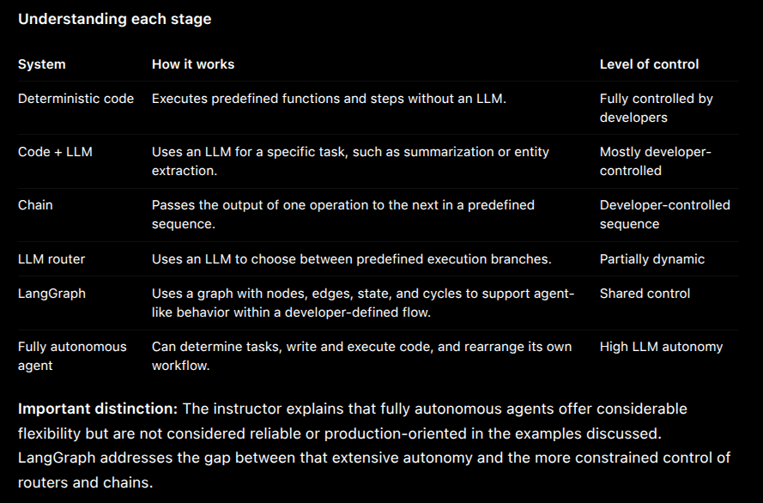

3. What is the difference between a chain and an agent?
The main difference is a chain follows a predefined, one-way sequence, whereas an agent can dynamically decide the next step and use cycles.
Comparison | Chain | Agent
Definition | A sequence of operations where outputs feed into subsequent steps. | A control flow in which an LLM decides where to go next.
Execution flow | Predefined and one-directional. | Dynamic and can include loops.
Decision-making | Developers define the execution sequence. | LLM decides which action or tool to execute.
LLM usage | LLMs perform predefined tasks at specific steps. | LLMs determine the next action, often through tool calling.
Tool usage | Tools or operations are included in the predefined sequence. | The LLM can select among available tools dynamically.
Flexibility | Relatively limited because the flow is predefined. | High because the flow can change according to the LLM's decisions.
Predictability | More predictable because the execution path is predefined. | Less predictable because decisions depend on LLM outputs.
Cycles | Typically does not have cycles. | Supports cycles to repeat decisions and actions.
Example | RAG pipeline: question → retrieval → context augmentation → answer generation. | An agent that decides whether to query a database, call an API, use another tool, or return an answer.

Why does LangGraph help?
According to the instructor, the problem with agents is that allowing every possible action and sequence creates excessive freedom. That freedom can make agents unreliable.
LangGraph addresses this by allowing developers to:
- Define the execution flow.
- Control which nodes can be executed.
- Introduce conditional branching and cycles.
- Let LLMs make decisions within the defined workflow.
- Use state to retain intermediate results.
- Add persistence, human-in-the-loop workflows, debugging, and tracing.
This approach aims to combine the flexibility of agents with the control and reliability needed for production systems.

5. What does the term "graph" represent in LangGraph?
In LangGraph, a graph represents the application's execution flow using nodes and edges. The instructor also describes this structure as a state machine.

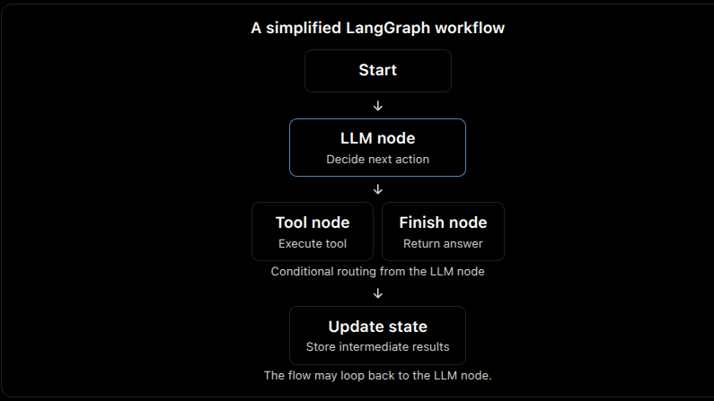

Key graph components
Component | Meaning
Nodes | Individual operations or steps in the workflow, such as calling an LLM or executing a tool.
Edges | Connections that determine how execution moves from one node to another.
Conditional edges | Routing decisions that determine which node executes next.
Cycles | Connections that allow execution to return to a previous node, supporting iterative agent behavior.
State | Shared information across nodes and edges that stores intermediate results and provides context for decisions.

2. What is a State Machine?
A state machine is a system that moves from one state to another based on some event or condition.
Think about a simple order system:
Pay
┌────────────────────┐
│ v
[Pending] ----------> [Paid]
|
| Ship
v
[Shipped]
|
| Deliver
v
[Delivered]
So:
State machine = States + Rules for moving between states.

3. How is a State Machine related to a Graph?
This is the important connection for LangGraph.
A state machine can be represented using a graph:
condition/event
|
v
┌───────────┐
│ State A │
└─────┬─────┘
|
| transition
v
┌───────────┐
│ State B │
└─────┬─────┘
|
v
┌───────────┐
│ State C │
└───────────┘
Here:
- State = Node
- Transition = Edge
This is essentially the idea from the transcript.

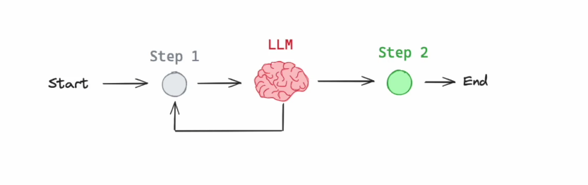

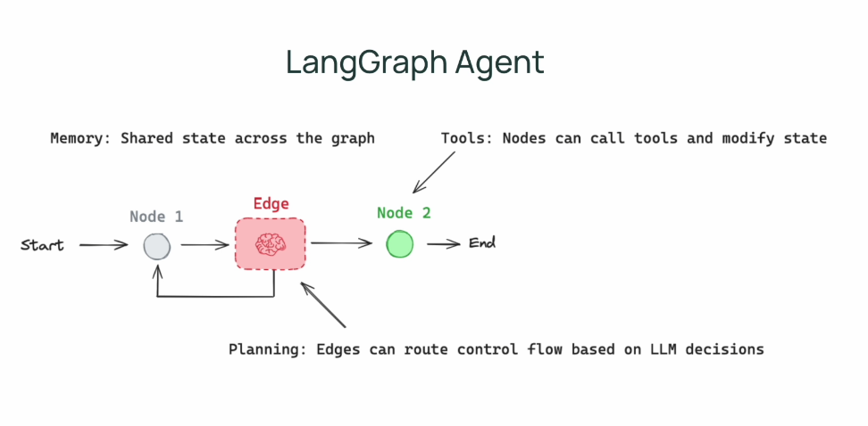
1. What is Flow Engineering?

Answer
Flow Engineering is a systematic and strategic approach to software development that integrates AI-based decision-making into defined workflows.
The main goal is to control and optimize how an AI system handles tasks by defining a clear flow or sequence of operations.
The flow is not necessarily linear. It can contain:
- Decision-making nodes
- Multiple possible outputs
- Evaluation of outputs
- Refinement of outputs
- Iterative cycles

2. Why is Flow Engineering important for AI systems?

Answer
Flow Engineering gives developers more control over how an AI system performs a task.
Instead of giving an AI a goal and allowing it to independently decide everything it should do, developers:
- Define the overall flow.
- Define the tasks and steps.
- Define the scope in which the LLM can operate.
- Allow the LLM to make decisions within that defined flow.
The LLM still has flexibility, but it operates within a workflow created by the developer.

3. What is the problem with fully autonomous agents?

Answer
The transcript mentions projects such as AutoGPT and BabyAGI as examples of autonomous-agent approaches.
The problem discussed is long-term planning.
A fully autonomous agent may:
Goal
↓
Create Tasks
↓
Execute Tasks
↓
Create Subtasks
↓
Execute Subtasks
↓
Create More Subtasks
↓
...

LangGraph – Core Components

1. What is the main idea behind LangGraph?

Answer
LangGraph is used to implement a well-defined control flow, which can be thought of as:
- A control flow
- A state machine
- A graph
Within this controlled flow, LLMs can play an important role.
The LLM can:
- Determine where to go next in the control flow.
- Make the next step non-deterministic.
- Be called directly within the control flow.
- Be used as an agent within a node.
The key idea is that the overall graph execution remains under control.

2. What are the three basic components of LangGraph?

Answer
The three basic components are:
- Nodes
- Edges
- Conditional Edges
These components allow us to build and control the execution flow of a graph.

3. What is a Node in LangGraph?

Answer
A node is literally a Python function.
You have complete flexibility over what code you put inside a node.
A node can contain:
- Deterministic code
- Normal Python code
- Python code that calls an LLM
- An LLM agent
So, a node represents a step where we perform some work.

Key Point
Node = Python function that performs some work.

4. What is an Edge in LangGraph?

Answer
An edge connects nodes within the graph execution.
It helps define how execution moves from one node to another.
For example:
Node A → Node B → Node C

5. What are Conditional Edges?

Answer
Conditional edges help make decisions about where the graph should go next.
For example:
┌──→ Node A
Decision ────┤
└──→ Node B
The decision can dynamically determine whether execution should go to Node A or Node B.
This makes the graph flexible and allows the execution path to change based on the situation.

Key Point
Conditional Edge = dynamically decides which node to execute next.

6. What is the power of LangGraph's edges and conditional edges?

Answer
They provide control over how the graph execution navigates.
With nodes, edges, and conditional edges, we have significant control over the execution flow.
The flow can therefore contain dynamic decisions while still following a structure defined by the developer.

. What are the Start and End nodes?

Answer
LangGraph has two important built-in nodes:
- Start node
- End node

Start Node
The Start node is the entry point of graph execution.
START
↓
Node A
Execution begins from the Start node.

End Node
The End node is the last point of graph execution.
Node B
↓
END

Important
Both Start and End nodes do not actually perform any work.
They can therefore be thought of as non-operation points in the graph.

State in LangGraph

8. What is State in LangGraph?

Answer
The state is simply a dictionary containing important information needed to continue tracking the graph execution.
The state can contain things such as:
- Results from node execution
- Temporary results
- Chat history
- LLM results
The state can be very simple or highly complex depending on what we need to store.

9. Where is the State available?

Answer
The state is local to the graph execution.
It is available to:
- Every node
- The edges
- The conditional edges
This allows different parts of the graph execution to access the information stored in the state.

10. Can LangGraph persist the State?

Answer
Yes.
LangGraph provides persistence, which allows the graph state to be stored persistently.
This means that if graph execution needs to stop for some reason, execution can later continue from the same point using the specific state that was stored.
The course will demonstrate this using LangGraph's persistence functionality.

Nodes and State

11. What does a LangGraph node receive as input?

Answer
Every LangGraph node is a Python function, but it is a special type of function.
The node receives the current graph state as its input.
The state contains the information that the node needs to perform its work.
Current State
↓
Node
↓
Updated State

12. What does a node return?

Answer
A node returns a dictionary containing the keys that we want to update in the state.
Therefore, every node updates the state.
Conceptually:
State
↓
Node
↓
Dictionary of updates
↓
Updated State

13. How does the State change during graph execution?

Answer
The state changes over time as different nodes execute.
Each node can update the state.
The resulting state can then be used by:
- Other nodes
- Edges
- Conditional edges
Conditional edges can use the state to determine whether execution should go to Node A or Node B.

Cycles and Advanced LangGraph Concepts

14. Can LangGraph implement loops?

Answer
Yes.
LangGraph can implement cyclic graphs, meaning the execution flow can contain loops.
This is considered powerful because implementing loops was difficult with LangChain.
Example:
Node A
↓
Node B
↓
Node C
↓
Node A
The execution can return to an earlier node.

15. What is Human-in-the-Loop?

Answer
Human-in-the-loop means that human feedback can participate in determining where the graph execution goes next.
For example:
┌──→ Node A
Human ──┤
Feedback└──→ Node B
The human's feedback can help determine which node should be executed next.

16. What is Persistence in LangGraph?

Answer
Persistence allows the state of the graph to be maintained.
This can be useful when:
- Graph execution needs to stop.
- We want to continue execution later.
- We want to continue from the same point.
- We need to preserve the specific state.
LangGraph provides built-in functions that make maintaining graph state simple.

Complete LangGraph Execution Model

17. How do the main LangGraph components work together?

Answer
The main components work together like this:
┌───────────────┐
│ START │
└───────┬───────┘
↓
┌─────────────┐
│ Node A │
│ Python func │
└──────┬──────┘
│
Updates State
↓
┌─────────────────┐
│ Conditional Edge│
└───────┬─────────┘
│
┌────────┴────────┐
↓ ↓
┌─────────────┐ ┌─────────────┐
│ Node B │ │ Node C │
└──────┬──────┘ └──────┬──────┘
│ │
└────────┬────────┘
↓
┌─────────────┐
│ END │
└─────────────┘
The important idea is:
Nodes → perform work
Edges → connect nodes
Conditional Edges → make dynamic routing decisions
State → stores information used during execution
START → entry point
END → final point

Recap

Revolution of Agents
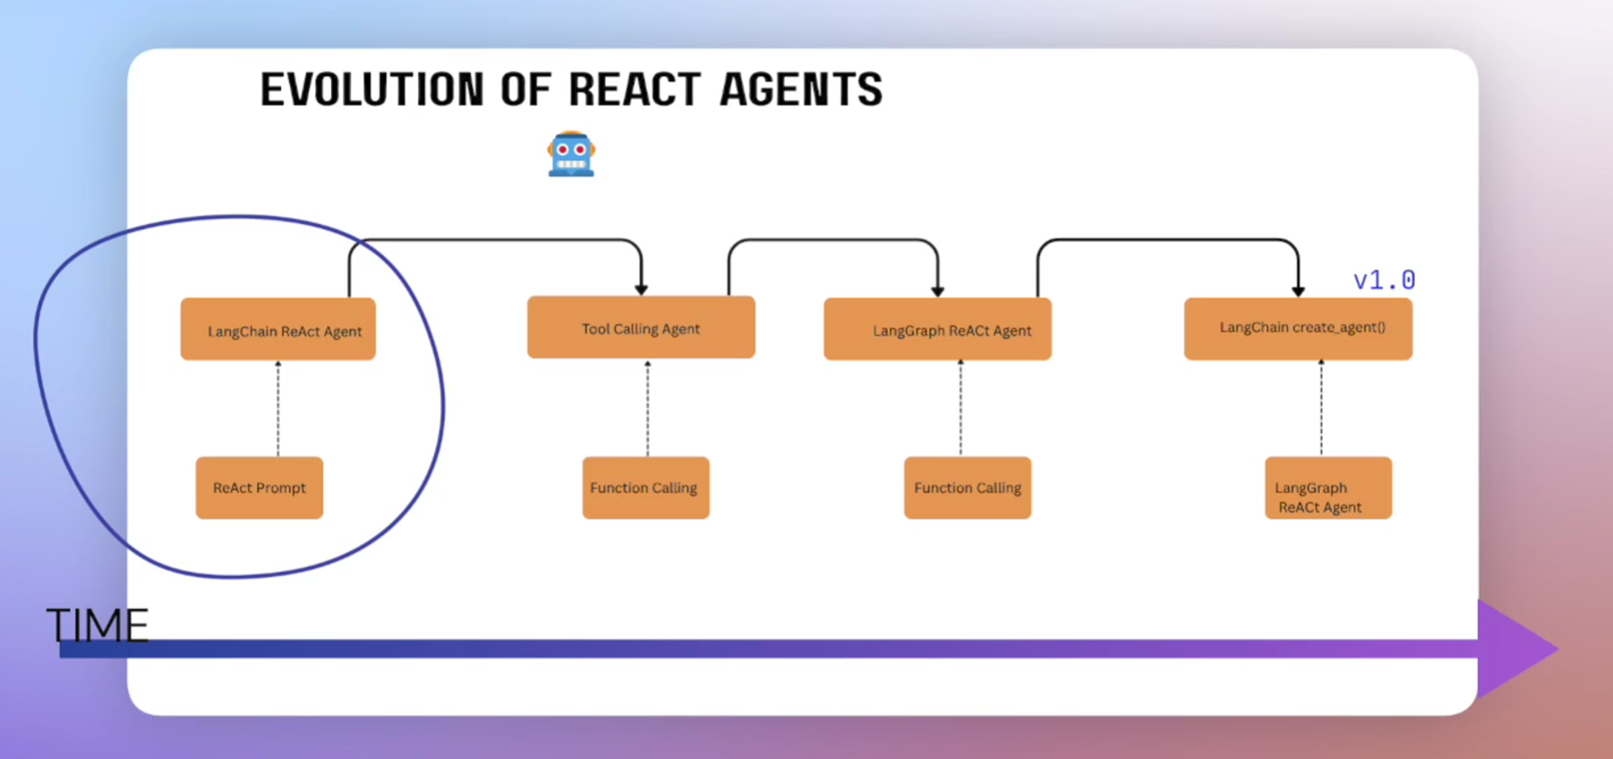

Evolution of ReAct Agents in LangChain and LangGraph

1. What is the basic execution flow of the ReAct algorithm?
The ReAct algorithm follows an iterative process in which an LLM decides which tools to use until it can provide a final answer.

ReAct execution flow
- Send the user's request to the ReAct agent.
- The LLM reasons about the request and decides which tool to call.
- Execute the selected tool.
- Return the tool's result to the agent.
- Repeat the process if another tool is needed.
- Stop when the agent has enough information to provide a final answer.
Key idea: The LLM acts as the reasoning engine, while tools perform the required operations.

2. How did ReAct agents evolve?
ReAct agents evolved through several architectural improvements.
Stage | Approach | Main improvement
Original ReAct | ReAct prompting and output parsing | Used an LLM as a reasoning engine
Function calling | Model-supported function calling | Reduced the need for special prompts and fragile output parsing
LangChain tool-calling interface | Unified interface across providers | Standardized tool-calling integrations
LangGraph agents | Graph-based architecture | Added explicit control flow, shared state, and greater flexibility
create_agent | Simplified agent creation API | Provides a ready-to-use agent backed by LangGraph

3. How did the original ReAct implementation work?
The original ReAct implementation combined:
- ReAct prompting: A specially designed prompt guided the LLM's reasoning and tool selection.
- LLM reasoning: The LLM decided which tool should be executed.
- Output parsing: LangChain parsed the LLM's generated text to identify the selected tool and its arguments.

What were the limitations?
- Unreliable parsing: The output parser depended on the format generated by the LLM.
- Sensitivity to formatting: Even a single incorrect character could confuse the parser.
- Non-deterministic output: The application had limited control over the exact text generated by the LLM.
- Production challenges: Models at the time were less reliable, making the implementation difficult to use reliably in production.
Key idea: The original ReAct approach was impressive, but its dependence on parsing free-form LLM output created reliability problems.

4. How did function calling improve ReAct agents?
As LLMs improved, function calling provided a more structured way for models to request tool execution.
Instead of generating text that LangChain had to parse, the model could return information about the function to call in a dedicated part of its response.

Benefits of function calling
- Removed the need for the special ReAct prompt used in the original approach.
- Reduced dependence on fragile output parsing.
- Allowed the model provider to handle the function-calling mechanism.
- Made tool selection more structured and reliable.

What new problem did it introduce?
Different model providers implemented function calling differently.
For example:
- Some providers used the term function calling.
- Others used tool calling.
- The information could appear in different parts of the model response.
This created integration differences between providers.

5. How did LangChain solve provider differences?
LangChain introduced a unified tool-calling interface.
Instead of requiring developers to handle every provider's implementation separately, LangChain provided a common interface for working with tool calls.

Main advantages
- One consistent interface for tool calling.
- Integration with different model providers.
- Less provider-specific handling in application code.
- Easier interaction with tools across supported providers.
Key idea: LangChain standardized the way applications work with tool calls, even when providers use different underlying formats.

6. What limitations did the original LangChain Agent Executor have?
The original LangChain agent architecture used an agent execution loop, essentially a while loop abstracted by the Agent Executor.
Although it handled the iterative agent process, it offered limited flexibility and visibility into the execution loop.

Limitations
- Limited control over the internal execution flow.
- Limited visibility into what was happening during execution.
- Difficulties tracking and managing state.
- Less flexibility when building more complex agent workflows.
For example, adding custom state to the original Agent Executor was difficult and often involved configuration objects and keyword arguments.

7. How did LangGraph change the agent architecture?
LangGraph introduced a graph-based architecture for building agents.
Instead of hiding the agent execution loop inside an executor, LangGraph represented the workflow explicitly as a graph.

Three main components
Component | Description
State | A shared dictionary that stores conversation history and intermediate results
Nodes | Python functions that receive state, perform operations, and return updates
Edges | Define the control flow and determine which node executes next

How do these components work together?
- A node receives the current state.
- The node performs a calculation, calls an LLM, or executes a tool.
- The node returns updates to the state.
- Edges determine the next node.
- The process continues until the graph reaches its stopping point.

Simplified flow
Start
|
v
LLM Node
|
Select an action
|
v
Tool Node
|
Update the state
|
v
LLM Node
|
Final response?
/ \
No Yes
| |
v v
Tool End

How does state management work in LangGraph?
State is a shared dictionary that stores the information needed during graph execution.
It may contain:
- Conversation history.
- Intermediate results.
- Information produced by LLM calls.
- Other data required by the workflow.
Each node receives the current state and returns a dictionary containing updates.

How did create_agent simplify agent creation?
With the release of LangChain and LangGraph version 1.0, the agent API was simplified.
The newer create_agent function replaced the earlier ReAct agent creation approach and the previously available prebuilt LangGraph agent interface described in the course.
It provides a simple way to create a ReAct agent by supplying a model and tools.

What happens under the hood?
- create_agent returns a compiled graph.
- The graph is powered by LangGraph internally.
- The API provides a simpler interface for developers.
- The resulting agent retains LangGraph capabilities such as observability, debugging, and customization.

Conceptual example
agent = create_agent(
model=model,
tools=tools
)
The developer supplies the model and tools rather than manually implementing every part of the agent's execution graph.

13. What is the difference between the original ReAct agent and the modern create_agent approach?
Aspect | Original ReAct / Agent Executor | Modern create_agent
Architecture | Agent execution loop | Compiled LangGraph
Control flow | Mostly abstracted inside the executor | Represented by a graph internally
State management | Custom state was more difficult to manage | Uses a graph state schema
Observability | Limited visibility into internal execution | Supports LangGraph observability
Debugging | Less built-in execution inspection | Supports checkpointing and debugging capabilities
Customization | More limited control over the loop | More flexible graph-based customization
Developer experience | More implementation details to manage | Simple API for creating agents

Important Terminologies

ToolNode
StateGraph
MessageState
https://docs.langchain.com/oss/python/langgraph/graph-api#messagesstate

