**Tutorial 2**

1. Discuss various modes of Vi editor with graphical representation.

1. Command Mode is the first screen of VI editor. It is case-sensitive. Any character that is typed during this mode is treated as a command. These characters are not visible on the window. We can cut, copy, paste, or delete a piece of text or even move through the file in this mode

[ESC] used to enter the Command Mode from another mode (Insert Mode)

2. Insert Mode

We can quickly move from Command mode à Insert mode by pressing ‘i’ or ‘Insert’ key from the keyboard. Characters typed in this mode are treated as input and added text to your file

Pressing ESC will take you from Insert Mode -> Command Mode

3. Escape Mode

Press [:] to move to the escape mode. This mode is used to save the files & execution the commands.

1. Write a Shell Script to accept Name, Qualification, Name of Institute and display in the proper format.

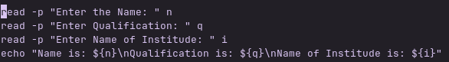

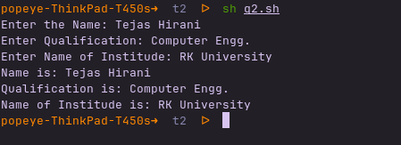

1. Write a SS to total of two numbers using command line argument

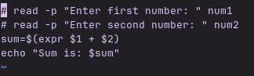

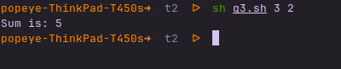

1. Write a SS for take two values and perform addition, subtraction, multiplication and division operation ,finally generate appropriate answer using command line argument

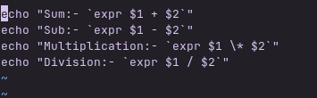

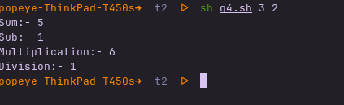

1. Write a shell script to find total and average of three values.





1. Write a shell script for take three values first do the addition of those three values after than subtract forth value of this total, finally generate appropriate answer should be display.

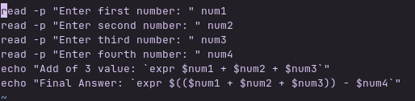

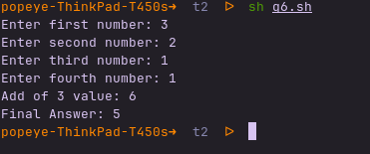

1. Write a shell script to generate following output:

Enter the value : 8

Answer is : 64





1. Write a Shell Scripts to generate following output:

Enter the first value : 8

Enter the second value : 6

Answer is : 48

Enter the third value : 4

Final Answer is : 12

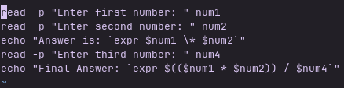

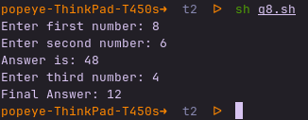

1. Write a Shell Program to find average of three numbers entered by user

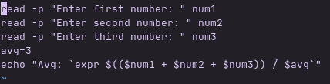

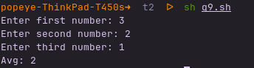

1. Write a Shell Program to swap two numbers with and without using third variable

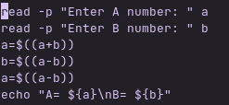

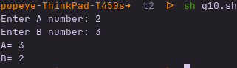

1. Write a Shell Program to find simple interest, the value of P, N and R are entered by user.

