

UE22CS441A – Capstone Project Phase – 3
Project Progress Review # 1

Cognitive Load Estimation from EEG + fNIRS Signals
using Hybrid Deep Learning

Project Title : Cognitive Load Estimation from EEG + fNIRS
Project ID :
Project Guide :
Project Team :

Outline
- Abstract and Scope of the Project
- Summary of Work Done in Capstone Project Phase – 2
- Preprocessing, hybrid model, and leakage-audited LOSO evaluation
- Binary reframing and the 42-experiment improvement campaign
- Inferences Drawn from Literature Survey
- List of Tasks / Modules with Individual Contribution
- Design of Overall Architecture
- Demonstration and Testing of Completed Modules
- Key Results — Confusion Matrix & Per-Subject Performance
- Explainability — SHAP & Attention Analysis
- Experiment Campaign — Rigor & Negative Results
- References

Abstract and Scope
Mental workload cannot be measured directly — it has to be inferred from physiological signals. This project estimates cognitive load from two complementary brain signals recorded simultaneously: EEG (electrical activity, 200 Hz, fast but noisy) and fNIRS (hemodynamic/blood-oxygenation activity, 10 Hz, slower but stable), using the open TU Berlin n-back dataset (Shin et al., 2018) — 26 subjects performing 0-back / 2-back / 3-back working-memory tasks, an experimentally imposed workload level that gives objective ground truth.
A hybrid deep-learning network — per-modality residual-MLP encoders fused through a learned attention gate — predicts Low / Medium / High load (original protocol) or Low / High (binary reframing).
Scope: (1) an end-to-end, leakage-audited pipeline; (2) an honest headline metric — leave-one-subject-out (LOSO) accuracy, not an inflated fixed-split number (see chart below); (3) a full-stack demo where every UI number traces to a committed artifact; (4) SHAP + attention-gate explainability; (5) a documented negative result (DANN) as evidence of rigor, not hidden.
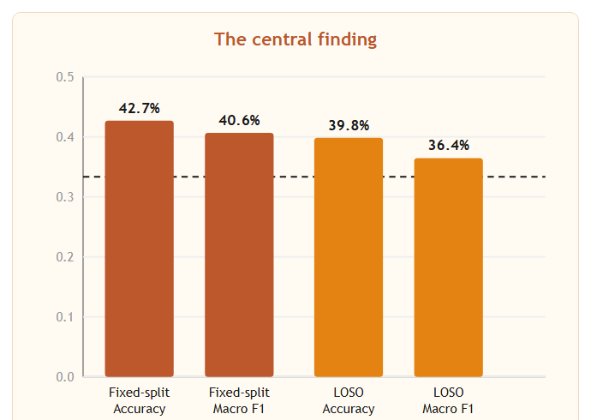

Summary of Work Done in Capstone Project Phase – 2
- Built the full preprocessing pipeline: raw .mat recordings → band-power / hemodynamic features → sliding-window extraction, with EEG epoched on NIRS markers to keep both modalities aligned.
- Trained and evaluated the 3-class Hybrid network; identified the fixed-split-vs-LOSO gap as the project's central methodological finding.
- Adopted per-subject z-score + log-compression preprocessing; ran a 26-fold LOSO rigor pass with paired significance tests and Random-Forest ensembling.
- Explored a Domain-Adversarial Neural Network (DANN) for subject-invariant features — documented as a rigorous, honest negative result.
- Reframed the task as Binary (Low vs High) with sliding-window augmentation, lifting LOSO accuracy from ~40% to 63.09%.
- Built a leakage-audited experiment framework (research/) and ran 42 controlled experiments on the binary model against a development/lockbox split — none beat the baseline within one standard error.
- Exported the frozen model to a portable serving/ bundle and built the FastAPI backend + React frontend demo, including a CSV-upload endpoint verified byte-exact against the training pipeline.

Architecture
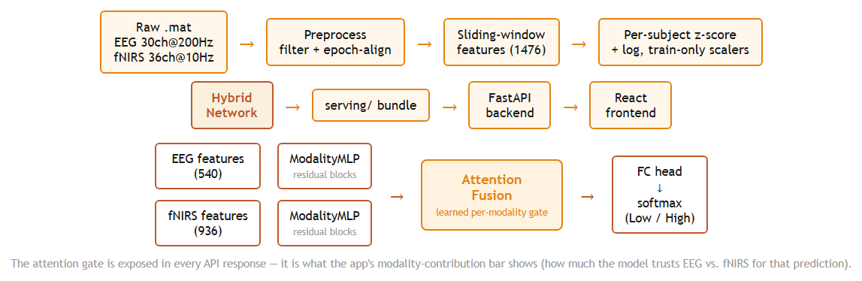

List of Tasks / Modules
- Data Preparation — preprocess_tuberlin.py, sliding_window_extractor.py, data_loader.py: raw .mat → filtered, epoch-aligned, per-subject-normalized feature tensors (1476 features/window).
- Model Architecture & Training — models/architectures.py, trainer.py: attention-fusion Hybrid network; validation-macro-F1 checkpoint selection, class weighting, early stopping.
- Rigor / Research Framework — research/ (leakage.py, datamod.py, train.py, campaign.py): leakage-audited LOSO folds, the 42-experiment binary-model campaign, development/lockbox protocol.
- Explainability — explain_model.py, visualize_attention.py: SHAP (GradientExplainer) + attention-gate analysis.
- Export & Packaging — export_for_serving.py, export_research_data.py: freeze model + artifacts into portable, versioned bundles.
- Backend API — FastAPI (main.py, model_service.py, data_service.py, upload_service.py): inference, CSV-upload validation, run-archive access.
- Frontend UI — React + Vite, 7 pages: Overview, Research, Live Prediction, Session Trend, Upload Data, Model Insights, Methodology.
Tools / technologies (all open-source): Python 3.14, PyTorch, scikit-learn, SHAP, pandas / NumPy, FastAPI, Pydantic, React 18, Vite, Recharts.

Individual Contribution
Module | Approx. Lines of Code | Description | Owner
Data & Training Pipeline | ~10,600 | Preprocessing, model training, evaluation, ablation scripts (top-level *.py)
Research / Leakage-Audit Framework | ~5,070 | Binary-model campaign, leakage assertions, run archive (research/)
Backend (FastAPI) | ~1,630 | Serving API, model inference, CSV upload (backend/)
Frontend (React / Vite) | ~9,330 | 7-page demo UI, charts, explainability views (frontend/src)
Total | ~26,600 lines | Across 202 tracked files, Python + JS/JSX

Single-member team — all modules designed, implemented, evaluated and documented by the contributor named above. Timeline: Phase 1 – dataset, preprocessing, 3-class model; Phase 2 – leakage-audited framework, binary reframing, backend/frontend demo; Phase 3 (current) – frontend redesign, reporting.

Demonstration and Testing of Completed Modules
Protocol (Binary model) | Accuracy | Macro F1 | ROC-AUC
LOSO, 26 subjects (4,576 pooled windows) | 63.09% ± 10.1% | 0.6255 | 0.6775
Lockbox, 8 unseen subjects (evaluated once) | 63.71% ± 8.5% | 0.6275 | 0.6888

- Live Prediction demo — pick a subject + window, run a real forward pass; the app shows predicted class, probability bars, confidence / margin / entropy, and the attention-gate bar (how much the model trusts EEG vs. fNIRS).
- Automated correctness check — research.verify_run recomputes every metric from each run's saved predictions.csv and reports zero mismatches.
- Leakage testing — subject / trial / window / duplicate-row / scaler-fit / held-out-subject assertions run before every fold trains; a failure raises LeakageError and aborts the run.
- Upload-path testing — the CSV-upload preprocessing is a self-contained reimplementation of the training pipeline, verified byte-exact (max abs diff 0.0) against data_loader.py.

Key Results — Confusion Matrix & Per-Subject Performance
 | Pred. Low | Pred. High
True Low | 1561 | 727
True High | 962 | 1326

4,576 pooled held-out windows, 26-fold LOSO · overall accuracy 63.09%
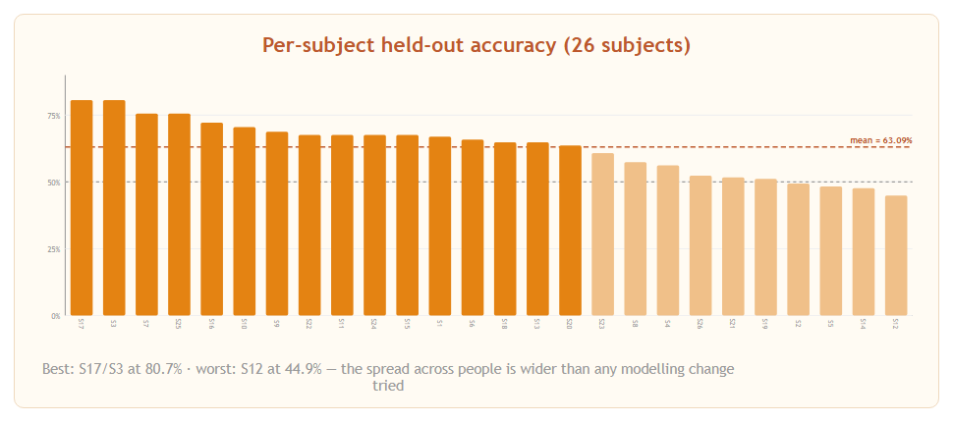

Explainability — What Drives the Prediction
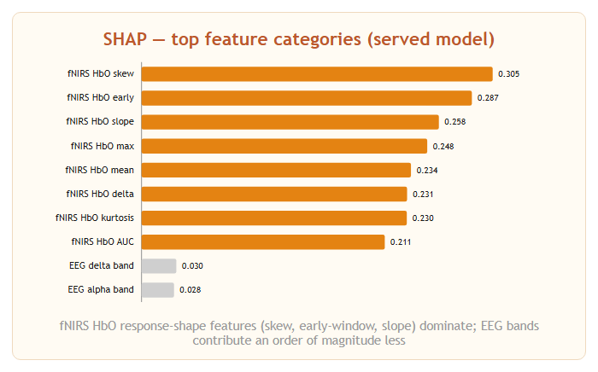 | 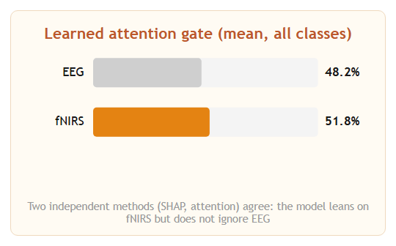

- SHAP (GradientExplainer) and the network's own learned attention gate were computed independently — both point the same way, which is the reassuring part.
- The attention gate is exposed in every live API response; it is what the app's modality-contribution bar shows for each individual prediction.

Experiment Campaign — Rigor & Negative Results
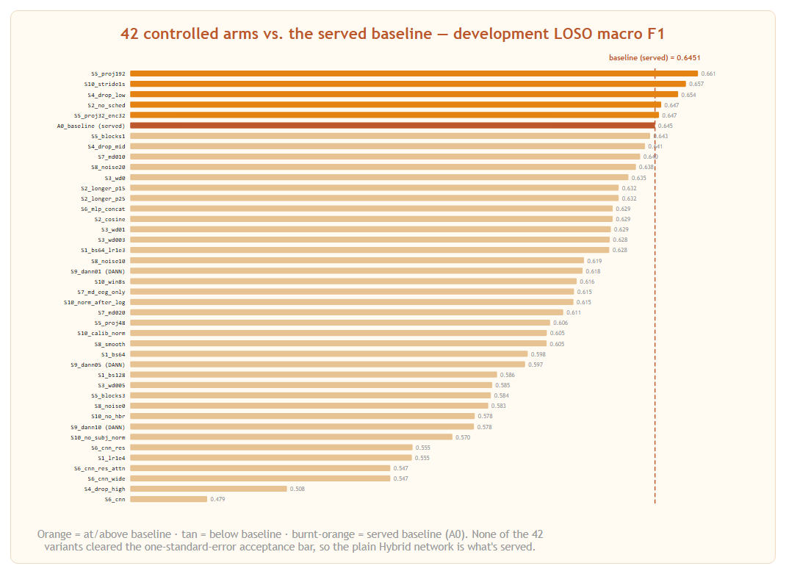
References

1. J. Shin, A. von Lühmann, B. Blankertz, D.-W. Kim, J. Jang, H.-J. Hwang, and K.-R. Müller, “Simultaneous acquisition of EEG and NIRS during cognitive tasks for an open access dataset,” Scientific Data, vol. 5, no. 180003, 2018.
2. Y. Ganin and V. Lempitsky, “Unsupervised Domain Adaptation by Backpropagation,” in Proc. 32nd Int. Conf. on Machine Learning (ICML), 2015, pp. 1180–1189.
3. S. M. Lundberg and S.-I. Lee, “A Unified Approach to Interpreting Model Predictions,” in Advances in Neural Information Processing Systems (NeurIPS), 2017, pp. 4765–4774.
4. L. Breiman, “Random Forests,” Machine Learning, vol. 45, no. 1, pp. 5–32, 2001.
5. R. M. Yerkes and J. D. Dodson, “The relation of strength of stimulus to rapidity of habit-formation,” J. Comparative Neurology and Psychology, vol. 18, no. 5, pp. 459–482, 1908.

Thank You

