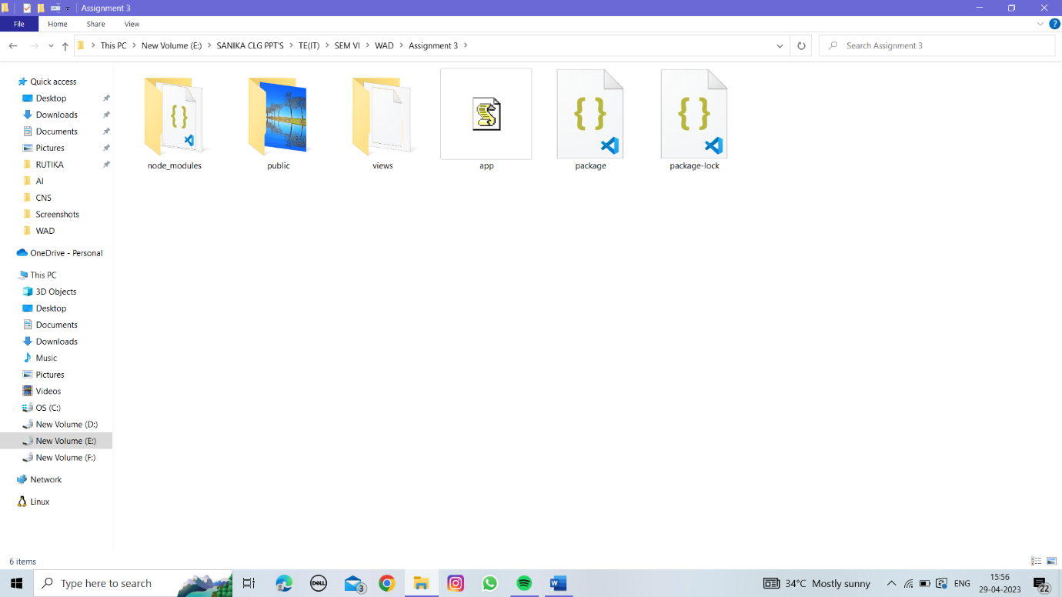

**app.js**

const express = require('express')

const path = require('path')

const app = express()

const port=8081

// Static Middleware

app.use(express.static(path.join(__dirname, 'public')))

// View Engine Setup

app.set('views', path.join(__dirname, 'views'))

app.set('view engine', 'ejs')

app.get('/', function(req, res){

res.render('Demo')

})

app.listen(port, function(error){

// if(error) throw error

console.log(`Server created Successfully on port : ${port}`)

})

**Demo.ejs**

<!DOCTYPE html>

<html>

<head>

<title>Static Middleware Demo</title>

</head>

<body>

<img src="nature.jpg" width="600" height="600" />

</body>

</html>

