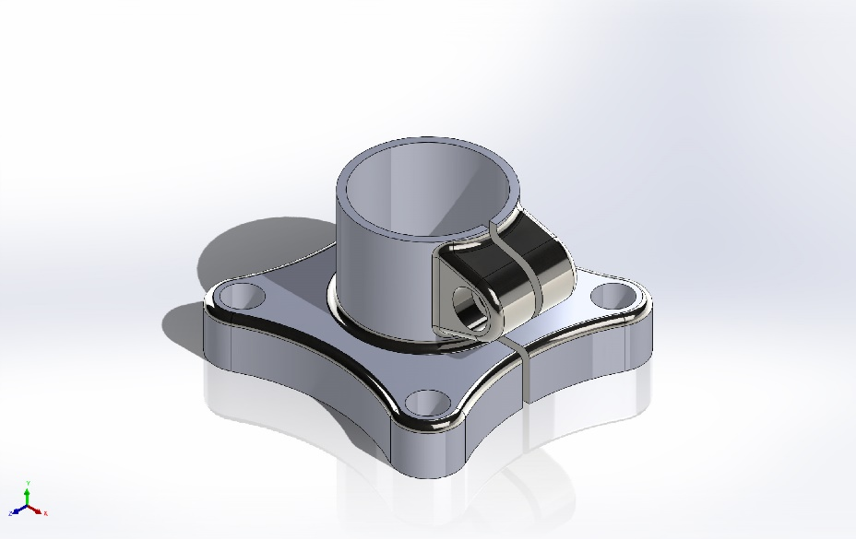
  Simulation of Solidworks_practice_1
  Date: Tuesday, January 6, 2026
  Designer: Solidworks
  Study name: Static 1
  Analysis type: Static
  Table of Contents
  Description 1
  Assumptions 2
  Model Information 3
  Study Properties 4
  Units 4
  Material Properties 5
  Loads and Fixtures 6
  Connector Definitions 6
  Contact Information 7
  Mesh information 7
  Sensor Details 7
  Resultant Forces 8
  Beams 8
  Study Results 9
  Conclusion 12

Description
No Data

Assumptions

Model Information

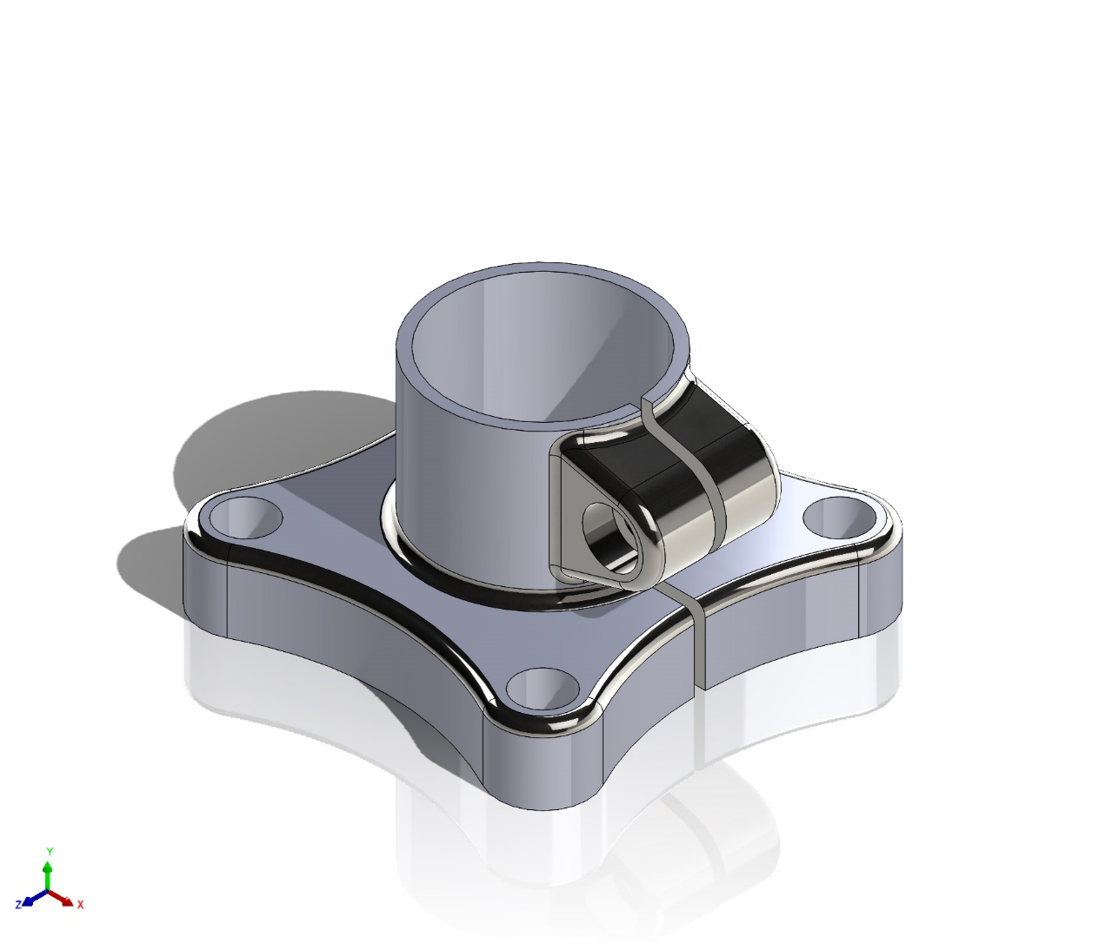
Model name: Solidworks_practice_1
Current Configuration: Default
Solid Bodies
Document Name and Reference | Treated As | Volumetric Properties | Document Path/Date Modified
CBORE for M8 SHCS2  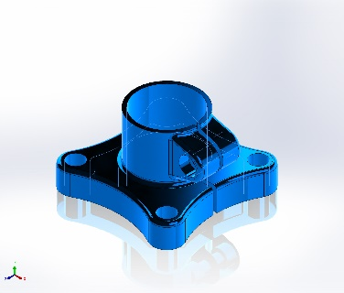 | Solid Body | Mass:0.878176 kg  Volume:0.000112587 m^3  Density:7,800 kg/m^3  Weight:8.60613 N | C:\Users\tjbis\Documents\CAD\practice_1\Solidworks_practice_1.SLDPRT  Jan 6 13:01:21 2026

Study Properties
Study name | Static 1
Analysis type | Static
Mesh type | Solid Mesh
Thermal Effect: | On
Thermal option | Include temperature loads
Zero strain temperature | 298 Kelvin
Include fluid pressure effects from SOLIDWORKS Flow Simulation | Off
Solver type | Automatic
Inplane Effect: | Off
Soft Spring: | Off
Inertial Relief: | Off
Incompatible bonding options | Automatic
Large displacement | Off
Compute free body forces | On
Friction | Off
Use Adaptive Method: | Off
Result folder | SOLIDWORKS document (C:\Users\tjbis\Documents\CAD\practice_1)

Units
Unit system: | SI (MKS)
Length/Displacement | mm
Temperature | Kelvin
Angular velocity | Rad/sec
Pressure/Stress | N/m^2

Material Properties
Model Reference | Properties | Components
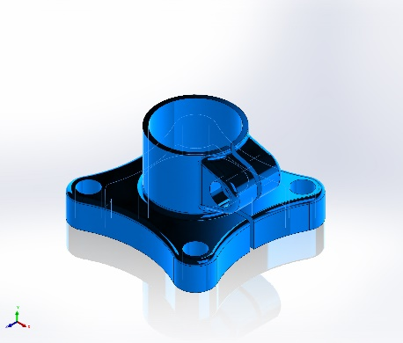 |  | SolidBody 1(CBORE for M8 SHCS2)(Solidworks_practice_1)
  Name: | Plain Carbon Steel
  Model type: | Linear Elastic Isotropic
  Default failure criterion: | Unknown
  Yield strength: | 2.20594e+08 N/m^2
  Tensile strength: | 3.99826e+08 N/m^2
  Elastic modulus: | 2.1e+11 N/m^2
  Poisson's ratio: | 0.28
  Mass density: | 7,800 kg/m^3
  Shear modulus: | 7.9e+10 N/m^2
  Thermal expansion coefficient: | 1.3e-05 /Kelvin
Curve Data:N/A

Loads and Fixtures
Fixture name | Fixture Image | Fixture Details
Fixed-1 | 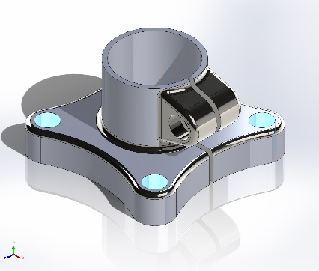
  Entities: | 4 face(s)
  Type: | Fixed Geometry
Resultant Forces
Components | X | Y | Z | Resultant
Reaction force(N) | 10,000 | -6.3777e-06 | -4.8399e-05 | 10,000
Reaction Moment(N.m) | 0 | 0 | 0 | 0

Load name | Load Image | Load Details
Force-1 | 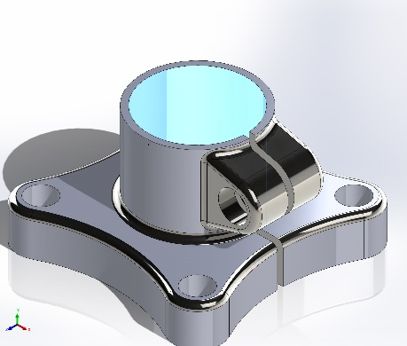
  Entities: | 1 face(s)
  Reference: | Edge< 1 >
  Type: | Apply force
  Values: | ---, ---, 10,000 N

Connector Definitions
No Data

Contact Information
No Data

Mesh information
Mesh type | Solid Mesh
Mesher Used: | Standard mesh
Automatic Transition: | Off
Include Mesh Auto Loops: | Off
Jacobian points for High quality mesh | 16 Points
Element Size | 4.83015 mm
Tolerance | 0.241507 mm
Mesh Quality | High

Mesh information - Details
Total Nodes | 17909
Total Elements | 9576
Maximum Aspect Ratio | 11.703
% of elements with Aspect Ratio < 3 | 97.5
Percentage of elements with Aspect Ratio > 10 | 0.0627
Percentage of distorted elements | 0
Time to complete mesh(hh;mm;ss): | 00:00:03
Computer name: | MBP

Sensor Details
No Data

Resultant Forces

Reaction forces
Selection set | Units | Sum X | Sum Y | Sum Z | Resultant
Entire Model | N | 10,000 | -6.3777e-06 | -4.8399e-05 | 10,000

Reaction Moments
Selection set | Units | Sum X | Sum Y | Sum Z | Resultant
Entire Model | N.m | 0 | 0 | 0 | 0

Free body forces
Selection set | Units | Sum X | Sum Y | Sum Z | Resultant
Entire Model | N | 0.0102458 | 8.64463e-05 | -3.25556e-05 | 0.0102462

Free body moments
Selection set | Units | Sum X | Sum Y | Sum Z | Resultant
Entire Model | N.m | 0 | 0 | 0 | 1e-33

Beams
No Data

Study Results

Name | Type | Min | Max
Stress1 | VON: von Mises Stress | 1.535e+05N/m^2  Node: 183 | 1.322e+08N/m^2  Node: 13195
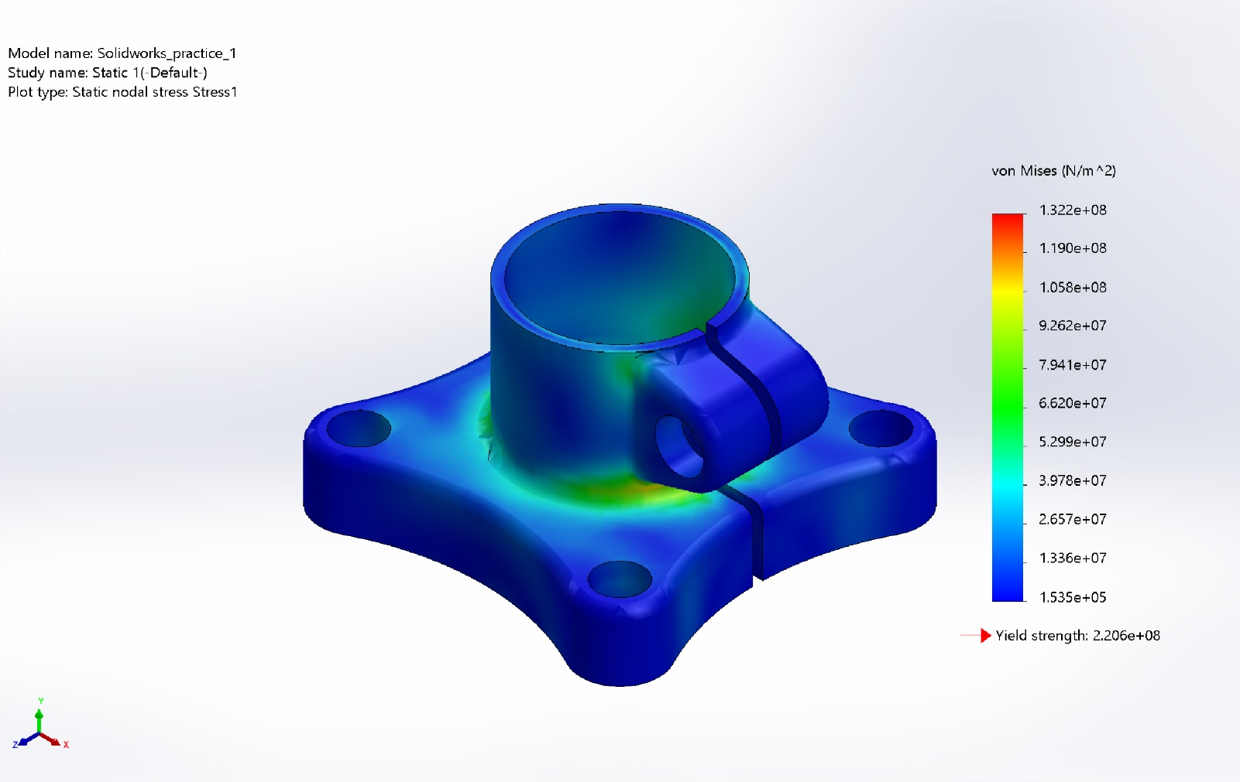
Solidworks_practice_1-Static 1-Stress-Stress1

Name | Type | Min | Max
Displacement1 | URES: Resultant Displacement | 0.000e+00mm  Node: 550 | 7.199e-02mm  Node: 2239
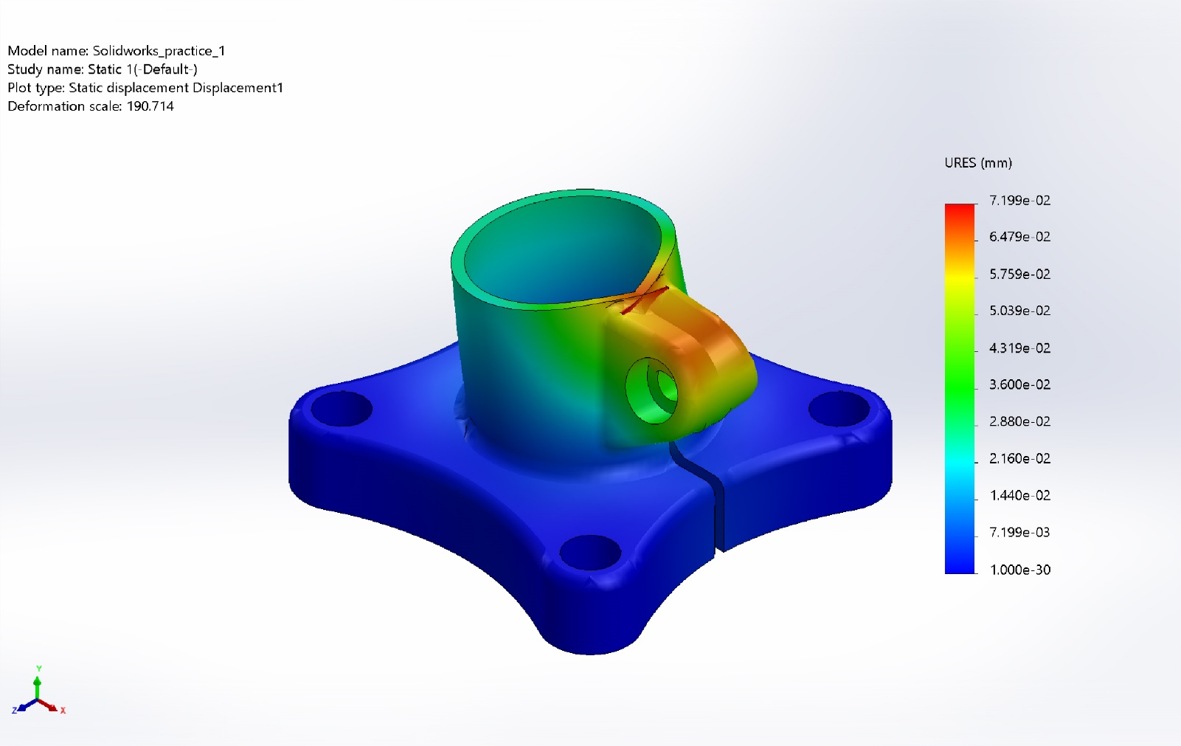
Solidworks_practice_1-Static 1-Displacement-Displacement1

Name | Type | Min | Max
Strain1 | ESTRN: Equivalent Strain | 4.215e-07  Element: 1419 | 4.022e-04  Element: 221
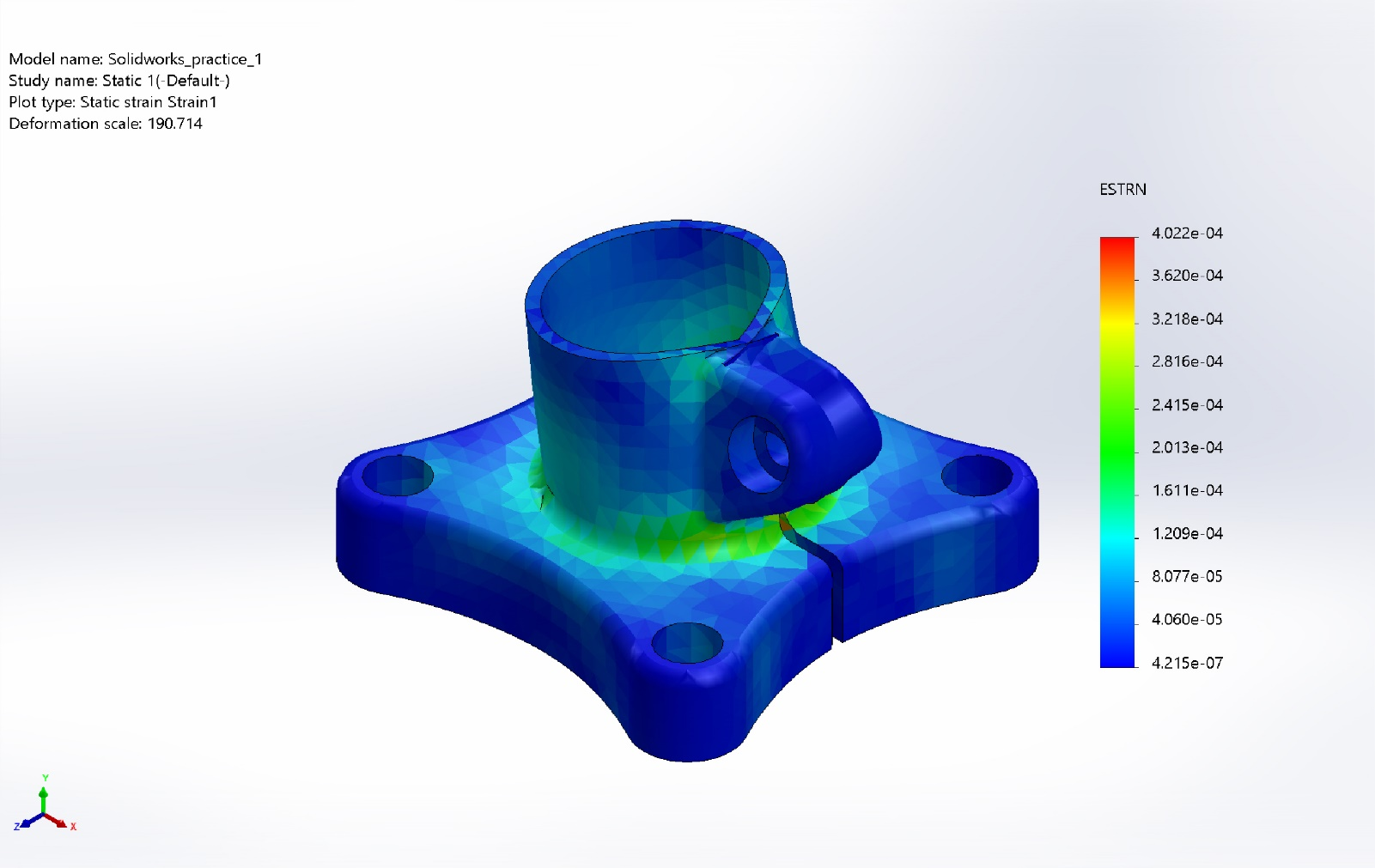
Solidworks_practice_1-Static 1-Strain-Strain1

Name | Type
Displacement1{1} | Deformed shape
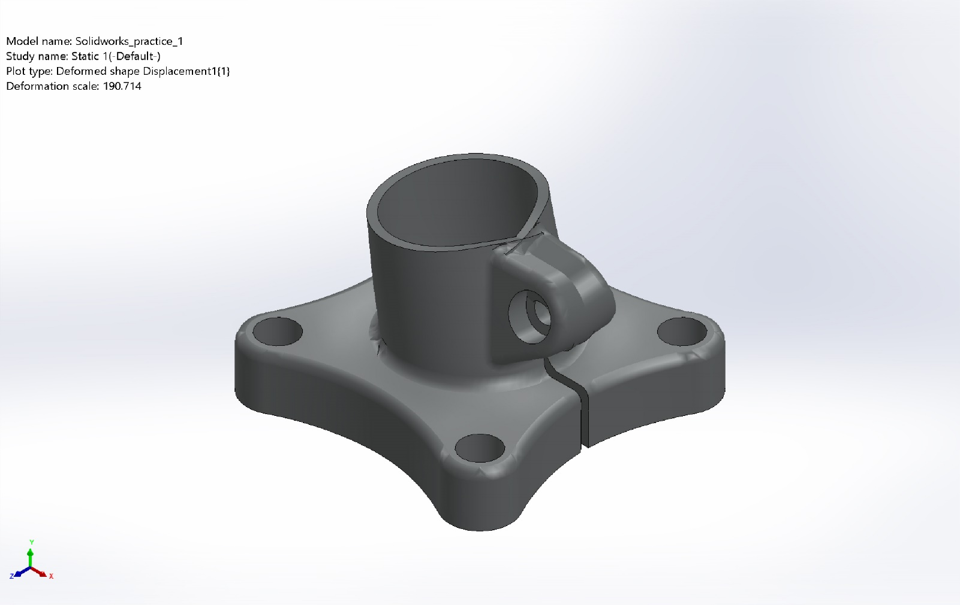
Solidworks_practice_1-Static 1-Displacement-Displacement1{1}

Conclusion

