Assignment-2

Modified E-R diagram:

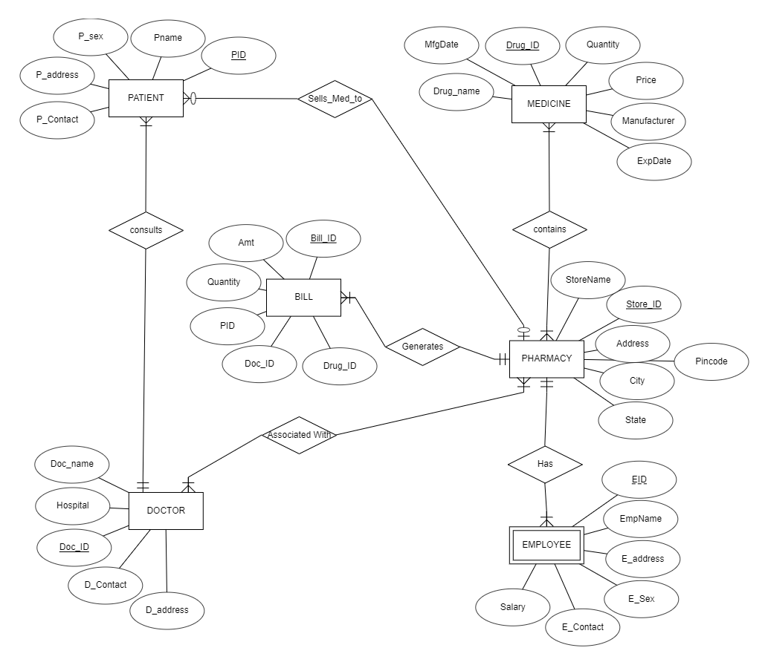
Relational schema:
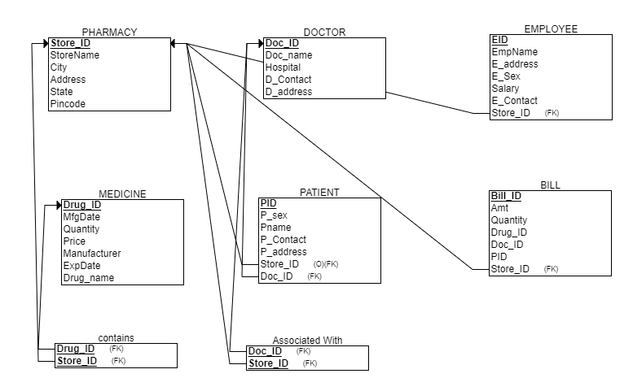

RDBMS – PostgreSQL used to build the script files
Reasons to choose PostgreSQL:
- Since we have a fixed schema the tables are related to each other, relational DBMS is to be used and so one of them is PostgreSQL.
- PostgreSQL is the database design and implementation software that we have decided to use.
- PostgreSQL has easier commands to design the relations and their respective constraints.
- It is also easy to delete a relation or a database in case such situation arises which is not available in SQLite.
- PSQL(PostgreSQL) can be downloaded from https://www.postgresql.org/download/. The installation involves setting up a local server for the same.
- Final we can add the executable path into the environment variable so that it can be accessed from anywhere.

After writing SQL commands and executing:

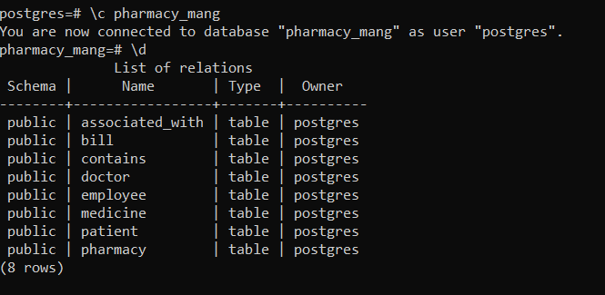

SQL ddl commands and insert commands are written as two .sql files and attached with thisfile

