**CERTIFICATE OF PARTICIPATION**

This i s to certify that

###

Has participated in KIA (Know It All) conducted by Geeks for Geeks and Student Empowerment Cell on 27th September 2022 at

Vishwakarma Institute of Information and Technology, Pune.

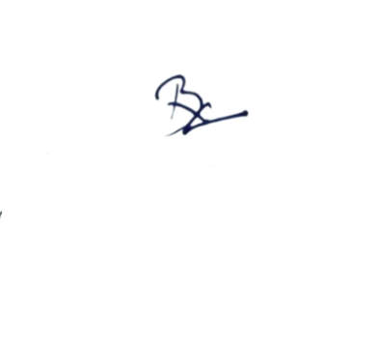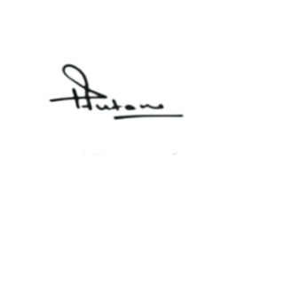

**MR. RAJKUMAR V. PATIL FACULTY IN-CHARGE**

**DEPARTMENT STUDENT ACTIVITY VIIT**

**DR. RATNMALA N. BHIMANPALLEWAR FACULTY IN-CHARGE**

**STUDENT EMPOWERMENT CELL, VIIT**

**DR. PRAVIN FUTANE HEAD OF DEPARTMENT**

**(IT), VIIT PUNE**