SPHERICITY -

Sphericity is the measure of how closely the shape of an object approaches that of a mathematically perfect sphere.

The sphericity, of a particle is: the ratio of the surface area of a sphere(with the same volume as the given particle) to the surface area of the particle:

ANISOTROPY -

Anisotropy is the property of being directionally dependent, which implies different properties in different directions. It can be defined as a difference in topology(or any geometrical property), when measured along different axes.

An anisotropic surface changes in appearance as it rotates about its geometric normal.

CURVATURE -

Curvature of a point is defined as the difference between the angles of the normals at those points.

LINEARITY is also measures the same way. In pyntcloud(python-pcl) planarity = (1/curvature).

VOXEL -
In point clouds, the entire cluster of points is is contained in an imaginary cube.
This cube is internally divided into smaller sub-cubes called ‘voxels’. Voxels are very useful in removing outliers.
The voxelgrid function in pyntcloud library has a built-in minimum density function which checks whether the number of points in a voxel are more than the minimum threshold. If not, then the points in that voxel are deleted.
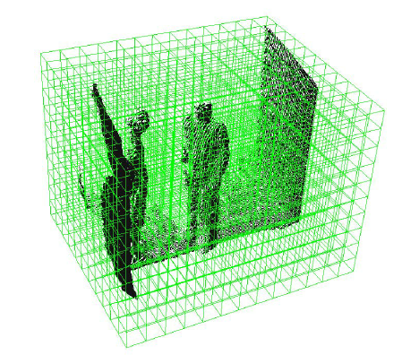

Combining the voxelgrid function with KNN will increase efficiency of removal (of outliers).

