Architectural Documentation

Project Name: Chess-Simulator
Date: 26-February-2025
Version: 0.0.1
By: Tejas Kayande and Sammed Burse

1 Overview

This documentation dives into the architectural choices made to develope the application and an overview of the design choices and the architecture.

2 Architecture

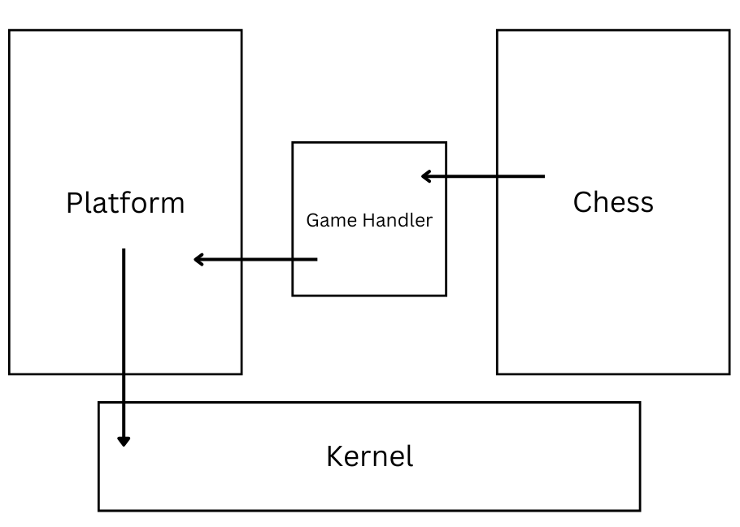

Fig. Architecture of the application

The archicture of this application is divided into 3 components that are elaborated as follow:
2.1 Platform

This layer provides all the Operating System-specific utilities, such as:
- Creating a window to display the game.
- Handling keyboard and mouse inputs.
- Providing functions to draw pixels on the screen.
This is the only layer that interacts with the kernel of the Operating System and makes OS calls. This approach helps maintain a clean codebase and reduces the number of kernel calls by batching them efficiently.
2.2 Chess
This layer is responsible for handling the core chess logic, including:
- Board Representation: Manages the 8x8 chessboard state.
- Move Validation: Ensures that all moves adhere to standard chess rules.
- Game Rules Enforcement: Implements check, checkmate, stalemate, and special moves (castling, en passant, and pawn promotion).
- Move History & Tracking: Stores previous moves and allows for undo/redo functionality.

2.3 Game Handler

The Game Handler is the bridge between the Platform and Chess layers, managing game flow and interactions. Key responsibilities include:
- Turn Management: Alternates moves between players.
- User Input Processing: Captures and translates player actions into game commands.
- Rendering Coordination: Requests the Platform layer to draw the board and pieces based on game state updates.
- Game State Management: Determines whether the game is in progress, paused, or has ended.
- UI Updates: Displays status messages (e.g., check, checkmate) and maintains a smooth user experience.

