SQL Practical Assignment 1
Roll No: 2501087
Name: Tejas Sunil Kayande
Division: A

Question: 1. Create a database and two tables in it.
Query:
CREATE DATABASE InvestmentDB;
USE InvestmentDB;
Output:
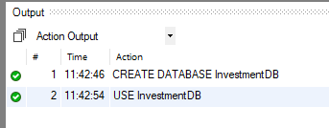

Query:
CREATE TABLE Emp(
emp_id INT,
emp_name VARCHAR(10),
emp_address VARCHAR(30),
bdate DATE
);
DESC Emp;
Output:
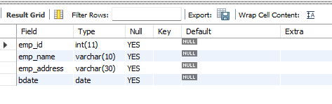

Query:
CREATE TABLE Investor(
inv_name VARCHAR(20),
inv_no INT,
inv_date DATE,
inv_amt INT
);
DESC Investor;
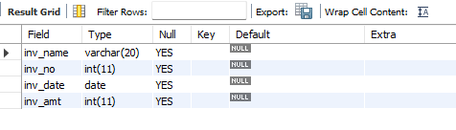
Output:
Question: 2. Add a Column ‘Salary’ in to an Emp table.

Query:
ALTER TABLE Emp ADD emp_salary INT;
DESC Emp;
Output:
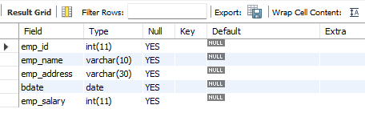
Question: 3. Add a column ‘Age’ in to an investor table.

Query:
ALTER TABLE Investor ADD inv_age INT;
DESC Investor;
Output:
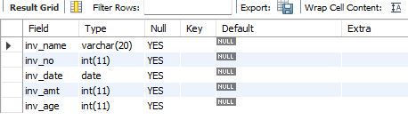

Question: 4. Change the datatype of inv_no from int to big int in Investor table
Query:
ALTER TABLE Investor MODIFY COLUMN inv_no BIGINT;
DESC Investor;

Output:
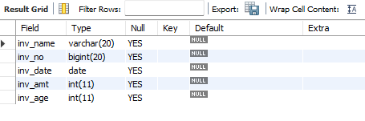

Question: 5. Change the data type of any one column in an existing table.

Query:
ALTER TABLE Emp MODIFY COLUMN emp_name TEXT;
DESC Emp;

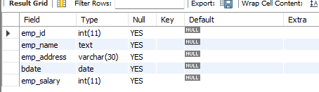
Output:

Question: 6. Change the name of column/field Emp_id to E_id.

Query:
ALTER TABLE Emp CHANGE emp_id e_id INT;
DESC Emp;

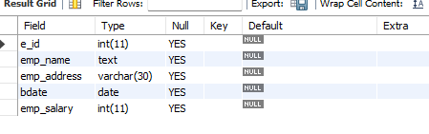
Output:

Question: 7. Drop a column ‘Age’ from an Investor table.

Query:
ALTER TABLE Investor DROP COLUMN inv_age;
DESC Investor;

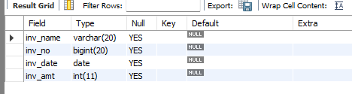
Output:

Question: 8. Create a Primary key constraint between two tables.
Query:
ALTER TABLE Emp ADD PRIMARY KEY (e_id);
DESC Emp;
Output:
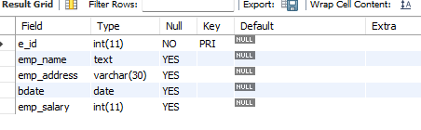
Query:
ALTER TABLE Investor ADD PRIMARY KEY (inv_no);
DESC Investor;

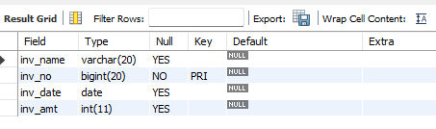
Output:

Question: 9. Create a foreign key constraint between two tables.
Query:
ALTER TABLE Emp ADD COLUMN inv_no BIGINT;
ALTER TABLE Emp ADD FOREIGN KEY (inv_no) REFERENCES Investor(inv_no);
DESC Emp;
Output:
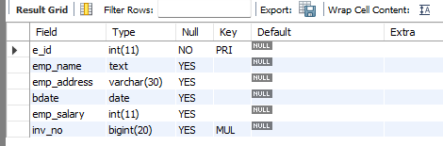

Question: 10. Drop a foreign key constraint between two tables.
Query:
ALTER TABLE Emp DROP FOREIGN KEY emp_ibfk_1;
ALTER TABLE Emp DROP COLUMN inv_no;
DESC Emp;
Output:
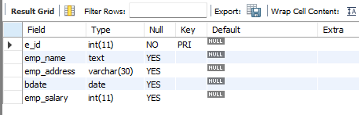

Question: 11. Create a Not Null constraint to emp_name and Check constraint to age into an Emp table.
Query:
ALTER TABLE Emp MODIFY emp_name TEXT NOT NULL;
DESC Emp;
Output:
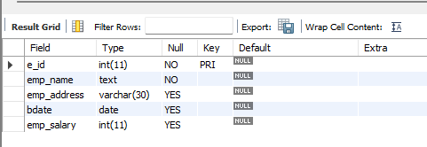

Query:
ALTER TABLE Emp ADD COLUMN emp_age INT;
ALTER TABLE Emp ADD CONSTRAINT CHECK(emp_age > 18);
SHOW CREATE TABLE Emp;
Output:
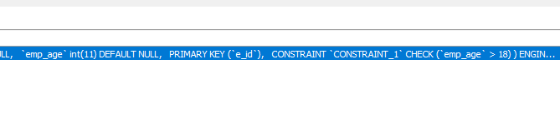
Question: 12. Create a Unique key constraint between two tables.
Query:
ALTER TABLE Emp ADD CONSTRAINT UNIQUE(emp_name);
DESC Emp;
Output:
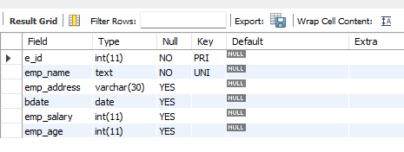

Query:
ALTER TABLE Investor ADD CONSTRAINT UNIQUE(inv_name);
DESC Investor;
Output:
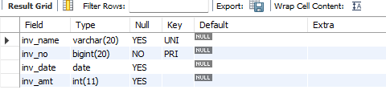

Question: 13. Drop a Unique key constraint between two tables.
Query:
ALTER TABLE Emp DROP INDEX emp_name;
DESC Emp;
Output:
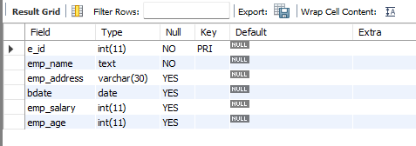

Question: 14. Rename a table.
Query:
RENAME TABLE Emp TO Employee;
DESC Employee;
Output:


Question: 15. Drop anyone a table.
Query:
DROP TABLE Employee;
DESC Employee;
Output:

