Name: Tejas Kayande
Class: MCA 1st
Division: A
Roll No: 2501087

Question:
Create a table EMPLOYEE with following schema:
(Emp_no, E_name, E_address, E_ph_no, Dept_no, Dept_name,Job_id , Salary)
Query:
CREATE TABLE Employee(
Emp_no INT,
E_name TEXT,
E_address TEXT,
E_ph_no TEXT,
Dept_no TEXT,
Dept_name TEXT,
Job_id INT,
Salary INT
);
DESC Employee;
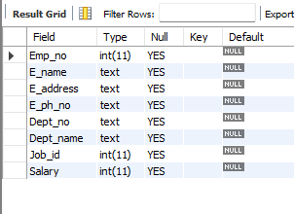
Output:

Question 1: Insert at least 5 rows in the table.
Query:
INSERT INTO Employee VALUES
(001, "Raj" , "Pune" , "9999999999", “D10”, "Tech-Support", 11, 20000),
(002, "Karan" , "Mumbai" , "8787878787", “D12”, "Accounts" , 12, 53000),
(003, "Aryan" , "Sambhaji Nagar", "1233211233", “D10”, "Tech-Support", 13, 23000),
(004, "Ritesh", "Nashik" , "8766766666", “D13”, "HR" , 14, 75000),
(005, "Kunal" , "Pune" , "9899980000", “D14”, "Sales" , 15, 40000);
SELECT * FROM Employee;
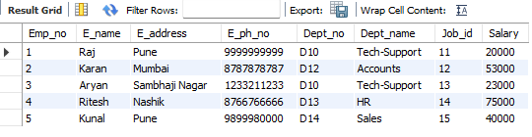
Output:
Question 2: Display all the information of EMP table.
Query:
Select * FROM Employee;
Output:

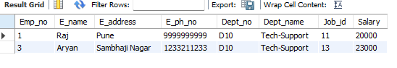
Question 3: Display the record of each employee who works in department D10.
Query:
SELECT * FROM Employee WHERE Dept_no="D10";
Output:

Question 4: Update the city of Emp_no-10 with current city as Nagpur.
Query:
UPDATE Employee SET e_address="Nagpur" WHERE Emp_no=10;
SELECT * FROM Employee WHERE Emp_no=10;
Output:
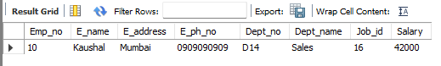

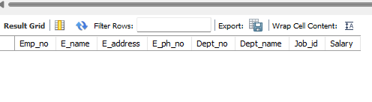
Question 5: Display the details of Employees who works in department MECH.
Query:
SELECT * FROM Employee WHERE Dept_name=”MECH”;
Output:

Question 6: Delete the email_id of employee Ravi
(modified where e_name = “Raj”)
Query:
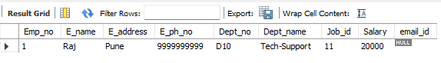
UPDATE Employee SET email_id=NULL WHERE e_name="Raj";
SELECT * FROM Employee WHERE e_name="Raj";
Output:
Question 7: Display the complete record of employees working in SALES Department
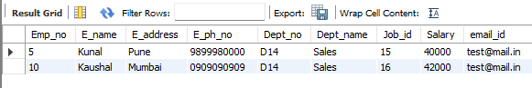
Query:
SELECT * FROM Employee WHERE Dept_name=”Sales”;
Output:
Question 8: Delete one record from the table
Query:
DELETE FROM Employee WHERE Emp_no=10;
SELECT * FROM Employee WHERE Emp_no=10;
Output:
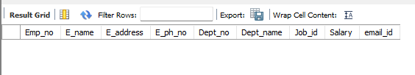
Question 9: Create Index on E_name table
Query:
CREATE INDEX idx_emp_name ON Employee (E_name);
Question 10: Apply transaction control statement using Commit, Rollback & Savepoint
Query:
START TRANSACTION;
UPDATE Employee SET Salary=30000 WHERE E_name=”Raj”;
SAVEPOINT A;
DELETE FROM Employee WHERE E_name=”Kunal”;
SELECT * FROM Employee;
Output:
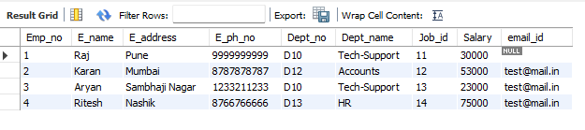

Query:
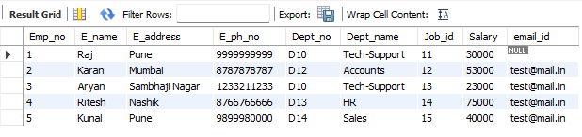
ROLLBACK TO A;
SELECT * FROM Employee;
Output:

Query:
COMMIT;
SELECT * FROM Employee;
Output
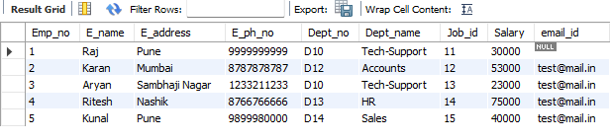
Question 11: Sort the employee by Salary.
Query:
SELECT * FROM Employee ORDER BY Salary;
Output:
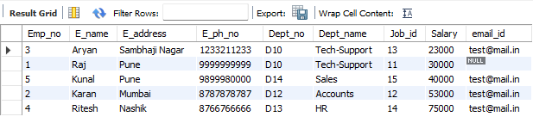

Question 12: Sort the employee from highest to lowest Salary.
Query:
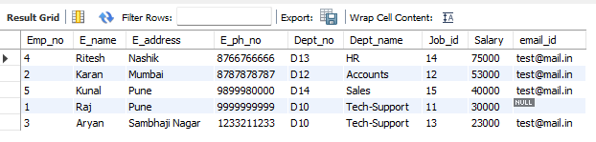
SELECT * FROM Employee ORDER BY Salary DESC;
Output:

Question 13: Sort the employee from lowest to highest Salary.
Query:
SELECT * FROM Employee ORDER BY Salary ASC;
Output:
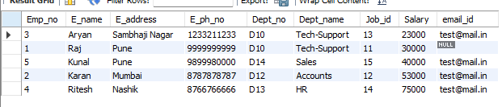

Question 14: Sort the employee name in Ascending and Salary in Descending order.
Query:
SELECT * FROM Employee ORDER BY E_name ASC, Salary DESC;

Output:
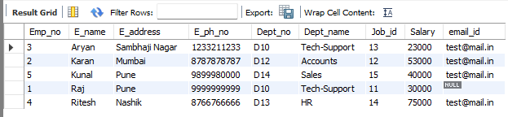

Question 15:Delete all the records using the Truncate command.
Query:
TRUNCATE TABLE Employee;
SELECT * FROM Employee;
Output:
