ARTVAULT – Project Documentation

Chapter 1: Introduction

1.1 Introduction to the Project
ArtVault is a modern, interactive digital platform designed to showcase different art forms in an immersive way. Unlike traditional galleries that focus on static images, ArtVault allows users to explore artworks in 3D and listen to audio descriptions that narrate the meaning, background, and emotions behind each creation.

1.2 Motivation for the Project
Today’s art consumers demand engaging, accessible, and technologically rich ways to experience creativity. ArtVault was developed to bridge the gap between physical art galleries and digital convenience, giving users the ability to experience art from anywhere in a more immersive format.

1.3 Objectives of the Project
- To build a platform that hosts multiple categories of art forms.
- To allow users to view artworks in a 3D interactive environment.
- To integrate audio descriptions for better storytelling and accessibility.
- To create a smooth, interactive, and user-friendly interface.

1.4 Scope of the Project
ArtVault covers:
- Painting, sculptures, digital art, photographs, and mixed media.
- 3D models of artworks viewable from 360° angles.
- Built-in audio guides for each artwork.

1.5 Limitations
- Requires stable internet for smooth 3D rendering.
- Audio quality depends on device hardware.
- Large 3D files may increase loading time.

Chapter 2: Literature Review / Background

2.1 Evolution of Digital Art Platforms
Digital galleries have become common, but most platforms focus on 2D representation. ArtVault improves on this by enabling 3D interaction and immersive audio.

2.2 Need for 3D Visualization in Art
3D viewing enhances understanding, especially for sculptures, textured paintings, and multi-layered artwork.

2.3 Use of Audio Guides
Inspired by physical museums, audio guides assist users with narration, context, and better appreciation.

2.4 Summary
Existing platforms lack a combination of 3D viewing + audio narration. ArtVault fills this gap.

Chapter 3: Methodology

3.1 Project Type
This is a design and development-based project.

3.2 Tools and Technologies Used
- Front-End: HTML5, CSS3, JavaScript, React.js
- 3D Rendering: Three.js / Babylon.js
- Audio Processing: Web Audio API
- IDE / Environment: VS Code, Node.js

3.3 System Architecture
1. User Interface Layer – Displays art, manages navigation.
2. 3D Rendering Engine – Loads models and interactive controls.
3. Audio Engine – Plays descriptions.
4. Database / Storage – Stores metadata, artwork files, and audio.

3.4 Module Description
- Art Upload Module: Upload images, models, and audio files.
- 3D Viewer Module: Rotate, zoom, and explore art.
- Audio Guide Module: Play, pause, and control narration.
- Search & Categories Module: Filter art forms easily.

3.5 Implementation Steps
- UI Layout design
- Artwork database setup
- 3D model integration
- Audio guide integration
- Testing and performance optimization

Chapter 4: Results and Discussion

4.1 Preview of Interface
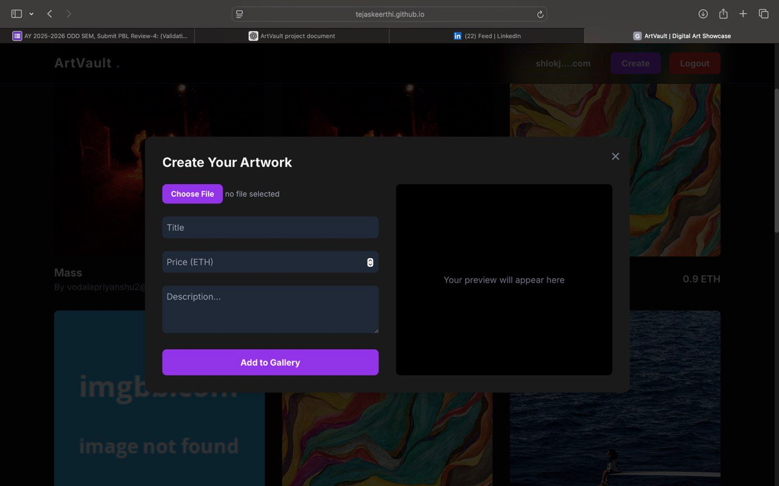
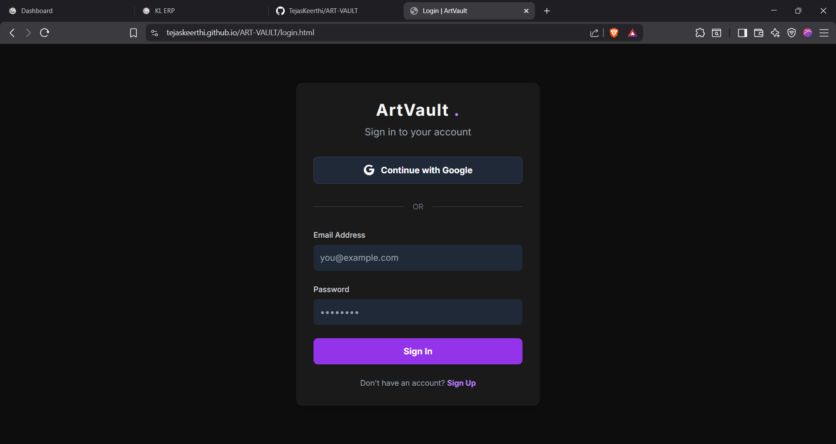

4.2 Output Explanation
Users can:
- Select an art piece.
- View it in a 3D space.
- Rotate or zoom.
- Click on audio guide for narration.

4.3 Testing
- Checked loading speed of 3D models.
- Tested audio sync and quality.
- Verified cross-browser compatibility.

4.4 Challenges and Solutions
- 3D model size too large: Used compression and optimized formats.
- Audio delay: Preloading techniques solved the issue.
- Rendering performance: Used efficient Three.js rendering strategies.

Chapter 5: Conclusion and Future Work

5.1 Summary
ArtVault successfully delivers an immersive art-viewing experience using 3D visuals and audio storytelling.

5.2 Key Findings
- Immersive technology greatly enhances user engagement.
- Audio narration increases understanding of artworks.

5.3 Limitations
- Heavy models may slow loading.
- Limited offline functionality.

5.4 Future Enhancements
- AR/VR support
- Artist profiles and portfolios
- Social sharing features
- AI-based art recommendations

Appendices

A. Source Code Snippets

1. Gallery Item Component (HTML Snippet)

<div id="gallery-grid" class="grid grid-cols-1 sm:grid-cols-2 lg:grid-cols-3 gap-8">
<div class="group relative"
data-description="Crimson Tide. An abstract digital painting with swirling patterns of red, black, and gold."
data-image-url="https://placehold.co/600x800/2D033B/FFFFFF?text=Crimson+Tide">
<img src="https://placehold.co/600x800/2D033B/FFFFFF?text=Crimson+Tide"
alt="Abstract digital art" class="gallery-image">
<!-- Hover Overlay with Actions -->
<div class="absolute inset-0 bg-black/60 card-overlay rounded-lg
flex items-center justify-center space-x-2">
<!-- Audio Description -->
<button class="audio-btn p-3 bg-white/20 rounded-full hover:bg-white/30 transition-colors">
<svg class="h-6 w-6 text-white" fill="none" stroke="currentColor">...</svg>
</button>
<!-- Remix Button -->
<button class="remix-btn p-3 bg-white/20 rounded-full hover:bg-white/30 transition-colors">
<svg class="h-6 w-6 text-white" fill="none" stroke="currentColor">...</svg>
</button>
<!-- Buy Now -->
<button class="buy-now-btn font-bold bg-purple-600 text-white py-3 px-6
rounded-lg hover:bg-purple-700">
Buy Now
</button>
</div>
<!-- Artwork Title + Price -->
<div class="mt-4 flex justify-between items-center">
<div>
<h3 class="text-xl font-bold">Crimson Tide</h3>
<p class="text-gray-400">By AuraFlow</p>
</div>
<div class="text-lg font-bold flex items-center gap-1">
<svg class="w-5 h-5" viewBox="0 0 320 512">...</svg>
0.5 ETH
</div>
</div>
</div>
</div>

2. JavaScript Snippet – Gallery Logic

// --- Notification Logic ---
function showNotification(message, isSuccess = true) {
const banner = document.getElementById("notification-banner");
banner.textContent = message;
banner.classList.remove("opacity-0");
banner.style.backgroundColor = isSuccess ? "#10B981" : "#EF4444";
setTimeout(() => banner.classList.add("opacity-0"), 2500);
}
// --- Gallery Actions ---
galleryGrid.addEventListener("click", function (event) {
const target = event.target;
if (target.closest(".audio-btn")) { /* Play audio */ }
if (target.closest(".remix-btn")) { /* Remix tool */ }
if (target.closest(".buy-now-btn")) { showNotification("Redirecting to checkout…"); }
});
// --- Image Upload + Add to Gallery ---
imageUpload.addEventListener("change", (event) => {
const file = event.target.files[0];
if (!file) return;
currentImageUrl = URL.createObjectURL(file);
});
// --- Firebase Authentication ---
auth.onAuthStateChanged((user) => {
if (user) updateHeaderUI("consumer", user.email);
else updateHeaderUI(null, null);
});

B. User Manual
- Open platform
- Browse artwork
- Select 3D view
- Play audio guide

C. Additional Screenshots
